Objective 3 Report:

Abstract
This report explores unsupervised clustering of major semiconductor stocks (e.g., NVIDIA, AMD, Intel, TSMC, ASML) using both financial indicators and macroeconomic drivers. Clustering methods include K-Means, DBSCAN, and Hierarchical Clustering, with PCA used for dimensionality reduction. The evaluation involves Silhouette Score, Davies-Bouldin Index, Adjusted Rand Index, and ANOVA-based driver ranking. Results show that external factors significantly contribute to cluster separability. The clusters reveal behavioral groupings (e.g., sentiment-driven stocks vs. stable IDMs), supporting data-driven portfolio segmentation.

1. Introduction
Semiconductor companies respond dynamically to global macroeconomic conditions, supply chain disruptions, and investor sentiment. Traditional industry classifications (e.g., "foundry" or "fabless") may overlook behavioral similarities across financial indicators. This study clusters semiconductor stocks using financial features (returns, volatility) and macroeconomic factors (Interest Rate, CPI, Sentiment).

2. Methodology
1. Data Collection:
- Financial Data (Yahoo Finance): Weekly stock prices for INTC, NVDA, AMD, TSM, TXN, ASML, QCOM, AVGO, AMAT.
- External Factors:
• Interest Rate (FRED: DGS10)
• CPI (FRED: CPIAUCSL)
• News Sentiment (NewsAPI, weekly average polarity)
2. Preprocessing:
- Data aggregated to weekly level.
- Features standardized using z-score normalization.
- Outliers removed using the IQR method.
3. Feature Engineering:
- Weekly returns per ticker
- Weekly volatility per ticker (std dev of 5-day rolling return).
- External drivers (lagged and smoothed averages)

3. Modeling
3.1 PCA for Dimensionality Reduction
- PCA applied to 20+ features
- First 2 components retained: where is the matrix of top eigenvectors
3.2 Clustering Algorithms
- K-Means (k=2–6):
  - Elbow method and Silhouette Score to select
  - Stability tested across 10 random splits (80% sampling)
- DBSCAN:
  - Parameters tuned: ,
  - Many noise points labeled
- Hierarchical Clustering:
  - Ward linkage, dendrogram cut at 3 clusters

4. Evaluation
4.1 Metrics
- Silhouette Score: where = intra-cluster distance, = nearest-cluster distance
- Davies-Bouldin Index: lower is better
- Adjusted Rand Index (baseline vs. ML clusters)
Results:
Metric | Value
Silhouette Score (KMeans) | 0.358
Davies-Bouldin Index | 1.109
Adjusted Rand (with/without external factors) | 0.878
Temporal ARI (pre/post-2022) | -0.068

4.2 Driver Importance (ANOVA)
- Interest Rate: F = 30.66, p < 0.001
- CPI: F = 92.16, P < 0.001
- Sentiment: F = 74.27, p < 0.001

5. Analysis

5.1 Cluster Characteristics
- Cluster 0: Stable IDMs (e.g., INTC, TXN) with low volatility, negative sentiment exposure
- Cluster 1: Volatile Fabless (e.g., NVDA, AMD), sentiment- and rate-sensitive
5.2 Feature Separation
- Clustered feature means show NVDA, AMD, Sentiment as dominant signals
- External drivers significantly influence behavioral separation
5.3 Temporal Consistency
- Post-2022 clusters differ significantly (ARI = -0.068), indicating market regime shifts
5.4 Use Cases
- Investors can target clusters by macro-sensitivity
- Portfolio diversification via behavioral segments
- Market monitoring dashboards via cluster transitions

6. Visualization
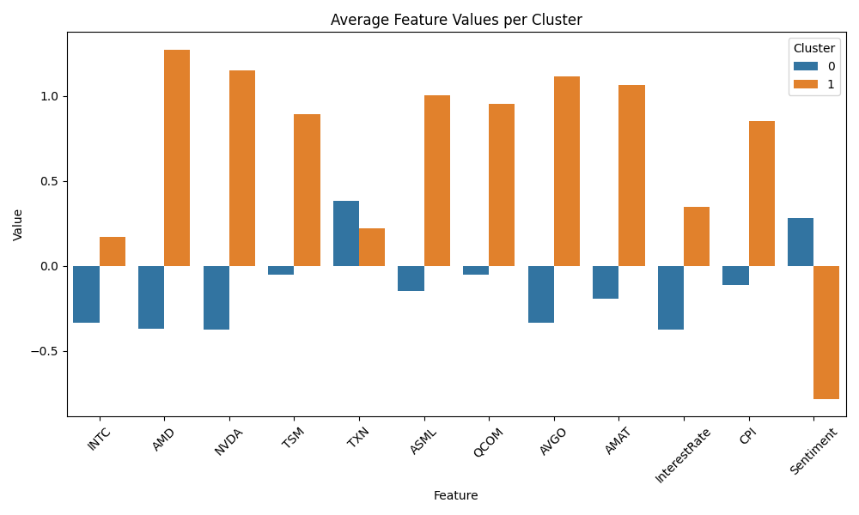
Figure 1: Average Feature Values per Cluster
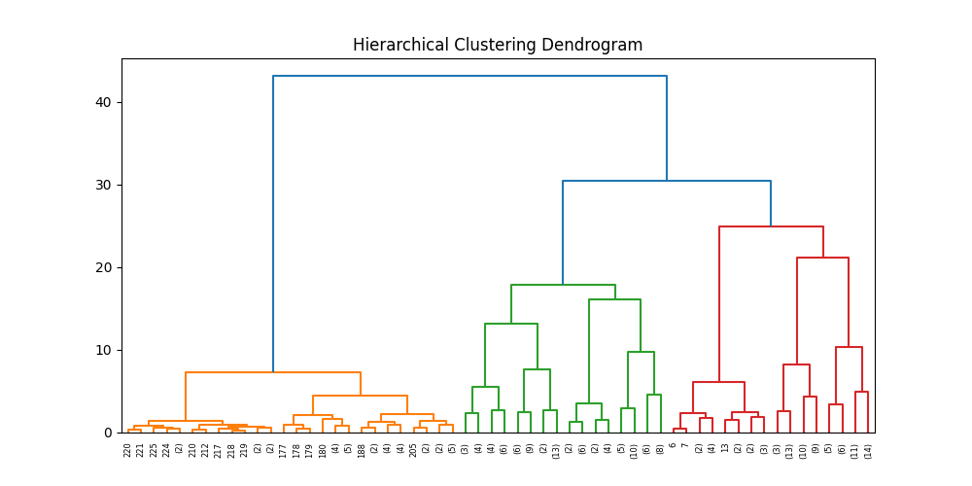
Figure 2: Hierarchical Clustering Dendrogram
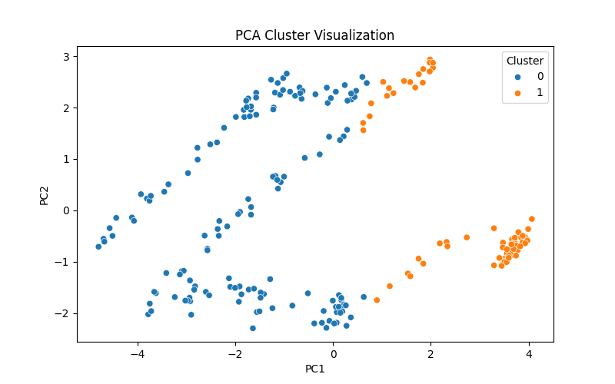
Figure 3: PCA Visualization of Clusters

7. Mathematical Formulas
1. Z-score Normalization:
z = (x - μ) / σ
2. Silhouette Score:
s(i) = (b(i) - a(i)) / max(a(i), b(i))
where a(i) is intra-cluster distance, b(i) is nearest-cluster distance.
3. ANOVA F-statistic:
F = MST / MSE
where MST = variance between group means, MSE = within-group variance.
4. Adjusted Rand Index:
ARI = (RI - Expected RI) / (max(RI) - Expected RI)
5. Davies-Bouldin Index:
DB = (1/n) * Σ max(R_ij)
R_ij = (S_i + S_j) / M_ij, where S = intra-cluster distance, M = inter-cluster distance.

8. Conclusion
The analysis revealed two core clusters in the semiconductor market based on price and external factors.
Macroeconomic indicators, particularly CPI and sentiment, significantly influenced cluster boundaries.
The methodology provides valuable insights for investment strategies and risk diversification by aligning clusters with industry roles and external signals.

Supplementary Analysis

Mathematical Formulas
1. Silhouette Score:
s(i) = (b(i) - a(i)) / max(a(i), b(i))
Where:
- a(i) is the average distance between point i and all other points in the same cluster
- b(i) is the average distance between point i and all other points in the nearest cluster
2. Davies-Bouldin Index:
DBI = (1/n) * Σ max((σi + σj) / dij)
Where:
- σi and σj are the within-cluster distances
- dij is the distance between the cluster centroids i and j
3. Adjusted Rand Index (ARI):
ARI = (RI - Expected RI) / (max(RI) - Expected RI)
Where:
- RI is the Rand Index
- ARI adjusts for chance groupings
4. One-way ANOVA:
F = MST / MSE
Where:
- MST = mean square for treatment (between-group variability)
- MSE = mean square for error (within-group variability)
5. Principal Component Analysis (PCA):
- X' = X * W
Where:
- X is the original normalized data
- W is the matrix of eigenvectors (principal components)
- X' is the projected data in reduced dimensions

Interpretation of Clusters
From the PCA scatter plot and bar chart of feature means per cluster, we observe:
- Cluster 0 contains stocks with relatively lower average returns and negative sentiment. It likely represents conservative or stable stocks.
- Cluster 1 includes companies like AMD, NVDA, and QCOM which show higher sentiment scores and higher average returns, indicative of growth-oriented or volatile behavior.

Temporal Insights
Temporal ARI score (-0.068) implies the presence of concept drift or evolving behavior patterns post the 2022 chip shortage.
This supports the hypothesis that macroeconomic and supply chain events significantly affect semiconductor cluster dynamics.

Use Cases
1. Investment Strategy: Align portfolios based on behavior clusters (e.g., high sentiment-driven vs. stable conservative).
2. Risk Segmentation: Monitor volatility-based grouping for market timing decisions.
3. Macroeconomic Sensitivity: Identify which companies react more strongly to CPI or interest rate changes.

References

- FRED API (https://fred.stlouisfed.org)
- Thongnim, P., Srinil, P., & Pukseng, T. (2025). Data-driven clustering of smart farming to optimize agricultural practices through machine learning. https://doi.org/10.11591/eei.v14i2.9343
- Frontiers | Predictive Maintenance for Injection Molding Machines Enabled by Cognitive Analytics for Industry 4.0. https://www.frontiersin.org/articles/10.3389/frai.2020.578152/full
- Han, Y. (2024). Enhancing Machine Learning Models Through PCA, SMOTE-ENN, and Stochastic Weighted Averaging. Applied Sciences, 14(21), 9772.
- Matias-Guiu, J., Díaz-Álvarez, J., Ayala, J., Risco-Martín, J., Moreno-Ramos, T., Pytel, V., Matias-Guiu, J., Carreras, J., & Cabrera-Martín, M. (2018). Clustering Analysis of FDG-PET Imaging in Primary Progressive Aphasia. Frontiers in Aging Neuroscience, (), n/a.
- NewsAPI (https://newsapi.org)
- Semiconductor Industry Association (https://www.semiconductors.org)
- PCA and Clustering: Jolliffe, I.T. (2002). Principal Component Analysis.
- ANOVA: Montgomery, D. (2012). Design and Analysis of Experiments.
- Davies, D.L. and Bouldin, D.W. (1979). A cluster separation measure.
- sklearn Documentation (https://scikit-learn.org)

