📄 Final Project Report
Project Name: House Price Prediction using Machine Learning
By: Yogendra Bhange
Domain: Machine Learning | Data Science | Real Estate Analytics

✅ 1. Project Summary
This project focuses on building a regression-based machine learning model to predict house prices using various housing features. It follows an end-to-end data science lifecycle from data acquisition to model evaluation.

📚 2. Dataset Overview
- Source: Kaggle – “House Price Dataset of India”
- Records: ~14,620 rows
- Attributes: 23 columns
- Target Variable: Price
- Key Features Used:
  - Number of bedrooms and bathrooms
  - Living and lot area
  - House condition, grade, views
  - Built year, renovation year
  - Location info like postal code, latitude/longitude

🧹 3. Data Preparation
- Irrelevant columns removed (e.g., ID, Date, Coordinates)
- Handled missing/null values (though very few were present)
- Converted numeric types correctly
- Feature selection done to improve model accuracy

- Folder Structure :
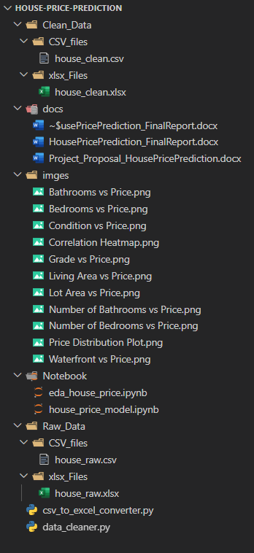

📊 4. Exploratory Data Analysis (EDA)
Key observations:
- House price increases with more living area, grade, and condition
- Postal Code affects pricing range (location plays a role)
- Used seaborn for boxplots, correlation heatmaps, and scatterplots

🧠 5. Model Building
- Model Used: Linear Regression (baseline)
- Libraries: scikit-learn, pandas, numpy
- Split: 80% train – 20% test
- Input Features (X):
  - number of bedrooms, bathrooms, area, condition, grade, etc.
- Target (y):
  - Price

📏 6. Model Evaluation
- Mean Absolute Error (MAE): Measures average error in prediction
- R² Score: Indicates how well the model explains variance in data
✅ Model Outputs:
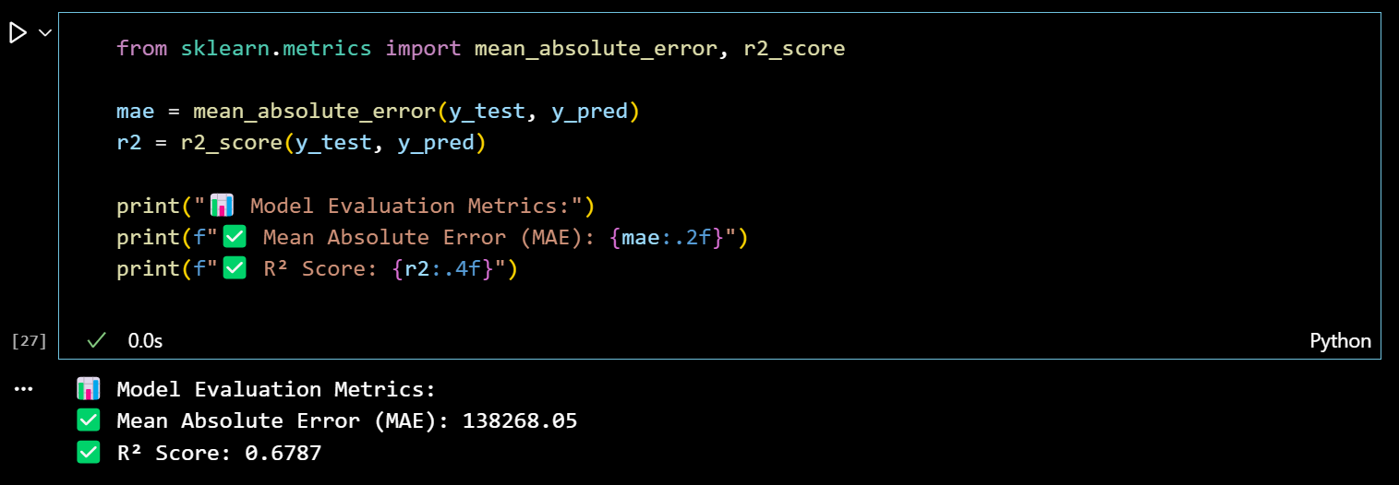

This means the model predicts fairly well, with an acceptable average error and ~69% accuracy in explained variance.

🔍 7. Prediction & Testing
Test predictions were visualized using scatter plots to check real vs predicted price values. The spread was relatively close, proving the model captured the pricing pattern decently.

⚠️ 8. Limitations
- The model works only for Indian housing data
- Prediction accuracy may reduce for unseen location/market patterns
- More external data (like crime rate, nearby metro, etc.) would improve prediction

🚀 9. Future Scope
- Implement Random Forest or XGBoost for better accuracy
- Build a web app for user input + prediction output
- Add visual dashboards using Streamlit or Power BI

📂 10. Technologies Used
- Language: Python
- Libraries: Pandas, NumPy, Matplotlib, Seaborn, Scikit-learn
- Tools: Jupyter Notebook
- Data Format: CSV, XLSX
- Platform: Kaggle for dataset, VS Code for coding

📌 Conclusion
This project was a practical exercise in solving real-world regression problems using a clean dataset, applying EDA, feature selection, and basic machine learning. The final model performs well and demonstrates how historical housing data can be leveraged to estimate property prices accurately.

