**Capstone Project**

**Testing Medicare web application**

**DESCRIPTION**

This project requires end-to-end development of a comprehensive QA and test environment for a healthcare website. This QA and test environment should be inclusive of the following testing layers:

1. Browser-based end user testing using Selenium WebDriver & TestNG
2. API testing with Postman on AWS cloud
3. Automating the whole testing process by a Jenkins job

**Implementation steps:**

1. Write an automation script using page object design to store the web elements of the home page
2. Create Selenium scripts to test the pages on the website
3. Execute using TestNG
4. Create Postman scripts to test the API endpoints mentioned
5. Create and build Jenkins job for all the automation testing phases performed in the previous steps

# Write an automation script using page object design to store the web elements of the home page

Create maven project

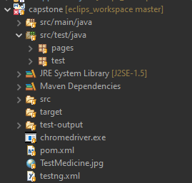

Add all dependencies in pom.xml

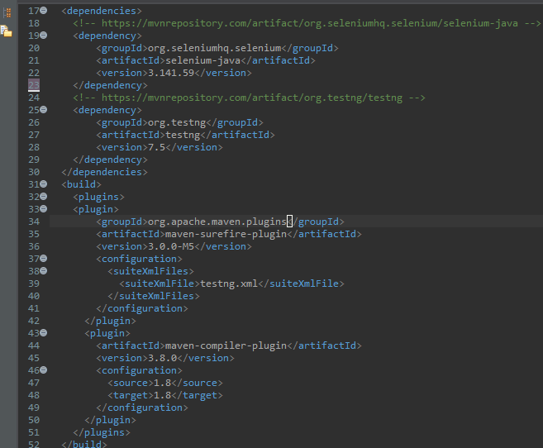

Create pages package and add all necessary page class files

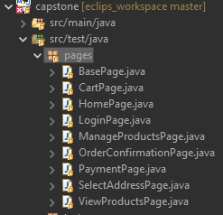

BasePage.java

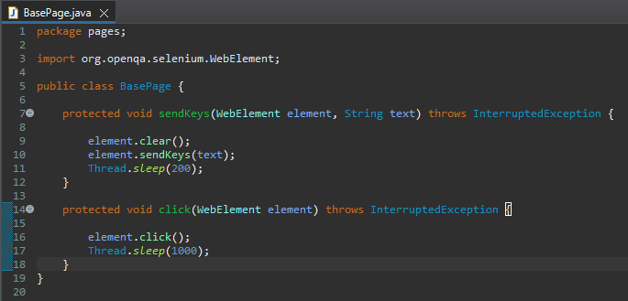

HomePage.java

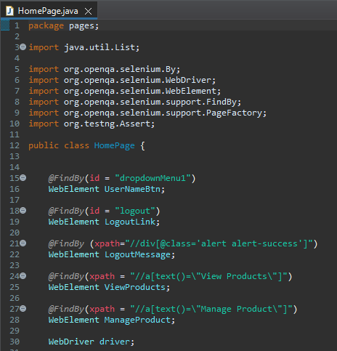

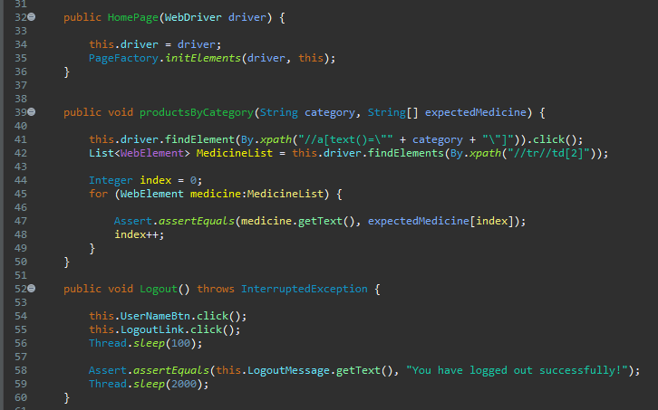

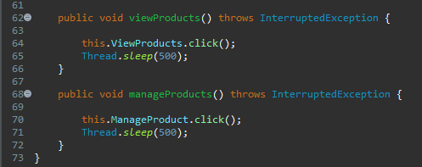

LoginPage.java

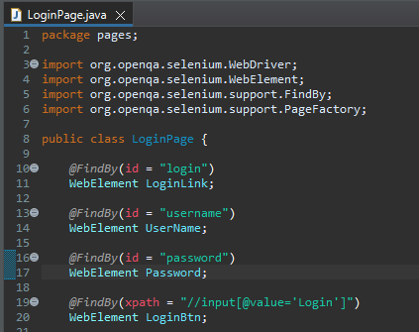

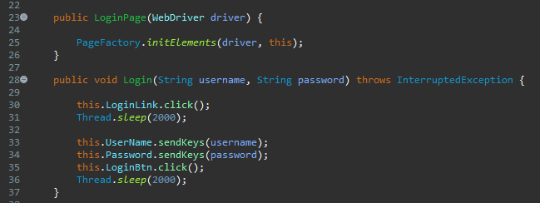

ViewProductsPage.java

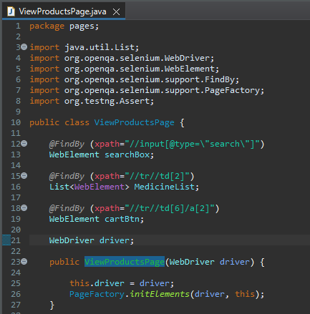

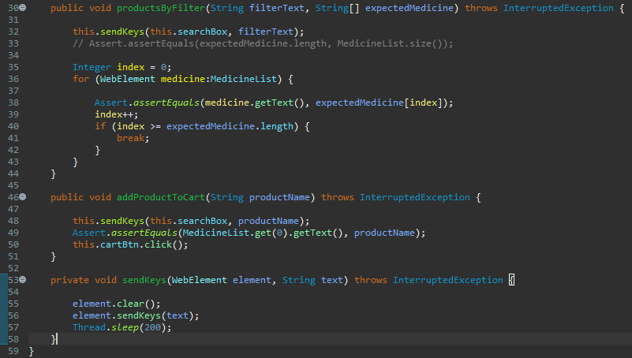

CartPage.java

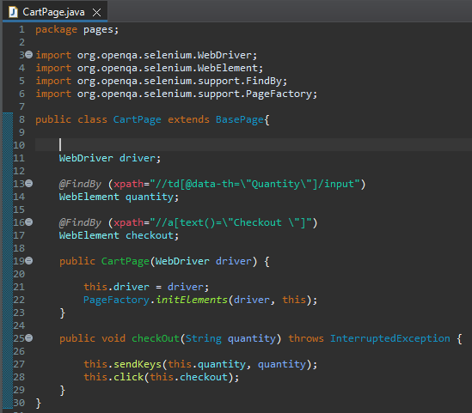

SelectAddressPage.java

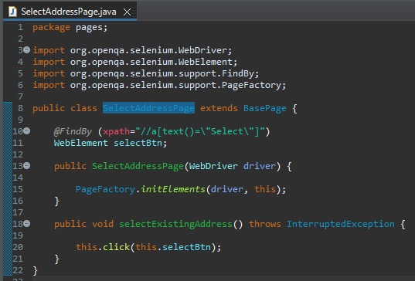

PaymentPage.java

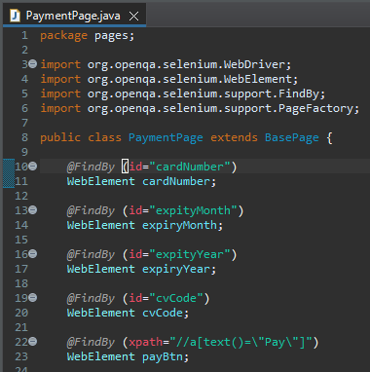

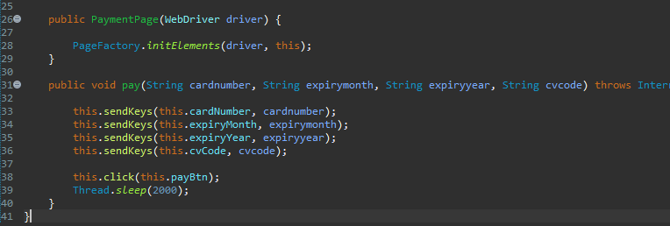

OrderConfirmationPage.java

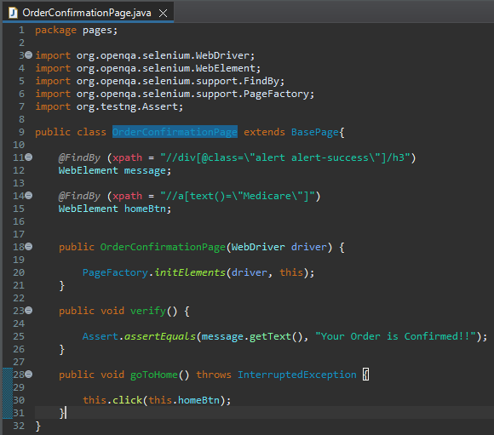

ManageProductsPage.java

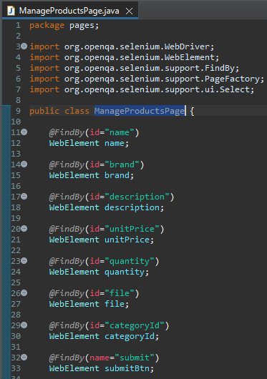

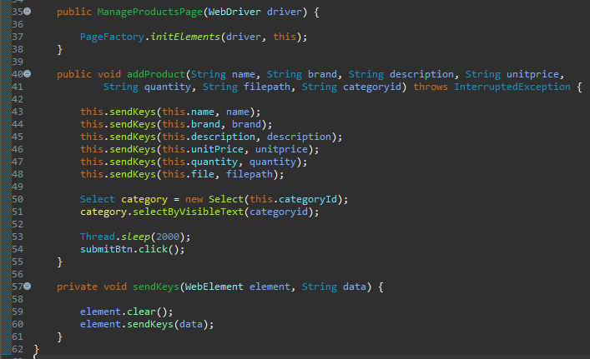

# Create Selenium scripts to test the pages on the website

Creating test package with all required test files

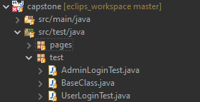

BaseClass.java

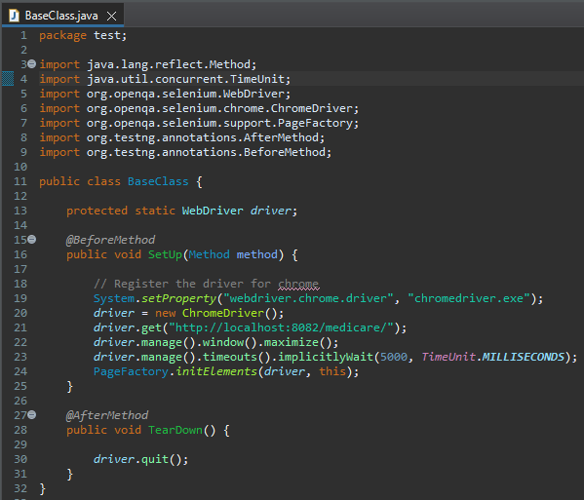

UserLoginTest.java

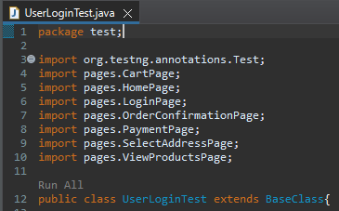

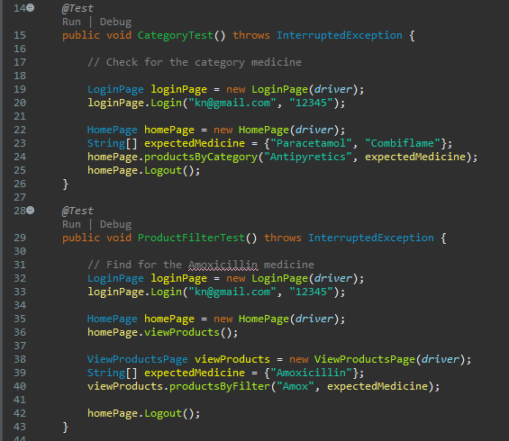

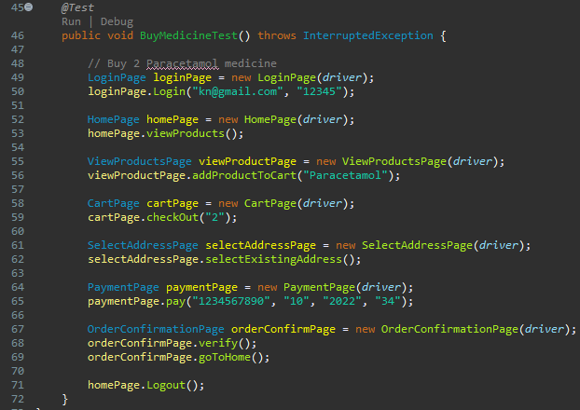

AdminLoginTest.java

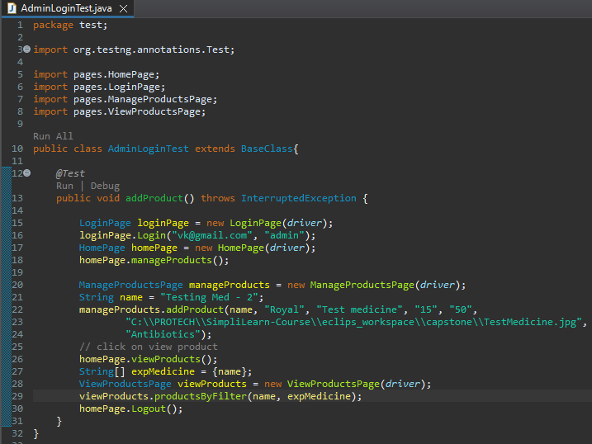

# Execute using TestNG

Converting project to TestNG and generating testing.xml file

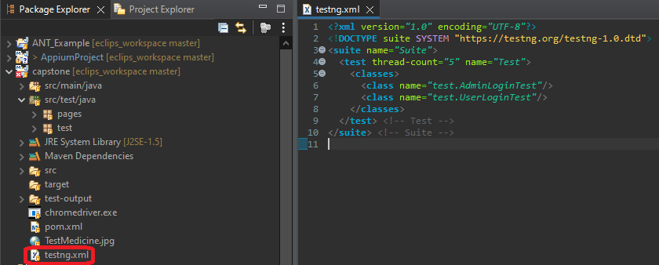

Running this project locally using TestNG

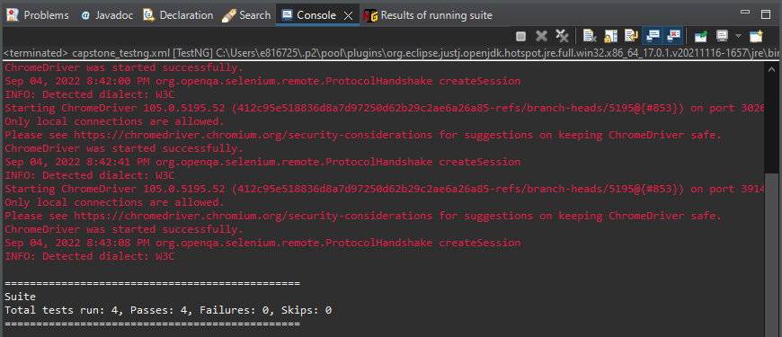

Generated testing report

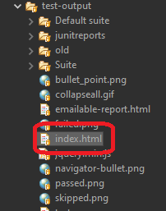

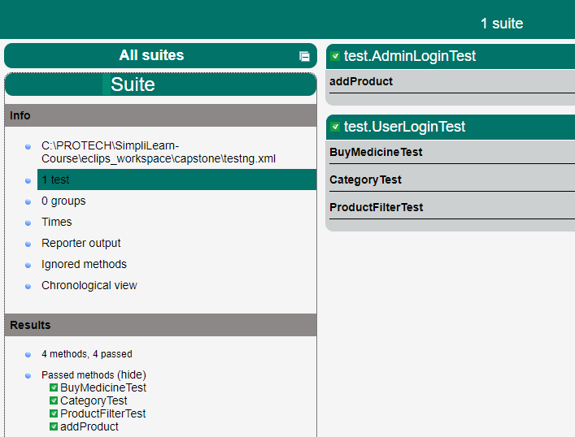

# Create Postman scripts to test the API endpoints mentioned

Created below API tests in Postman

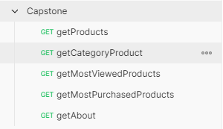

getProducts

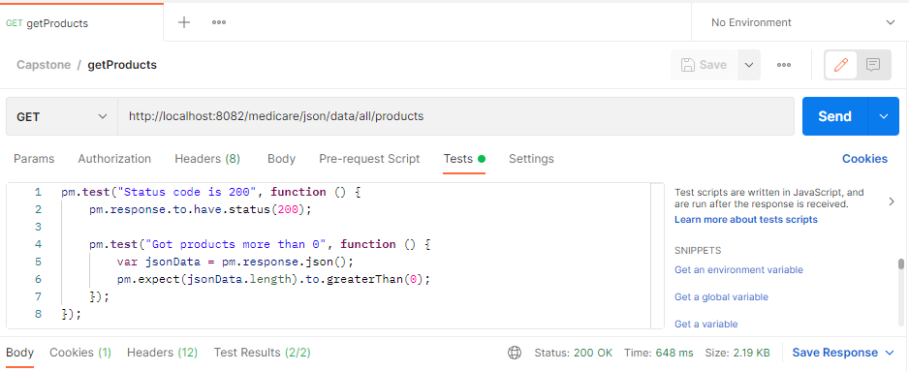

getCategoryProduct

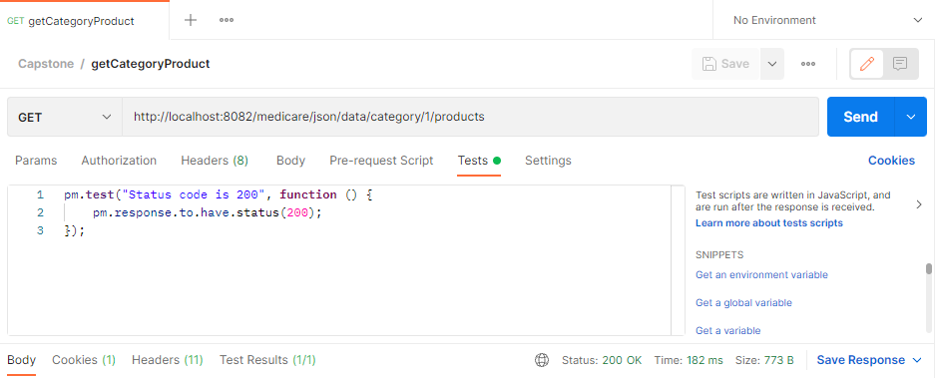

getMostViewedProducts

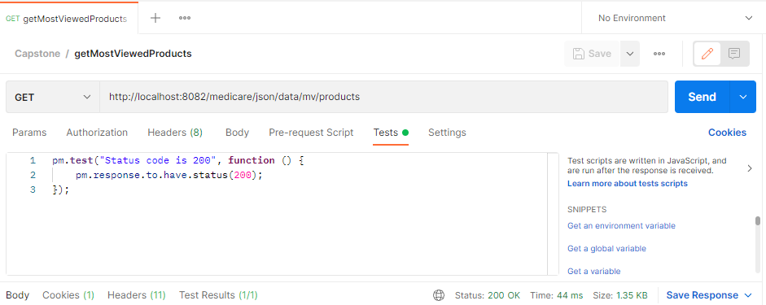

getMostPurchasedProducts

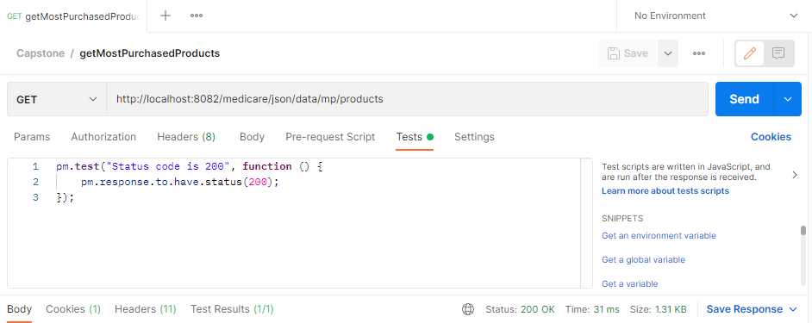

getAbout

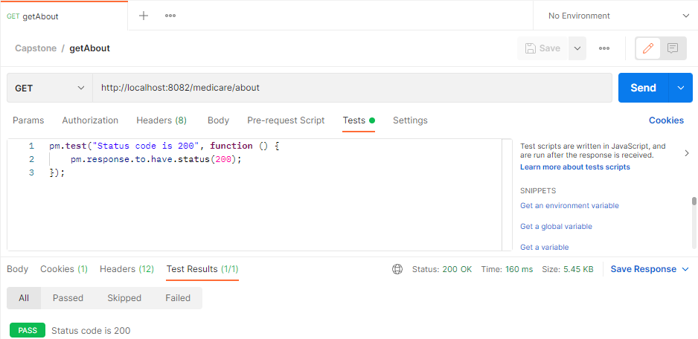

Export this collection as json file

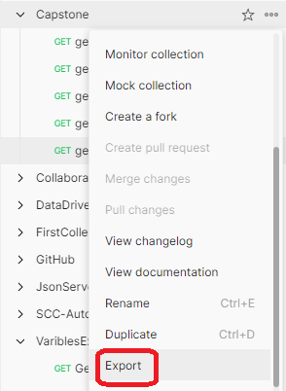

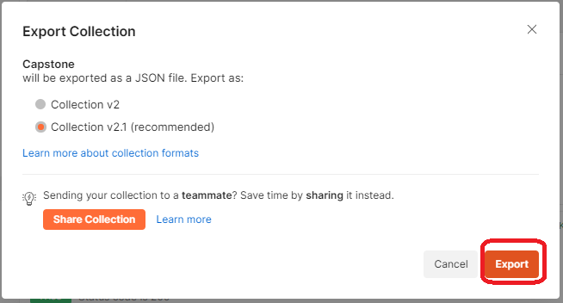

Run this json collection file using newman locally with command

newman run Capstone.postman_collection.json

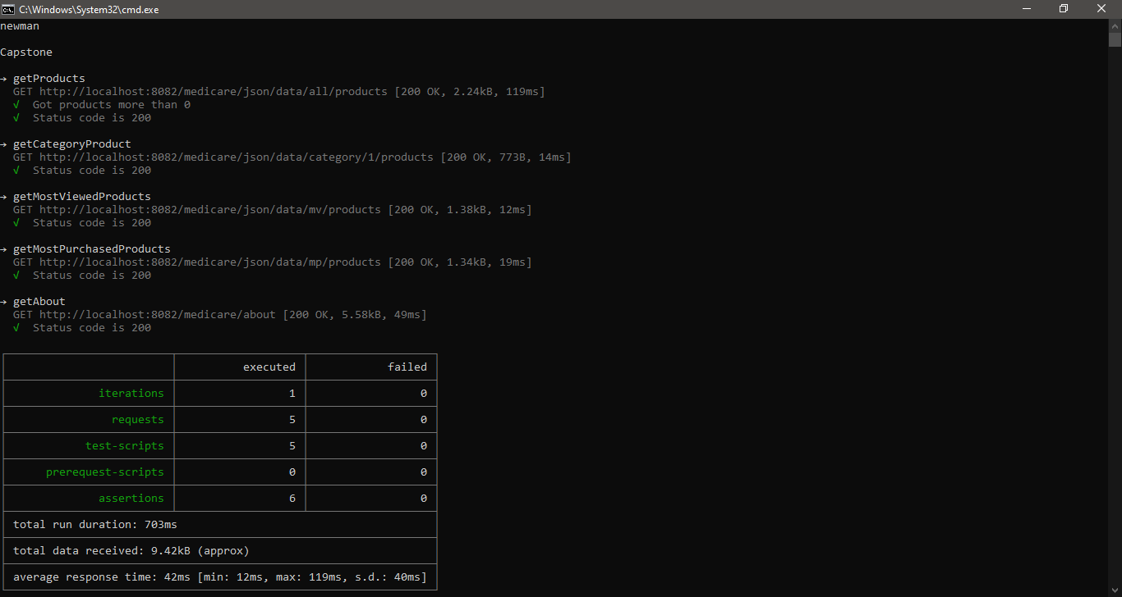

# Create and build Jenkins job for all the automation testing phases

Creating Jenkins job for Web application testing using selenium, TestNG, Maven and Git

Login to Jenkins

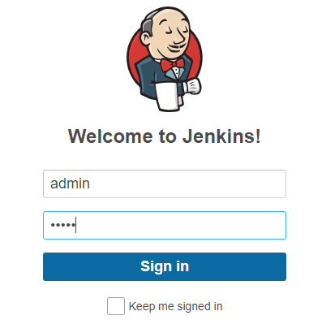

Landing page (Dashboard)

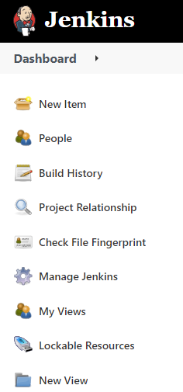

Create new item for this job

Creating free style project Capstone_Job

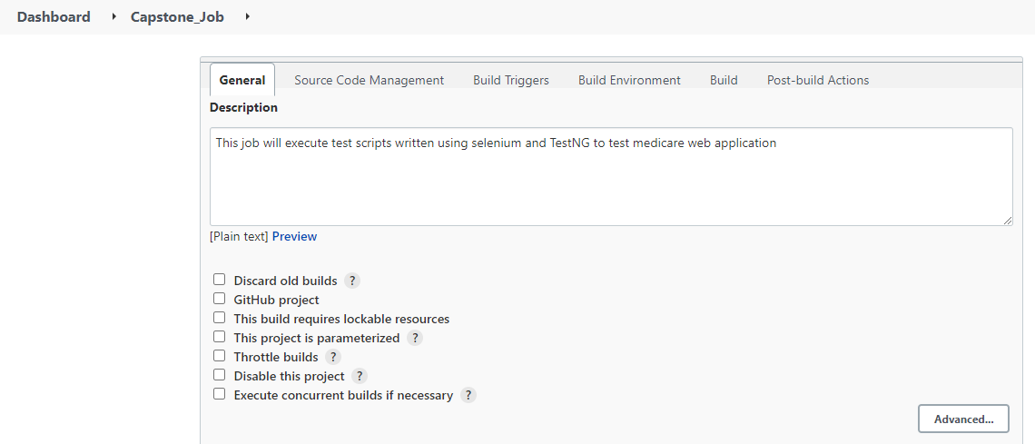

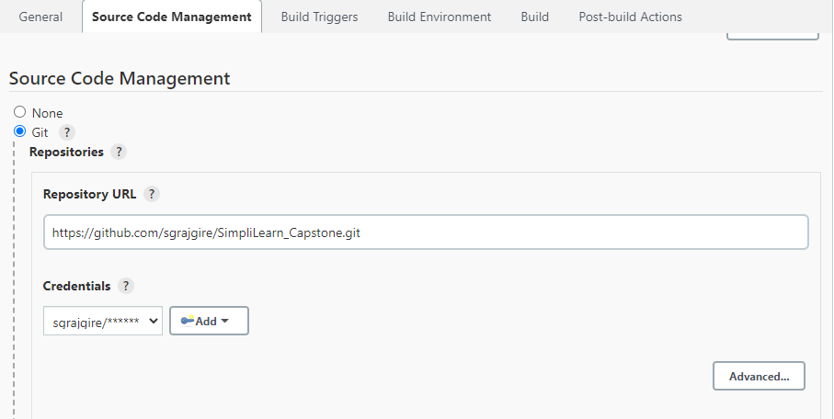

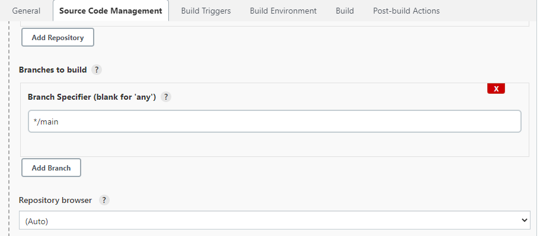

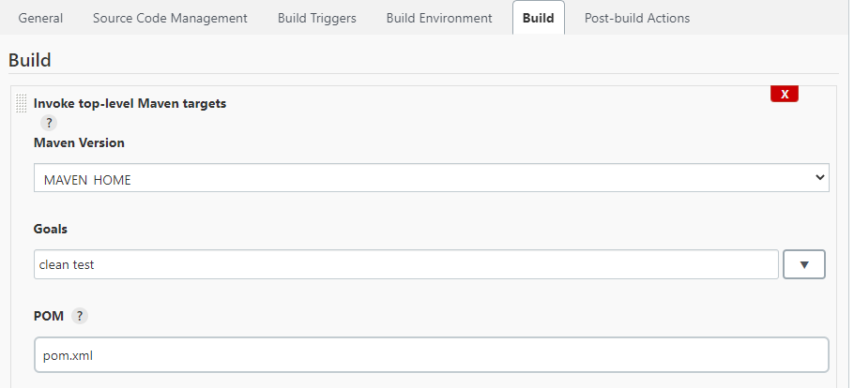

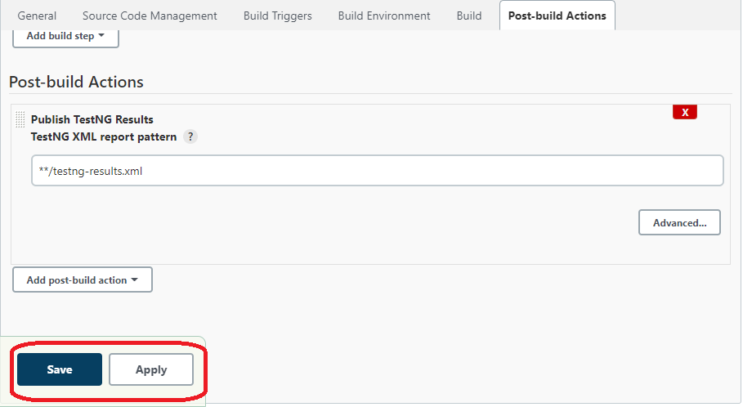

Apply and Save as shown above.

Goto job and click on Build now

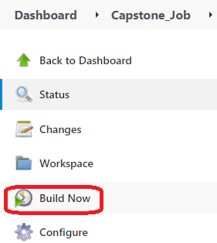

Console output

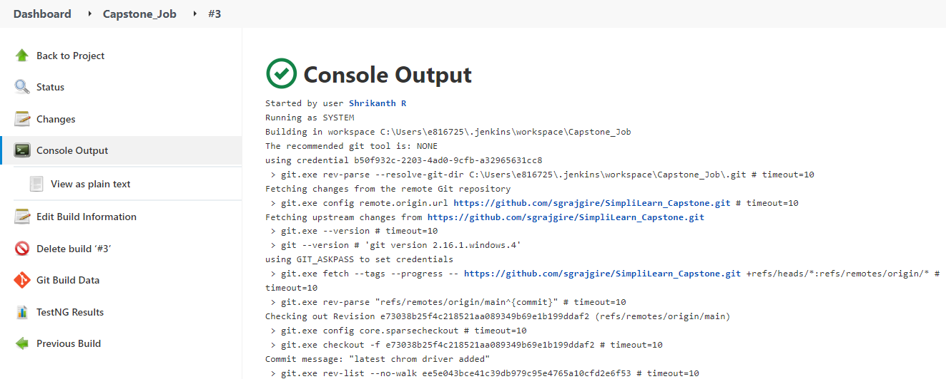

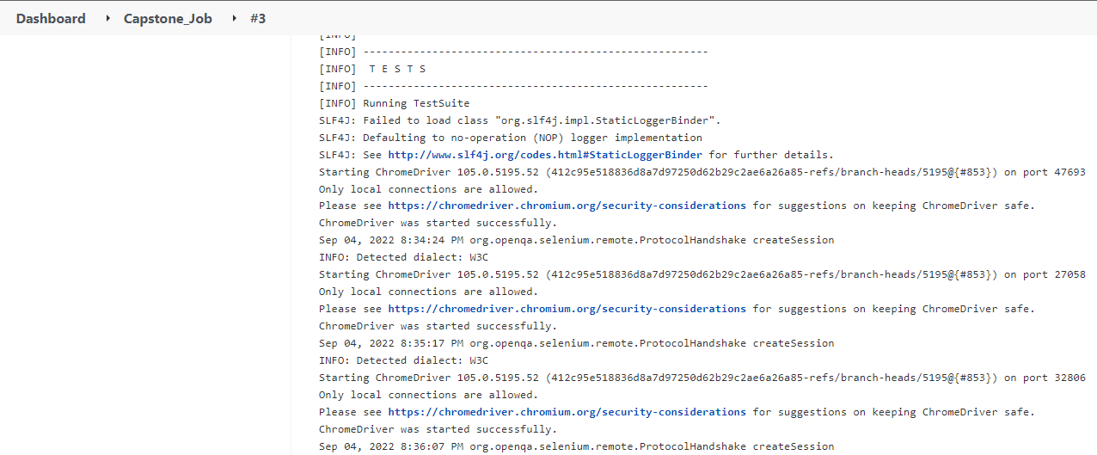

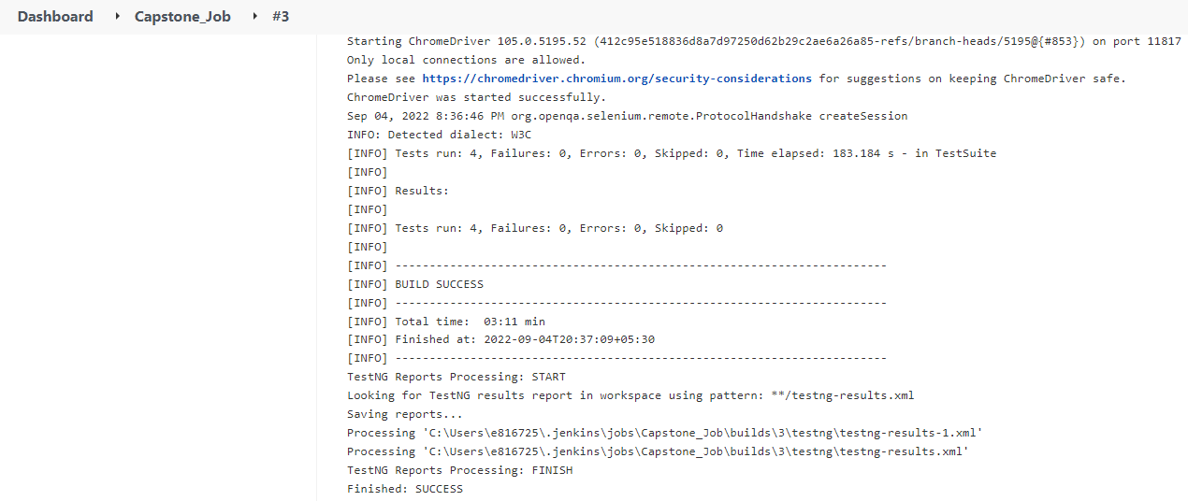

TestNG results in Jenkins

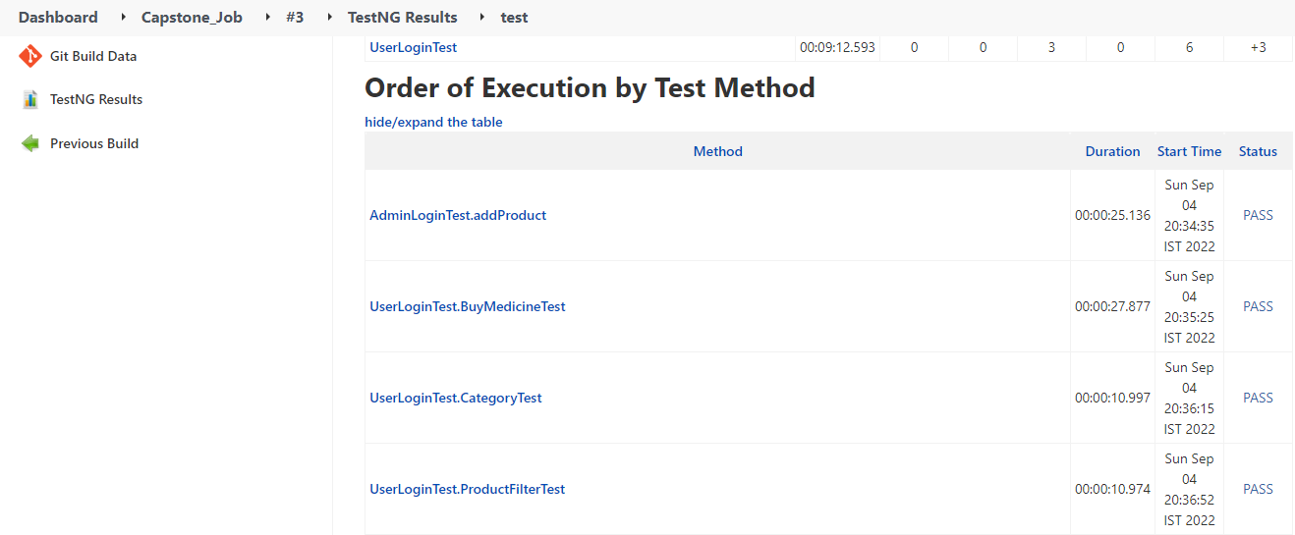

Creating API testing Jenkins job Capstone_API_TestingJob

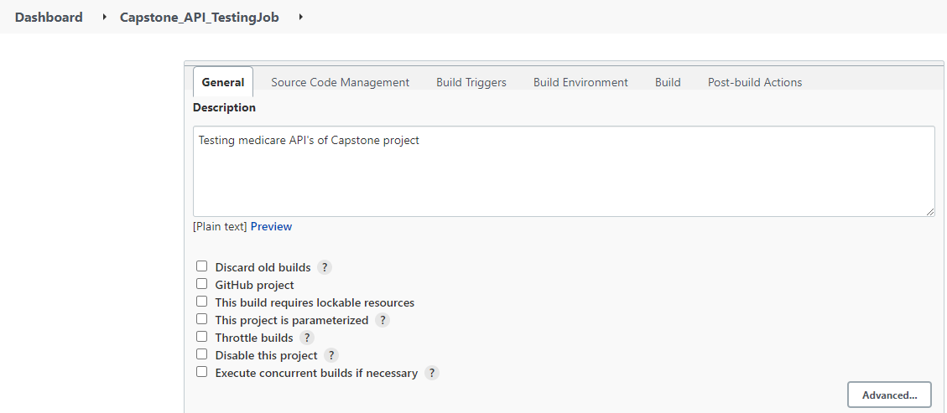

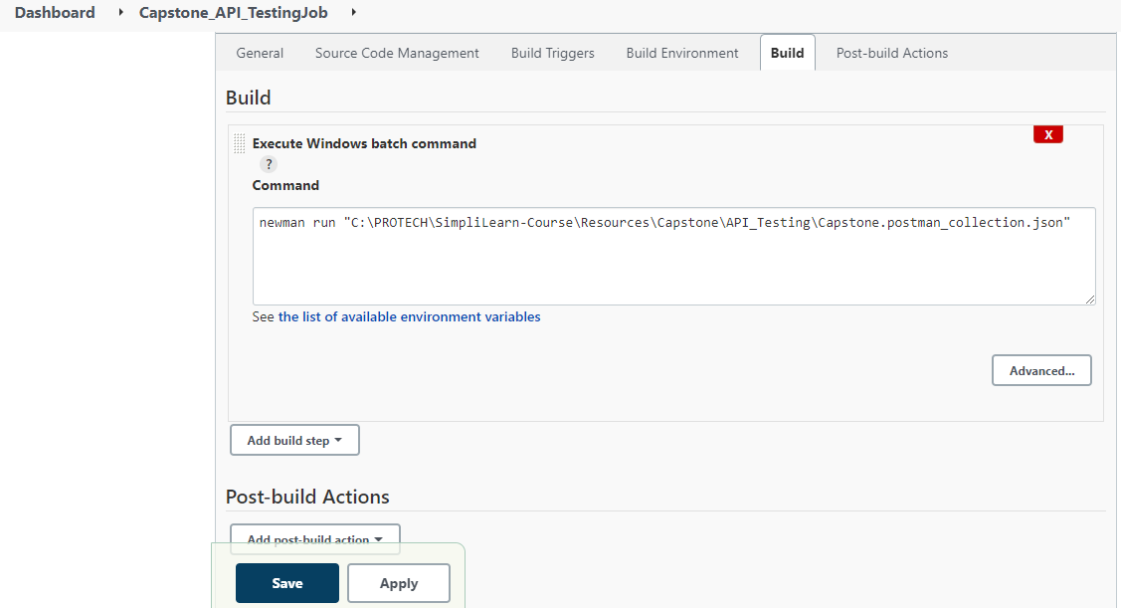

Build now job

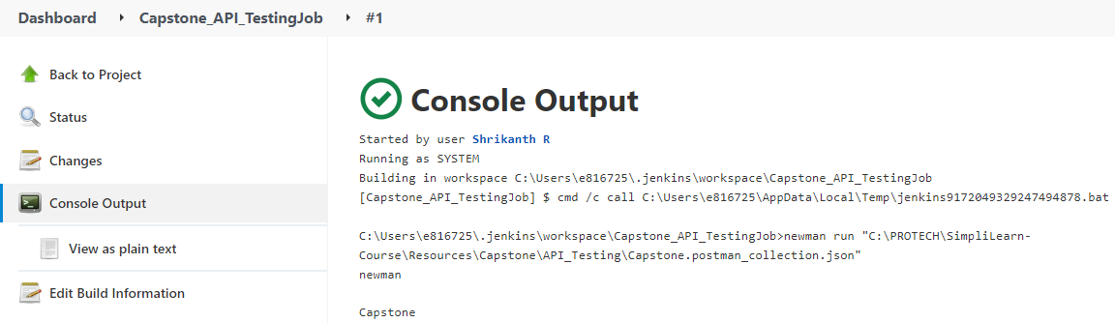

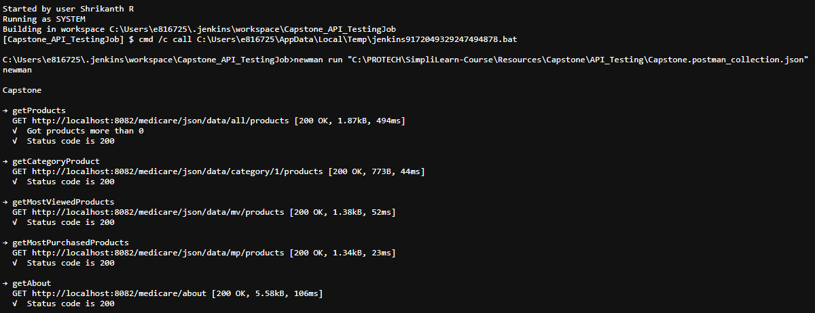

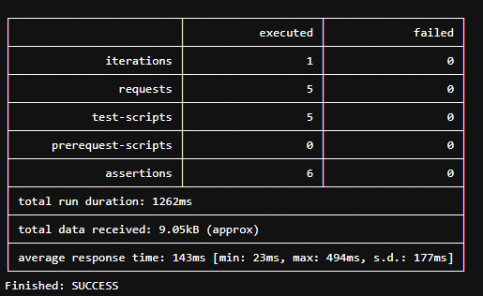

Tester Details:

Shrikanth Rajgire

Honeywell Technology solutions limited Bangalore

[Shrikanth.rajgire@honeywell.com](mailto:Shrikanth.rajgire@honeywell.com)

Concepts used in this project:

* Page object design to store the web elements
* Writing Selenium scripts
* TestNG for running scripts
* Postman to create and run API test cases along with newman
* Jobs creation using Jenkins for CI/CD pipeline

Link to Github repository

<https://github.com/sgrajgire/SimpliLearn_Capstone.git>

Conclusion

Application has good interface where we can purchase medicine online at our convenience

Ease of payment methods and address selection or addition

Application can be improved with more consistent xpath creation. (Spelling mistake in some places with id and name attributes of elements ex: expityMonth instead of expiryMonth)

Admin can be provided with delete medicine option