1. **Introduction -**

* **Problem Definition :**

**Project** –*“Vivir - Make your stay easy” ,* an android application for solving the daily life “House Rental and Tenancy” problem.

**Major User** – Tenant(renter) and Owner

**Abstract** – It would be an android application for booking of apartment/flat /room and making easy stay for an user (Tenant/Renter).

*“Tenant”* can search and book the flat. After booking he can do all transaction during the whole stay at that flat through this application. He can complain and communicate with the owner by this application.He will get notification prior to due date of payment. He has to clear all dues before leaving the flat.

*“Owner”* can upload and update flat/room details that he want to lend. He can approve all request of booking and will respond to complaints through this application. Payment details uploaded by the user can be validated.

Each user has their own dashboard section. This application will provide all principle functionalities needed for room owning/renting and easy stay.

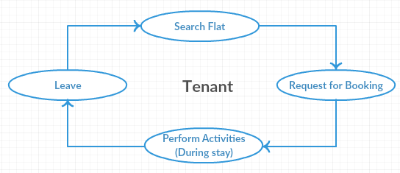

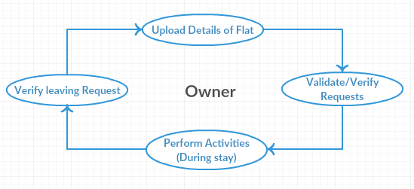

* **Background and Motivations :**

Vivir is a standalone application. It aims to replace the existing manual searching/booking of flats/ rooms and activities associated with that. It just needs an android operating system and Internet connection to perform these activities. Thus, Vivir is a self contained application working with two types of peers - Tenant and Owner.

**How it is useful ?**

**To Tenant** : It will help to a Tenant in following aspects.

* Easy and efficient searching and booking of flats/rooms.
* Easy to stay and
* Removes the conflicts of rent payment and memorization of due date.
* Makes the communication with owner easier.

**To Owner :** Owner will get benefits in following aspects.

* Application will provide an easy way to let their property.
* Approaching to the Customer/Tenant would be easier and efficient.
* Easy to perform all activities needed in room rental.
* Complaint handling and communication with Tenant would be easier.
* Timely payment of rents and no need to memorize/note anything, application will automatically give notifications to both peers.

**To Social aspects :**

* Cost and time efficient, needs only an internet connection and Android phone.
* Will help in maintaining the good relationship between Tenant and Owner.

**2. Literature Survey**

**3. Solution and Overall Description -**

The project will be devised by

**Major Functionalities :**

* Registration and Login
* Searching
* Booking
* Payment approval
* Complaint Handling
* Notifications
* Communication(Messaging)

**Minor Functionalities :**

Apart from this there would be several Minor Functionalities. These are the supporting functionalities for maintaining the accurate system flow.

* User Profile setting
* Adding flat details
* Dues clearance
* Details managing

## **Operating and Development Environment**

* **Client Side Requirement**

Operating System : Android OS (android 4.0 and above)

Connectivity: Good Internet connection

* **Server Side Requirements**

Operating System : Linux/Windows/Mac

Development Platform: Android Studio and JVM

Database : MySQL

Languages : Java and XML

## 

## **References**

Following are the references that will be used in whole project.

* Android Studio:<http://developer.android.com/studio/index.html>
* Udacity :<https://in.udacity.com/>
* Java - [The Complete Reference](http://dl.flipkart.com/dl/java-complete-reference-9th/p/itmezunq7v2zhkhg?pid=9789339212094&lid=LSTBOK9789339212094IPWB23&cmpid=content_book_8965229628_gmc) by Herbert Schildt
* XML - [www.tutorialspoint.com](http://www.tutorialspoint.com/)
* <https://en.wikipedia.org/wiki/Android_Studio>
* Java Code Conventions - http://www.oracle.com/technetwork/ java/codeconventions- 150003.pdf