SIMATS ENGINEERING
ASSESSMENT TOOL 1

COURSE NAME: INTERNET PROGRAMMING
COURSE CODE: CSA43

COURSE OUTCOME COVERED

CO 3: Implement dynamic web applications by utilizing DOM-based client-side scripting and employing Java Servlets for server-side request processing and response handling. (L3)

Assessment Tool : Scenario-Based Assessment

Weightage: 40%
Dr.V.Parthipan

QUESTIONS: Total Marks: 30

Question 1
Suppose that a college wants to develop an online student registration system where students submit their details through a web form, and the data is processed using a Java Servlet.
Explain the architecture of a servlet-based application. Design and implement a servlet to handle form data using both GET and POST methods. Describe the servlet life cycle (init, service, destroy) and justify which method is more appropriate for handling sensitive data.

Question 2
Suppose that a website requires users to log in and maintain their session across multiple pages after authentication.
Design a session management system using HttpSession and Cookies in Servlets. Explain how session tracking works in web applications and compare session-based tracking with cookies.

Question 3
Suppose that an e-commerce platform needs to store and retrieve product details from a database using a Java-based web application.
Design a JDBC-based application to connect to a database, insert product data, and retrieve it using SQL queries. Explain the JDBC architecture and describe the steps involved in database connectivity along with proper exception handling.

Code of Conduct:

I _B Yogendra-192325046__ (Name / Reg No) certify that this submission is my original work and that I have adhered to the guidelines specified for this assessment.
I understand that any violation of academic integrity rules will result in disciplinary action.

B.Yogendra
Signature of the student:

RUBRICS FOR CALCULATION:

Criteria | Weightage (%) | Level 4 (Exemplary) | Level 3 (Proficient) | Level 2 (Developing) | Level 1 (Beginning)
Understanding of Scenario | 20% | Demonstrates clear and complete understanding of the scenario and context | Shows good understanding with minor gaps | Partial understanding; misses key aspects | Misinterprets or fails to understand the scenario
Identification of Key Issues | 20% | Accurately identifies all relevant issues and factors involved | Identifies most key issues with minor omissions | Identifies limited issues; some irrelevant points | Unable to identify key issues
Application of Concepts | 25% | Applies appropriate concepts effectively to address the scenario | Applies concepts with minor errors | Limited or partially correct application | Unable to apply relevant concepts
Decision Making | 20% | Makes well-reasoned, logical decisions with strong rationale | Makes reasonable decisions with some justification | Makes weak decisions with limited justification | No clear decisions made or rationale provided
Clarity of Response | 15% | Response is clear, structured, and logically presented | Generally clear with minor issues | Somewhat unclear or poorly structured | Disorganized and difficult to understand

Question 1: Servlet-Based Student Registration System
1. Introduction
A servlet-based student registration system is a web application that allows students to enter their personal and academic details through an HTML form. The form data is sent to a Java Servlet, which processes the request, validates the information, and returns a response to the browser.
The system uses HTML for the user interface, HTTP for communication, Java Servlets for request processing, and optionally JDBC to store student information in a database.
2. Architecture of a Servlet-Based Application
The architecture consists of the following components:
- Client (Web Browser): Displays the registration form and allows students to enter their details.
- Web Server and Servlet Container: Receives HTTP requests and manages servlet execution. Apache Tomcat is a common servlet container.
- Java Servlet: Processes submitted form data, performs validation, and generates a response.
- HTTP Response: Returns a registration confirmation or an error message to the browser.
Working process:
Client Browser
HTML student registration form
HTTP Request / Response
GET or POST
Servlet Container (Tomcat)
Manages servlet lifecycle and requests
Student Registration Servlet
Reads, validates and processes form data
Database (Optional)
Stores student records using JDBC
3. HTML Registration Form
The following form collects a student's name, registration number, department, and email address. It supports both GET and POST methods.

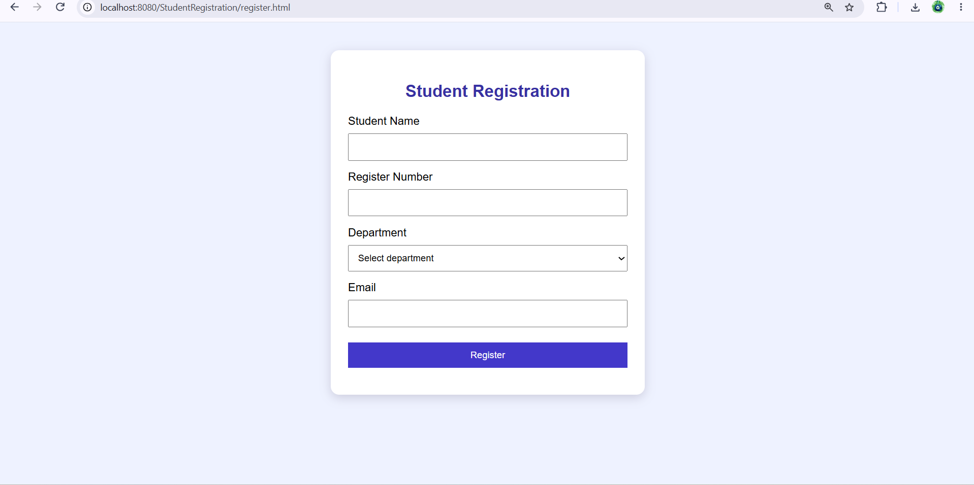
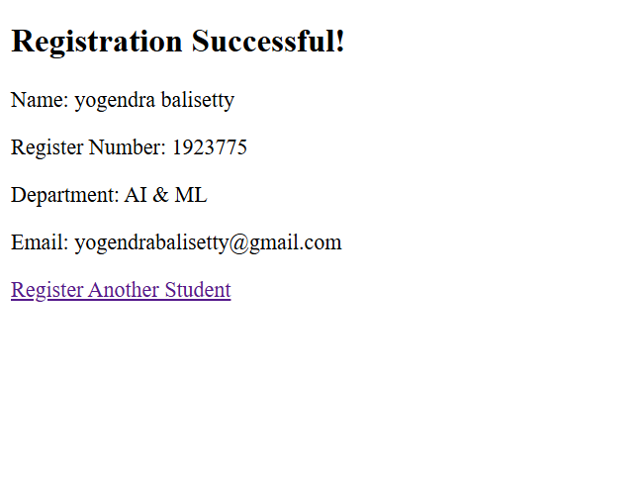

5. Explanation of GET and POST Methods
Feature | GET | POST
Purpose | Retrieve information or perform safe queries | Submit data for processing
Data location | Usually in the URL query string | In the request body
Visibility | Parameters can appear in browser history and logs | Parameters are not normally shown in the URL
Data size | Limited by practical URL length restrictions | Supports larger request bodies
Bookmarking | URLs can be bookmarked | Form submission is not normally bookmarked with its body
Security | Not suitable for sensitive form data | Preferable for sensitive form submissions, with HTTPS
Typical use | Searching or filtering records | Registration, login and data submission
Justification: POST is more appropriate for student registration because student details should not appear in the URL. However, POST alone does not encrypt information. HTTPS must be used to protect data during transmission, and server-side validation must be performed.
6. Servlet Life Cycle
The servlet life cycle is managed by the servlet container.
1. init() — Initialization
Called once when the servlet is initialized. It is used to perform initialization tasks, such as loading configuration or preparing resources.
2. service() — Request Processing
Called for each request handled by the servlet. In HttpServlet, it dispatches requests to methods such as doGet() and doPost() according to the HTTP method.
3. destroy() — Cleanup
Called when the servlet is taken out of service. It allows the servlet to release resources and perform cleanup operations.
Important points:
- init() is normally called once per servlet instance.
- service() processes incoming requests and dispatches them to the appropriate handler.
- destroy() is normally called once before the servlet instance is removed.
- Multiple requests may be processed concurrently by the same servlet instance, so shared mutable instance variables must be handled carefully.
7. Conclusion
A servlet-based registration system provides a structured way to collect and process student information. The servlet container manages the servlet lifecycle, while doGet() and doPost() handle different types of HTTP requests. POST is the preferred method for submitting registration details, combined with HTTPS and proper validation.
Question 2: Session Management Using HttpSession and Cookies
1. Introduction
Session management is the process of maintaining a user's state across multiple HTTP requests. HTTP is a stateless protocol, meaning each request is independent and the server does not automatically remember previous requests.
For example, after logging in to an e-commerce website, a user should be able to visit the home page, profile page, and order page without logging in again on every page. This can be achieved using HttpSession and cookies in Java Servlets.
2. Session Management Architecture
The system follows these steps:
- The user submits login credentials through a login form.
- The login servlet verifies the credentials.
- If authentication succeeds, the servlet creates an HttpSession.
- The server associates a unique session identifier with the session and typically sends it to the browser in a cookie named JSESSIONID.
- The browser sends the session cookie with subsequent requests.
- The server uses the session identifier to retrieve the associated session and recognize the authenticated user.
- The user logs out, and the server invalidates the session.
1. User Login Form
Username and password
2. Login Servlet
Verify credentials
3. Create HttpSession
Store authenticated user information on the server
4. Session Cookie
Browser stores and sends session ID
5. Protected Pages
Check session before granting access
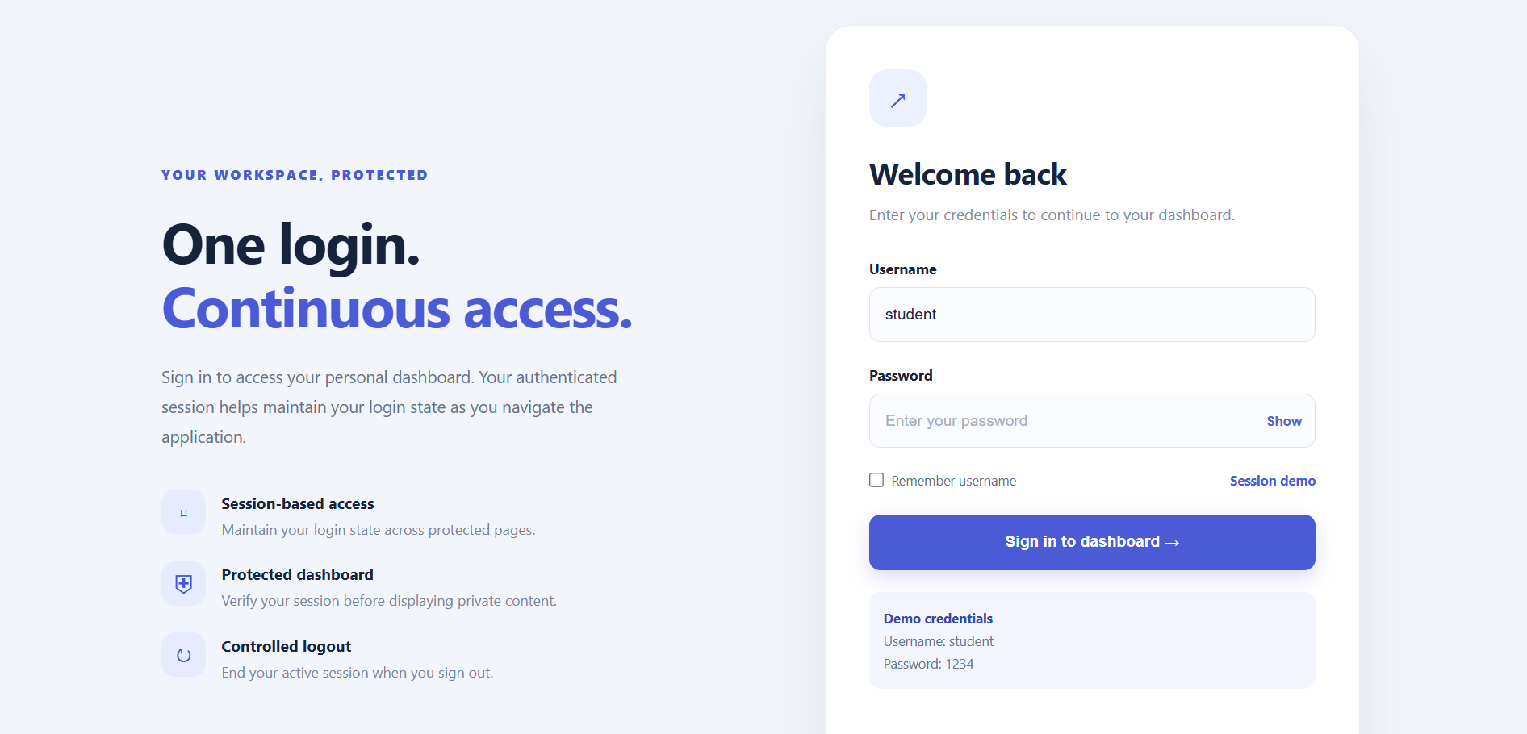
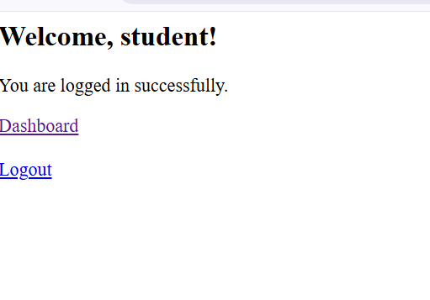
How Session Tracking Works
Session tracking links multiple requests from the same browser to the same user session.
- Step 1: The user logs in successfully.
- Step 2: The server creates an HttpSession and assigns a session identifier.
- Step 3: The browser stores the identifier, usually in the JSESSIONID cookie.
- Step 4: The browser sends the cookie in later HTTP requests.
- Step 5: The servlet container uses the identifier to locate the session and its stored attributes.
- Step 6: The application checks authentication and grants access to permitted pages.
- Step 7: The session expires, or the user logs out and the session is invalidated.
A session identifier is effectively a bearer credential: anyone who obtains a valid one may be able to impersonate the user. Therefore, use HTTPS and configure session cookies with Secure, HttpOnly, and an appropriate SameSite policy.

8. Comparison Between Session-Based Tracking and Cookies
Feature | HttpSession | Cookies
Storage | Session attributes are stored on the server | Cookie values are stored in the browser
Identification | Commonly uses a session ID cookie | Cookie values are sent with matching requests
Security | Sensitive application data can remain on the server | Browser-stored values may be inspected or modified
Capacity | Can store multiple objects as attributes | Each cookie has a limited size
Lifetime | Depends on inactivity timeout, invalidation and server configuration | Can be session-only or have a specified expiry
Server resources | Requires session storage | Cookie data is stored on the client
Common uses | Login state, shopping cart data, temporary workflow state | Preferences, language selection, session identifiers
Decision: HttpSession is appropriate for maintaining authenticated login state because user-specific data remains on the server. Cookies help the browser identify the session and can store non-sensitive preferences. Neither mechanism replaces proper authorization checks, HTTPS, or secure authentication.
9. Conclusion
Session management allows a web application to preserve authentication state across multiple pages. HttpSession stores server-side user data, while cookies allow the browser to carry a session identifier or user preferences between requests. Together, they provide convenient and secure session tracking when implemented with appropriate security controls.
Question 3: JDBC-Based Product Management System
1. Introduction
Java Database Connectivity (JDBC) is a Java API used to connect Java applications to relational databases, execute SQL statements, and process query results.
In an e-commerce platform, JDBC can be used to insert new product details, retrieve product information, and display products to users. A MySQL database can store fields such as product ID, product name, price, and quantity.
2. JDBC Architecture
The JDBC architecture consists of the following components:
- Java Application: Contains the business logic for adding and retrieving products.
- JDBC API: Provides classes and interfaces such as Connection, PreparedStatement, and ResultSet.
- JDBC Driver Manager: Helps establish a database connection using a registered JDBC driver.
- JDBC Driver: Translates JDBC calls into database-specific communication.
- Database: Executes SQL queries and stores or returns product records.
Java Web Application
Product management logic
JDBC API
Connection, PreparedStatement, ResultSet
JDBC Driver / DriverManager
Connects Java to the database
MySQL Database
Stores and retrieves product records
3. Database Creation
First, create a database and a table to store product information.
SQL commands:

CREATE DATABASE ecommerce;

USE ecommerce;

CREATE TABLE products (
id INT PRIMARY KEY AUTO_INCREMENT,
name VARCHAR(100) NOT NULL,
price DECIMAL(10, 2) NOT NULL,
quantity INT NOT NULL
);
Explanation:
- CREATE DATABASE creates the database.
- USE ecommerce selects the database.
- id uniquely identifies each product and automatically increases.
- name stores the product name.
- price stores the product price with two decimal places.
- quantity stores the available stock.
4. JDBC Steps for Database Connectivity
The main steps involved in JDBC connectivity are:
- Import JDBC classes: Import the required classes from java.sql.
- Load or register the driver: Modern JDBC drivers are usually registered automatically when present on the classpath.
- Establish a connection: Use DriverManager.getConnection() with the database URL and credentials.
- Prepare the SQL statement: Use PreparedStatement to define the SQL query and bind parameters.
- Execute the statement: Use executeUpdate() for INSERT, UPDATE, or DELETE operations and executeQuery() for SELECT operations.
- Process results: Read returned rows through ResultSet.
- Handle exceptions: Catch SQLException and handle database failures appropriately.
- Close resources: Use try-with-resources to close connections, statements, and result sets automatically.
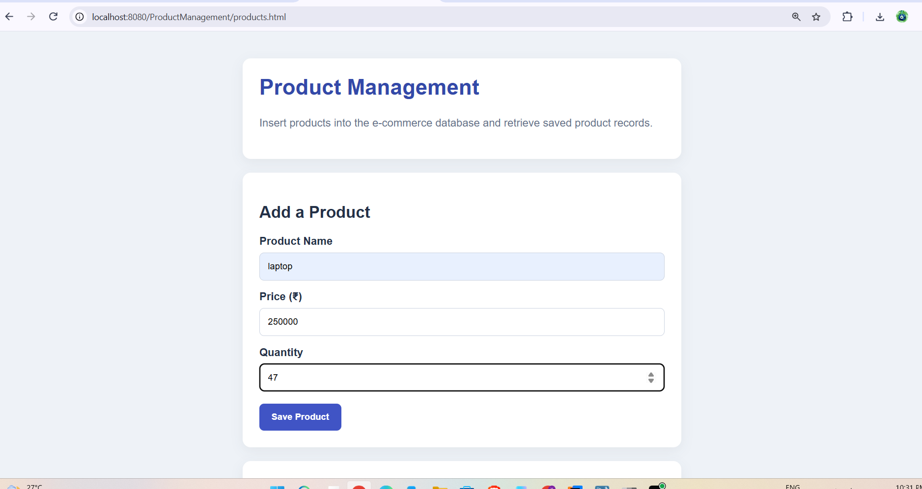
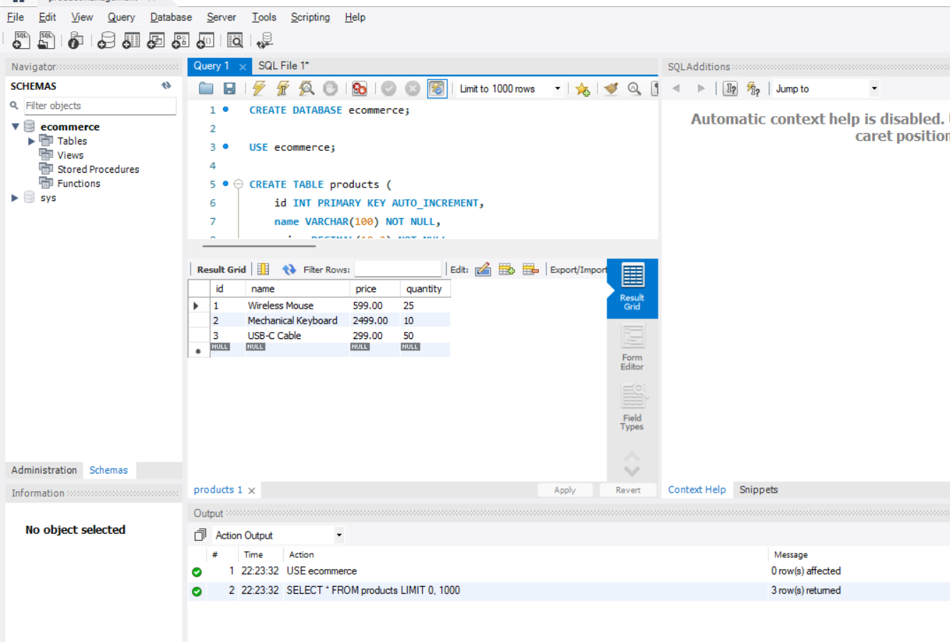
Explanation of the Program
A. Database connection
Connection con =
DriverManager.getConnection(URL, USER, PASSWORD);
This statement establishes a connection to the MySQL database using the URL, username, and password. If the connection cannot be established, a SQLException is thrown.
B. Inserting product details
PreparedStatement ps =
con.prepareStatement(insertSQL);

ps.setString(1, "Laptop");
ps.setBigDecimal(2, new BigDecimal("55000.00"));
ps.setInt(3, 10);

ps.executeUpdate();
The prepared statement inserts a product named Laptop, priced at 55,000.00, with a quantity of 10. The question marks in the SQL statement are replaced by parameter values. executeUpdate() returns the number of affected rows.
C. Retrieving product details
ResultSet rs = ps.executeQuery();

while (rs.next()) {
System.out.println(rs.getString("name"));
}
executeQuery() runs the SELECT statement and returns a ResultSet. The next() method moves to the next row, allowing the program to process every product returned by the query.
D. Exception handling
The catch (SQLException e) block handles errors such as invalid credentials, connection failures, incorrect SQL statements, and database constraint violations. The SQL state and vendor error code provide additional diagnostic information.
E. Resource management
Try-with-resources automatically closes the JDBC connection, prepared statements, and result sets, even if an exception occurs. This helps prevent resource leaks.
7. Importance of PreparedStatement
PreparedStatement is preferred over building SQL queries through string concatenation.
Its advantages include:
- SQL injection prevention: Parameter values are bound separately from the SQL statement.
- Readability: SQL commands and input values are separated.
- Type safety: Methods such as setInt(), setString(), and setBigDecimal() bind appropriate data types.
- Maintainability: Queries are easier to update and understand.
For example, using WHERE id = ? and ps.setInt(1, productId) is safer than concatenating user-supplied values directly into SQL.
8. Proper Exception Handling and Security
A reliable JDBC application should:
- Catch database exceptions and provide meaningful error handling.
- Close all resources with try-with-resources.
- Validate product names, prices, and quantities before insertion.
- Use prepared statements for queries containing input values.
- Store database credentials in environment variables or a secure configuration system.
- Use a database account with only the permissions required by the application.
- Avoid displaying database credentials or sensitive internal details to end users.
- Use transactions when several database operations must succeed or fail together.
In a production web application, database access should generally be placed in a DAO (Data Access Object) or repository layer rather than directly inside the servlet. This separates request handling from database operations and improves maintainability.
9. Conclusion
JDBC enables Java applications to communicate with relational databases using SQL. The product management system demonstrates how to connect to MySQL, insert product information, retrieve records, and handle database exceptions. Using PreparedStatement, try-with-resources, and secure credential management makes the application more reliable and maintainable.

