**Assignment**

# **Instruction set:**

The **instruction set**, also called **ISA** (**instruction set architecture**), is part of a computer that pertains to programming, which is more or less machine language. The instruction set provides commands to the processor, to tell it what it needs to do. The instruction set consists of addressing modes, instructions, native data types, registers, memory architecture, interrupt, and exception handling, and external I/O.

An example of an instruction set is the x86 instruction set.Different computer processors can use almost the same instruction set while still having very different internal design. Both the Intel Pentium and AMD Athlon processors use nearly the same x86 instruction set. An instruction set can be built into the hardware of the processor, or it can be emulated in software, using an interpreter. The hardware design is more efficient and faster for running programs than the emulated software version.

## **Examples of instruction set**

* **ADD** - Add two numbers together.
* **COMPARE** - Compare numbers.
* **IN** - Input information from a device, e.g., keyboard.
* **JUMP** - Jump to designated RAM address.
* **JUMP IF** - Conditional statement that jumps to a designated RAM address.
* **LOAD** - Load information from RAM to the CPU.
* **OUT** - Output information to device, e.g., monitor.
* **STORE** - Store information to RAM.

\*\*\*\*\*\*\*\*\*\*\*\*\*\*\*\*\*\*\*\*\*\*\*\*\*\*\*\*\*\*\*\*\*\*\*\*\*\*\*\*\*\*\*\*\*\*\*\*\*\*\*\*\*\*\*\*\*\*\*\*\*\*\*\*\*\*\*\*\*\*\*\*\*\*\*\*\*\*\*\*\*\*\*\*\*\*\*\*\*\*\*\*\*\*\*\*\*\*\*\*\*\*\*\*\***What is assembly language?**

An assembly language is a programming language that communicates with the hardware of a computer directly. An assembly language allows a software developer to code using words and expressions that can be easier to understand and interpret than the binary or hexadecimal data the computer stores and reads.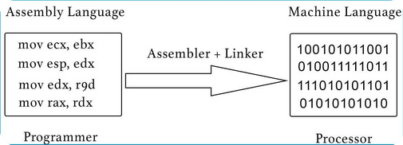********************************************************************************************************

**Flip-flop (electronics):**

Flip-flop is a circuit that maintains a state until directed by input to change the state. A basic flip-flop can be constructed using four-NAND or four-NOR gates. Types of flip-flops:

1. RS Flip Flop
2. JK Flip Flop
3. D Flip Flop
4. T Flip Flop

### **Applications of Flip-Flops:**

These are the various types of flip-flops being used in digital electronic circuits and the applications of Flip-flops are as specified below.

* Frequency Dividers
* Storage Registers
* Data storage
* Data transfer
* Registers
* Memory

*********************************************************************************************************

**Integrated Circuit:**

Integrated circuits are made up of several components such as R, C, L, diodes and transistors. They are built on a small single block or chip of a semiconductor known as an integrated circuit (IC).

Integrated circuits can function as an oscillator, amplifiers, microprocessors or even as computer memory.

A single IC could contain thousands or millions of:

* transistors
* resistors
* capacitors
* diodes

### **Types of integrated circuits**

ICs can be linear (analog), digital or some combination of the two, depending on their intended application.

********************************************************************************************************

**Analog:**

Analog signal is a continuous signal which represents physical measurements.

Denoted by sine waves

**Example:** Human voice in air, analog electronic devices.

**Digital:**

Digital signals are discrete time signals generated by digital modulation.

Denoted by square waves

**Example:** Computers, CDs, DVDs, and other digital electronic devices.

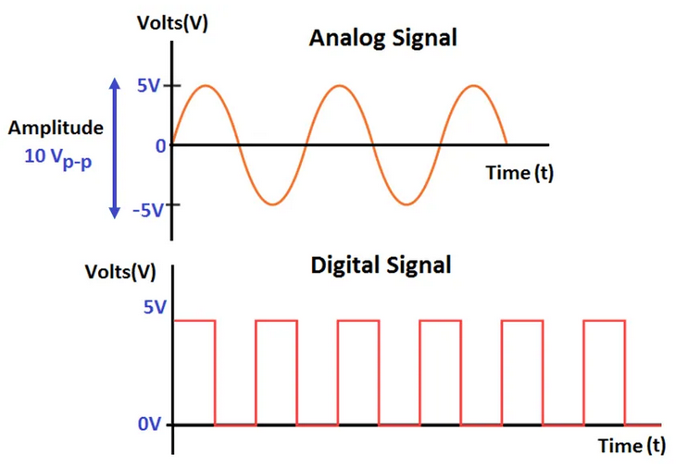

\*\*\*\*\*\*\*\*\*\*\*\*\*\*\*\*\*\*\*\*\*\*\*\*\*\*\*\*\*\*\*\*\*\*\*\*\*\*\*\*\*\*\*\*\*\*\*\*\*\*\*\*\*\*\*\*\*\*\*\*\*\*\*\*\*\*\*\*\*\*\*\*\*\*\*\*\*\*\*\*\*\*\*\*\*\*\*\*\*\*\*\*\*\*\*\*\*\*\*\*\*\*\*\*\***Frequency of Alternating Current :**

## **The frequency of Alternating Current in India is 50 Hz.**

Alternating current (ac) frequency is the number of cycles per second in an ac sine wave. Frequency is the rate at which current changes direction per second. It is measured in hertz (Hz), an international unit of measure where 1 hertz is equal to 1 cycle per second.

* Hertz (Hz) = One hertz is equal to one cycle per second.
* Cycle = One complete wave of alternating current or voltage.
* Alternation = One half of a cycle.
* Period = The time required to produce one complete cycle of a waveform.

At its most basic, frequency is how often something repeats. In the case of electrical current, frequency is the number of times a sine wave repeats, or completes, a positive-to-negative cycle.

The more cycles that occur per second, the higher the frequency.

*********************************************************************************************************

**Von Neumann architecture**

The modern computers are based on a stored-program concept introduced by John Von Neumann. In this stored-program concept, programs and data are stored in a separate storage unit called memories and are treated the same. This novel idea meant that a computer built with this architecture would be much easier to reprogram.

The basic structure is like this,

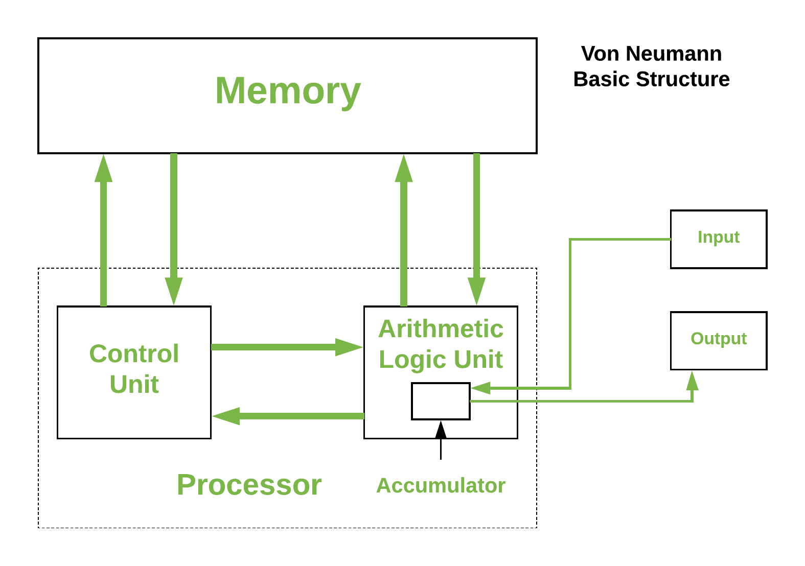

It is also known as **ISA** (Instruction set architecture) computer and is having three basic units:

1. The Central Processing Unit (CPU)
2. The Main Memory Unit
3. The Input/Output Device

* **Control Unit –**   
  A control unit (CU) handles all processor control signals. It directs all input and output flow, fetches code for instructions, and controls how data moves around the system.
* **Arithmetic and Logic Unit (ALU) –**   
  The arithmetic logic unit is that part of the CPU that handles all the calculations the CPU may need, e.g. Addition, Subtraction, Comparisons. It performs Logical Operations, Bit Shifting Operations, and Arithmetic operations.

**Figure –** Basic CPU structure, illustrating ALU

\*\*\*\*\*\*\*\*\*\*\*\*\*\*\*\*\*\*\*\*\*\*\*\*\*\*\*\*\*\*\*\*\*\*\*\*\*\*\*\*\*\*\*\*\*\*\*\*\*\*\*\*\*\*\*\*\*\*\*\*\*\*\*\*\*\*\*\*\*\*\*\*\*\*\*\*\*\*\*\*\*\*\*\*\*\*\*\*\*\*\*\*\*\*\*\*\*\*\*\*\*\*\*\*\***Bootstrap:**

A bootstrap program is the first code that is executed when the computer system is started. The entire operating system depends on the bootstrap program to work correctly as it loads the operating system.The booting procedure starts with the hardware procedures and then continues onto the software procedures that are stored in the main memory. The bootstrapping process involves self-tests, loading BIOS, configuration settings, hypervisor, operating system etc.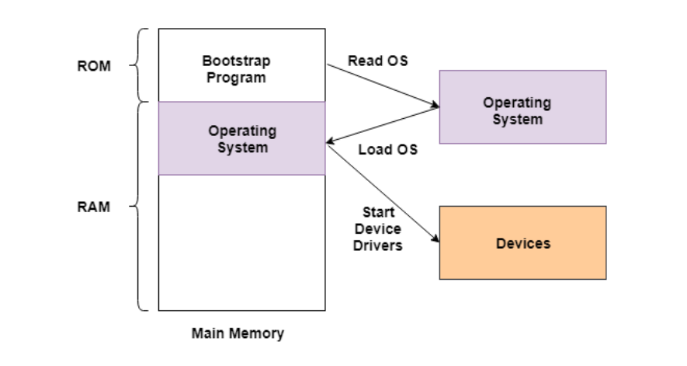

**Computer’s CPU details:**

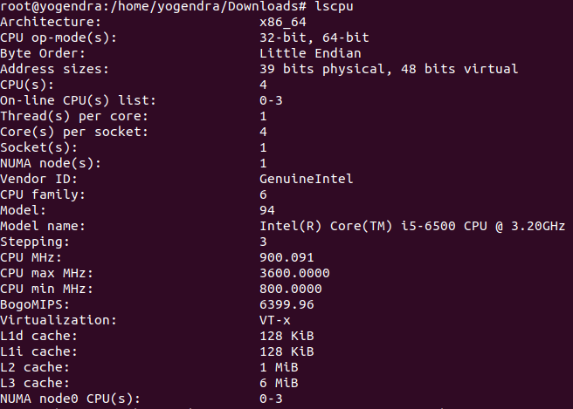

The estimated transistor count is *around 8.2 billion* in Intel(R) Core(TM) i5-6500 CPU @ 3.20GHz

**Transistors in my Mobile CPU:**

Mobile Model - Vivo Y51A

| **Memory** |  |  |
| --- | --- | --- |
| **Internal** | **128GB 6GB RAM, 128GB 8GB RAM** |

| **Platform** | **OS** | **Android 12** |
| --- | --- | --- |
| **Chipset** | **Qualcomm SM6115 Snapdragon 662 (11 nm)** |
| **CPU** | **Octa-core (4x2.0 GHz Kryo 260 Gold & 4x1.8 GHz Kryo 260 Silver)** |
| **GPU** | **Adreno 610**  **Armv8-A Instruction Set:**  Armv8-A supports three instruction sets: **A32, T32 and A64.**  The **A64 instruction set** is used when executing in the AArch64 Execution state. It is a fixed- length 32-bit instruction set. The ‘64’ in the name refers to the use of this instruction by the AArch64 Execution state. It does not refer to the size of the instructions in memory.  The A32 and T32 instruction sets are also referred to as ‘ARM’ and ‘Thumb', respectively. These instruction sets are used when executing in the AArch32 Execution state. |