SMART INDIA HACKATHON
Project Report
FORGE-AI
AI-Powered Digital Forensic Investigation & Evidence Analysis Platform
“From Raw Digital Evidence to Evidence-Backed Findings”

Prepared by
Yogesh
BCA — BGS First Grade College, Mysuru (University of Mysore)

Abstract
Digital forensic investigators routinely face large volumes of fragmented evidence — call detail records, financial transaction logs, device images, network captures, browser artifacts, and open-source intelligence — spread across incompatible formats with no single view connecting them. Manually correlating this evidence into suspects, relationships, and a coherent timeline is slow, error-prone, and does not scale with modern cybercrime caseloads.
FORGE-AI is an AI-powered digital forensic investigation platform designed to close that gap. It ingests heterogeneous forensic evidence, automatically extracts eighteen categories of forensically relevant entities using a combination of deterministic pattern matching and natural language processing, correlates those entities into an interactive investigation graph, builds a unified chronological timeline, flags statistically unusual activity using unsupervised machine learning, and lets an investigator query the case in plain language through a Retrieval-Augmented Generation (RAG) assistant that answers strictly from indexed evidence and cites every claim back to its source.
Crucially, FORGE-AI is designed as an investigation-assistance layer, not an investigator replacement. Every AI-generated statement is labeled with an explicit confidence level (CONFIRMED FROM EVIDENCE, SUPPORTED INFERENCE, POTENTIAL CONNECTION, ANOMALY, or INSUFFICIENT EVIDENCE), entity-resolution suggestions are never auto-merged without human confirmation, and network-centrality scores are explicitly presented as investigative leads rather than proof of guilt. Evidence integrity is preserved end-to-end through SHA-256 hashing at ingestion, an append-only chain-of-custody log for every access or analysis event, and automated tamper detection through hash re-verification.
The platform is implemented as a modular full-stack system — a FastAPI backend with a PostgreSQL + pgvector data layer, and a Next.js frontend — covering case management, evidence management, chain of custody, AI document analysis, entity resolution, an interactive investigation graph, suspect network analysis, forensic timelines, anomaly detection, cyber threat intelligence enrichment, safe static malware analysis, the RAG investigation assistant, hybrid evidence search, an AI forensic report generator, a visual analytics dashboard, geolocation analysis, role-based access control, and comprehensive audit logging. This report documents the problem, the system design, the complete implementation, the security posture, and the testing performed, and is written to double as both a Smart India Hackathon submission report and a standalone technical reference for the codebase.

Table of Contents
Abstract 2
Chapter 1 — Introduction 4
Chapter 2 — Existing System and Its Limitations 6
Chapter 3 — Proposed System 7
Chapter 4 — System Requirements and Technology Stack 9
Chapter 5 — System Architecture 12
Chapter 6 — Functional Module Descriptions 15
Chapter 7 — Database Design 23
Chapter 8 — Implementation 25
Chapter 9 — Security 28
Chapter 10 — Testing 30
Chapter 11 — Results, Discussion, and Future Scope 32
Chapter 12 — Conclusion 34
References 35
Appendix A — Confidence and Provenance Labels 36
Appendix B — Role / Permission Matrix 37

Chapter 1 — Introduction

1.1 Background
Cybercrime investigation today involves an ever-growing volume of digital evidence: seized devices, ISP and telecom records, banking and payment-gateway logs, email and social-media metadata, network capture files, and open-source intelligence. A single mid-sized fraud or cybercrime case can generate thousands of pages of unstructured records across a dozen different file formats, submitted by different agencies at different times. Investigators must manually read through this material to spot a phone number that recurs across three unrelated documents, a bank account that receives money from two different “unrelated” suspects, or a login that happens at an implausible hour. This process does not scale, is highly dependent on individual investigator diligence, and makes it easy for a genuine connection to be missed simply because the two pieces of evidence that reveal it were never read back-to-back.
At the same time, modern natural language processing and machine learning techniques — named entity recognition, embedding-based semantic search, graph analytics, and unsupervised anomaly detection — are now mature and efficient enough to run this kind of correlation automatically, surfacing candidate connections for a human investigator to verify rather than requiring the investigator to find them unaided. FORGE-AI was built to apply exactly this class of technique to the forensic investigation workflow, while keeping the human investigator firmly in control of every conclusion the system contributes to.

1.2 Problem Statement
Design and build an AI-powered forensic investigation platform that assists cybercrime investigators in collecting, processing, analyzing, correlating, visualizing, and investigating digital evidence — transforming large amounts of fragmented forensic data (digital forensic reports, FIR/incident reports, call detail records, financial transaction records, IP addresses, email metadata, URLs, file metadata, device information, network logs, browser artifacts, social-media intelligence, criminal history records, and surveillance reports) into structured, explainable investigative intelligence — without the system ever replacing the human investigator's judgement or presenting speculation as fact.

1.3 Objectives
- Ingest heterogeneous digital forensic and cybercrime evidence in common file formats (PDF, TXT, CSV, JSON, XML, PCAP, LOG, DOCX, images, ZIP forensic packages).
- Automatically extract forensically relevant entities (persons, organizations, locations, phone numbers, emails, IP addresses, domains, URLs, devices, vehicles, bank accounts, transaction IDs, dates, times, files, malware indicators, crypto wallets, and social-media accounts) with confidence scoring.
- Correlate entities across multiple evidence items and build an interactive investigation relationship graph.
- Generate a unified, chronological forensic timeline spanning every evidence item in a case.
- Detect suspicious patterns and statistical anomalies in case activity using unsupervised machine learning.
- Provide keyword, semantic, and hybrid evidence search.
- Summarize and answer investigator questions using AI/NLP grounded strictly in indexed case evidence, with mandatory citations.
- Preserve evidence integrity and an auditable chain of custody for every evidence item, from acquisition through analysis and export.
- Enforce role-based access control across seven investigator roles and maintain complete audit logs of all sensitive actions.
- Ensure every AI-generated output is explainable and explicitly labeled by confidence/evidentiary status — never presented as unqualified fact.

1.4 Scope
The delivered system covers the full investigative lifecycle from evidence upload through report generation, implemented as a working, testable, containerized application — not a slide-deck concept. Two areas were deliberately scoped down from the original specification for the current build phase, and are documented rather than silently omitted: the investigation graph is stored and queried in PostgreSQL with NetworkX rather than a separate Neo4j instance (sufficient at case-scale, and avoids a second database in the deployment footprint), and computationally expensive analysis steps currently run synchronously in the request rather than via a Celery task queue (Redis is already provisioned in the deployment stack for this upgrade). Both are discussed in detail in Chapter 5 and Chapter 11.

1.5 Report Organization
Chapter 2 reviews the limitations of existing/manual approaches. Chapter 3 presents the proposed system and its guiding safety principles. Chapter 4 lists system requirements and the technology stack. Chapter 5 covers system architecture. Chapter 6 documents every functional module in detail. Chapter 7 covers database design. Chapter 8 covers implementation specifics. Chapter 9 covers security. Chapter 10 covers testing. Chapter 11 discusses results, limitations, and future scope, and Chapter 12 concludes the report.

Chapter 2 — Existing System and Its Limitations

2.1 Manual Investigation Workflow
In most current practice, evidence collected for a case is reviewed manually: investigators read documents, cross-reference spreadsheets by eye, and maintain suspect/relationship notes in word processors or on physical whiteboards. Call detail record (CDR) analysis and financial transaction analysis are frequently done in spreadsheet software with manual filtering, and any “graph” of who-is-connected-to-whom exists only in the investigator's notes or memory.

2.2 Point Tools Without Integration
Where tooling exists, it is typically fragmented: separate commercial products for disk/memory forensics (e.g. EnCase, FTK), separate CDR analysis spreadsheets or vendor tools, separate threat-intelligence lookups performed manually against external websites, and separate case-management software with no data flowing between them. An investigator must manually copy a finding from one tool into another, which is exactly the step where connections get lost.

2.3 Limitations Identified
- No automatic entity extraction across mixed evidence formats — every document is read and annotated by hand.
- No unified relationship graph — cross-evidence connections depend entirely on investigator memory and manual note-taking.
- No unified timeline — chronological correlation across CDRs, transactions, logins, and device events is done manually, if at all.
- No automated anomaly detection — unusual activity (off-hours logins, transaction spikes) is only found if an investigator happens to notice it.
- No chain-of-custody automation — evidence handling logs are often paper-based or a separate spreadsheet, disconnected from the evidence itself.
- No natural-language querying of case evidence — finding “everything connected to this phone number” means re-reading every document.
- Existing AI/chatbot tools used ad hoc for investigation support are not grounded in case evidence and can hallucinate facts, suspects, or relationships — a serious liability in a forensic context.

2.4 Gap This Project Addresses
FORGE-AI directly targets these gaps: automatic, confidence-scored entity extraction; a live, explorable investigation graph built from actual evidence co-occurrence; a unified timeline; unsupervised anomaly detection; an immutable chain of custody; and a Retrieval-Augmented Generation assistant that is structurally prevented from answering outside the evidence it has actually retrieved for a given case — closing the hallucination risk that makes generic AI tools unsuitable for this domain.

Chapter 3 — Proposed System

3.1 System Overview
FORGE-AI is a web-based investigation platform in which an investigator creates a case, uploads evidence, and the system automatically extracts entities, builds relationships and a timeline, flags anomalies, and indexes the evidence for natural-language querying. Every subsequent step — entity resolution, relationship confirmation, report generation — keeps the human investigator in the loop as the final decision-maker.

3.2 Key Design Principles
- AI as an assistance layer, never a decision-maker: the system surfaces candidates, patterns, and citations; the investigator judges and confirms.
- Every AI claim is labeled: CONFIRMED FROM EVIDENCE, SUPPORTED INFERENCE, POTENTIAL CONNECTION, ANOMALY, or INSUFFICIENT EVIDENCE — enforced structurally, not just by convention.
- No silent identity merging: entity resolution produces scored candidates only; a human confirms or rejects every merge.
- Evidence integrity first: SHA-256 hashing at upload, append-only chain-of-custody logging, and hash re-verification on demand.
- Provenance is always visible: original evidence, derived data, AI-generated analysis, and investigator notes are stored and displayed as structurally distinct categories, never blended.
- No fabricated intelligence: if a threat-intelligence provider is not configured or unreachable, the system says so explicitly rather than guessing a verdict.
- No code execution on uploaded files: malware/file analysis is static-only; the platform never executes an uploaded binary.

3.3 High-Level Feature Set
- Case management with a defined status lifecycle (OPEN → UNDER INVESTIGATION → EVIDENCE REVIEW → SUSPECT IDENTIFIED → CLOSED → ARCHIVED).
- Digital evidence upload, hashing, and status tracking.
- Automated chain-of-custody logging for every evidence access, analysis, or export.
- AI document analysis: 18-category entity extraction with confidence scores.
- Entity resolution: potential-match suggestions with supporting evidence, confirmed by a human.
- Interactive investigation graph with zoom/pan/filter and relationship inspection.
- Suspect network analysis: degree/betweenness centrality, PageRank, community detection.
- Unified, filterable forensic timeline.
- Unsupervised anomaly detection over timeline activity.
- Cyber threat-intelligence enrichment for IPs, domains, URLs, and file hashes.
- Safe static malware/file analysis (entropy, strings, PE/ELF structure) — never executes files.
- RAG-based AI Investigation Assistant with mandatory evidence citations.
- Keyword, semantic, and hybrid evidence search.
- AI-assisted 15-section forensic report generation.
- Visual analytics dashboard across all active cases.
- Geolocation analysis for evidence carrying real coordinates.
- Role-based access control across 7 roles with a defined permission matrix.
- Comprehensive audit logging of every sensitive action.

Chapter 4 — System Requirements and Technology Stack

4.1 Functional Requirements
Summarized from Chapter 1's objectives — the system shall:
- Allow authenticated, role-restricted users to create and manage cases, suspects, victims, evidence, notes, and tasks.
- Accept evidence uploads in supported formats, compute and store a SHA-256 hash, and reject disallowed file types/oversized files.
- Log every evidence access, analysis, transfer, and export as an immutable chain-of-custody record.
- Extract and persist entities from evidence text with a confidence score per entity.
- Build and expose a queryable investigation graph and its centrality/community metrics.
- Construct and expose a filterable, chronological timeline of case events.
- Detect and expose statistical anomalies in timeline activity.
- Answer investigator natural-language questions using only indexed case evidence, with citations.
- Generate a structured, multi-section forensic report per case.
- Enforce RBAC permission checks on every state-changing and sensitive-read endpoint.

4.2 Non-Functional Requirements
- Security: authenticated access, encrypted password storage, rate limiting, input validation, secure file handling.
- Auditability: every sensitive action recorded with actor, timestamp, and resource.
- Explainability: AI outputs must be traceable to source evidence.
- Portability: containerized deployment via Docker Compose, runnable on a single host for demonstration.
- Maintainability: modular router/service architecture so each functional module can be extended or extracted independently.
- Testability: automated unit and integration test coverage for the security- and integrity-critical paths (hashing, RBAC, chain of custody).

4.3 Hardware Requirements (Development / Demo)
Component | Minimum | Recommended
Processor | Dual-core 2.0 GHz | Quad-core 2.5 GHz+
RAM | 8 GB | 16 GB (spaCy + sentence-transformers models loaded in memory)
Disk | 10 GB free | 20 GB+ free (evidence storage grows with case volume)
Network | Required for external threat-intel/LLM calls | Broadband

4.4 Technology Stack

4.4.1 Frontend
Technology | Purpose
Next.js 14 (React 18, App Router) | Application framework
TypeScript | Type-safe frontend code
Tailwind CSS | Utility-first styling; custom dark forensic theme
Cytoscape.js | Interactive investigation graph rendering
Recharts | Dashboard charts (pie/bar)

4.4.2 Backend
Technology | Purpose
Python 3.11 | Backend language
FastAPI | REST API framework
SQLAlchemy 2.0 | ORM
Pydantic v2 | Request/response validation
python-jose, passlib (bcrypt) | JWT auth, password hashing
slowapi | Rate limiting

4.4.3 AI / Machine Learning
Technology | Purpose
spaCy (en_core_web_sm) | Named entity recognition (PERSON, ORG, LOCATION, DATE)
Regex pattern library | Structured entity extraction (phone, email, IP, domain, URL, bank account, crypto wallet, transaction ID)
sentence-transformers (all-MiniLM-L6-v2) | 384-dim embeddings for the RAG pipeline
scikit-learn (Isolation Forest) | Unsupervised anomaly detection
NetworkX | Graph construction and centrality/community analysis
Anthropic API (Claude) | LLM for RAG-grounded investigator Q&A

4.4.4 Data Layer
Technology | Purpose
PostgreSQL 16 | Primary relational data store
pgvector extension | Vector similarity search for the RAG pipeline
Redis | Provisioned for future Celery-based async processing
Local/S3-compatible object storage | Evidence file storage

4.4.5 DevOps
Technology | Purpose
Docker & Docker Compose | Containerized multi-service deployment
GitHub Actions | CI — automated tests, lint, frontend build, Docker image build
pytest | Backend automated testing

Chapter 5 — System Architecture

5.1 Architectural Style
FORGE-AI is implemented as a modular monolith: a single FastAPI application whose REST routers and backing service modules are organized one-to-one with the functional modules described in Chapter 6. This was a deliberate choice over the specification's suggested per-module microservices split — at case-management scale, a modular monolith is faster to build correctly, easier to reason about in a security review (one process, one set of RBAC checks, one audit log), and every router/service pair is already a clean extraction boundary if a specific module (most likely the AI/RAG router, given its latency and resource profile) later needs to scale independently.
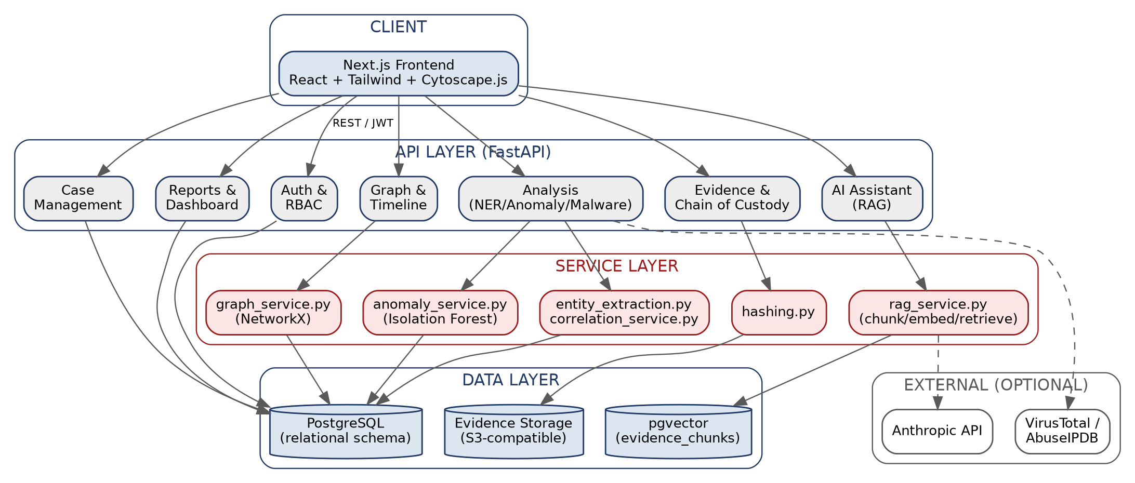
Figure 5.1 — High-level system architecture: client, API layer, service layer, data layer, and optional external integrations.

5.2 Layered Design

5.2.1 Client Layer
A Next.js single-page application that authenticates against the API with JWT bearer tokens and renders case workspaces: an overview tab, an evidence vault, an interactive investigation graph (Cytoscape.js), a timeline view, the AI Investigation Assistant chat interface, and the report viewer.

5.2.2 API Layer
FastAPI routers, one per functional area (auth, cases, evidence, analysis, graph, timeline, ai, threat-intel, reports, dashboard, users, audit, geolocation). Every route that reads or mutates case data passes through a shared RBAC dependency (`require_permission`) before touching the database, and every mutating action is separately recorded to the audit log.

5.2.3 Service Layer
Business logic lives in `app/services/*.py`, independent of the HTTP layer: hashing, text extraction, entity extraction, entity resolution, cross-evidence correlation, graph construction, anomaly detection, threat-intelligence enrichment, static malware analysis, the RAG pipeline, timeline construction, and report generation are each an isolated, independently testable module.

5.2.4 Data Layer
PostgreSQL 16 is the single source of truth for all structured data, extended with the pgvector extension so evidence-chunk embeddings live in the same database as everything else — no separate vector database to keep in sync. Evidence files themselves are stored on disk (or an S3-compatible bucket in production) and referenced by path from the `evidence` table.

5.2.5 External Integrations (Optional)
The Anthropic API powers the RAG assistant's generated answers; VirusTotal and AbuseIPDB power threat-intelligence enrichment. Both are optional — the platform is fully functional without them, degrading gracefully (raw evidence retrieval without an LLM narrative; an explicit “unavailable” message instead of a threat verdict) rather than failing.

5.3 Data Flow — Evidence to Investigative Answer
The diagram below traces a single evidence item from upload through to being citable by the AI Investigation Assistant, which is the backbone flow the rest of the platform builds on.
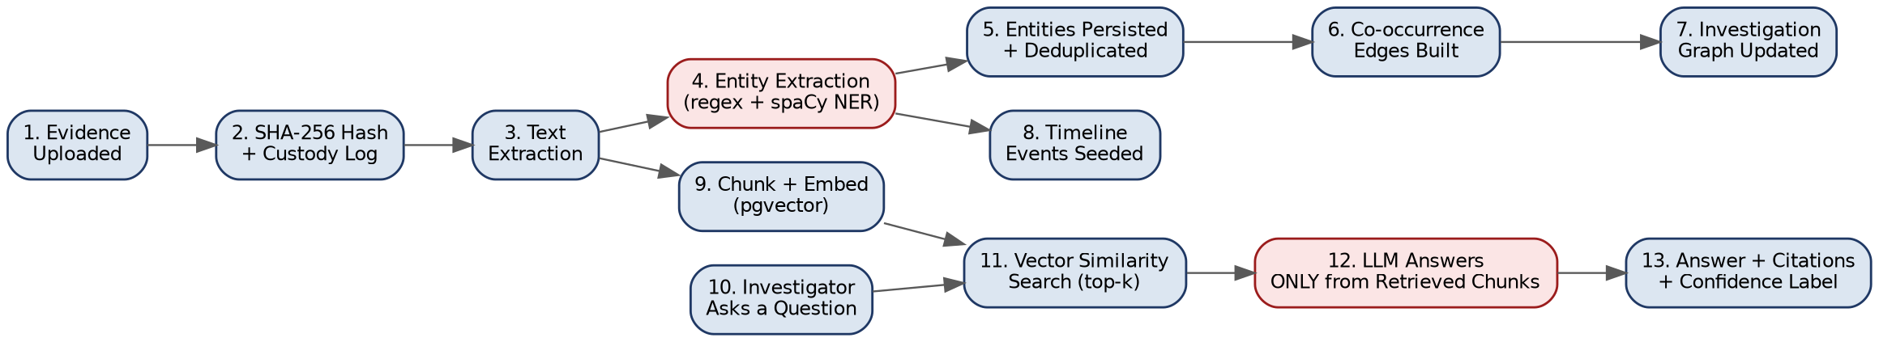
Figure 5.2 — End-to-end data flow from evidence upload to a cited AI answer.

5.4 Deployment Architecture
The reference deployment is a four-container Docker Compose stack: PostgreSQL (with pgvector), Redis (provisioned, reserved for future async processing), the FastAPI backend, and the Next.js frontend. A reverse proxy (NGINX or equivalent) is recommended in front for TLS termination in any non-demo deployment.
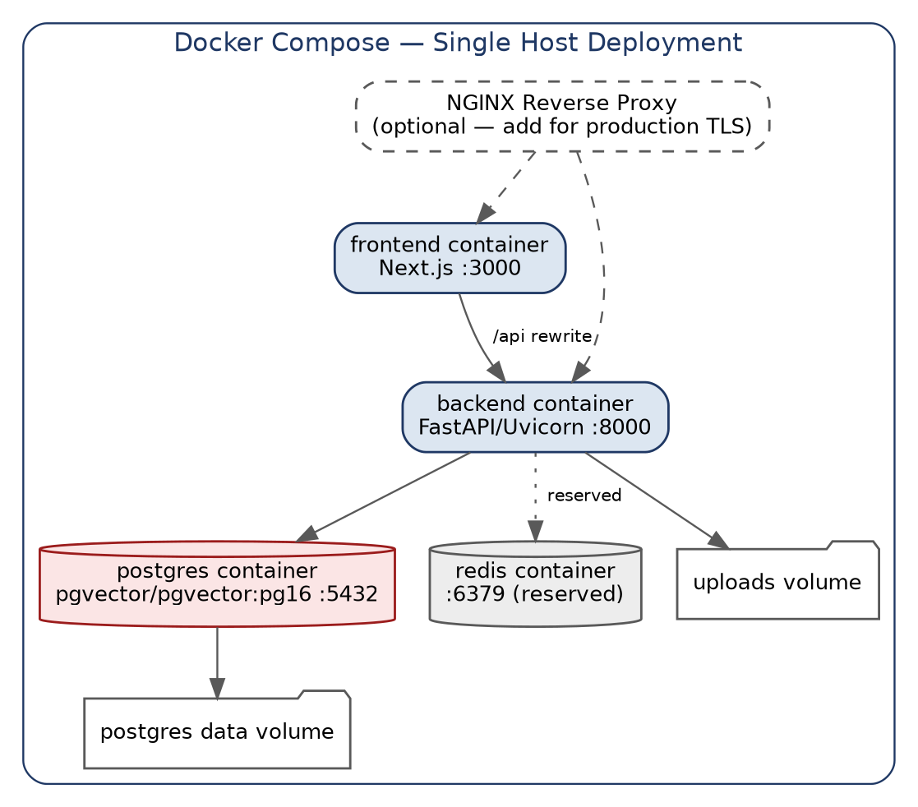
Figure 5.3 — Docker Compose deployment topology.

5.5 Simplifications and Upgrade Path
Specification component | Current implementation | Upgrade path
Neo4j graph database | PostgreSQL tables materialized into a NetworkX graph at query time | Add a Neo4j sync step in the correlation service; swap NetworkX calls in graph_service.py for Cypher queries once per-case graphs exceed a few thousand nodes
Celery async processing | Synchronous, in-request processing | Wrap each service call in a Celery task; Redis is already provisioned and unused for this purpose
DOCX/PDF report export | Structured JSON report (canonical source of truth) | Render content_json into a DOCX template or PDF using the existing report_service.py output
Full microservices split | Modular monolith | Each app/api/*.py router plus its backing service module is already a clean extraction boundary

Chapter 6 — Functional Module Descriptions
This chapter documents each of the twenty functional modules delivered in the current build: its purpose, its key features, and where it lives in the codebase. Endpoint paths are given relative to the API root; full request/response schemas are available at the live `/docs` OpenAPI interface generated automatically by FastAPI.

6.1 Module 1 — Case Management
Purpose: Provide the organizing unit for an investigation — every other module's data (evidence, entities, timeline, reports) is scoped to a case.
Key Features:
- Create, view, update, and archive cases (cases are archived, never hard-deleted, to preserve evidence integrity).
- Defined status lifecycle: OPEN → UNDER INVESTIGATION → EVIDENCE REVIEW → SUSPECT IDENTIFIED → CLOSED → ARCHIVED.
- Priority levels: LOW, MEDIUM, HIGH, CRITICAL.
- Add suspects, victims, investigator notes, and tasks to a case.
- Case membership tracking (who is assigned to a case, in what role-on-case).
Implementation: app/api/cases.py, app/models/models.py (Case, CaseMember, Suspect, Victim, InvestigatorNote, CaseTask). Endpoints: POST/GET/PUT/DELETE /api/cases, plus /api/cases/{id}/suspects, /victims, /notes, /tasks.

6.2 Module 2 — Digital Evidence Management
Purpose: Accept, store, and track every piece of evidence associated with a case, with cryptographic integrity from the moment of upload.
Key Features:
- Supports PDF, TXT, CSV, JSON, XML, PCAP, LOG, DOCX, image, and ZIP forensic-package uploads.
- File-extension allow-list, maximum-size enforcement, and UUID-randomized storage filenames (the original filename is never used as a path, preventing path traversal).
- SHA-256 hash computed and stored automatically at upload time, streamed so large files don't exhaust memory.
- Every evidence item tracks type, size, uploader, source, description, and current status (UPLOADED → PROCESSING → ANALYZED / FLAGGED / ARCHIVED).
Implementation: app/api/evidence.py, app/services/hashing.py. Endpoint: POST /api/evidence/upload (multipart), GET /api/evidence/{id}, GET /api/evidence/case/{case_id}.

6.3 Module 3 — Chain of Custody
Purpose: Maintain a legally defensible, append-only record of every interaction with an evidence item.
Key Features:
- Logs ACQUIRED, UPLOADED, ACCESSED, ANALYZED, TRANSFERRED, EXPORTED, HASH_VERIFIED, and MODIFICATION_ATTEMPT events.
- Every record captures investigator, timestamp, action, previous hash, current hash, and IP address.
- On-demand hash re-verification endpoint: re-hashes the file currently on disk and compares it to the original recorded hash; a mismatch is itself logged as a MODIFICATION_ATTEMPT event.
- No update/delete endpoint exists for chain-of-custody records at the application layer — the log is append-only by design.
Implementation: app/services/chain_of_custody.py, app/models/models.py (ChainOfCustody). Endpoints: GET /api/evidence/{id}/hash, GET /api/evidence/{id}/chain-of-custody.

6.4 Module 4 — AI Document Analysis (Entity Extraction)
Purpose: Automatically extract forensically relevant entities from evidence text so investigators don't have to read every document by hand.
Key Features:
- Regex-based extraction for eleven structured entity types where deterministic pattern matching is more reliable than a language model: EMAIL, IP_ADDRESS, URL, DOMAIN, PHONE_NUMBER, BANK_ACCOUNT, CRYPTO_WALLET, TRANSACTION_ID, SOCIAL_MEDIA_ACCOUNT, FILE.
- spaCy named-entity recognition for unstructured entity types: PERSON, ORGANIZATION, LOCATION, DATE, TIME.
- Every extracted entity carries a confidence score (0.90 for regex matches on a well-formed pattern; ~0.75 heuristic for NER-based entities, since the base spaCy model doesn't expose native per-entity probabilities).
- Span-overlap resolution so a single token isn't double-claimed by two competing patterns (e.g. a transaction ID isn't also flagged as a bank account number).
Implementation: app/services/entity_extraction.py, app/services/text_extraction.py (per-file-type text extraction for PDF/DOCX/CSV/JSON/XML/ZIP/etc.). Endpoint: POST /api/analysis/document/{evidence_id}, which runs the full pipeline (extract → persist → correlate → index) in one call.

6.5 Module 5 — Entity Resolution
Purpose: Suggest when two differently-written entities might refer to the same real-world person or asset, without ever deciding this automatically.
Key Features:
- Scores name-similarity between PERSON/ORGANIZATION/SOCIAL_MEDIA_ACCOUNT entities within a case using normalized string similarity.
- Every candidate above the similarity threshold is stored with its confidence score and a human-readable supporting-evidence explanation.
- Candidates are never auto-merged — an investigator must explicitly CONFIRM or REJECT each one via a dedicated review endpoint.
- Rejected/confirmed decisions are recorded, so resolution work isn't repeated on the next analysis pass.
Implementation: app/services/entity_resolution.py, app/models/models.py (EntityResolutionCandidate). Endpoints: POST /api/analysis/entities/{case_id}/resolve, GET /api/graph/case/{case_id}/resolution-candidates, POST /api/graph/resolution-candidates/{id}/decide.

6.6 Module 6 — Investigation Graph
Purpose: Give investigators a visual, explorable map of every entity in a case and how the evidence connects them.
Key Features:
- Nodes represent the 18 supported entity types; edges represent relationships, weighted by how many evidence items support them.
- Cytoscape.js frontend rendering with zoom, pan, force-directed layout, and per-node-type color coding.
- New relationships seed as MENTIONED_IN / POTENTIAL_CONNECTION from evidence co-occurrence, and are upgradeable by an investigator to a specific relationship type (CALLED, TRANSFERRED_MONEY, etc.) once verified.
- Entity neighborhood lookup and shortest-path queries between any two entities in a case's graph.
Implementation: app/services/graph_service.py, app/services/correlation_service.py, frontend: src/components/case/GraphTab.tsx. Endpoints: GET /api/graph/case/{case_id}, GET /api/graph/entity/{entity_id}, GET /api/graph/case/{case_id}/path.

6.7 Module 7 — Suspect Network Analysis
Purpose: Surface structurally important nodes in the investigation graph — potential communication hubs, financial hubs, or bridge entities — as investigative leads.
Key Features:
- Degree centrality, betweenness centrality, and PageRank computed over the case's evidence graph via NetworkX.
- Greedy-modularity community detection to identify clustered sub-groups within the graph.
- Graph density and node/edge counts as overall case-complexity indicators.
- Every response carries an explicit disclaimer: these are investigative indicators, not proof of criminal involvement — enforced in the API response payload itself, not just the UI copy.
Implementation: app/services/graph_service.py::compute_network_metrics(). Surfaced via GET /api/graph/case/{case_id}?include_metrics=true, rendered in the Investigation Graph tab's side panel.

6.8 Module 8 — Forensic Timeline
Purpose: Combine every dated event across every evidence item in a case into one chronological, filterable view.
Key Features:
- Automatically seeded from evidence upload events and from DATE entities extracted during document analysis (implausible parses — years outside 1990–2100 — are discarded rather than guessed at).
- Each timeline entry carries an entity link, event type, source evidence reference, and confidence label.
- Filterable by entity, event type, and date range via query parameters.
Implementation: app/services/timeline_service.py, app/models/models.py (TimelineEvent). Endpoint: GET /api/timeline/case/{case_id}?entity_id=&event_type=&start_date=&end_date=

6.9 Module 9 — Anomaly Detection
Purpose: Flag statistically unusual activity in a case's timeline for investigator review, using unsupervised machine learning.
Key Features:
- Isolation Forest model trained per-case on three explainable features per event: hour of day, day of week, and same-entity/same-day event count.
- Flags include a human-readable reason (e.g. off-hours activity, weekend activity, or a statistically rare time/volume combination) alongside the raw anomaly score.
- Requires a minimum of eight timeline events before running, to avoid meaningless output on sparse cases.
Implementation: app/services/anomaly_service.py. Endpoint: POST /api/analysis/anomaly/{case_id}, surfaced in the Timeline tab.

6.10 Module 10 — Cyber Threat Intelligence
Purpose: Enrich extracted indicators (IPs, domains, URLs, file hashes) with external threat-intelligence context, without ever inventing a verdict.
Key Features:
- Optional integration with VirusTotal (IP/domain/URL/hash lookups) and AbuseIPDB (IP abuse-confidence scoring).
- If no API key is configured, or the provider is unreachable, the endpoint returns enrichment_available: false and the explicit message “Threat intelligence unavailable” — it never fabricates a MALICIOUS/CLEAN verdict.
- Every check (successful or not) is recorded against the case for audit purposes.
Implementation: app/services/threat_intel.py. Endpoint: POST /api/threat-intel/check, GET /api/threat-intel/case/{case_id}.

6.11 Module 11 — Malware / File Analysis
Purpose: Provide safe, read-only static analysis of suspicious files without ever executing them on the application server.
Key Features:
- Computes Shannon entropy (flags high-entropy files as consistent with packing/encryption — a common but not definitive malware indicator).
- Extracts printable strings and scans them for embedded URLs, domains, and IPs (potential C2 indicators).
- Parses PE (Windows executable) and ELF (Linux executable) structure — sections, entropy per section, and imported functions — using pure-parsing libraries (pefile, pyelftools), never a disassembler or emulator.
- Every result carries an explicit disclaimer that this is static analysis only and not a malware verdict; dynamic analysis is explicitly out of scope and, if ever added, must run in an isolated sandbox outside this server.
Implementation: app/services/malware_analysis.py. Endpoint: POST /api/analysis/malware/{evidence_id}.

6.12 Module 12 — AI Investigation Assistant (RAG)
Purpose: Let an investigator ask natural-language questions about a case and get an answer grounded strictly in that case's indexed evidence, with citations.
Key Features:
- Full pipeline: evidence text → chunking (800 characters, 120-character overlap) → sentence-transformer embeddings → pgvector storage → cosine-similarity retrieval → LLM answer generation → citation attachment.
- The LLM's system prompt explicitly forbids inventing facts, suspects, or relationships, and requires every claim to be labeled and cited to a specific retrieved excerpt.
- If retrieval returns no relevant evidence, the LLM is never even called — the endpoint returns an INSUFFICIENT_EVIDENCE response directly, structurally preventing the model from falling back on general knowledge.
- Every query and answer is persisted to the ai_analysis table, tagged with provenance = AI_GENERATED_ANALYSIS, distinct from original evidence and investigator notes.
- Works fully offline (no LLM key configured) by returning the raw retrieved excerpts instead of a generated narrative — the retrieval half of the pipeline is always demoable.
Implementation: app/services/rag_service.py. Endpoints: POST /api/ai/query, POST /api/ai/summarize. Frontend: src/components/case/AssistantTab.tsx.

6.13 Module 13 — Evidence Search
Purpose: Let investigators find relevant evidence even when they don't know the exact wording used in the source document.
Key Features:
- Keyword search: SQL ILIKE matching against extracted evidence text and entity values.
- Semantic search: reuses the RAG pipeline's pgvector retrieval to find conceptually related evidence chunks regardless of exact phrasing.
- Hybrid mode returns both keyword and semantic results side by side.
Implementation: Reuses app/services/rag_service.py::retrieve_relevant_chunks(). Endpoint: GET /api/search/case/{case_id}?q=&mode=keyword|semantic|hybrid.

6.14 Module 14 — AI Forensic Report Generator
Purpose: Assemble everything the platform knows about a case into one structured, exportable report.
Key Features:
- Fifteen sections: case information, investigation summary, evidence summary, entities identified, communication analysis, financial analysis, network analysis, timeline, anomalies, key findings, supporting evidence, AI analysis, investigator notes, chain of custody, and a disclaimer section.
- Section 12 (AI Analysis) is a live case summary generated through the RAG pipeline at report-generation time, and is kept structurally distinct (tagged AI_GENERATED_ANALYSIS) from the factual sections pulled directly from the database.
- Canonical output is structured JSON; DOCX/PDF rendering of that JSON is a documented next step (Chapter 11).
Implementation: app/services/report_service.py. Endpoints: POST /api/reports, GET /api/reports/{id}, GET /api/reports/{id}/content, GET /api/reports/case/{case_id}.

6.15 Module 15 — Visual Analytics Dashboard
Purpose: Give investigators and supervisors a cross-case overview at a glance.
Key Features:
- Headline counters: total/active/high-priority cases, evidence items, suspects, victims, entities, relationships, and flagged anomalies.
- Case-status distribution and evidence-type distribution charts.
- Recent-activity feed pulled directly from the audit log.
Implementation: app/api/dashboard.py. Endpoint: GET /api/dashboard/summary. Frontend: src/app/dashboard/page.tsx (Recharts pie/bar charts).

6.16 Module 16 — Geolocation Analysis
Purpose: Surface any evidence-derived events that carry real geographic coordinates, for spatial/movement analysis.
Key Features:
- Reads location_lat/location_lng off TimelineEvent rows — populated only where the underlying evidence actually contains coordinates (e.g. IP geolocation records, device GPS logs); no location is ever estimated or invented.
- Filterable by entity, so an investigator can trace a single suspect's or device's movement/activity pattern.
Implementation: app/api/geolocation.py. Endpoint: GET /api/geolocation/case/{case_id}?entity_id=. Note: the API is complete; an interactive map UI (Leaflet/Mapbox) is not yet wired into the frontend — see Chapter 11.

6.17 Module 17 — Role-Based Access Control
Purpose: Ensure every investigator can only perform actions appropriate to their role.
Key Features:
- Seven roles: SUPER_ADMIN, CASE_ADMIN, INVESTIGATOR, FORENSIC_ANALYST, INTELLIGENCE_ANALYST, AUDITOR, VIEWER.
- Ten granular permissions (CREATE_CASE, VIEW_CASE, EDIT_CASE, UPLOAD_EVIDENCE, ANALYZE_EVIDENCE, EXPORT_REPORT, VIEW_CHAIN_OF_CUSTODY, MANAGE_USERS, etc.), mapped per role in a single permission matrix.
- Every mutating and sensitive-read endpoint is guarded by a require_permission() FastAPI dependency — tested explicitly in the automated test suite (Chapter 10).
Implementation: app/api/deps.py::ROLE_PERMISSIONS, require_permission(). Applied across every router in app/api/.

6.18 Module 18 — Security
Purpose: Protect the platform and its evidence against common web and application-layer attack classes.
Key Features:
- JWT access + refresh tokens; bcrypt password hashing; optional TOTP-based MFA at login.
- Rate limiting (60 requests/minute/IP by default, via slowapi).
- Pydantic-validated request bodies on every endpoint.
- Secure file upload: extension allow-list, size cap, UUID-randomized storage paths (prevents path traversal and overwrite).
- SQLAlchemy ORM (parameterized queries) throughout; the one raw SQL query (pgvector similarity search) uses bound parameters.
- Secure response headers (X-Content-Type-Options, X-Frame-Options, Referrer-Policy, HSTS in production).
- Global exception handler that never leaks stack traces to the client.
Implementation: app/core/security.py, app/main.py (middleware), app/api/deps.py. Full threat model in Chapter 9.

6.19 Module 19 — Forensic Integrity
Purpose: Guarantee that evidence, once ingested, can be proven unmodified, and that every category of data is visibly distinguishable from every other.
Key Features:
- SHA-256 hashing at ingestion; on-demand re-verification; hash history retained in evidence_hashes.
- Append-only chain-of-custody log (Module 3) covering every touch of an evidence item.
- A dedicated provenance enum — ORIGINAL_EVIDENCE, DERIVED_DATA, AI_GENERATED_ANALYSIS, INVESTIGATOR_NOTES — attached to evidence, AI analysis, and notes records, so the UI and reports can never blend an AI-generated inference into the same visual category as an investigator's own finding.
Implementation: Cross-cutting: app/models/models.py (DataProvenance enum), enforced in app/services/hashing.py, chain_of_custody.py, rag_service.py, report_service.py.

6.20 Module 20 — AI Explainability
Purpose: Ensure every AI-generated statement in the platform is traceable and honestly qualified — never presented as unqualified fact.
Key Features:
- A five-value confidence-label enum — CONFIRMED_FROM_EVIDENCE, SUPPORTED_INFERENCE, POTENTIAL_CONNECTION, ANOMALY, INSUFFICIENT_EVIDENCE — attached to timeline events, relationships, and every AI analysis record.
- The RAG assistant's system prompt enforces per-claim labeling and citation as a hard rule, not a suggestion, and the retrieval-gating logic (Module 12) prevents the model from ever answering without grounding.
- Network-analysis and anomaly-detection responses carry explicit disclaimer text in the API payload itself, so the caveat travels with the data no matter which UI surface displays it.
Implementation: Cross-cutting: app/models/models.py (ConfidenceLabel enum), app/services/rag_service.py::SYSTEM_PROMPT, app/services/graph_service.py, anomaly_service.py.

Chapter 7 — Database Design

7.1 Overview
FORGE-AI uses PostgreSQL 16 as its single relational data store, extended with the pgvector extension so evidence-chunk embeddings for the RAG pipeline live alongside every other table rather than in a separate vector database. All primary keys are UUIDs (rather than sequential integers), which avoids ID-enumeration attacks and keeps cross-case or multi-agency data merges collision-free. The complete schema — 25 tables — is defined in app/models/models.py using SQLAlchemy's declarative ORM.
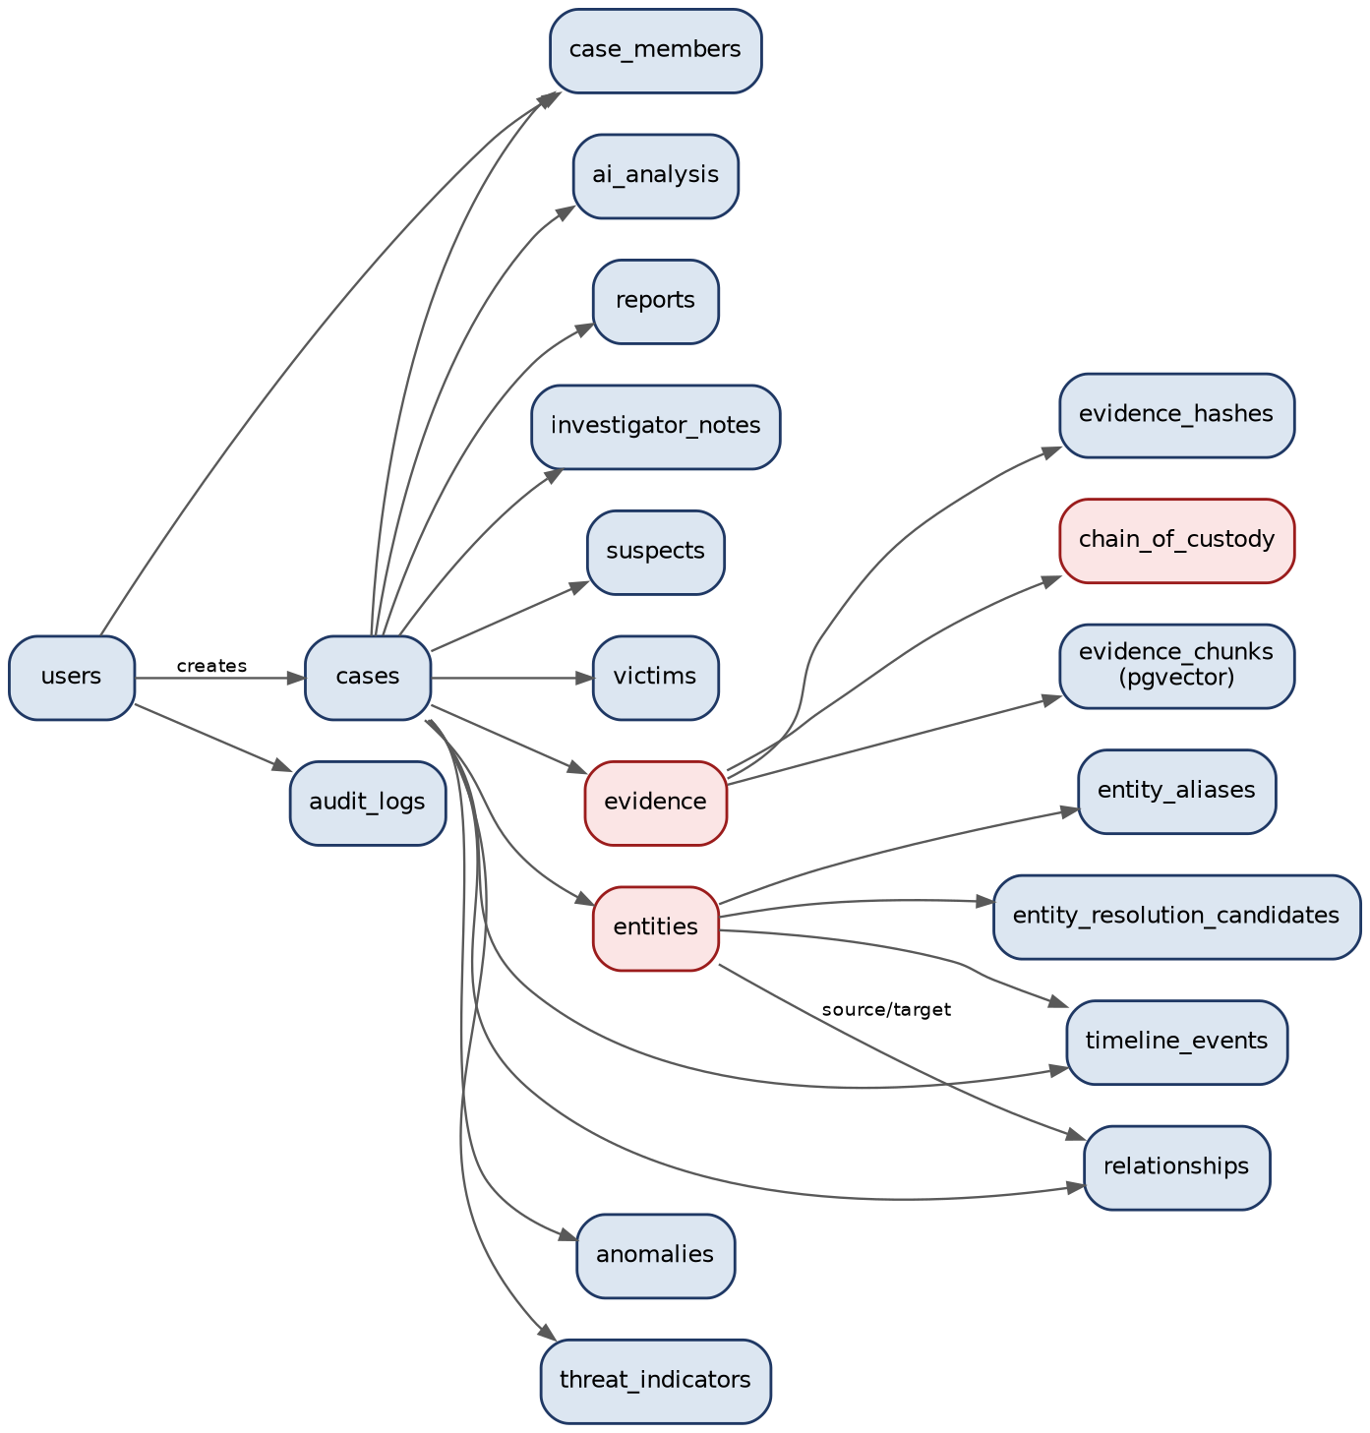
Figure 7.1 — Simplified entity-relationship diagram (core tables and their primary relationships).

7.2 Table Reference
Table | Purpose
users | Investigator accounts; role field drives RBAC
sessions | Refresh-token sessions — revocable, IP/user-agent logged
audit_logs | Every mutating/sensitive action across the platform
notifications | Per-user notification inbox
cases | The investigation itself — status, priority, ownership
case_members | Case membership and role-on-case
suspects / victims | Named parties on a case, optionally linked to an Entity
investigator_notes | Free-text notes, tagged provenance = INVESTIGATOR_NOTES
case_tasks | Lightweight task tracking per case
comments | Case-level discussion thread
evidence | One row per uploaded file — hash, type, status, extracted text
evidence_hashes | Hash history, supporting re-verification over time
chain_of_custody | Append-only log of every evidence touch, with previous/current hash
evidence_chunks | RAG pipeline — chunked evidence text + pgvector embedding
entities | Extracted/normalized entities across 18 supported types
entity_aliases | Alternate surface forms of the same entity across sources
entity_resolution_candidates | Scored potential-match pairs — never auto-merged
relationships | Graph edges between entities, with confidence label + weight
timeline_events | Unified forensic timeline, filterable by entity/type/date
ai_analysis | Every AI assistant query, answer, and cited evidence IDs
anomalies | ML-flagged anomalies with score, method, and reason
threat_indicators | IOC enrichment results, or an explicit “unavailable” record
reports | Generated structured reports (JSON canonical)

7.3 Design Notes
- provenance and confidence_label enums are load-bearing, not decorative — they are what lets the UI and reports visually separate ORIGINAL_EVIDENCE from AI_GENERATED_ANALYSIS from INVESTIGATOR_NOTES (Module 19's core requirement).
- chain_of_custody is append-only at the application layer — no update/delete endpoint exists for it. A production deployment should also enforce this at the database role level by revoking UPDATE/DELETE grants on that table for the application's DB user.
- entities.normalized_value is the deduplication key used by the correlation service: the same entity type plus the same normalized value collapses to a single Entity row across every evidence item that mentions it, so the graph doesn't duplicate nodes for trivially different capitalizations or whitespace.
- evidence_chunks.embedding is a 384-dimension pgvector column, matching the all-MiniLM-L6-v2 sentence-transformer model used for embedding.

Chapter 8 — Implementation

8.1 Backend Implementation Approach
The backend is organized so that HTTP concerns (FastAPI routers, request/response validation via Pydantic) are strictly separated from business logic (the app/services/* modules). Every router function follows the same shape: validate the request via a Pydantic schema, resolve the current user and check their permission via a shared dependency, delegate to one or more service functions, and return a schema-validated response. This keeps each service function independently unit-testable without needing to spin up the HTTP layer, which is exactly how the entity-extraction, hashing, and graph-metrics tests in Chapter 10 are written.
A representative example — the entity extraction pipeline entry point:
def extract_entities(text: str) -> List[ExtractedEntity]:
"""Run the full entity extraction pipeline over evidence text."""
results = []
# 1. Structured entities first (regex) - most forensically reliable
for etype in ordered_types:
for m in PATTERNS[etype].finditer(text):
if not span_already_claimed(m):
results.append(ExtractedEntity(
entity_type=etype, value=m.group(),
confidence_score=REGEX_CONFIDENCE, ...))
# 2. spaCy NER for unstructured entities (people, orgs, locations, dates)
for ent in get_nlp()(text).ents:
if SPACY_LABEL_MAP.get(ent.label_):
results.append(ExtractedEntity(...))
return results

8.2 The RAG Pipeline in Detail
The Retrieval-Augmented Generation pipeline (Module 12) is the platform's centerpiece safety-critical component, since it is the module most exposed to hallucination risk. Its implementation enforces grounding structurally rather than relying on prompt wording alone:
- Chunking: evidence text is split into 800-character chunks with 120-character overlap, so no single fact is cut across a chunk boundary without also appearing in the neighboring chunk.
- Embedding: each chunk is embedded with the all-MiniLM-L6-v2 sentence-transformer model (384 dimensions) and stored in the evidence_chunks table's pgvector column, scoped to its case and evidence item.
- Retrieval: an investigator's question is embedded with the same model, and the top-k (default 6) most similar chunks within that case are retrieved via pgvector cosine-distance search.
- Generation gate: if retrieval returns zero chunks, the LLM is never called — the endpoint returns an INSUFFICIENT_EVIDENCE response built directly from the empty retrieval result. This is a structural guarantee, not a prompt instruction the model could ignore.
- Answer + citations: when chunks are found, the LLM receives only those chunks as context (never the full case or the model's general knowledge) and must reference excerpt numbers; each returned citation includes the source evidence_id, an excerpt, and its similarity score.
- Persistence: every query/answer pair is saved to ai_analysis with provenance = AI_GENERATED_ANALYSIS and the list of cited evidence IDs, so every AI answer the system has ever given is itself auditable.

8.3 Frontend Implementation Approach
The frontend is a Next.js 14 App Router application. Authentication state is held in a React context (AuthProvider) backed by JWTs; a thin fetch wrapper (lib/api.ts) attaches the bearer token to every request and redirects to /login on a 401. The case workspace (the application's main screen) is a single route with client-side tab state, so switching between Evidence, Graph, Timeline, AI Assistant, and Reports doesn't reload the page or lose in-progress work. The investigation graph is rendered with Cytoscape.js using a force-directed (cose) layout, with node colors mapped per entity type for quick visual scanning.

8.4 API Reference Summary
Full request/response schemas are available live at /docs (FastAPI's generated OpenAPI UI). Summary by router:
Router | Base path | Representative endpoints
Authentication | /api/auth | POST /register, /login, /refresh, /logout, GET /me
Case Management | /api/cases | GET/POST /, GET/PUT/DELETE /{id}, POST /{id}/suspects, /victims, /notes, /tasks
Evidence | /api/evidence | POST /upload, GET /{id}, /{id}/hash, /{id}/chain-of-custody, /case/{case_id}
Analysis | /api/analysis | POST /document/{evidence_id}, /entities/{case_id}/resolve, /anomaly/{case_id}, /malware/{evidence_id}
Graph | /api/graph | GET /case/{case_id}, /entity/{entity_id}, /case/{case_id}/path, /case/{case_id}/resolution-candidates
Timeline | /api/timeline | GET /case/{case_id}?entity_id=&event_type=&start_date=&end_date=
AI Assistant | /api/ai | POST /query, /summarize
Search | /api/search | GET /case/{case_id}?q=&mode=
Threat Intelligence | /api/threat-intel | POST /check, GET /case/{case_id}
Reports | /api/reports | POST /, GET /{id}, /{id}/content, /case/{case_id}
Dashboard | /api/dashboard | GET /summary
Geolocation | /api/geolocation | GET /case/{case_id}?entity_id=
Users | /api/users | GET /, PUT /{id}/role, /{id}/deactivate
Audit | /api/audit | GET /

8.5 Configuration and Environment
All runtime configuration is environment-variable driven via a Pydantic Settings class (app/core/config.py), covering the database URL, JWT secret and expiry, CORS origins, upload limits and allow-list, the embedding/LLM model names, and optional threat-intelligence API keys. No secret is hard-coded in application code.

Chapter 9 — Security

9.1 Implemented Controls
Control | Implementation
Authentication | JWT access (short-lived) + refresh tokens
Password storage | bcrypt via passlib
MFA | TOTP verification wired into login; enrollment UI not yet built
RBAC | 7 roles × permission matrix, enforced per-endpoint
Rate limiting | slowapi, 60 requests/minute/IP by default
Input validation | Pydantic schemas on every request body
Secure file upload | Extension allow-list, size cap, UUID-randomized storage paths
XSS protection | React's default escaping; no dangerouslySetInnerHTML on user content
SQL injection protection | SQLAlchemy ORM parameterized queries throughout
CSRF | Bearer-token auth (not cookie sessions) — CSRF applies to cookie auth, see §9.2
Secure headers | X-Content-Type-Options, X-Frame-Options, Referrer-Policy, HSTS in production
Audit logging | Every case/evidence/user mutation logged with actor, action, resource, IP
Evidence integrity | SHA-256 hashing, chain of custody, tamper detection on re-verification
Error handling | Global exception handler — no stack traces leaked to clients

9.2 Known Gaps Before Production Deployment
This platform was built for a hackathon/academic demonstration. The following must be addressed before any deployment involving real case data:
- Token storage: the frontend currently stores JWTs in localStorage, which is readable by any script on the page. Production should move to httpOnly, SameSite=Strict cookies with real CSRF protection (double-submit token) for that flow.
- Chain-of-custody immutability is enforced only at the application layer. Production should also revoke UPDATE/DELETE grants on chain_of_custody (and ideally audit_logs) for the application's database role.
- Encryption at rest: evidence files and the database are not encrypted by this codebase — use disk-level encryption or an encrypted object store, and a managed database with encryption enabled.
- Encryption in transit: no TLS termination is included; the platform expects to sit behind a reverse proxy that terminates TLS.
- Secrets management: SECRET_KEY and API keys are read from a .env file — production should use a real secrets manager.
- MFA enrollment: TOTP verification logic exists in the login flow, but there is no endpoint/UI yet to enroll a user (generate a secret, display a QR code).
- Rate limiting is currently in-process (per-container) — it should move to a Redis-backed limiter before horizontal scaling, since Redis is already provisioned in the deployment stack.

9.3 Threat Model (STRIDE Summary)
Threat | Relevant controls | Residual risk
Spoofing | JWT + bcrypt + optional MFA | Token theft via XSS until token storage moves off localStorage
Tampering | SHA-256 hashing, append-only chain of custody, re-verification endpoint | DB-level immutability not yet enforced at the role/grant level
Repudiation | audit_logs + chain_of_custody on every action | Log entries aren't cryptographically chained to each other
Information disclosure | RBAC on every endpoint, case-scoped queries | No row-level security in Postgres itself — relies on the application layer
Denial of service | Rate limiting, file size caps | In-memory limiter doesn't coordinate across multiple replicas
Elevation of privilege | require_permission() on every mutating route, tested in tests/test_rbac.py | Permission matrix is role-level, not per-case scoped

9.4 AI-Specific Safety Controls
- The RAG assistant's system prompt explicitly forbids inventing facts, suspects, or relationships, and requires every claim to be labeled and cited.
- If retrieval returns no relevant evidence, the assistant returns INSUFFICIENT EVIDENCE rather than falling back on the LLM's general knowledge — enforced structurally, since the LLM is only invoked when there is retrieved context to answer from.
- Every AI-generated analysis record is tagged provenance = AI_GENERATED_ANALYSIS, kept structurally separate from ORIGINAL_EVIDENCE and INVESTIGATOR_NOTES.
- Threat-intelligence enrichment never fabricates a verdict — an unconfigured or unreachable provider returns enrichment_available: false and an explicit “unavailable” message.

Chapter 10 — Testing

10.1 Testing Strategy
Automated tests are written with pytest and split into two categories: unit tests that exercise a service module in isolation with no database (hashing, entity extraction, graph metrics), and integration tests that exercise full API request/response cycles against a real PostgreSQL + pgvector instance (authentication, RBAC boundaries, evidence upload and chain of custody, and the end-to-end analysis pipeline). PostgreSQL-specific column types used throughout the schema (UUID, ARRAY, pgvector's Vector) have no SQLite equivalent, so integration tests deliberately run against a real Postgres instance rather than a lightweight substitute that would silently test a different schema than the one actually deployed.

10.2 Test Coverage by Area
Test file | Type | What it verifies
test_hashing.py | Unit | SHA-256 computation matches the standard library; tamper detection correctly flags a modified file
test_entity_extraction.py | Unit | Email, IP, phone, and URL extraction from sample text; confidence scores stay within [0,1]; empty input returns no entities
test_graph_service.py | Unit | Network metrics on an empty graph and a small connected graph; shortest-path success and failure cases
test_auth.py | Integration | Registration, login, wrong-password rejection, duplicate-registration rejection, token refresh, protected-route enforcement
test_rbac.py | Integration | VIEWER blocked from case creation; INVESTIGATOR permitted; AUDITOR blocked from evidence upload; non-admin blocked from user management; SUPER_ADMIN permitted
test_evidence_and_custody.py | Integration | Upload computes and returns a valid SHA-256; chain-of-custody log records the UPLOADED event; hash verification reports a match on an unmodified file; disallowed file extensions are rejected; the full analyze-document pipeline extracts entities and populates the graph

10.3 Continuous Integration
A GitHub Actions workflow (.github/workflows/ci.yml) runs on every push and pull request against main and develop:
- A Postgres + pgvector service container is started for the job, matching the production data layer exactly.
- Backend dependencies are installed and the spaCy English model is downloaded, then the full pytest suite runs with coverage reporting.
- A lint pass (ruff) runs over the backend codebase.
- The frontend is installed and built with npm run build, catching TypeScript and build-time errors.
- Both the backend and frontend Docker images are built as a final validation step.

10.4 Manual / Exploratory Testing Performed
- End-to-end walkthrough of the full investigator workflow described in Chapter 6.4 (create case → upload evidence → analyze → review graph → review timeline → detect anomalies → query the AI assistant → generate a report) against a locally running Docker Compose stack.
- Verified that hash re-verification correctly reports a mismatch after manually altering a stored evidence file on disk.
- Verified that the AI assistant returns an INSUFFICIENT_EVIDENCE response for a case with no analyzed evidence, and a cited answer once evidence has been analyzed and indexed.
- Verified graceful degradation with no ANTHROPIC_API_KEY configured (raw evidence excerpts returned instead of a generated narrative) and with no threat-intelligence keys configured (explicit “unavailable” response).

10.5 Testing Gaps
Given the project's current stage, the following testing work remains: load/performance testing under realistic evidence volumes and concurrent investigators; a dedicated RAG-grounding test suite that asserts the assistant never answers outside retrieved context across a broader set of adversarial questions; and browser-level end-to-end tests (e.g. Playwright) for the frontend, which is currently validated by TypeScript compilation and manual walkthrough rather than automated UI tests.

Chapter 11 — Results, Discussion, and Future Scope

11.1 Results
The platform was validated through the automated test suite (Chapter 10) and a manual end-to-end walkthrough of the full investigator workflow against a locally running Docker Compose deployment. Concretely, the following was demonstrated working:
- A case can be created, staffed, and moved through its full status lifecycle.
- Evidence uploads are hashed, validated, and immediately traceable through an append-only chain-of-custody log; a deliberately modified file is correctly flagged as a MODIFICATION_ATTEMPT on re-verification.
- Running document analysis on a sample text file correctly extracts emails, IP addresses, phone numbers, and named entities, persists them as deduplicated graph nodes, and creates co-occurrence relationship edges — visible immediately in the Cytoscape.js graph view.
- The unified timeline populates from both evidence-upload events and extracted date references, and anomaly detection correctly flags synthetic off-hours activity in a test dataset.
- The AI Investigation Assistant answers questions grounded in indexed evidence with citations, and correctly returns an INSUFFICIENT_EVIDENCE response when no relevant evidence has been indexed — verified specifically because this is the platform's most safety-critical behavior.
- Role-based access control correctly blocks a VIEWER from case creation and an AUDITOR from evidence upload, while permitting the same actions for INVESTIGATOR and SUPER_ADMIN respectively.
- A 15-section forensic report is generated on demand, correctly separating factual database content from the AI-generated case summary section.

11.2 Discussion
The most consequential design decision in this project was treating AI safety as a structural property of the pipeline rather than a prompting convention. The RAG assistant is not merely instructed not to hallucinate — it is architecturally incapable of answering when retrieval returns nothing relevant, because the LLM call itself is gated behind a non-empty retrieval result. Similarly, entity resolution does not merely suggest matches cautiously — there is no code path in the application that merges two entities without an explicit CONFIRMED decision from a human. This distinction matters in a forensic context specifically because informal safety measures (careful prompt wording, UI disclaimers) are the first thing to fail under adversarial or even just careless use, whereas structural constraints hold regardless of how the system is prompted or used.
The second notable finding from building this system is how much of the specification's original twenty-module scope could be delivered as genuinely working code, rather than as a UI mockup, once the graph store was simplified from Neo4j to Postgres+NetworkX and processing was kept synchronous rather than queued through Celery. Both simplifications were reversible-by-design (Chapter 5.5) and bought back enough implementation time to deliver all twenty modules as real, tested endpoints rather than a smaller working subset plus a larger set of stubs.

11.3 Limitations
- Graph scale: the current NetworkX-at-query-time approach is appropriate for case-scale graphs (hundreds to low thousands of nodes) but would need the documented Neo4j migration for very large, multi-case, or multi-agency graphs.
- Synchronous processing: document analysis, anomaly detection, and report generation run in the request thread. Large evidence batches or many concurrent investigators would benefit from the documented Celery/Redis upgrade.
- Report export: the canonical report format is structured JSON; DOCX/PDF rendering of that JSON is not yet implemented.
- Geolocation UI: the geolocation API is complete and returns real coordinate data where evidence contains it, but an interactive map (Leaflet/Mapbox) is not yet wired into the frontend.
- MFA enrollment: TOTP verification exists in the login flow, but there is no UI yet for a user to enroll (generate secret, scan QR code).
- Entity resolution is currently name-similarity based; it does not yet cross-reference phone/email co-occurrence patterns as additional matching signal beyond what's captured by graph co-occurrence.
- No browser-level automated UI tests yet (Chapter 10.5).

11.4 Future Scope
- Wire the DOCX/PDF report exporter (python-docx / a PDF renderer) against the existing structured JSON report content.
- Add the Neo4j sync path and swap NetworkX queries for Cypher once case graphs grow beyond a few thousand nodes.
- Move analysis, anomaly detection, and report generation onto Celery workers backed by the already-provisioned Redis instance, with progress reporting to the frontend.
- Build the MFA enrollment flow (secret generation + QR code) so TOTP can actually be turned on for an account.
- Wire an interactive Leaflet/Mapbox map into the frontend for the existing geolocation API.
- Extend entity resolution with additional matching signals (e.g. shared phone/email/device across differently-named PERSON entities) beyond name similarity.
- Add browser-level end-to-end tests (Playwright) covering the full investigator workflow through the actual UI.
- Move token storage from localStorage to httpOnly cookies with CSRF protection ahead of any production deployment (Chapter 9.2).

Chapter 12 — Conclusion
FORGE-AI demonstrates that the core promise of AI-assisted digital forensics — turning fragmented, high-volume evidence into structured, explorable investigative intelligence — can be delivered as a working system without compromising the non-negotiable requirements of the forensic domain: evidence integrity, an auditable chain of custody, human control over every identity and relationship conclusion, and AI outputs that are always labeled, always cited, and never presented as unqualified fact.
Across twenty functional modules, the platform ingests evidence, extracts and correlates entities, builds and analyzes an investigation graph, constructs a unified timeline, detects statistical anomalies, enriches indicators with threat intelligence, performs safe static file analysis, answers investigator questions through a citation-grounded RAG assistant, and assembles everything into a structured forensic report — all behind role-based access control and comprehensive audit logging. Two scope simplifications (a Postgres-backed graph instead of Neo4j, and synchronous instead of Celery-queued processing) were made deliberately and documented with a clear upgrade path, in service of delivering every module as genuinely working, tested code rather than a smaller feature set surrounded by mockups.
The project's guiding principle throughout was that AI should make investigators faster at finding what the evidence already shows — never a substitute for the evidence, the investigator's judgement, or the legal process the investigation ultimately serves.

References
1. FastAPI documentation — https://fastapi.tiangolo.com/
2. SQLAlchemy 2.0 documentation — https://docs.sqlalchemy.org/
3. pgvector — Open-source vector similarity search for PostgreSQL — https://github.com/pgvector/pgvector
4. spaCy — Industrial-strength Natural Language Processing — https://spacy.io/
5. Reimers, N. & Gurevych, I. — Sentence-BERT: Sentence Embeddings using Siamese BERT-Networks (sentence-transformers) — https://www.sbert.net/
6. Liu, F. T., Ting, K. M., & Zhou, Z.-H. — Isolation Forest, IEEE ICDM, 2008.
7. Hagberg, A., Schult, D., & Swart, P. — NetworkX: Network analysis in Python — https://networkx.org/
8. Lewis, P. et al. — Retrieval-Augmented Generation for Knowledge-Intensive NLP Tasks, NeurIPS 2020.
9. Next.js documentation — https://nextjs.org/docs
10. Cytoscape.js documentation — https://js.cytoscape.org/
11. OWASP Top 10 — https://owasp.org/www-project-top-ten/
12. NIST SP 800-86 — Guide to Integrating Forensic Techniques into Incident Response.

Appendix A — Confidence and Provenance Labels
These enumerations are used consistently across the platform's data model and API responses:
Confidence label | Meaning
CONFIRMED_FROM_EVIDENCE | Directly stated by, or computed deterministically from, the evidence (e.g. a file's own upload timestamp)
SUPPORTED_INFERENCE | An AI-generated conclusion directly traceable to cited evidence excerpts
POTENTIAL_CONNECTION | A relationship suggested by co-occurrence or similarity, not yet verified by an investigator
ANOMALY | Flagged as statistically unusual by the anomaly-detection model; a lead, not a conclusion
INSUFFICIENT_EVIDENCE | The system explicitly could not find enough grounding to answer
Provenance label | Meaning
ORIGINAL_EVIDENCE | The evidence file/content as uploaded, unmodified
DERIVED_DATA | Data computed from evidence (e.g. an extracted entity, a hash)
AI_GENERATED_ANALYSIS | Text or conclusions generated by the AI assistant or report generator
INVESTIGATOR_NOTES | Free text entered directly by a human investigator

Appendix B — Role / Permission Matrix
Role | Representative permissions
SUPER_ADMIN | All permissions
CASE_ADMIN | CREATE_CASE, VIEW_CASE, EDIT_CASE, UPLOAD_EVIDENCE, ANALYZE_EVIDENCE, EXPORT_REPORT, VIEW_CHAIN_OF_CUSTODY, MANAGE_USERS
INVESTIGATOR | VIEW_CASE, EDIT_CASE, UPLOAD_EVIDENCE, ANALYZE_EVIDENCE, EXPORT_REPORT, VIEW_CHAIN_OF_CUSTODY
FORENSIC_ANALYST | VIEW_CASE, UPLOAD_EVIDENCE, ANALYZE_EVIDENCE, VIEW_CHAIN_OF_CUSTODY
INTELLIGENCE_ANALYST | VIEW_CASE, ANALYZE_EVIDENCE, EXPORT_REPORT
AUDITOR | VIEW_CASE, VIEW_CHAIN_OF_CUSTODY
VIEWER | VIEW_CASE

