Practical No.8
Aim:.Create virtual Machine Server.
Perfromed by: Komal Bahekar
Class: BCA-III SEM-VI
Date:14/02/2025

How to Create a Virtual Machine
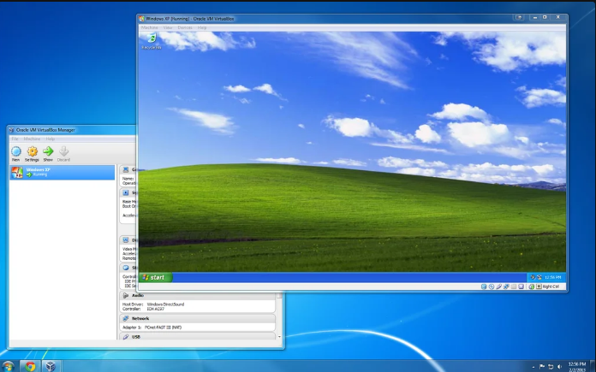

Step 1: Download and Install VirtualBox
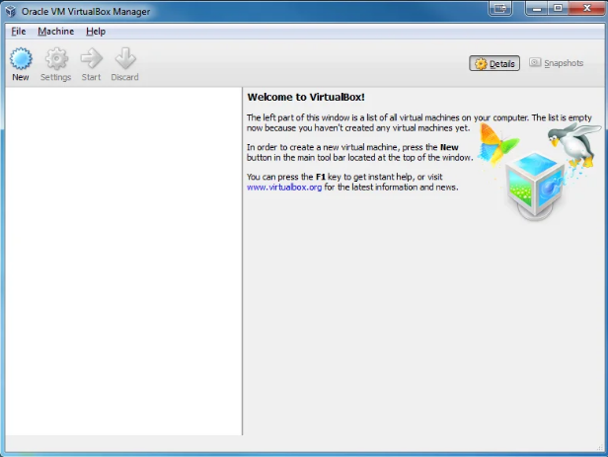
Download VirtualBox from https://www.virtualbox.org/wiki/Downloads. Select the version for your Operating System.
Install VirtualBox.
Keep all of the default settings.
You will be prompted to install several Oracle components. Install all of them.

Step 2: Create a Virtual Machine

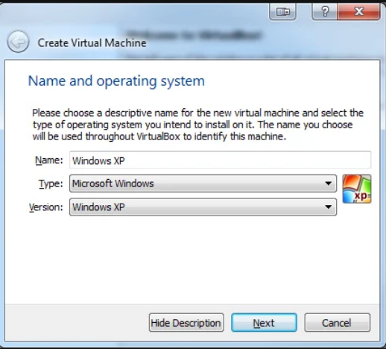
Start VirtualBox and Click on 'New' in the menu.
Enter the Name of your VM. This is how you will identify it in VirtualBox so name it something meaningful to you.
Select Type and Version. This depends on what OS you are installing.

Step 3: Allocate Memory

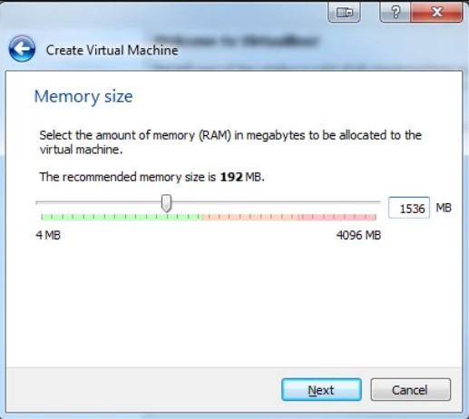

This depends on how much memory you have on your host computer. Never allocate more than half of your available RAM.
If you are creating a Windows VM I recommend at least (1-2 GB.
If you are creating a Linux VM I recommend at least (512 MB)

Step 4: Setup the Hard Drive

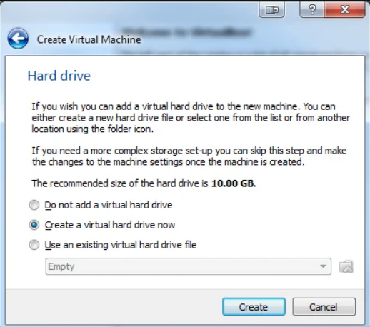

If you already have an existing VM that you want to add select "Use an existing Virtual hard drive file."
Otherwise select "Create a virtual hard drive now."

Step 5: Select Hard Drive File Type

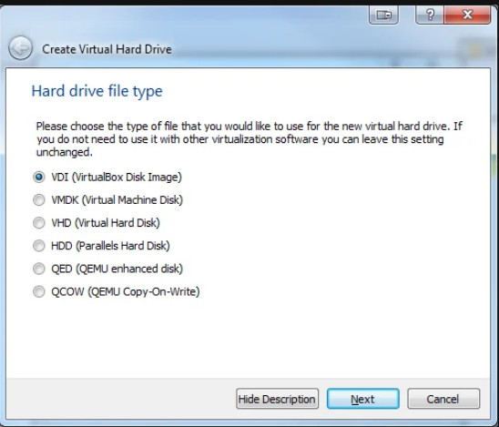

Select 'VDI.' This is usually the best option.
The VM will be stored in a single file on your computer with the .vdi extension.

Step 6: Select Storage on Physical Hard Drive

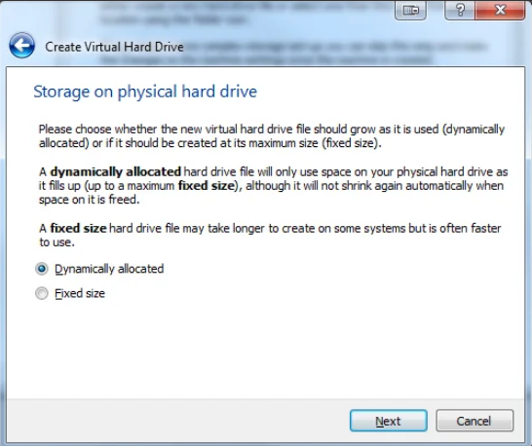

I recommend you choose "Dynamically allocated." This will save space on your computer.
NOTE: "Fixed size" may have a slightly better performance, but will take up more space on your computer.

Step 7: Setup File Location and Size

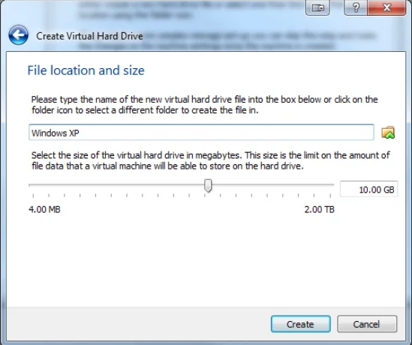

By default, Virtualbox selects the minimum size you should choose.
Depending on what you want to do with the VM you may want to select a bigger size.
NOTE: This will take up space on your computer. Do not select more space than you are willing to give the VM.

You have created a VM. Now you need to install an OS on it.

Step 8: Install the Operating System

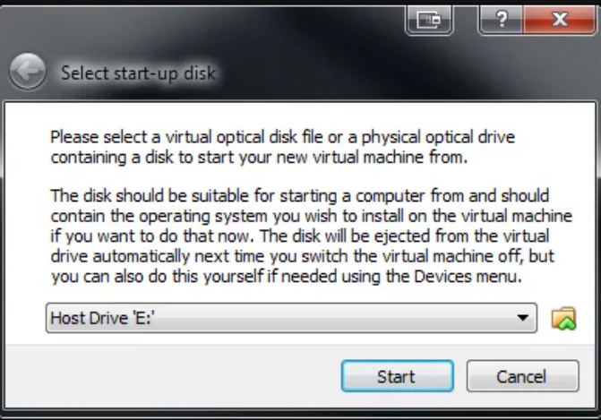
Double click on your newly created VM (It will be on the left hand side and will have the name you gave it in Step 2).
Browse to your installation media or .iso file.
Finish installation.
The actual installation process will depend on which OS you are installing.

Step 9: Install Guest Additions

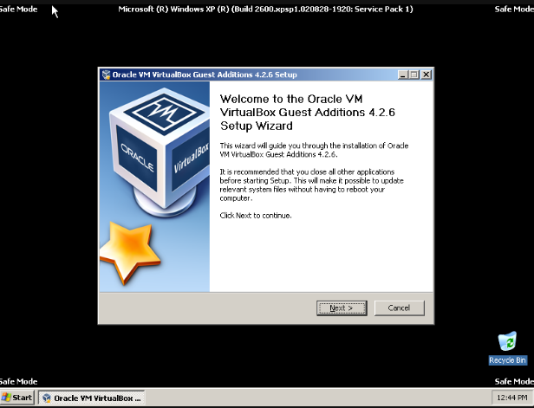

Guest additions add more functionality to your VM, including the option to make the VMfullscreen.

NOTE: You must install guest additions in safe mode (Windows) to enable 2D and 3D acceleration.
Guest additions add more functionality to your VM, including the option to make the VM fullscreen.
NOTE: You must install guest additions in safe mode (Windows) to enable 2D and 3D acceleration.
Boot in Safe Mode.
Instructions for Windows XP
When you have booted in Safe Mode, click Devices --> Install Guest Additions
Follow the Prompts and Install.
Shutdown the VM.

