**Practical No .12**

**Aim :** Install Guest Operating System

**Performed By :** Piyush Vanjari

**Class :** BCA-III SEM - VI

**Date :** 08/03/2025

Since Windows 11 is still a new operating system, installing it on VMWare Workstation Player requires minor workarounds, such as editing VM settings to match Windows 11 requirements.

However, the process is straightforward and consists of three steps:

1. Creating a Windows 11 virtual machine.
2. Configuring the VM.
3. Installing Windows 11 on the VM.

**Step 1: Create Windows 11 Virtual Machine**

To create a Windows 11 virtual machine, launch VMWare Workstation Player and:

1. Select **Create a New Virtual Machine** in the main window.

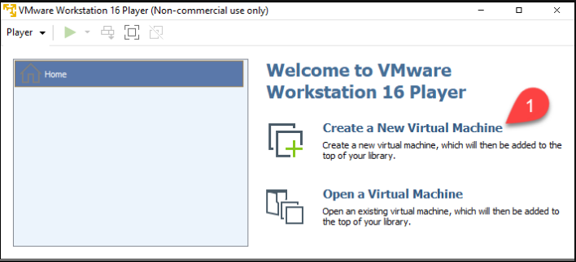

The *New Virtual Machine Wizard* starts.

2. Select the **Installer disc image file (iso)** option.

3. Click **Browse** and locate your Windows 11 ISO file.

4. Select **Next**.

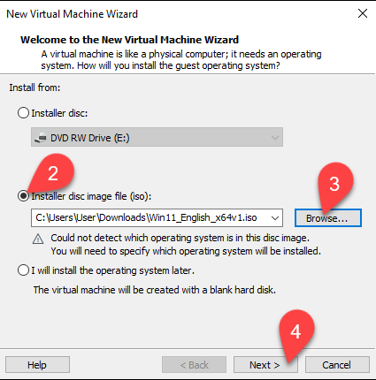

The *Select a Guest Operating System* window loads.

5. Select **Microsoft Windows** in the *Guest operating system* section.

6. Pick **Windows 10 and later x64** from the dropdown list.

7. Select **Next**.

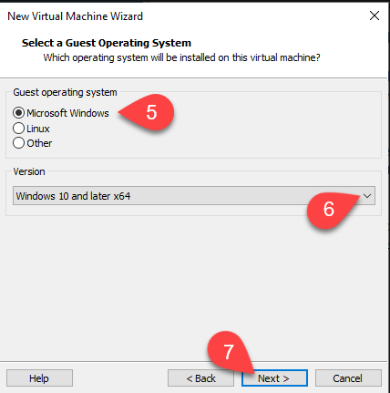

The *Name the Virtual Machine* window appears.

8. Type the name for the virtual machine. The example VM is named *Windows11*.

9. Click Browse to **choose the location** of the VM. Skip this step to use the tool's default location.

10. Select **Next**.

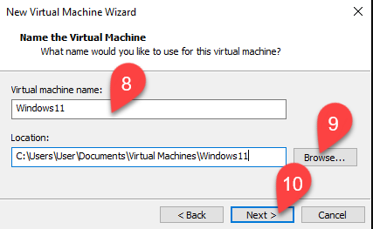

The *Specify Disk Capacity* window appears.

11. Choose the maximum disk size in gigabytes. Assign 60 gigabytes or more for the Windows 11 VM.

12. Select **Store virtual disk as a single file** option.

13. Select **Next**.

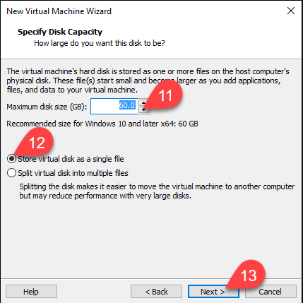

In the *Ready to Create Virtual Machine* window, you can see all the VM settings.

14. Select **Finish** to create your Windows 11 VM.

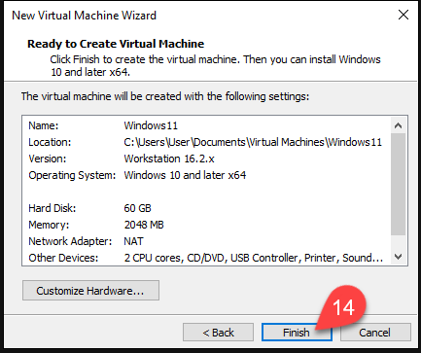

**Step 2: Modify and Start Windows 11 Virtual Machine**

Since the virtual machine has been created with *Windows 10 and later x64* settings, edit the VM to satisfy Windows 11 minimum requirements.

1. Select your VM in the list on the left side of the window.

2. Select **Edit virtual machine settings**.

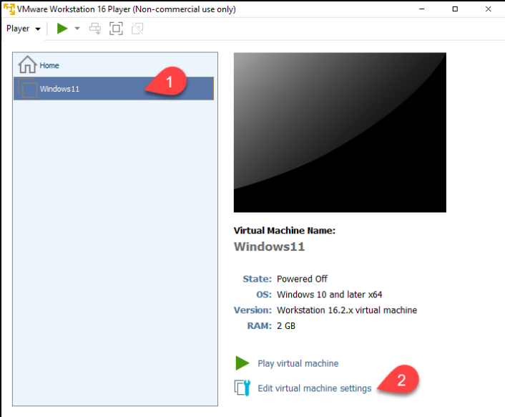

The *Virtual Machine Settings* window opens.

3. The menu on the left side contains the VM's virtual devices. Select the device you want to adjust.

4. Change the device settings in the section on the right side of the window.

**Note**: To satisfy Windows 11 requirements, set at least 4 GB of memory and two processor cores.

5. Select **OK** when you finish setting up your VM.

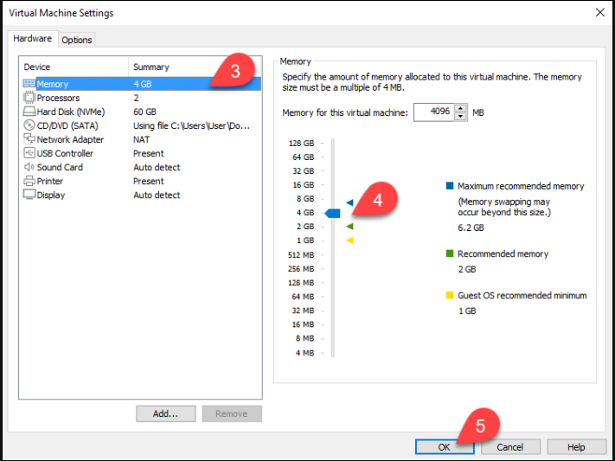

6. Select **Play virtual machine** in the main VMWare Workstation Player window.

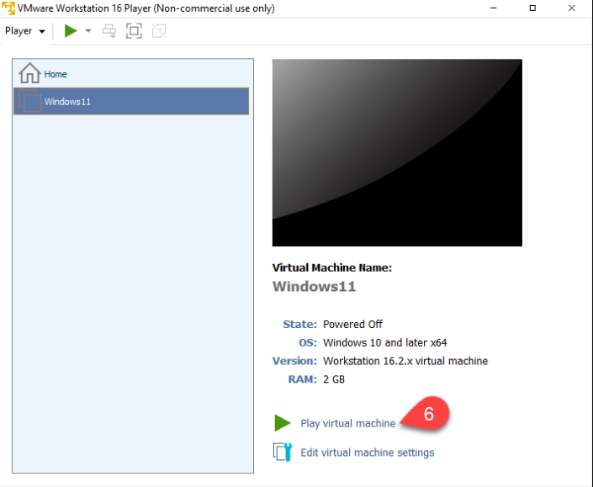

The VM window opens.

7. Press any key while in the VM window to boot the ISO file.