**Practical No: 05**

**Aim:** Write a c graphics program to perform 2D Shearing Transformation in Geometrical

Transformation **Performed By:**

**Class:**

**Date:**

___________________________________________________________________________

**Shearing of a Triangle along x-axis:**

#include<stdio.h>

#include<graphics.h> #include<conio.h> main() { int gd=DETECT,gm;

int x,y,x1,y1,x2,y2,shear_f; initgraph(&gd,&gm,"C:\\TURBOC3\\BGI"); printf("\n please enter first coordinate = "); scanf("%d %d",&x,&y); printf("\n please enter second coordinate = "); scanf("%d %d",&x1,&y1); printf("\n please enter third coordinate = "); scanf("%d %d",&x2,&y2); printf("\n please enter shearing factor x = "); scanf("%d",&shear_f); cleardevice(); line(x,y,x1,y1); line(x1,y1,x2,y2); line(x2,y2,x,y);

setcolor(RED); x=x+ y*shear_f; x1=x1+ y1*shear_f; x2=x2+ y2*shear_f;

line(x,y,x1,y1); line(x1,y1,x2,y2); line(x2,y2,x,y); getch(); closegraph();

}

**Output:**

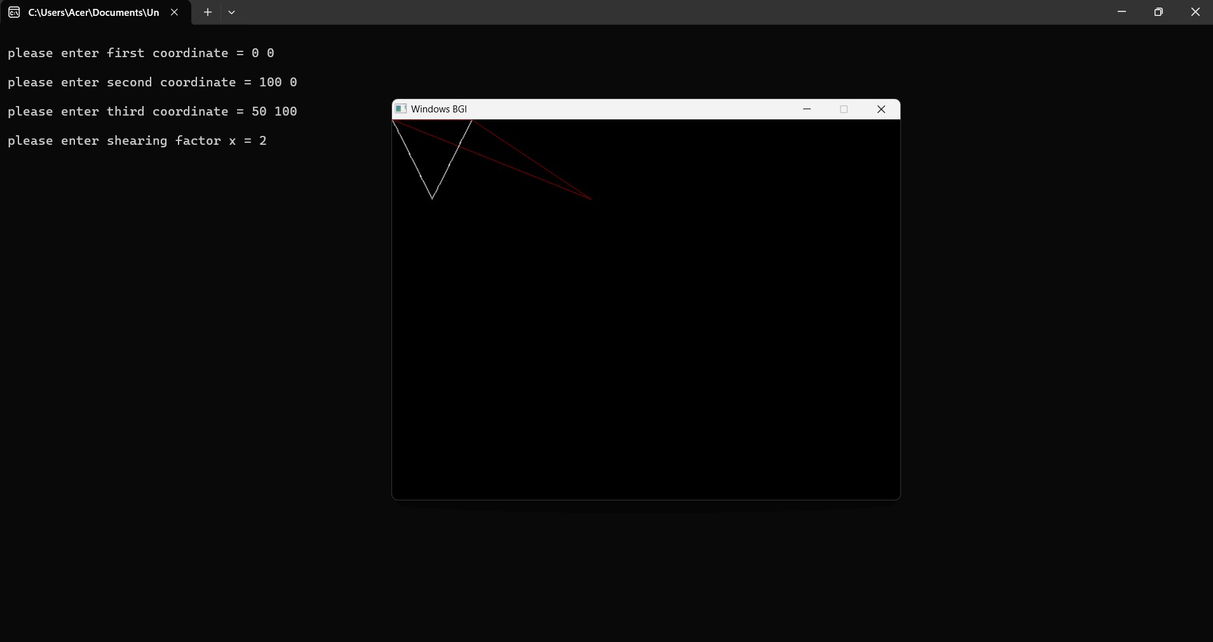

**Shearing of a Triangle along y-axis:**

#include<stdio.h>

#include<graphics.h> #include<conio.h> main() { int gd=DETECT,gm;

int x,y,x1,y1,x2,y2,shear_f; initgraph(&gd,&gm,"C:\\TURBOC3\\BGI"); printf("\n please enter first coordinate = "); scanf("%d %d",&x,&y); printf("\n please enter second coordinate = "); scanf("%d %d",&x1,&y1); printf("\n please enter third coordinate = "); scanf("%d %d",&x2,&y2); printf("\n please enter shearing factor y = "); scanf("%d",&shear_f); cleardevice(); line(x,y,x1,y1); line(x1,y1,x2,y2); line(x2,y2,x,y);

setcolor(YELLOW); y=y+ x*shear_f; y1=y1+ x1*shear_f; y2=y2+ x2*shear_f;

line(x,y,x1,y1); line(x1,y1,x2,y2); line(x2,y2,x,y); getch(); closegraph();

}

**Output:**

