Practical No. 16

**Aim:** Program for Advance Animation Activity.

**Performed By:** Yogesh Gavande

**Class:** BCA-III SEM-V

**Date:** 14/08/2024

# Code:

**MainActivity.java**

package com.example.advanceanimation;

import androidx.appcompat.app.AppCompatActivity;

import android.graphics.drawable.AnimationDrawable; import android.media.Image;

import android.os.Bundle;

import android.widget.ImageView;

public class MainActivity extends AppCompatActivity { private ImageView animationview;

private AnimationDrawable animationDrawable; @Override

protected void onCreate(Bundle savedInstanceState) { super.onCreate(savedInstanceState); setContentView(R.layout.*activity_main*);

animationview = findViewById(R.id.*animation*); animationDrawable=(AnimationDrawable) animationview.getDrawable();

}

@Override

protected void onStart() { super.onStart(); animationDrawable.start();

}

}

# activity_main.xml

<?xml version="1.0" encoding="utf-8"?>

<androidx.constraintlayout.widget.ConstraintLayout xmlns:android=["http://schemas.android.com/](http://schemas.android.com/apk/res/android)a[pk/res/android"](http://schemas.android.com/apk/res/android)

xmlns:app=["http://sc](http://schemas.android.com/apk/res-auto)h[emas.android.com/apk/res-auto"](http://schemas.android.com/apk/res-auto) xmlns:tools=["http://schemas.android.com/tool](http://schemas.android.com/tools)s" android:layout_width="match_parent" android:layout_height="match_parent" tools:context=".MainActivity">

<ImageView android:id="@+id/animation" android:layout_width="wrap_content" android:layout_height="wrap_content"

app:layout_constraintEnd_toEndOf="parent" app:layout_constraintHorizontal_bias="0.0" app:layout_constraintStart_toStartOf="parent" app:srcCompat="@drawable/animation_file" tools:layout_editor_absoluteY="255dp" />

</androidx.constraintlayout.widget.ConstraintLayout>

android:textStyle="normal" app:layout_constraintBottom_toBottomOf="parent" app:layout_constraintEnd_toEndOf="parent" app:layout_constraintStart_toStartOf="parent" app:layout_constraintTop_toTopOf="parent" />

</androidx.constraintlayout.widget.ConstraintLayout>

# animationDrawable.xml

package com.example.advanceanimation;

public class animationDrawable { public void start() {

}

}

# Output:

**Before animation**

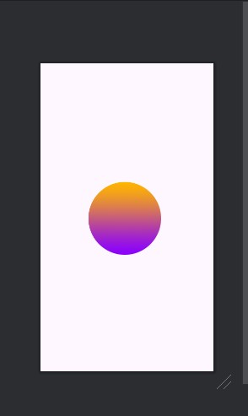

# After animation

