Yogesh kargeti
jamia millia islamia
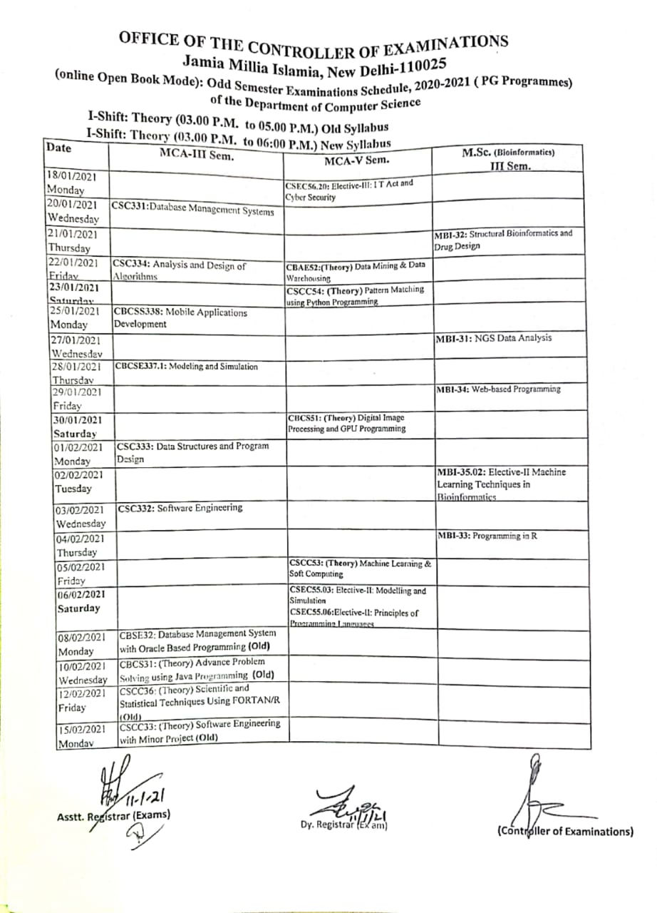
This is the image.
Thank you
How are you man
fine
thank you
It is not adding what should i do
dont know

