

**Module Code & Module Title**

**FC6W51NI Work Related Learning**

**Assessment Weightage & Type**

**100% Individual Coursework**

**Draft WRL**

**Year and Semester**

**2022-23 Autumn, Semester**

**Student Name: Yogesh Khatiwada**

**Group: L3C2**

**College ID: NP05CP4S210093**

**London Met ID:20048544**

**Assignment Submission Date:2023/03/31**

**Assignment Due Date: 2023/03/31**

**I confirm that I understand my coursework needs to be submitted online via Google Classroom under the relevant module page before the deadline in order for my assignment to be accepted and marked. I am fully aware that late submissions will be treated as non-submission and a mark of zero**

**will be awarded.**

# 1. Introduction:

## 1.1 Background of the Placement:

GrihaSewa PVT.LTD, located in Itahsari-03, has accepted me for an internship program. GrihaSewa Pvt. Ltd, the top web design company in Sirsa, provides effective web, mobile, and software development solutions. They have a team of committed designers, developers, and analysts who work closely with businesses and enterprises to create innovative products and solutions that establish new industry standards. They are highly respected by entrepreneurs in the Gurugram and Delhi NCR region and are well on their way to becoming India's leading web services brand. If you have digital goals, don't hesitate to contact them to discuss your needs.

WEB link: <https://grihasewa.com/>



Location of a company:

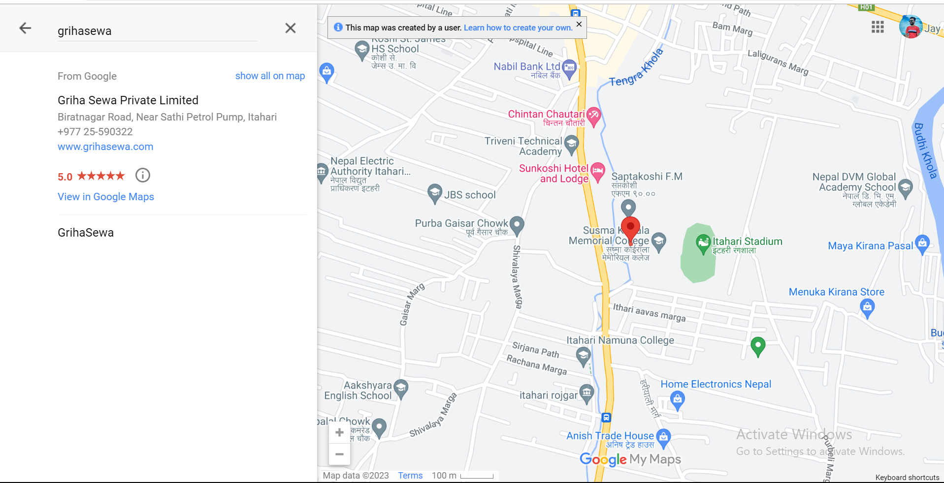

The company is in Itahari, Sunsari, and its workspace is easily accessible from any location within the Itahari area. As part of my internship program, I will be working remotely for the company and will need to visit the workspace during working days, except for Saturdays, to complete my work and collect the necessary documents for my internship.

## 1.2 Structure and Role of the company:

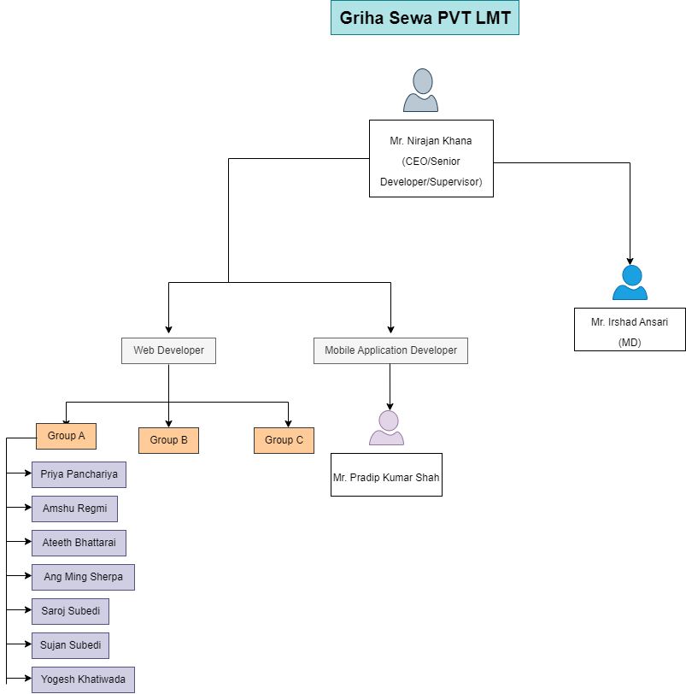

Grihasewa PVT.LTD has made significant contributions to the IT industry over the past two years, resulting in a large workforce. The company has a strong presence in digital marketing, helping brands share their stories with the world. They also have an active app development team, albeit smaller than their digital marketing team. As our internship program was conducted remotely, we were not fully acquainted with all the company's departments. Grihasewa Pvt. Ltd., a prominent design and development firm that has emerged in Nepal over the past decade. Our team consists of over ten experienced designers, developers, and analysts who specialize in crafting intelligent, cost-effective, and user-friendly web applications, mobile applications, and software products. At Grihasewa, we collaborate closely with businesses and entrepreneurs to streamline their processes, generate new revenue streams, and drive positive change at the grassroots level. We have been operating in the industry for the past five years and have established ourselves as trusted technology partners for businesses across various cities in Nepal, including Itahari, Biratnagar, Kathmandu, Dharan, Sankhusaba, and beyond.

# 2. Review of Activities:

## 2.1 WRL Form:

|  |  |  |  |
| --- | --- | --- | --- |
| **Learning  Outcome**  **ID** | **Learning outcomes**  By the end of my work placement, I will be able  to develop what skills or knowledge: (e. g. develop  my XXX skills, enhance  my knowledge of XXX) | **Activities and tasks**  I will achieve this  learning outcome by  carrying out what tasks  (e. g. participating in a  Web development  project, or to work in a  team, or to engage in  group discussion) | **Evidence**  Evidence I could use to  demonstrate that I have  achieved this learning  outcome? (e. g. feedback  from the employer,  artefacts I will develop,  screen shots or video  capture, meeting minutes) |
| LO1 | Before starting, firstly research about all the knowledge and important  of using that and Learn  HTML For web  structuring. | I have learn different  tags with structure  format. Design different  form and websites. | Photographs of learning  meets with supervisor and  mates along with list of  online resources visited and screenshot related it  will be submitted. |
| LO2 | After learning html, learn CSS for web Formatting. | I have developed the  ability to use CSS and  used to design a  website. | I will be providing the  screenshots of my design. |
| LO3 | To make websites  functioning, Learn  JavaScript. | With physical meetings  with supervisor and  online resources along  with feedbacks from  mates | Photographs of learning  meets with supervisor and  mates along with list of  online resources visited  will be submitted. |
| LO4 | Learn Git and GitHub. | With online resources  and feedbacks from  supervisor. | Screenshots of executed  git commits will be  submitted. |
| L05 | Learn Bootstrap. | By modifying previously  done projects using  bootstrap with  supervisor’s guidance. | Screenshots and GitHub  links to developed projects will be submitted. |
| L06 | Learn PHP Programming. | With online resources and feedbacks from  supervisor. | I Can show the pictures of my work. |
| L07 | Learn Laravel for backend. | With guidance and  feedback from  supervisor. | Screenshots of the related project with project GitHub link will be submitted after  complete intern. |

|  |  |  |  |
| --- | --- | --- | --- |
| L08 | I have learned communication Skills also during this project. | With interactions with supervisor and friends, I learn to interaction with them related to project done. | Photographs of project related communications will be submitted. |
| L09 | I have gain Teamwork skills. | With a group project done under supervisor’s guidance, I learn to  work in a team and  construct the entire  project and work on a live project. | I can provide the  feedbacks and report of my work from employer. Screenshot of project  fragments and GitHub link to final project will be submitted. |

## 2.2 WRL Learning Outcome:

2.2.1 (LO1) Learn HTML:

During my internship, I embarked on an educational journey that primarily revolved around HTML. I initially acquainted myself with the fundamental syntax of HTML, which encompassed comprehending the concept of tags, attributes, and values. Additionally, I learned how to employ different types of tags, including headings, paragraphs, lists, and tables, to arrange and structure the content of web pages in an organized and comprehensible manner.

Another crucial facet of HTML that I familiarized myself with was the creation of hyperlinks. Hyperlinks facilitate the connection of web pages, and I discovered that they can be generated using the anchor tag. Moreover, I became well-versed with the various types of hyperlinks, such as internal and external links, and understood how to employ them optimally.

As I delved deeper into my internship, I acquired knowledge about HTML forms, which serve as a conduit for collecting user input. Forms have diverse applications, including user registration and surveys, and I learned how to utilize a variety of form elements, such as text boxes, radio buttons, and checkboxes, to collect and process user input.

Furthermore, I gained invaluable practical experience during my internship by creating a website from scratch. This exercise enabled me to apply my knowledge and hone my skills in crafting a web page using HTML. In addition, I became proficient in utilizing Cascading Style Sheets (CSS) to enhance the aesthetics and overall appeal of the website, which resulted in an excellent user experience.

During my internship, I also learned how to optimize HTML code to boost website performance and user experience. I learned about optimizing images, compressing files, minifying CSS, and JS files, and reducing the number of HTTP requests to enhance website speed.

In conclusion, my internship experience was a valuable learning opportunity that enhanced my knowledge and skills in HTML code. Through my hard work, determination, and curiosity, I gained practical experience and a deeper understanding of the concepts and best practices involved in crafting efficient, visually appealing, and user-friendly web pages. I had the opportunity to practice my HTML skills by creating a simple website from scratch. This was a great opportunity for me to apply what I had learned and to gain experience in creating a web page using HTML.

2.2.2 (LO2) Learn CSS for web Formatting.

After learning HTML, I continued my learning journey by delving into CSS. During my tenure as an intern, I furthered my knowledge in web development by exploring the world of CSS, which is an acronym for Cascading Style Sheets. CSS is a vital component in web development, as it is responsible for enhancing the aesthetics and appeal of web pages by working in tandem with HTML.

To begin with, I studied the various methods of incorporating CSS into an HTML document, which include inline styles, internal styles, and external stylesheets. Additionally, I delved into the syntax of CSS and its application in selecting HTML elements and applying styles to them.

A critical aspect of CSS that I mastered was the utilization of selectors to target specific HTML elements. This enabled me to tailor the styling and formatting of web pages with a high degree of accuracy. I also became proficient in the utilization of various selectors, such as element selectors, class selectors, and ID selectors, among others.

As my understanding of CSS evolved, I broadened my knowledge of the various CSS properties that can be employed to style HTML elements. These encompass properties that focus on text formatting, such as font size, font weight, and text color, as well as properties that relate to layout, such as width, height, and margin.

2.2.3 (LO3) Learn JavaScript:

As a language used extensively in web development, the specific things learned in JavaScript during an internship may vary based on the nature and scope of the project. However, some of the common areas where interns might learn and work on JavaScript could include:

* Learning the basics of JavaScript syntax, data types, variables, loops, and functions.
* Working with JavaScript libraries and frameworks such as React, Angular, or Vue.js.
* Learning how to use JavaScript for client-side scripting to build interactive web pages.
* Using JavaScript for server-side scripting to build scalable web applications with Node.js.
* Learning how to work with APIs and JSON data in JavaScript.
* Working with DOM manipulation to create dynamic web pages and responsive user interfaces.
* Learning how to debug and troubleshoot JavaScript code.
* Learning about best practices for code organization, optimization, and maintenance in JavaScript.

2.2.4 (LO4) Learn Git and GitHub:

Git and GitHub are widely used tools for version control and collaborative software development. During an internship, one may learn Git and GitHub to:

* Understand the basics of version control: Learn about how version control works, why it's important, and how Git helps manage changes to code.
* Create and manage repositories: Learn how to create and manage repositories on GitHub, and how to use Git to manage local repositories on your computer.
* Collaborate on projects: Learn how to use Git and GitHub to collaborate with other developers on a project, including creating branches, making changes, and merging code.

2.2.5 (LO5) Learn Bootstrap:

During an internship, one might learn Bootstrap, a popular front-end framework for building responsive and mobile-first websites. Some of the things that could be learned when working with Bootstrap during an internship include Understanding the basics of Bootstrap: Learning about the key components of Bootstrap, including the grid system, typography, and pre-built components like buttons, forms, and alerts. Creating responsive layouts: Learning how to use the Bootstrap grid system to create responsive layouts that adjust to different screen sizes and devices. Styling and customization: Learning how to customize the look and feel of a website using Bootstrap's built-in classes and utilities, as well as how to override default styles and create custom stylesheets.

2.2.6 (LO6) Learn PHP Programming:

During an internship, one might learn PHP programming, a server-side scripting language used for web development. Some of the things that could be learned when working with PHP during an internship include Understanding the basics of PHP: Learning about the syntax, data types, and control structures of PHP, as well as how to write functions and classes. Building dynamic websites: Learning how to use PHP to build dynamic websites that can interact with databases, handle user input, and generate dynamic content. Working with databases: Learning how to use PHP to interact with databases, including connecting to a database, querying data, and updating records.

2.2.7 (LO7) Learn Laravel:

During an internship, one might learn Laravel, a popular PHP web application framework. Some of the things that an intern could learn when working with Laravel during an internship include Setting up a Laravel environment: Learning how to set up a development environment for Laravel, including installing and configuring the necessary software. Understanding the basics of Laravel: Learning about the key components of Laravel, including its routing system, templating engine, and database ORM. Building web applications: Learning how to use Laravel to build web applications, including understanding how to handle user authentication, session management, and security. Working with databases: Learning how to use Laravel's database ORM, Eloquent, to interact with databases, including querying data and updating records. Creating APIs: Learning how to use Laravel to create APIs that can be used by other applications, including understanding how to handle requests and responses. Understanding best practices: Learning about best practices for using Laravel, including how to optimize website performance, maintain clean code, and collaborate effectively with other developers. Integrating with front-end tools: Learning how to integrate Laravel with front-end tools and frameworks.

2.2.8 (LO8) – Gain Communication Skills

As an intern, I came to realize the vital role that effective communication plays in the workplace, and I made a conscious effort to communicate in a clear and professional manner with my colleagues and superiors.

To improve my communication skills, I began by actively listening to my colleagues and supervisor, paying close attention to their expectations and requirements. I then proactively sought clarification by asking thoughtful and well-considered questions, which helped me gain a better understanding of my role and responsibilities within the organization.

In addition, I made it a point to communicate my work progress and any challenges that arose in a concise and timely manner. By doing so, I demonstrated my accountability and reliability, which earned me the trust and respect of my colleagues and supervisor.

Furthermore, I recognized the importance of non-verbal communication and made sure to always maintain a professional demeanor. This included dressing appropriately, maintaining good eye contact, and using appropriate body language.

Overall, my internship experience taught me that effective communication is a fundamental skill that is essential for success in any workplace. By actively listening, seeking clarification, and communicating clearly and professionally, I was able to build strong relationships with my colleagues and contribute to the success of the organization.

2.2.9 (LO9) – Teamwork Skills

During my internship, I had the opportunity to participate in various team exercises, such as paper trading and the spaghetti game, which required us to work collaboratively to achieve a set goal within a limited timeframe. I found that I was able to work effectively in a team environment during these exercises, and my contributions were valued and considered by my colleagues. I believe that effective communication and collaboration are crucial for successful teamwork. During these exercises, I was able to interact well with my colleagues by sharing my ideas and listening to their suggestions. This helped us to identify the strengths and weaknesses of each team member and allocate tasks accordingly. By working together, we were able to achieve our goals efficiently and effectively.

# 3. Academic Content:

After doing an internship in I learn many things which directly help me in the following modules:

## 3.1 Emerging Programming Platform and Technologies:

The group project for this module required us to work with two other individuals, allowing us to develop prior experience in teamwork. As a result, collaborating with our team members during the internship program was a seamless and effortless process.

3.2 Databases Module:

Learn about database help us to implement in database module which help us to make a relation between two table and how it implements in a system of a project. SQLite database without the support of any Object-Relational Mapping (ORM) operations. Therefore, relying on SQL commands was crucial to successfully implement the database into the application.

3.3. WRL Module

In my personal opinion, the WRL module is extremely valuable. The advantages of its learning outcomes in relation to the current modules being undertaken are unmatched. Specifically, the benefits of teamwork and acquiring proficiency in using Git and GitHub during the internship proved to be immensely helpful in the group coursework for the application development module, enabling all team members to collaborate effectively in the development process.

# 4. Challenges:

4.1 New Topic and Contents:

Our supervisors requested that we explore several new development concepts, which were entirely unfamiliar to us. These concepts included incorporating new services such as One Signal, and implementing a Nepal date format calendar known as B.S. At times, completing these tasks took several days, as they required extensive research followed by resolving numerous errors.

4.2 Time Management

Among the various challenges we encountered, time management proved to be the most daunting. As individuals who had not worked in an office setting before, we found it difficult to allocate time for personal responsibilities, academic studies, and work-related tasks. Juggling daily meetings, completing work assignments, and keeping up with college studies proved to be quite arduous. However, learning to effectively manage time between work and personal daily schedules has been one of the most significant accomplishments we gained through the WRL project.