A PROJECT REPORT ON
MediQueue
Doctor Appointment Booking and Queue Management System
Chapter I: Patient Appointment Booking System
Chapter II: Doctor Queue Management Dashboard
Submitted in partial fulfilment of the requirements for the award of the degree of
[Bachelor of Engineering in Computer Science and Engineering]
Submitted by
[Student name] – [USN]
[Student name] – [USN]
Under the guidance of
[Guide name], [Designation]
[College name]
[Department of Computer Science and Engineering]
Academic Year 2026–2027

ACKNOWLEDGEMENT
I express my sincere gratitude to [Principal name], Principal, [College name], for providing the facilities needed to complete this project.
I am thankful to [HOD name], Head of the Department of Computer Science and Engineering, for the encouragement and support during the work.
I extend my heartfelt thanks to my guide, [Guide name], [Designation], for the valuable guidance, suggestions and constant support throughout the project.
I also thank the teaching and non-teaching staff of the department, my friends and my family for their help and motivation.
[Student name]

TABLE OF CONTENTS
Chapter / Section |  | Page No.
ABSTRACT SUMMARY |  | iii
CHAPTER – I: MEDIQUEUE – PATIENT APPOINTMENT BOOKING SYSTEM
1 | Introduction | 1
2 | System Analysis | 1
2.1 | Problem Statement | 2
2.2 | Project Objectives | 2
2.3 | Project Scope | 3
2.4 | Infrastructure Requirements | 3
2.5 | Functional Requirements | 4
2.6 | Non-Functional Requirements | 4
3 | System Design | 5
3.1 | Entity–Relationship (ER) Diagram | 5
3.2 | Use Case Diagram | 6
3.3 | Activity Diagram | 8
4 | Implementation | 9
4.1 | Architecture | 9
4.2 | Technology Stack | 9
4.3 | Modules | 9
4.4 | Key Logic | 10
5 | Testing and Validation | 10
6 | Results | 11
7 | Conclusion | 13
8 | References | 13
CHAPTER – II: MEDIQUEUE – DOCTOR QUEUE MANAGEMENT DASHBOARD
1 | Introduction | 15
2 | System Analysis | 15
2.1 | Problem Statement | 16
2.2 | Project Objectives | 16
2.3 | Project Scope | 16
2.4 | Functional Requirements | 16
2.5 | Non-Functional Requirements | 17
3 | System Design | 17
3.1 | Entity–Relationship (ER) Diagram | 17
3.2 | Use Case Diagram | 18
3.3 | Activity Diagram | 20
4 | Implementation | 21
4.1 | Architecture and Data | 21
4.2 | Modules | 21
4.3 | Key Logic | 21
5 | Testing and Validation | 22
6 | Results | 23
7 | Conclusion | 24
8 | References | 24

ABSTRACT SUMMARY
Waiting in crowded clinics and hospital corridors without knowing when one’s turn will come is a common problem for patients, and it also makes it hard for doctors to manage their time. This report presents MediQueue, an online doctor appointment booking and queue management system developed as a prototype in two parts.
The first part is a patient website. A patient can sign up, log in, select a locality such as Rajarajeshwari Nagar, filter local clinics and hospitals by type and specialty, view each doctor’s fee and live queue, book a day and a time slot, and receive a token number with the number of patients ahead.
The second part is a doctor dashboard. Each doctor logs in with a personal account and sees the day’s queue, calls the next patient, completes visits or marks no-shows, adds walk-in patients, blocks slots and pauses new bookings. The average consultation time and the estimated waits are calculated automatically.
The system is analysed through functional and non-functional requirements and modelled with ER, use case and activity diagrams. The prototype is implemented with HTML, CSS and JavaScript, uses browser storage and salted SHA-256 password hashing, and a MERN (MongoDB, Express.js, React and Node.js) architecture is proposed for the full system.
Test cases cover authentication, input validation, booking and queue operations. The work shows that patients can plan their visits and doctors can run their queues from a single screen. The report ends with future enhancements such as OTP login, SMS alerts, online payment and a hospital administration module.

CHAPTER – I: MEDIQUEUE – PATIENT APPOINTMENT BOOKING SYSTEM

1 Introduction
Visiting a doctor in a city or a town still means, for most people, travelling to a clinic or a hospital, taking a paper token or registering at a counter, and then waiting for an unknown length of time. The patient does not know how many people are ahead, how long each consultation takes, or whether it is better to come an hour later. Elderly patients, parents with small children and working people are affected the most, because the waiting time is lost time that cannot be planned for.
Online appointment booking is a natural answer to this problem, but many existing platforms focus on large hospitals, require a phone call to confirm the slot, or do not show how long the queue is. The small neighbourhood clinics that people visit most often, for example those in localities such as Rajarajeshwari Nagar, Kengeri or Jayanagar in Bengaluru, are usually left out of such systems.
MediQueue is a web-based doctor appointment booking and queue management system designed to fill this gap. It lets a patient create an account, select the locality where they live, choose between local clinics and hospitals, compare doctors by specialty and fee, see the live queue of each doctor, book a day and a time slot, and receive a token number together with the number of patients ahead. The same data is used by a separate doctor dashboard, which is described in Chapter II.
The project is built as a working prototype. The patient website is implemented with HTML, CSS and JavaScript, and runs entirely in the browser using sample data and browser storage. Passwords are never stored in plain text; they are salted and hashed with SHA-256. For the complete system, a MERN stack (MongoDB, Express.js, React and Node.js) is proposed, so that the patient website, the doctor dashboard and the database work together.
This chapter covers the patient side of MediQueue. Section 2 analyses the problem and lists the requirements, Section 3 presents the system design with the ER, use case and activity diagrams, Section 4 explains the implementation, Section 5 describes the testing and validation, Section 6 shows the results, and Section 7 concludes the chapter with possible future enhancements.

2 System Analysis
System analysis studies how appointments are handled at present, finds the limitations of that method and then defines what the new system must do. The table below compares the existing method of visiting a doctor with the proposed MediQueue system.
Aspect | Existing system | Proposed system (MediQueue)
Booking | Phone call or walk-in at the counter | Online booking, any time of the day
Waiting information | None; patient waits in the clinic | Live queue with number waiting and estimated wait
Finding a doctor | Word of mouth or search for each clinic | Locality, type and specialty filters in one place
Proof of booking | Paper token or verbal confirmation | Digital token number with queue position
Double booking | Possible, handled manually | Booked slots are disabled automatically
Local clinics | Rarely listed on booking platforms | Local clinics listed beside hospitals

2.1 Problem Statement
Patients lose a large part of their day waiting in crowded clinics and hospital corridors without any idea of when they will be seen. Information about doctors, their consultation fees and their timings is scattered across many clinics, and a person looking for a doctor in their own locality has no single place to compare the options. Booking is mostly manual, by phone or in person, and is possible only during working hours. Local clinics, which most families visit first, are rarely covered by existing booking platforms.
There is therefore a need for a simple, locality-based online system in which a patient can find a nearby clinic or hospital, book a slot for a chosen day and time, and know the queue position before leaving home.

2.2 Project Objectives
The main objectives of the patient side of MediQueue are:
- To allow a patient to register and log in securely using a mobile number and password.
- To let the patient select their locality and find nearby local clinics and hospitals.
- To provide filters for facility type, specialty and doctor or clinic name.
- To show each doctor’s consultation fee and live queue (patients waiting and estimated wait).
- To allow booking of a day and a time slot while preventing double booking of the same slot.
- To generate a token number and the number of patients ahead after every booking.
- To keep a personal list of appointments for every patient.

2.3 Project Scope
The scope of this chapter is limited to the patient-facing website of MediQueue.
Within the scope
- Patient sign up, log in, session handling and log out.
- Locality, type and specialty based search of doctors, clinics and hospitals.
- Day and time slot booking for today and the next two days.
- Token generation and the My Appointments list.
- A responsive layout that works on phones, tablets and desktops.
Outside the scope of the prototype
- Real SMS or WhatsApp notifications and OTP verification.
- Online payment of consultation fees.
- Hospital administration and doctor onboarding screens.
- Use of real clinic data; the clinics and doctors shown are sample data.

2.4 Infrastructure Requirements
The infrastructure needed to develop and run the system is given below.
Hardware requirements
Component | Requirement
Client device | Smartphone, tablet or computer with at least 2 GB RAM
Server (for deployment) | 2 vCPU, 4 GB RAM and 20 GB storage
Network | Broadband or mobile data connection
Development machine | Computer with 8 GB RAM and a multi-core processor

Software requirements
Component | Requirement
Operating system | Windows 10/11, Linux, Android or iOS
Web browser | Latest version of Chrome, Edge, Firefox or Safari
Front end | HTML5, CSS3 and JavaScript (React proposed for the full system)
Back end (proposed) | Node.js and Express.js REST API
Database (proposed) | MongoDB
Tools | Visual Studio Code, Git and GitHub, Graphviz for diagrams

2.5 Functional Requirements
Functional requirements describe what the system must do. They are listed in the table below.
ID | Requirement | Description
FR1 | User registration | A new patient creates an account with name, mobile number and password.
FR2 | User login | A registered patient logs in with mobile number and password; wrong details are rejected.
FR3 | Session handling | The patient stays logged in until they choose to log out.
FR4 | Locality selection | The patient selects a locality; the choice is remembered for the next visit.
FR5 | Facility type filter | The list can show all facilities, only local clinics or only hospitals.
FR6 | Doctor search | Doctors can be filtered by specialty and searched by doctor or clinic name.
FR7 | Doctor listing | Each card shows name, specialty, facility, locality, fee and live queue.
FR8 | Slot booking | The patient chooses a day (today or the next two days) and an open time slot.
FR9 | Patient details | Patient name and a 10-digit mobile number are entered, pre-filled from the account.
FR10 | Double-booking prevention | A slot that is already booked is disabled for that doctor and day.
FR11 | Token generation | A token number and the number of patients ahead are shown after booking.
FR12 | My appointments | The patient can view all their bookings with token numbers.
FR13 | Logout | The patient can end the session and return to the login page.

2.6 Non-Functional Requirements
Non-functional requirements describe how well the system must perform.
Quality | Requirement
Usability | A new patient should be able to book an appointment in a few taps without training.
Performance | Filtering the doctor list and opening the booking form should feel instant.
Security | Passwords are stored only as salted SHA-256 hashes; input is validated and escaped before display.
Reliability | A slot cannot be booked twice; invalid input never changes stored data.
Availability | The service should be available round the clock when deployed on a server.
Scalability | The data model must support many localities, hospitals, doctors and patients.
Compatibility | The layout adapts to phone, tablet and desktop screens and to light and dark mode.
Maintainability | Data, interface and logic are kept separate so features can be added easily.
Accessibility | Form fields have labels, error messages are announced, and controls can be used with a keyboard.

3 System Design
System design converts the requirements into models that show what data is stored, who uses the system and how the work flows. Three diagrams are used for the patient website: the Entity–Relationship (ER) diagram, the use case diagram and the activity diagram.

3.1 Entity–Relationship (ER) Diagram
The ER diagram shows the entities stored in the database and the relationships between them. A hospital or clinic employs many doctors, a doctor offers many slots, and a patient makes many appointments. Each appointment reserves exactly one slot, and a slot is reserved by at most one appointment, which is what prevents double booking.
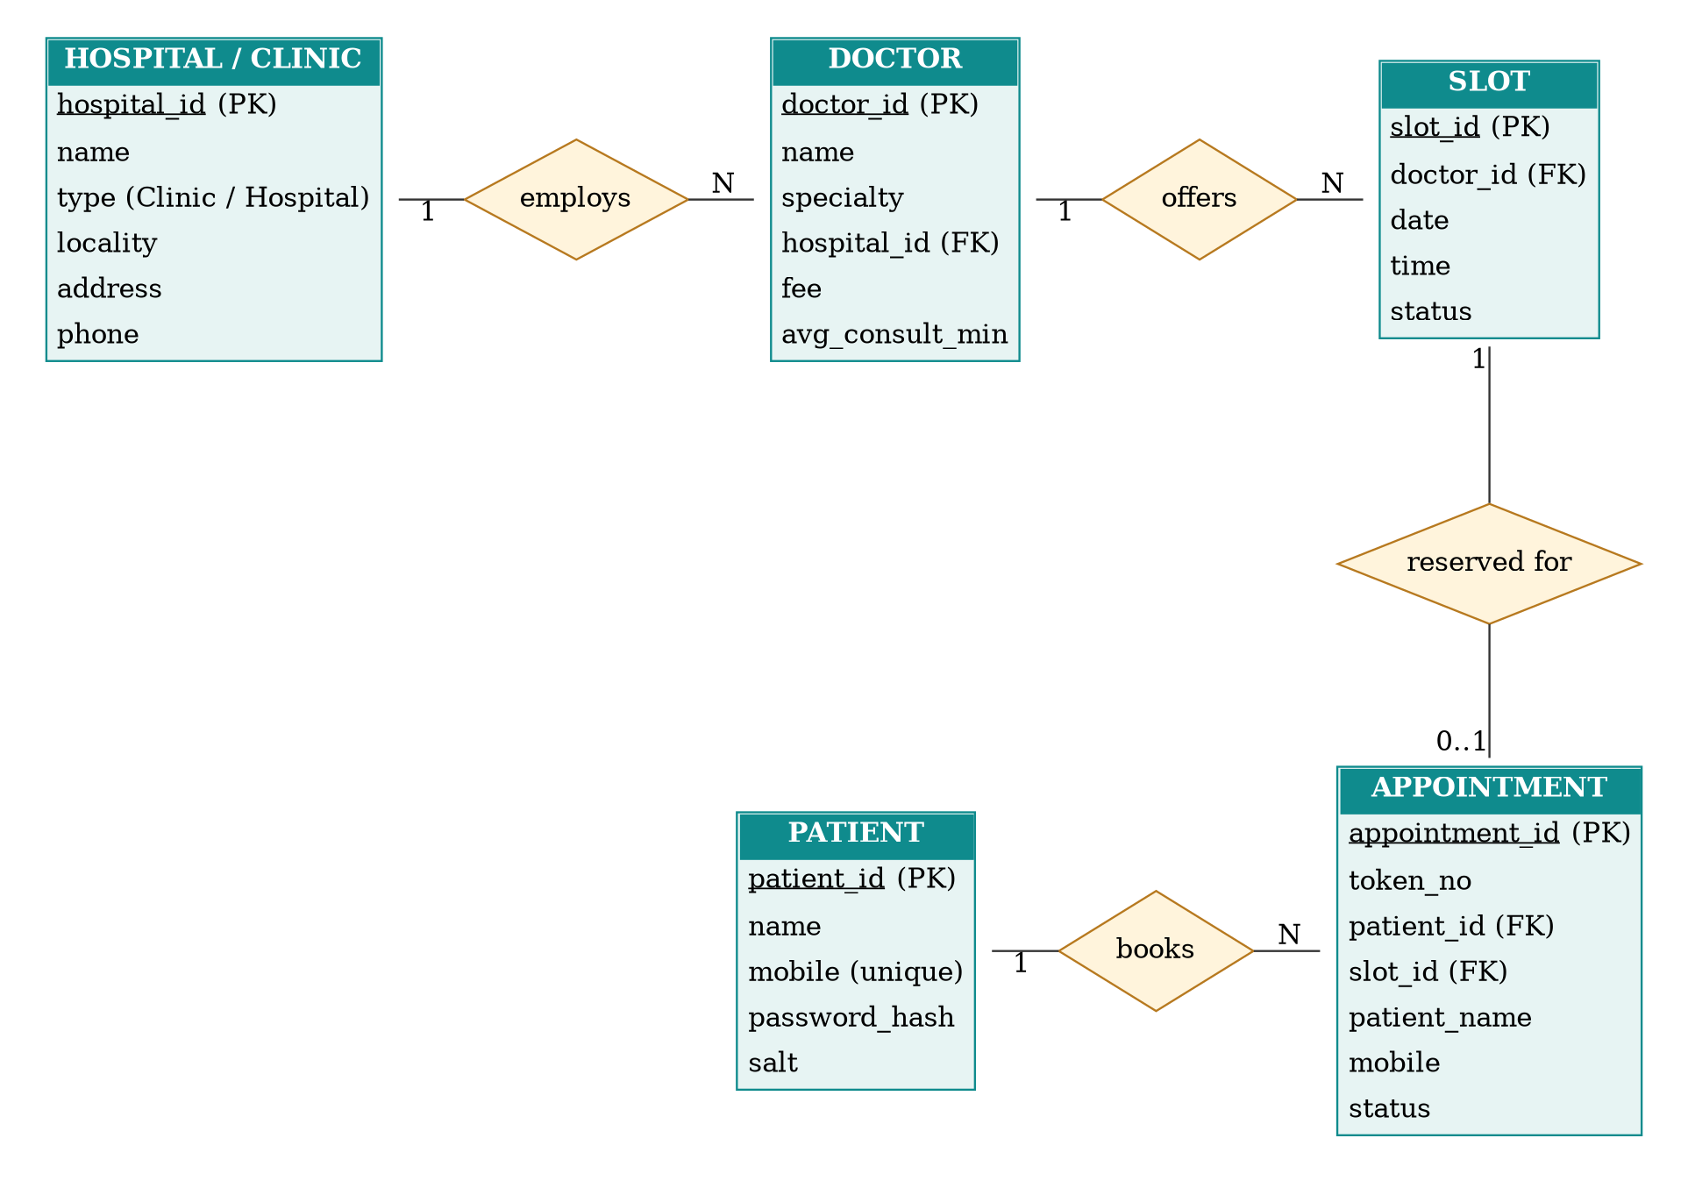
Figure 3.1: ER diagram of the MediQueue patient module
Entity | Purpose | Key attributes
Hospital / Clinic | Stores each facility and its locality | hospital_id, name, type, locality, address, phone
Doctor | Stores doctors working at a facility | doctor_id, name, specialty, hospital_id, fee, avg_consult_min
Slot | Stores the time slots offered by a doctor | slot_id, doctor_id, date, time, status
Patient | Stores registered users | patient_id, name, mobile, password_hash, salt
Appointment | Links a patient to a slot and holds the token | appointment_id, token_no, patient_id, slot_id, status

3.2 Use Case Diagram
The use case diagram shows how the patient interacts with the system. Booking an appointment requires the patient to be logged in, and it ends with the patient receiving a token and queue position, so these are shown as included use cases.
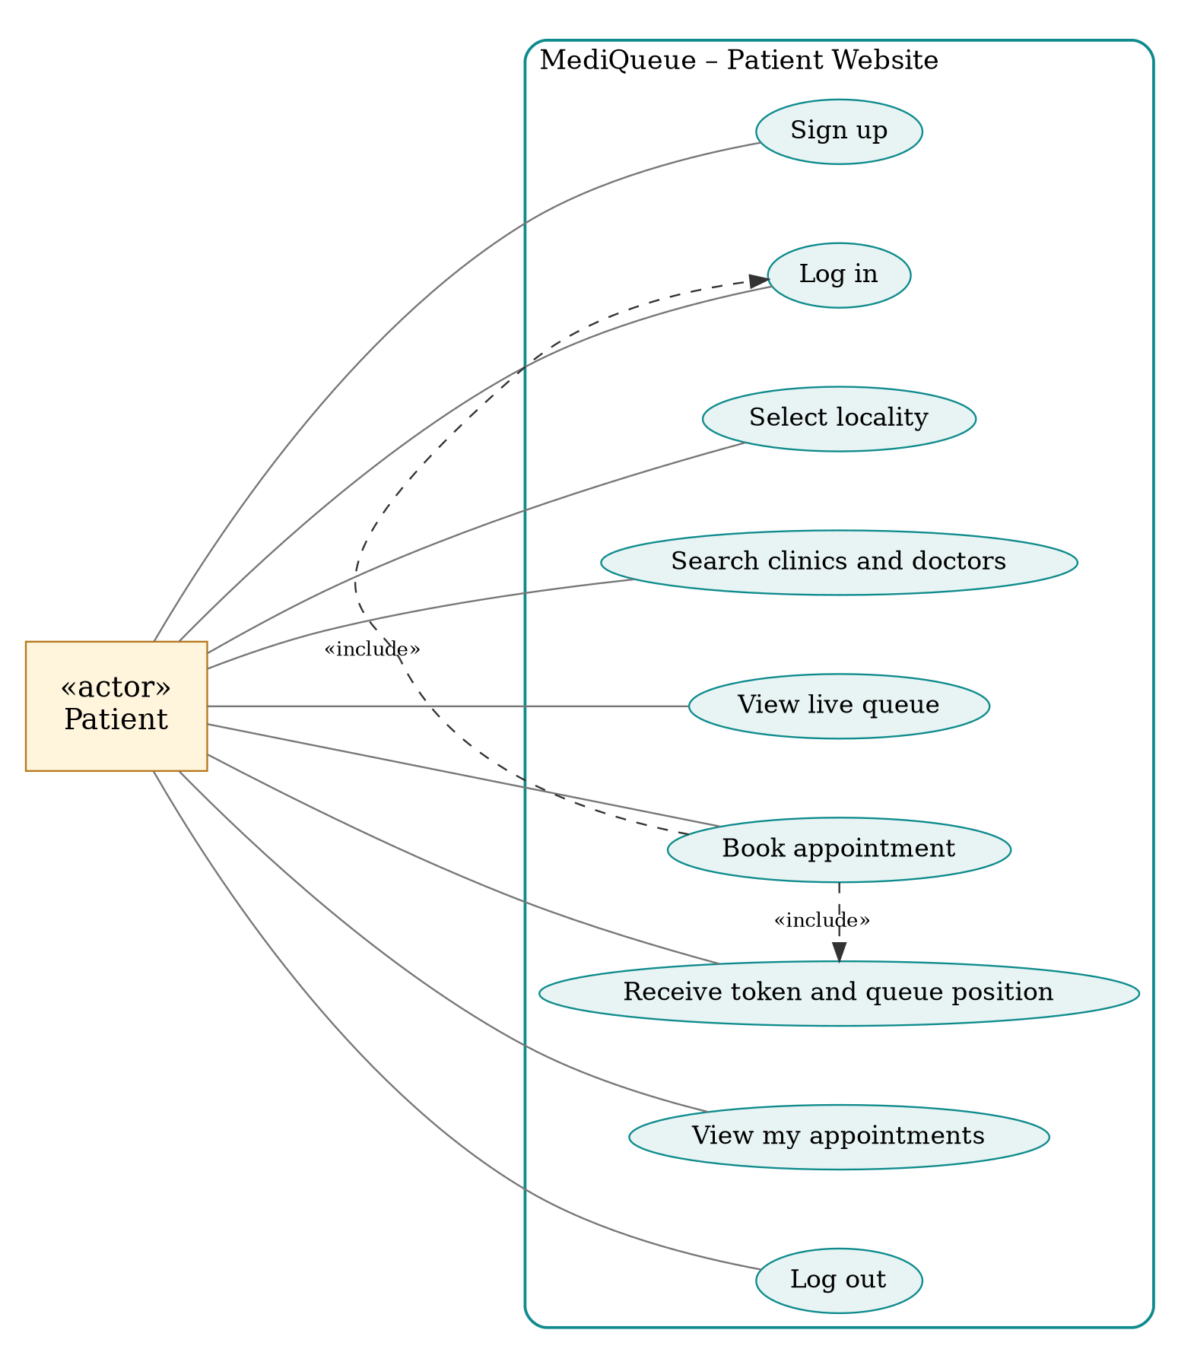
Figure 3.2: Use case diagram of the patient website
ID | Use case | Description
UC1 | Sign up | Create an account using name, mobile number and password.
UC2 | Log in | Authenticate with mobile number and password.
UC3 | Select locality | Choose the area in which to look for doctors.
UC4 | Search clinics and doctors | Filter by type and specialty or search by name.
UC5 | View live queue | See the patients waiting and the estimated wait.
UC6 | Book appointment | Choose a day and slot and confirm the booking.
UC7 | Receive token | Get a token number and queue position.
UC8 | View my appointments | See all bookings made by the patient.
UC9 | Log out | End the session.

3.3 Activity Diagram
The activity diagram shows the flow of work from opening the website to receiving a token. Decision points handle new users, wrong credentials and invalid booking details.
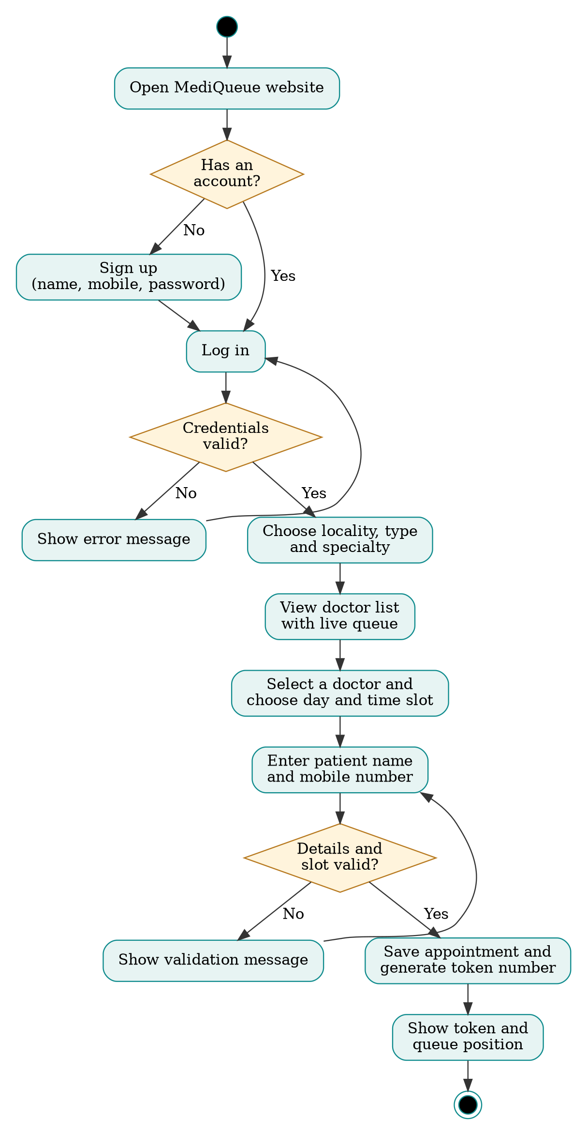
Figure 3.3: Activity diagram of patient registration and booking
The steps in the diagram are explained below.
- The patient opens the website. A new patient signs up; an existing patient logs in.
- If the credentials are wrong, an error message is shown and the patient tries again.
- After login the patient chooses a locality, a facility type and a specialty and sees the matching doctors with their live queue.
- The patient selects a doctor, a day and a time slot, and enters the patient name and mobile number.
- The system validates the details and checks that the slot is still free. If not, a message is shown.
- The appointment is saved, a token number is generated and the queue position is shown.

4 Implementation

4.1 Architecture
MediQueue follows a three-tier architecture. The presentation tier is the website that the patient sees, the logic tier validates input, handles login and booking, and the data tier stores users, doctors, slots and appointments. In the current prototype the three tiers run in the browser: the data is held in JavaScript objects and in the browser’s local storage. In the full system the logic tier becomes a Node.js and Express REST API and the data tier becomes a MongoDB database, so that the patient website and the doctor dashboard share the same data.

4.2 Technology Stack
Layer | Prototype | Proposed full system
Presentation | HTML5, CSS3 (responsive, dark-mode aware) | React
Logic | Vanilla JavaScript | Node.js and Express.js REST API
Data | JavaScript objects and local storage | MongoDB with Mongoose
Security | Salted SHA-256 hashing (Web Crypto API) | bcrypt and JWT based sessions
Hosting | Static page | Cloud server or platform service

4.3 Modules
Authentication module. The sign-up form checks the name, the 10-digit mobile number, the password length and the confirmation. A random salt is generated, the password and salt are hashed with SHA-256, and only the salt and hash are stored. At login the same hash is recomputed and compared. A session marker keeps the patient logged in until logout.
Search and filter module. The locality, type and specialty drop-downs and the name search work together. Every change re-filters the doctor list and updates the count. The chosen locality is saved so that the patient sees the same locality on the next visit.
Booking module. A booking form opens for the selected doctor. The patient chooses a day and a slot, and the name and mobile number are pre-filled from the account. Slots that are already booked are disabled, which prevents double booking.
Token module. After a valid booking a token number is generated, and the number of patients ahead is shown. For a booking on the current day this is the doctor’s current waiting count.
My appointments module. Every booking is stored under the patient’s account and listed in the My Appointments dialog with doctor, facility, day, time and token.

4.4 Key Logic
The following code shows how a password is hashed and how the doctor list is filtered.
async function hash(pw, salt) {
const data = new TextEncoder().encode(salt + pw);
const digest = await crypto.subtle.digest("SHA-256", data);
return [...new Uint8Array(digest)]
.map(b => b.toString(16).padStart(2, "0")).join("");
}

const result = DOCS.filter(d =>
(!area || d.a === area) &&
(!spec || d.s === spec) &&
(!kind || d.k === kind) &&
(!query || (d.n + d.h).toLowerCase().includes(query)));

5 Testing and Validation
Testing checks that every requirement works as expected. Functional testing was planned for the sign-up, login, search, booking and logout features using valid and invalid inputs. The table lists the test cases; the Status column is to be filled after running each test on the final build.
ID | Test case | Input | Expected result | Status
TC1 | Sign up with valid details | Name, 10-digit mobile, password of 6+ characters | Account is created and patient is logged in | [Pass/Fail]
TC2 | Sign up with invalid mobile | 12345 | Message asks for a valid 10-digit number | [Pass/Fail]
TC3 | Sign up with short password | abc | Message about minimum 6 characters | [Pass/Fail]
TC4 | Passwords do not match | Different confirm password | Message "Passwords do not match" | [Pass/Fail]
TC5 | Sign up with registered number | Existing mobile number | Message asks the user to log in | [Pass/Fail]
TC6 | Log in with correct details | Registered mobile and password | Home page opens with greeting | [Pass/Fail]
TC7 | Log in with wrong password | Registered mobile, wrong password | Message "Wrong mobile number or password" | [Pass/Fail]
TC8 | Filter by locality | Rajarajeshwari Nagar | Only doctors of that locality are shown | [Pass/Fail]
TC9 | Filter by type | Local clinics | Only clinics are shown | [Pass/Fail]
TC10 | Book without a slot | No slot selected | Message "Choose a time slot" | [Pass/Fail]
TC11 | Book with valid details | Day, slot, name, mobile | Token and queue position are shown | [Pass/Fail]
TC12 | Book the same slot again | Slot already booked | Slot is disabled | [Pass/Fail]
TC13 | View my appointments | Open My Appointments | Booked appointments with tokens are listed | [Pass/Fail]
TC14 | Log out | Press Log out | Login page is shown | [Pass/Fail]

Validation was also done by comparing the screens against the functional requirements FR1 to FR13 to confirm that every requirement has a matching feature.

6 Results
The patient website was built as a responsive prototype that runs in any modern browser. The screens below show the main results of this chapter.
[Insert screenshot: login page]
Figure 6.1: Login page
Figure 6.1 shows the login page. The patient enters a mobile number and password; wrong details show an error message, and a link switches to the sign-up form.
[Insert screenshot: sign-up page]
Figure 6.2: Sign-up page
Figure 6.2 shows the sign-up form with name, mobile number, password and confirm password, with validation messages for each field.
[Insert screenshot: home page with locality, type and specialty filters]
Figure 6.3: Locality selection and doctor list
Figure 6.3 shows the locality, type and specialty filters. When Rajarajeshwari Nagar is selected with the type set to local clinics, only clinics of that locality are listed with their fee and live queue.
[Insert screenshot: booking dialog with day and slot selection]
Figure 6.4: Booking form
Figure 6.4 shows the booking form where the patient picks a day and a time slot. Booked slots are struck through and cannot be selected.
[Insert screenshot: token confirmation]
Figure 6.5: Token and queue position
Figure 6.5 shows the confirmation with the token number, the day and time, and the number of patients ahead.
[Insert screenshot: My appointments dialog]
Figure 6.6: My appointments
Figure 6.6 shows the My Appointments list, which holds every booking made from the logged-in account.

7 Conclusion
This chapter presented the patient side of MediQueue, a locality-based doctor appointment booking system. The system lets a patient sign up, log in, choose a locality, compare local clinics and hospitals, see the live queue, book a slot and receive a token with the queue position. The analysis, the ER, use case and activity diagrams, and the prototype show that the main waiting and information problems of the present method can be reduced.
The prototype can be extended in the future with a real backend and database, OTP based login, SMS or WhatsApp alerts when a patient’s turn is near, online payment of fees, maps and directions to the clinic, and ratings and reviews of doctors.

8 References
- Ian Sommerville, Software Engineering, 10th ed., Pearson, 2015.
- Ramez Elmasri and Shamkant B. Navathe, Fundamentals of Database Systems, 7th ed., Pearson, 2016.
- Grady Booch, James Rumbaugh and Ivar Jacobson, The Unified Modeling Language User Guide, 2nd ed., Addison-Wesley, 2005.
- Mozilla Developer Network, "SubtleCrypto: digest() method", https://developer.mozilla.org/en-US/docs/Web/API/SubtleCrypto/digest
- React Documentation, https://react.dev/
- MongoDB Manual, https://www.mongodb.com/docs/manual/

CHAPTER – II: MEDIQUEUE – DOCTOR QUEUE MANAGEMENT DASHBOARD

1 Introduction
A booking system is useful only if the people who run the clinic can see and control the queue. In most clinics the doctor or the receptionist keeps the order of patients on paper, calls names aloud and has no record of how long consultations really take. When bookings and walk-ins are mixed, the queue becomes difficult to manage and the waiting patients become frustrated.
The MediQueue Doctor Dashboard is the second part of the system. Every doctor has a personal login and sees only their own queue, slots and statistics. From one screen the doctor can see who is waiting, call the next patient, finish the visit or mark a no-show, add a walk-in patient, block time slots for a break and pause new bookings.
Like the patient website, the dashboard is a browser-based prototype with sample data for four doctors from different clinics and hospitals. It is designed to use the same data model as the patient website, so that in the full system a booking made by a patient appears on the doctor’s dashboard, and the doctor’s actions update the queue shown to patients.
This chapter follows the same structure as Chapter I: system analysis, system design, implementation, testing, results and conclusion.

2 System Analysis
The table below compares the present way of managing a clinic queue with the MediQueue doctor dashboard.
Aspect | Existing system | Proposed dashboard
Queue record | Paper register or memory | Live digital queue with token numbers
Calling patients | Names called aloud | "Call next patient" button with a consultation timer
Waiting time estimate | Guess by the receptionist | Calculated from the doctor’s average consultation time
Walk-ins | Added informally | Added to the queue with the next token number
Breaks and slots | Told verbally | Slots can be blocked and bookings paused
Doctor accounts | Not applicable | Separate login and dashboard for every doctor

2.1 Problem Statement
Doctors and clinic staff manage queues manually. There is no reliable record of who has arrived, who has been seen and who did not turn up, and the estimated waiting time given to patients is only a guess. Booked patients and walk-in patients are mixed without a clear order, and doctors cannot easily block time for a break without informing every patient.
A dashboard is needed that gives each doctor a clear view of the day’s queue and simple controls to run it.

2.2 Project Objectives
- To provide a secure login so that each doctor sees only their own data.
- To show the day’s patients with token, name, reason, slot time and status.
- To let the doctor call the next patient and run a timer for the consultation.
- To let the doctor complete a visit or mark a no-show, and to undo a no-show.
- To calculate the average consultation time and the estimated waiting times automatically.
- To let the doctor add walk-in patients and block or open time slots.
- To let the doctor pause or resume new bookings.

2.3 Project Scope
Within the scope
- Doctor login and logout with separate dashboards for four sample doctors.
- Live queue, consultation timer and statistics.
- Slot management, walk-in registration and the bookings on/off switch.
Outside the scope of the prototype
- Real-time connection with the patient website; this needs the backend.
- Hospital administrator screens and doctor registration.
- Patient medical records and prescriptions.

2.4 Functional Requirements
ID | Requirement | Description
FR1 | Doctor login | The doctor logs in with a Doctor ID and password; wrong details are rejected.
FR2 | Separate dashboards | After login the doctor sees only their own patients, slots and statistics.
FR3 | Queue display | Patients are listed with token, name, reason, time, status and estimated wait.
FR4 | Call next patient | The first waiting patient moves to "In room" and a timer starts.
FR5 | Complete visit | The visit is closed and its duration is added to the average.
FR6 | No-show and undo | A patient can be marked as no-show and restored to waiting.
FR7 | Walk-in patients | A walk-in is added to the queue with the next token number.
FR8 | Slot management | Open slots can be blocked or opened; booked slots cannot be changed.
FR9 | Bookings switch | The doctor can pause or resume new bookings and a banner is shown.
FR10 | Statistics | Waiting count, completed count, average consultation and wait for the last patient are shown.
FR11 | Logout | The doctor ends the session and returns to the login page.

2.5 Non-Functional Requirements
Quality | Requirement
Usability | Main actions should be one tap away and readable at a glance during a busy clinic.
Performance | Queue, statistics and slots update immediately after each action.
Security | Each doctor can access only their own data; credentials are checked at login.
Reliability | Status changes follow fixed rules, so a completed patient cannot be called again.
Scalability | The data model supports many doctors and hospitals.
Compatibility | Works on desktop, tablet and phone, in light and dark mode.
Maintainability | Each doctor’s data is kept in one object so new doctors can be added easily.

3 System Design
The doctor dashboard is modelled with an ER diagram, a use case diagram and an activity diagram.

3.1 Entity–Relationship (ER) Diagram
The dashboard uses the Doctor, Slot and Appointment entities and a consultation statistics entity that stores how long each visit took. A doctor manages many slots, serves many appointments and records many consultation durations. Walk-in patients are appointments of type walk-in that have no slot.
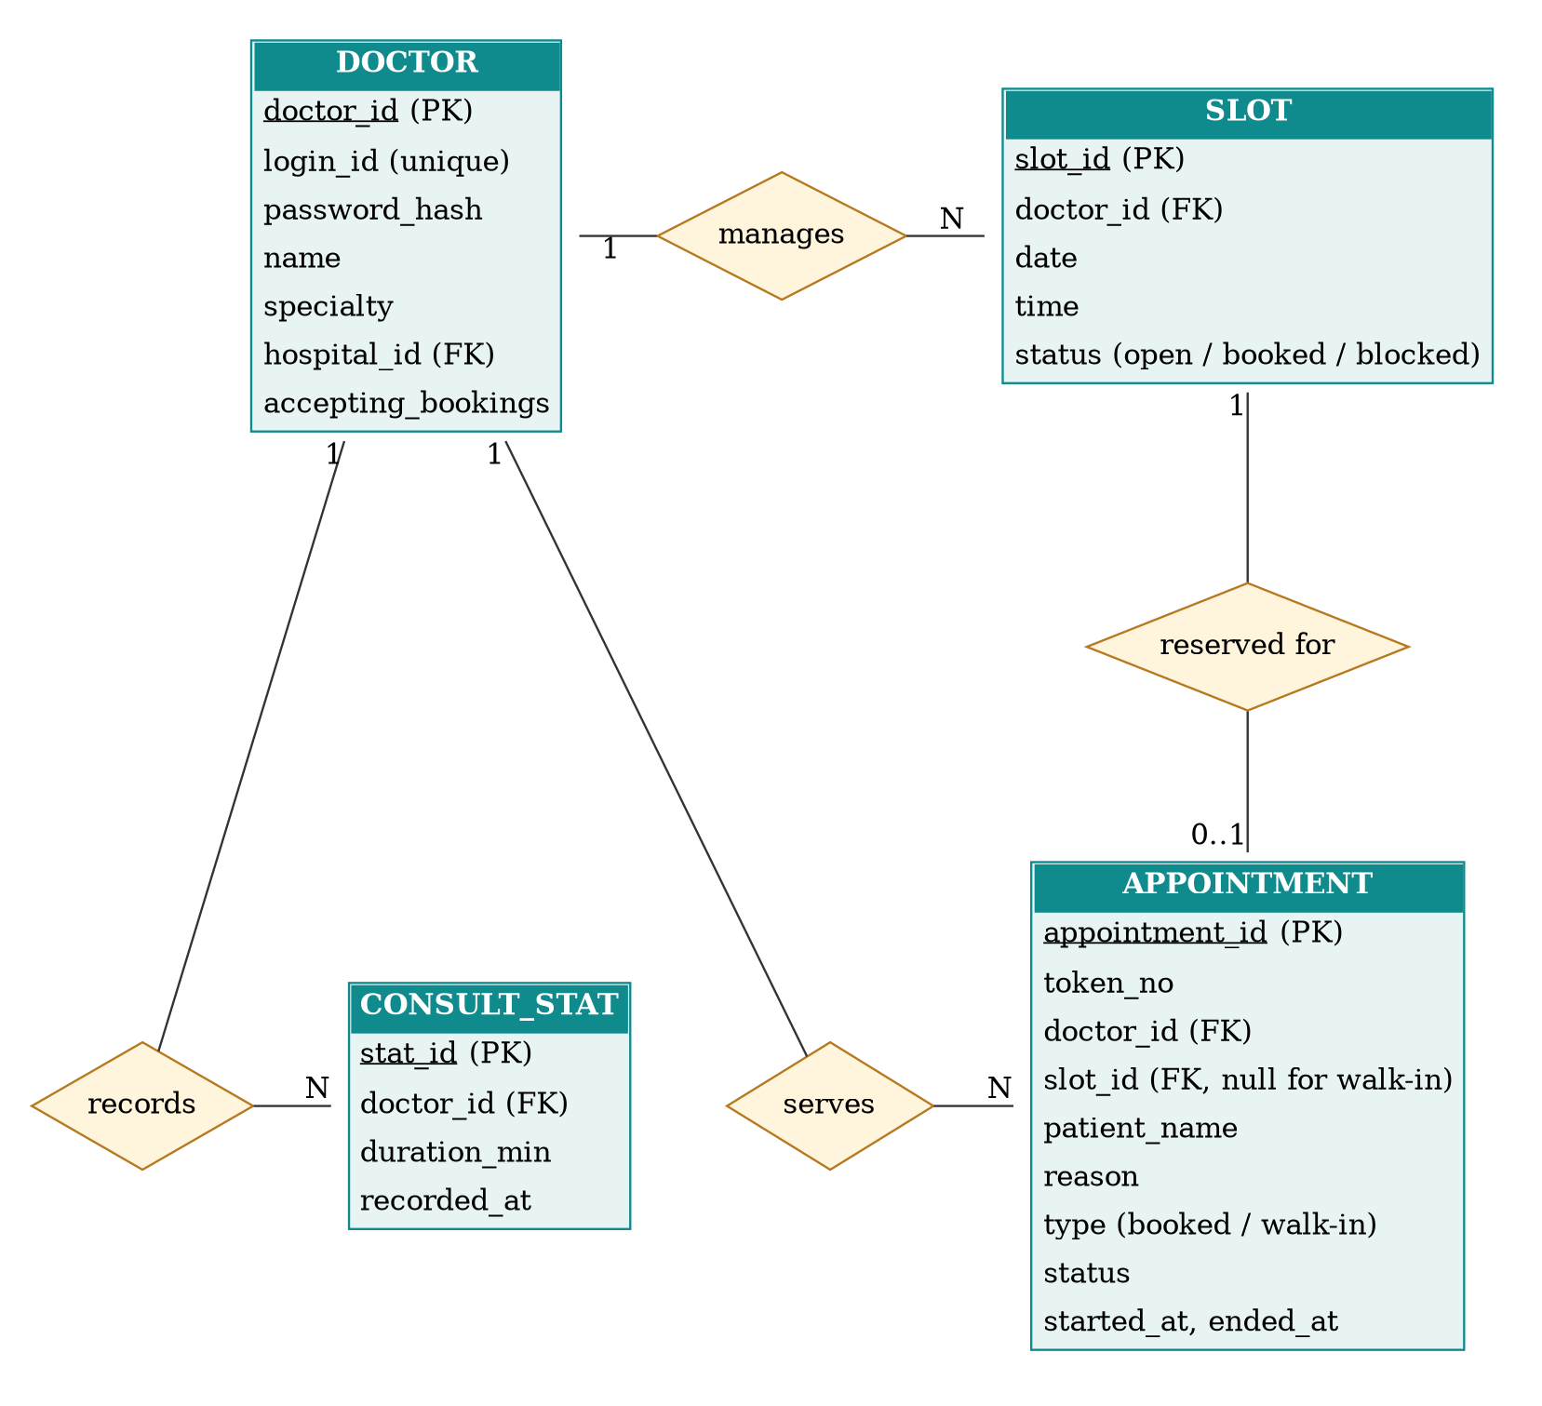
Figure 3.1: ER diagram of the doctor dashboard

3.2 Use Case Diagram
The doctor is the only actor of the dashboard. Calling the next patient requires the queue to be viewed, and completing a visit or marking a no-show extends the call-next-patient step.
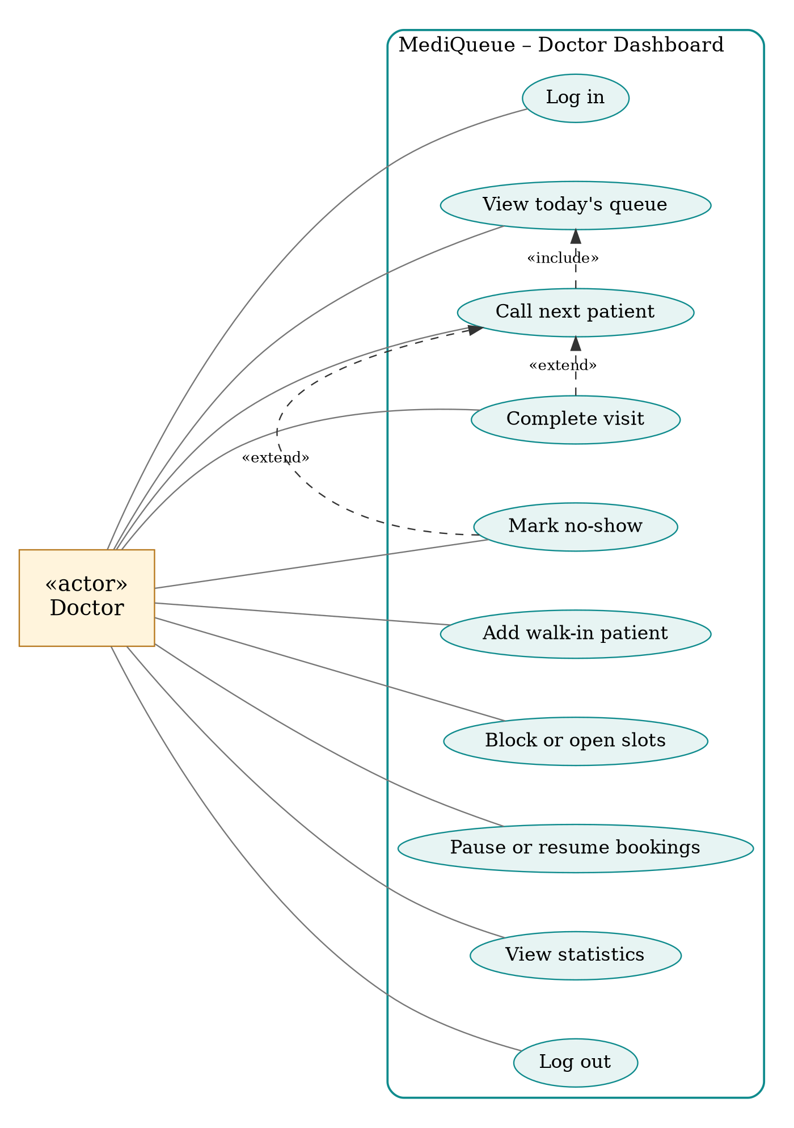
Figure 3.2: Use case diagram of the doctor dashboard
ID | Use case | Description
UC1 | Log in | Authenticate with Doctor ID and password.
UC2 | View today’s queue | See all patients with status and estimated wait.
UC3 | Call next patient | Move the first waiting patient to the consultation room.
UC4 | Complete visit | Finish the consultation and record its duration.
UC5 | Mark no-show | Close the visit of a patient who did not attend.
UC6 | Add walk-in patient | Add a patient without a booking to the queue.
UC7 | Block or open slots | Make a slot unavailable or available.
UC8 | Pause or resume bookings | Stop or allow new bookings from patients.
UC9 | View statistics | See waiting, completed, average time and last wait.
UC10 | Log out | End the session.

3.3 Activity Diagram
The activity diagram shows a doctor’s working day on the dashboard, from login to log out.
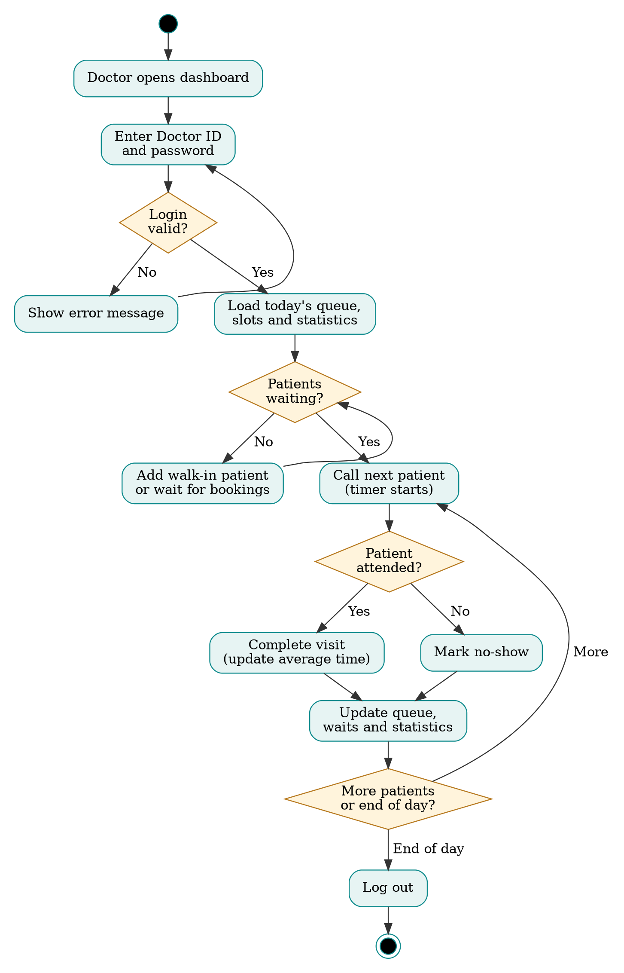
Figure 3.3: Activity diagram of the doctor’s queue handling
After login, the dashboard loads the queue, the slots and the statistics. If patients are waiting, the doctor calls the next patient and the timer starts. When the consultation ends, the doctor either completes the visit, which updates the average consultation time, or marks a no-show. The queue and statistics are refreshed, and the cycle repeats until the end of the day.

4 Implementation

4.1 Architecture and Data
The dashboard is a single web page with two views: the login view and the dashboard view. The data of every doctor is stored in one object that holds the credentials, the list of patients, the slots, the blocked slots, the list of consultation durations, the next token number and the bookings switch. Logging in selects that object, so each doctor sees a different dashboard, and the state of every doctor is kept separately while the page is open. In the full system this object corresponds to the Doctor, Slot and Appointment collections in MongoDB.

4.2 Modules
Login module. The Doctor ID and password are compared with the stored account. A wrong combination shows an error message. Four demo accounts are provided for the prototype.
Queue module. Patients are sorted by status: in room, waiting, no-show and done. Each waiting patient shows an estimated wait. Statistics at the side show the number waiting, the number completed, the average consultation time and the wait for the last patient.
Consultation module. Call next patient changes the status of the first waiting patient to in room and starts a timer. Complete visit stores the duration in the list used for the average and marks the patient done. No-show closes the visit without changing the average.
Slot and walk-in module. Slots that are already booked are shown dark and cannot be changed. Open slots can be blocked and reopened. A walk-in patient is added with the next token number.
Availability module. A switch pauses new bookings and shows a banner reminding the doctor that patients cannot book until bookings are resumed.

4.3 Key Logic
The average consultation time is the mean of all recorded durations. The estimated wait for the patient at position pos in the waiting list is the time for the patients before them, plus the remaining time of the patient currently in the room.
const avg = () => Math.round(
D.durs.reduce((a, b) => a + b, 0) / D.durs.length);

// estimated wait for the patient at position pos (1 = next)
const wait = (pos - 1) * avg() + (inRoom ? avg() : 0);

function finish(status) {
const c = cur();
c.status = status; // "done" or "skipped"
if (status === "done")
D.durs.push(Math.max(1, Math.round((Date.now() - D.start) / 60000)));
D.start = null;
render();
}

5 Testing and Validation
The dashboard was planned to be tested with valid and invalid logins and with each queue operation. The Status column is to be filled after running each test on the final build.
ID | Test case | Input | Expected result | Status
TC1 | Login with valid account | Correct Doctor ID and password | Dashboard of that doctor opens | [Pass/Fail]
TC2 | Login with wrong password | Correct ID, wrong password | Error message is shown | [Pass/Fail]
TC3 | Login with unknown ID | Unregistered ID | Error message is shown | [Pass/Fail]
TC4 | Separate dashboards | Log in as two different doctors | Each shows their own patients and slots | [Pass/Fail]
TC5 | Call next patient | Press Call next patient | First waiting patient is in room and timer starts | [Pass/Fail]
TC6 | Complete visit | Press Complete visit | Patient is marked done; completed count increases | [Pass/Fail]
TC7 | Mark no-show | Press No-show for a patient in the room | Patient is marked no-show; average is unchanged | [Pass/Fail]
TC8 | Undo no-show | Press Undo on a no-show patient | Patient returns to waiting | [Pass/Fail]
TC9 | Add walk-in | Enter a name and press Add | Patient is added with the next token | [Pass/Fail]
TC10 | Add walk-in without name | Empty field | Message asks for the patient’s name | [Pass/Fail]
TC11 | Block an open slot | Tap an open slot | Slot is shown struck through | [Pass/Fail]
TC12 | Change a booked slot | Tap a booked slot | Nothing changes; slot stays booked | [Pass/Fail]
TC13 | Pause bookings | Switch off bookings | Banner is shown and label changes | [Pass/Fail]
TC14 | Log out | Press Log out | Login page is shown | [Pass/Fail]

6 Results
The doctor dashboard was built as a responsive prototype with separate logins. The screens below show the main results of this chapter.
[Insert screenshot: doctor login page with demo accounts]
Figure 6.1: Doctor login page
Figure 6.1 shows the doctor login page. Four demo accounts are listed for quick sign-in, and a wrong ID or password shows an error.
[Insert screenshot: dashboard with Now in consultation panel and queue]
Figure 6.2: Dashboard with the current patient and queue
Figure 6.2 shows the patient in the consultation room with a running timer, the waiting patients with estimated waits, and the statistics.
[Insert screenshot: slots panel and add walk-in panel]
Figure 6.3: Slot management and walk-in patients
Figure 6.3 shows the slots panel, where booked slots are dark and blocked slots are struck through, and the form for adding a walk-in patient.
[Insert screenshot: dashboard of a second doctor]
Figure 6.4: Dashboard of a different doctor
Figure 6.4 shows a second doctor’s account. The patients, reasons, slots and average consultation time are different, which confirms that each doctor has a separate dashboard.
[Insert screenshot: bookings paused banner]
Figure 6.5: Bookings paused
Figure 6.5 shows the banner displayed after the doctor switches off new bookings.

7 Conclusion
This chapter presented the MediQueue doctor dashboard, which gives every doctor a personal login and a single screen to run the queue. The doctor can see who is waiting, call the next patient, complete visits or mark no-shows, add walk-ins, block slots and pause bookings, and the system calculates the average consultation time and the waiting estimates automatically.
Together, the patient website and the doctor dashboard form a complete prototype of MediQueue. The next steps are to connect both parts to a Node.js and MongoDB backend so that bookings and queue changes are shared in real time, and to add secure token based login, OTP, SMS alerts, a hospital administration module and online payment.

8 References
- Ian Sommerville, Software Engineering, 10th ed., Pearson, 2015.
- Roger S. Pressman, Software Engineering: A Practitioner’s Approach, 8th ed., McGraw-Hill, 2014.
- Ramez Elmasri and Shamkant B. Navathe, Fundamentals of Database Systems, 7th ed., Pearson, 2016.
- Node.js Documentation, https://nodejs.org/docs/latest/api/
- Express.js Documentation, https://expressjs.com/
- MongoDB Manual, https://www.mongodb.com/docs/manual/

