Design Patterns
Design patterns represent the best practices used by experienced object-oriented software developers. Design patterns are solutions to general problems that software developers faced during software development. These solutions were obtained by trial and error by numerous software developers over quite a substantial period of time.

Design patterns have been evolved over a long period of time and they provide best solutions to certain problems faced during software development. Learning these patterns helps un-experienced developers to learn software design in an easy and faster way. Design patterns are solutions to software design problems you find again and again in real-world application development.

What is Gang of Four (GOF)?
In 1994, four authors Erich Gamma, Richard Helm, Ralph Johnson and John Vlissides published a book titled Design Patterns - Elements of Reusable Object-Oriented Software which initiated the concept of Design Pattern in Software development. These authors are collectively known as Gang of Four (GOF). The book is divided into 2 parts, first part explaining about the “Pros and Cons” of Object Oriented Programming and in the second explaining the evolution of 23 software design patterns.

Types of Design Patterns:
As per the design pattern reference book Design Patterns - Elements of Reusable Object-Oriented Software, there are 23 design patterns which can be classified in three categories: Creational, Structural and Behavioral patterns.

- Creational Patterns: These design patterns provide a way to create objects while hiding the creation logic, rather than instantiating objects directly using new operator. This gives program more flexibility in deciding which objects need to be created for a given use case.
- Structural Patterns: These design patterns concern class and object composition. Concept of inheritance is used to compose interfaces and define ways to compose objects to obtain new functionalities.
- Behavioral Patterns: These design patterns are specifically concerned with communication between objects.

Creational Patterns:
- Abstract Factory Creates an instance of several families of classes.
- Builder Separates object construction from its representation.
- Factory Method Creates an instance of several derived classes.
- Prototype A fully initialized instance to be copied or cloned.
- Singleton A class of which only a single instance can exist.

Structural Patterns:
- Adapter Match interfaces of different classes.
- Bridge Separates an object’s interface from its implementation.
- Composite A tree structure of simple and composite objects.
- Decorator Add responsibilities to objects dynamically.
- Facade A single class that represents an entire subsystem.
- Flyweight A fine-grained instance used for efficient sharing.
- Proxy An object representing another object.
Behavioral Patterns:
- Chain of Responsibility A way of passing a request between a chain of objects
- Command Encapsulate a command request as an object
- Interpreter A way to include language elements in a program
- Iterator Sequentially access the elements of a collection
- Mediator Defines simplified communication between classes
- Memento Capture and restore an object's internal state
- Observer A way of notifying change to a number of classes
- State Alter an object's behavior when its state changes
- Strategy Encapsulates an algorithm inside a class
- Template Method Defer the exact steps of an algorithm to a subclass
- Visitor Defines a new operation to a class without change
Architectural Patterns

An architectural pattern is a general, reusable solution to a commonly occurring problem in software architecture within a given context. Architectural patterns are similar to software design pattern but have a broader scope.

Software application architecture is the process of defining a structured solution that meets all of the technical and operational requirements, while optimizing common quality attributes such as performance, security, and manageability.

It involves a series of decisions based on a wide range of factors, and each of these decisions can have considerable impact on the quality, performance, maintainability, and overall success of the application. The architectural patterns address various issues in software engineering, such as computer hardware performance limitations, high availability and minimization of a business risk.

List of Architectural Patterns:
- Blackboard system
- Broker pattern
- Event-driven architecture
- Implicit invocation
- Layers
- Microservices
- Model–View–Controller (MVC)
- Presentation-abstraction-control
- Model-View-Presenter (MVP)
- Model-View-ViewModel (MVVM)
- Entity–component–system
- Multitier architecture (often three-tier or n-tier)
- Naked objects
- Operational data store (ODS)
- Peer-to-peer
- Pipe and filter architecture
- Service-oriented architecture
- Space-based architecture
What is the MVC pattern?
The Model-View-Controller (MVC) architectural pattern separates an application into three main groups of components: Models, Views, and Controllers. This pattern helps to achieve separation of concerns. Using this pattern, user requests are routed to a Controller which is responsible for working with the Model to perform user actions and/or retrieve results of queries. The Controller chooses the View to display to the user, and provides it with any Model data if requires.

The following diagram shows the three main components and which ones reference the others:

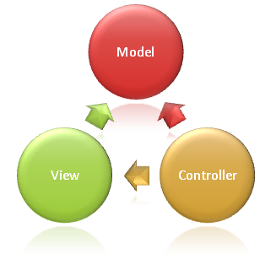

MODEL:
The Model in an MVC application represents the state of the application and any business logic or operations that should be performed by it. Business logic should be encapsulated in the model, along with any implementation logic for persisting the state of the application.

VIEW:
Views are responsible for presenting content through the user interface. There should be minimal logic within views, and any logic in them should relate to presenting content.

Controller:
Controllers are the components that handle user interaction, work with the model, and ultimately select a view to render. In an MVC application, the view only displays information; the controller handles and responds to user input and interaction. In the MVC pattern, the controller is the initial entry point, and is responsible for selecting which model types to work with and which view to render (hence its name - it controls how the app responds to a given request).

History of MVC:
MVC traditionally used for desktop graphical user interfaces (GUIs), this architecture has become popular for designing web applications and even mobile, desktop and other clients. Popular programming languages like Java, C#, Ruby, PHP and others have their own MVC frameworks that are currently being used in web application development.

Trygve Reenskaug introduced MVC into Smalltalk-76 while visiting the Xerox Palo Alto Research Center in the 1970s. In the 1980s, Jim Althoff and others implemented a version of MVC for the Smalltalk-80 class library.

The MVC pattern has subsequently evolved giving rise to variants such as hierarchical model–view–controller (HMVC), model–view–adapter (MVA), model–view–presenter (MVP), model–view–viewmodel (MVVM), and others that adapted MVC to different contexts.
Although originally developed for desktop computing, MVC has been widely adopted as architecture for World Wide Web applications in major programming languages. Several web frameworks have been created that enforce the pattern.
Language | MVC Framework
Java | Spring, Structs
PHP | Cake PHP, Code Igniter
Perl | Catalyst, Dancer
Python | Django, Flask, Grok
Ruby | Ruby on Rails, Nitro
Java Script | Angular JS, Spine
.NET | ASP.Net MVC
Differences between ASP.Net WebForms and ASP.Net MVC
“First of all, lets’ be clear that ASP.NET MVC is not a replacement for ASP.NET WebForms. Both these development models exist and can be used to develop ASP.NET applications. “
ASP.Net WebForms | ASP.Net MVC
ASP.NET Web Forms uses Page controller pattern approach for rendering layout. In this approach, every page has its own controller i.e. code-behind file that processes the request. | ASP.NET MVC uses Front Controller approach. That approach means, a common controller for all pages, processes the requests.
Lots of server side interactions and post backs. | Very minimum post backs and interactions.
Asp.Net Web Form has file-based URLs means file name exist in the URLs must have it’s physically existence. | Asp.Net MVC has route-based URLs means URLs are divided into controllers and actions and moreover it is based on controller not on physical file.
No separation of concerns. As we discussed that every page (.aspx) has its own controller (code behind i.e. aspx.cs/aspx.vb file), so both are tightly coupled. | Very clean separation of concerns. View and Controller are neatly separate.
Because of this coupled behavior, automated testing is really difficult. | Testability is key feature in ASP.NET MVC. Test driven development is quite simple using this approach.
In order to achieve stateful behavior, viewstate is used. Purpose was to give developers, the same experience of a typical WinForms application. | ASP.NET MVC approach is stateless as that of the web. So here no concept of viewstate.
Statefulness has a lot of problem for web environment in case of excessively large viewstate. Large viewstate means increase in page size. | As controller and view are not dependent and also no viewstate concept in ASP.NET MVC, so output is very clean.
Asp.Net Web Form follows Web Forms Syntax. | Asp.Net MVC follows customizable syntax both Web Forms as well as Razor (default).
ASP.NET WebForms model follows a Page Life cycle. | No Page Life cycle like WebForms. Request cycle is simple in ASP.NET MVC model.
In ASP.NET Web Forms we have server controls; so minimal knowledge of HTML, JavaScript and CSS is required. | In MVC we have html helpers, so detailed knowledge of HTML, JavaScript and CSS is required.
Provides limited control over HTML, JavaScript and CSS which is necessary in many cases. | Full control over HTML, JavaScript and CSS.
With lots of control libraries availability and limited knowledge of other related technologies, ASP.NET WebForms is RAD (Rapid Application Development) approach. | It’s a step back. For developers decrease in productivity.
It’s good for small scale applications with limited team size. | It’s better as well as recommended approach for large-scale applications where different teams are working together.
Response type can be HTML only and if we want any other response type we need to write some complex code. | Response type can either be HTML, XML, JSON, etc.
ASP.Net WebForms Page Processing (Page LifeCycle):
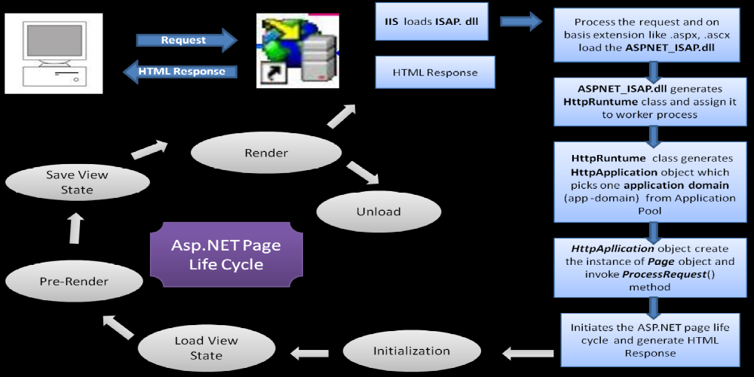
ASP.Net MVC Request Processing:
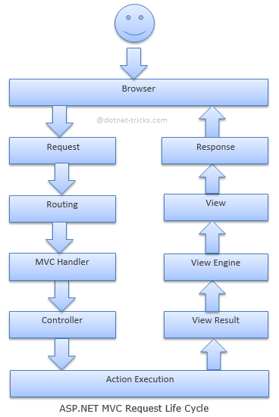

Routing:

Asp.net Routing is the first step in MVC request cycle. Basically it is a pattern matching system that matches the request’s URL against the registered URL patterns in the Route Table. When a matching pattern found in the Route Table, the Routing engine forwards the request to the corresponding IRouteHandler for that request. The default one calls the MvcHandler. The routing engine returns a 404 HTTP status code against that request if the patterns are not found in the Route Table. When application starts at first time, it registers one or more patterns to the Route Table to tell the routing system what to do with any requests that match these patterns. An application has only one Route Table and this is setup in the Global.asax file of the application.

MvcHandler:

The MvcHandler is responsible for initiating the real processing inside ASP.NET MVC. MVC handler implements IHttpHandler interface and further process the request by using ProcessRequest method.

Controller:

MvcHandler uses the IControllerFactory instance and tries to get a IController instance. If successful, the Execute method is called. The IControllerFactory could be the default controller factory or a custom factory initialized at the Application_Start event.

Action Execution:

Once the controller has been instantiated, Controller's ActionInvoker determines which specific action to invoke on the controller. Action to be execute is chosen based on attributes ActionNameSelectorAttribute (by default method which have the same name as the action is chosen) and ActionMethodSelectorAttribute(If more than one method found, the correct one is chosen with the help of this attribute).

View Result:

The action method receives user input, prepares the appropriate response data, and then executes the result by returning a result type. The result type can be ViewResult, RedirectToRouteResult, RedirectResult, ContentResult, JsonResult, FileResult, and EmptyResult.

View Engine:

The first step in the execution of the View Result involves the selection of the appropriate View Engine to render the View Result. It is handled by IViewEngine interface of the view engine. By default Asp.Net MVC uses WebForm and Razor view engines. You can also register your own custom view engine to your Asp.Net MVC application.

View:

Action method may returns a text string, a binary file or a Json formatted data. The most important Action Result is the ViewResult, which renders and returns an HTML page to the browser by using the current view engine.
Software Version Release Life Cycle:
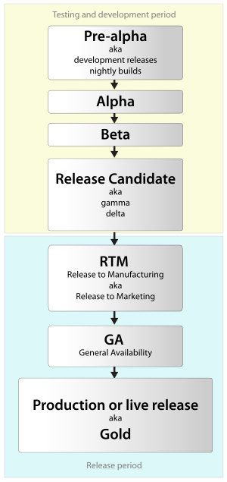
ASP MVC Versions:
ASP.NET MVC - Release history
Date | Version
10 December 2007 | ASP.NET MVC CTP
13 March 2009 | ASP.NET MVC 1.0
16 December 2009 | ASP.NET MVC 2 RC
4 February 2010 | ASP.NET MVC 2 RC 2
10 March 2010 | ASP.NET MVC 2
6 October 2010 | ASP.NET MVC 3 Beta
9 November 2010 | ASP.NET MVC 3 RC
10 December 2010 | ASP.NET MVC 3 RC 2
13 January 2011 | ASP.NET MVC 3
20 September 2011 | ASP.NET MVC 4 Developer Preview
15 February 2012 | ASP.NET MVC 4 Beta
31 May 2012 | ASP.NET MVC 4 RC
15 August 2012 | ASP.NET MVC 4
30 May 2013 | ASP.NET MVC 4 4.0.30506.0
26 June 2013 | ASP.NET MVC 5 Preview
23 August 2013 | ASP.NET MVC 5 RC 1
17 October 2013 | ASP.NET MVC 5
17 January 2014 | ASP.NET MVC 5.1
10 February 2014 | ASP.NET MVC 5.1.1
4 April 2014 | ASP.NET MVC 5.1.2
22 June 2014 | ASP.NET MVC 5.1.3
1 July 2014 | ASP.NET MVC 5.2.0
28 August 2014 | ASP.NET MVC 5.2.2
9 February 2015 | ASP.NET MVC 5.2.3
12 February 2018 | ASP.NET MVC 5.2.4
2 May 2018 | ASP.NET MVC 5.2.5
6 November 2014 | ASP.NET MVC 6.0.0-beta1
18 November 2015 | ASP.NET MVC 6.0.0-rc1

ASP.Net MVC Core Versions:
ASP.NET Core MVC - Release history
Date | Version
17 May 2016 | ASP.NET Core MVC 1.0.0-rc2
12 August 2016 | ASP.NET Core MVC 1.0.0
17 August 2016 | ASP.NET Core MVC 1.0.1
17 November 2016 | ASP.NET Core MVC 1.0.2
6 March 2017 | ASP.NET Core MVC 1.0.3
9 May 2017 | ASP.NET Core MVC 1.0.4
20 September 2017 | ASP.NET Core MVC 1.0.5
14 November 2016 | ASP.NET Core MVC 1.0.6
16 November 2016 | ASP.NET Core MVC 1.1.0
27 January 2017 | ASP.NET Core MVC 1.1.1
6 March 2017 | ASP.NET Core MVC 1.1.2
9 May 2017 | ASP.NET Core MVC 1.1.3
20 September 2017 | ASP.NET Core MVC 1.1.4
14 November 2017 | ASP.NET Core MVC 1.1.5
12 December 2017 | ASP.NET Core MVC 1.1.6
13 March 2018 | ASP.NET Core MVC 1.1.7
11 August 2017 | ASP.NET Core MVC 2.0.0
14 November 2017 | ASP.NET Core MVC 2.0.1
9 January 2018 | ASP.NET Core MVC 2.0.2
13 March 2018 | ASP.NET Core MVC 2.0.3
30 May 2018 | ASP.NET Core MVC 2.1.0
18 June 2018 | ASP.NET Core MVC 2.1.1
ASP.NET MVC Version History:

MVC Version | Visual Studio | .Net Version | Release Date | Features
MVC 1.0 | VS2008 | .Net 3.5 | 13-Mar-2009 | -MVC architecture with webform engine  -Routing  -HTML Helpers  -Ajax Helpers  -Auto binding  -Unit Testing
MVC 2.0 | VS2008 | .Net 3.5/4.0 | 10-Mar-2010 | -Area  -Asynchronous controller  -Html helper methods with lambda expression  -DataAnnotations attributes  -Client side validation  -Custom template  -Scaffolding
MVC 3.0 | VS2010 | .Net 4.0 | 13-Jan-2011 | -Unobtrusive validation  -Razor view engine  -Global filters  -Remote validation  -Dependency resolver for IoC  -ViewBag
MVC 4.0 | VS2010 SP1  VS2012 | .Net 4.0/4.5 | 15-Aug-2012 | -Mobile project template  -Bundling and minification  -Support for Windows Azure SDK
MVC 5.0 | VS2013 | .Net 4.5 | 17-Oct-2013 | -Authentication filters  -Bootstrap support  -New scaffolding items  -ASP.Net Identity  -Attribute based routing  -Bug fixes and minor features updates
MVC 6.0 | VS2015 | .Net4.6 | 6-Nov-2014 | -ASP.NET on OSX and Linux  -No More Web Forms  -No More Visual Basic  -Tag Helpers  -View Components  -GruntJS, NPM, and Bower Support  -Unified MVC and Web API Controllers  -AngularJS  -ASP.NET Dependency Injection Framework  -xUnit.net
What is Routing?
ASP.NET routing enables you to use URLs that do not have to map to specific files in a Web site. Because the URL does not have to map to a file, you can use URLs that are descriptive of the user's action and therefore are more easily understood by users.

In an ASP.NET application that does not use routing, an incoming request for a URL typically maps to a physical file that handles the request, such as an .aspx file. For example, a request for http://server/OnlineShopping/Product.aspx?id=4 maps to a file that is named Product.aspx that contains code and markup for rendering a response to the browser. The Web page uses the query string value of id=4 to determine what type of content to display.

In ASP.NET routing, you can define URL patterns that map to request-handler files, but that do not necessarily include the names of those files in the URL. In addition, you can include placeholders in a URL pattern so that variable data can be passed to the request handler without requiring a query string.

For example, in the request for http://server/OnlineShopping/Products/show/beverages, the routing parser can pass the values Products, show, and beverages to the page handler. In this example, if the route is defined by using the URL pattern server/application/{area}/{action}/{category}, the page handler would receive a dictionary collection in which the value associated with the key area is Products, the value for the key action is show, and the value for the key category is beverages. In a request that is not managed by URL routing, the /Products/show/beverages fragment would be interpreted as the path of a file in the application.

Routes
A route is a URL pattern that is mapped to a handler. The handler can be a physical file, such as an .aspx file in a Web Forms application. A handler can also be a class that processes the request, such as a controller in an MVC application. To define a route, you create an instance of the Route class by specifying the URL pattern, the handler, and optionally a name for the route.

You add the route to the application by adding the Route object to the static Routes property of the RouteTable class. The Routes property is a RouteCollection object that stores all the routes for the application.

You typically do not have to write code to add routes in an MVC application. Visual Studio project templates for MVC include pre-configured URL routes. These are defined in the MvcApplication class, which is defined in the Global.asax file.

URL Patterns
A URL pattern can contain literal values and variable placeholders (referred to as URL parameters). The literals and placeholders are located in segments of the URL which are delimited by the slash (/) character.

When a request is made, the URL is parsed into segments and placeholders, and the variable values are provided to the request handler. This process is similar to the way the data in query strings is parsed and passed to the request handler. In both cases variable information is included in the URL and passed to the handler in the form of key-value pairs. For query strings both the keys and the values are in the URL. For routes, the keys are the placeholder names defined in the URL pattern, and only the values are in the URL.
In a URL pattern, you define placeholders by enclosing them in braces ( { and } ). You can define more than one placeholder in a segment, but they must be separated by a literal value. For example, {language}-{country}/{action} is a valid route pattern. However, {language}{country}/{action} is not a valid pattern, because there is no literal value or delimiter between the placeholders. Therefore, routing cannot determine where to separate the value for the language placeholder from the value for the country placeholder.

Routing is ASP.Net Applications:
Step 1: Import the namespace System.Web.Routing.

Step 2: Write the following method in Global.asax:
public static void RegisterRoutes(RouteCollection routes)
{
routes.MapPageRoute("", "Category/{location}/{id}", "~/WebForm1.aspx");
}

Step 3: Write following code under Application_Start method of Global.asax:
RegisterRoutes(RouteTable.Routes);

Capturing route values in code:
Response.Write(Page.RouteData.Values["location"].ToString() + "<br />");
Response.Write(Page.RouteData.Values["id"].ToString() + "<br />");

