Component 1: Checklist

Student Name/ID: Yogesh Bahadur Singh (c7202814)

Development Choice: PHPStorm / XAMPP
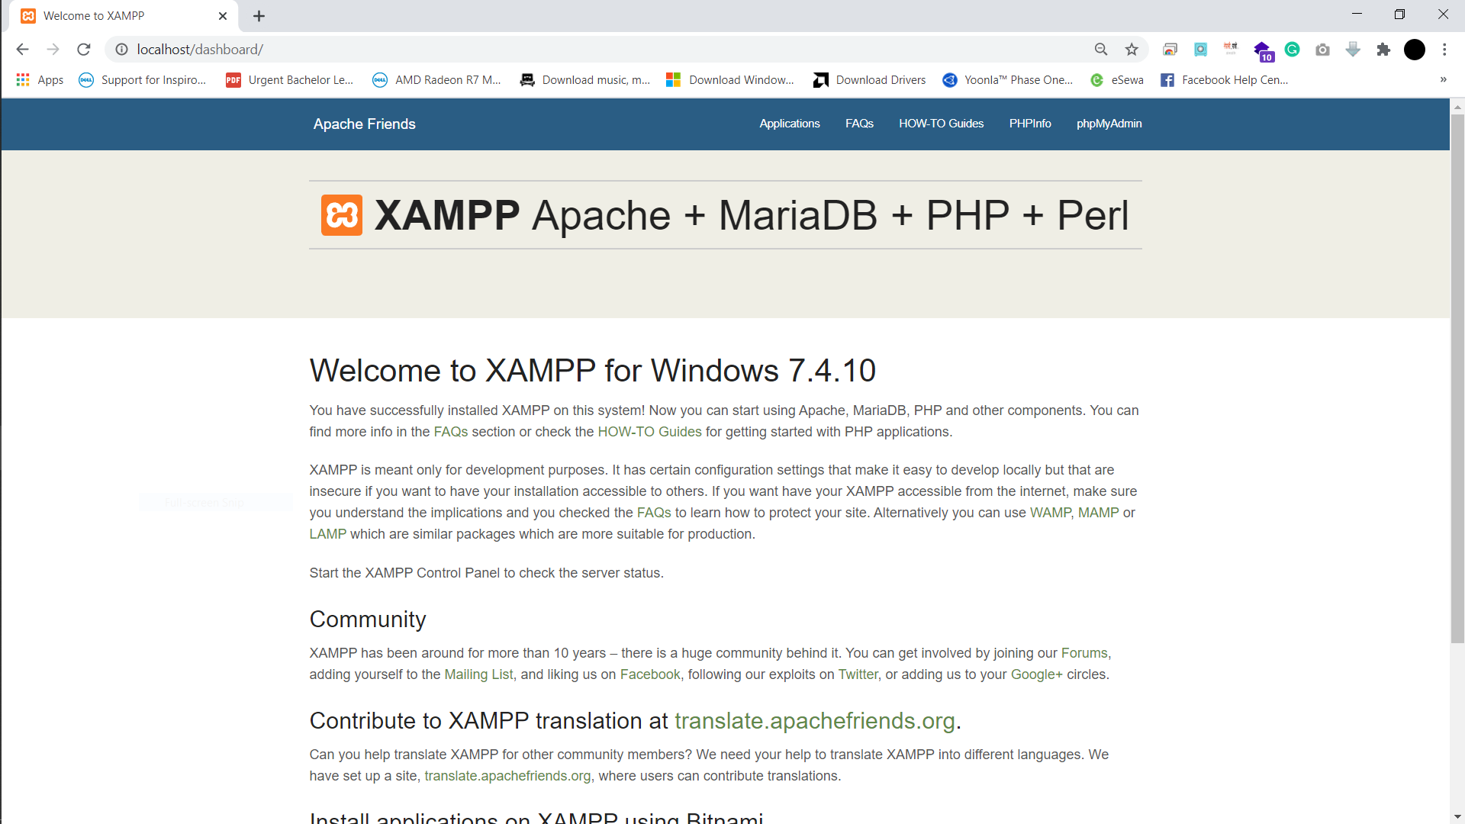

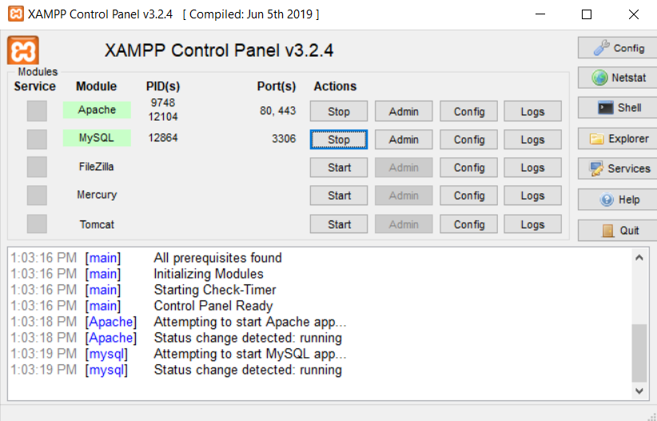

(3 marks)

PHP Version being used: ‘replace with version number’

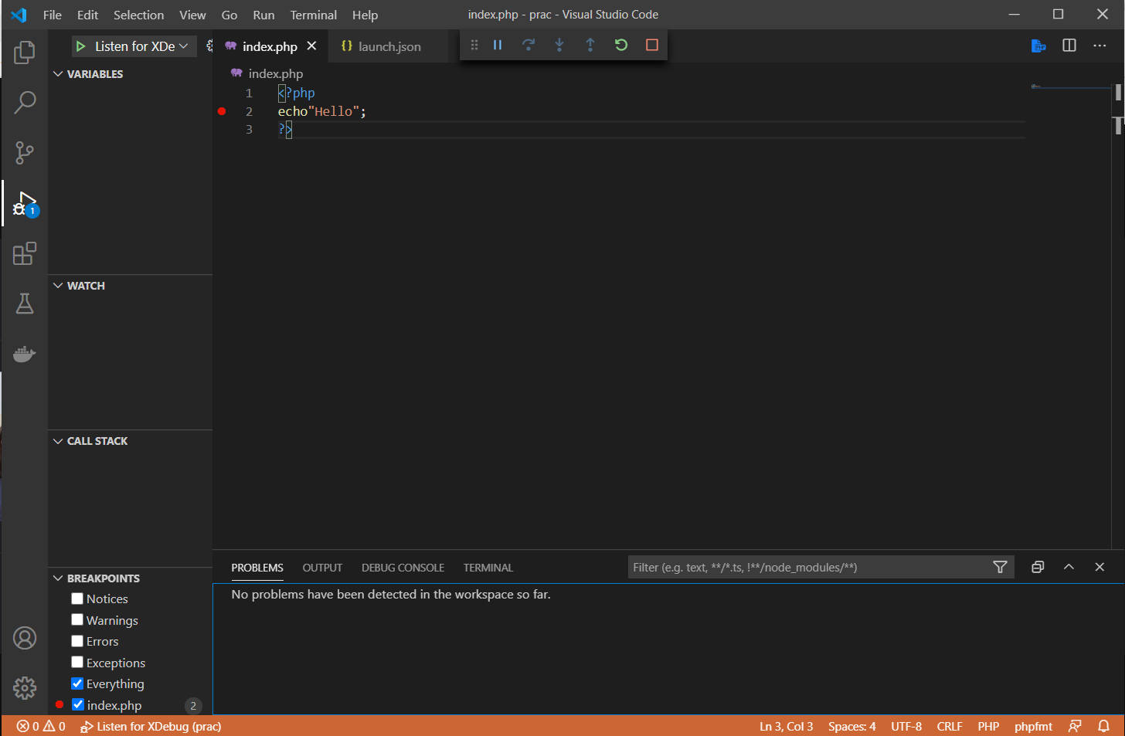

XDebug installed: Yes

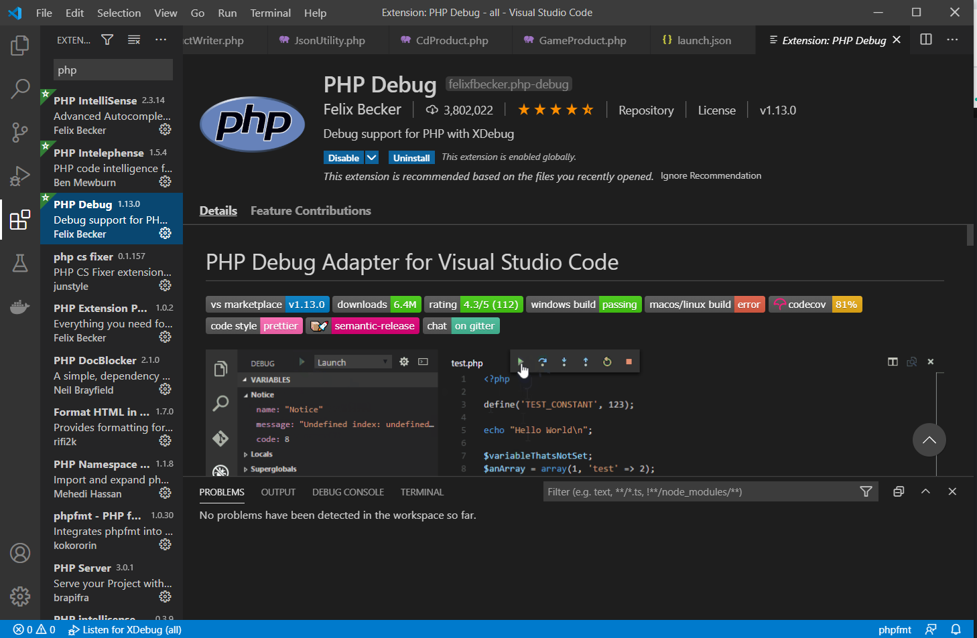

(add screenshot of output of php –v)
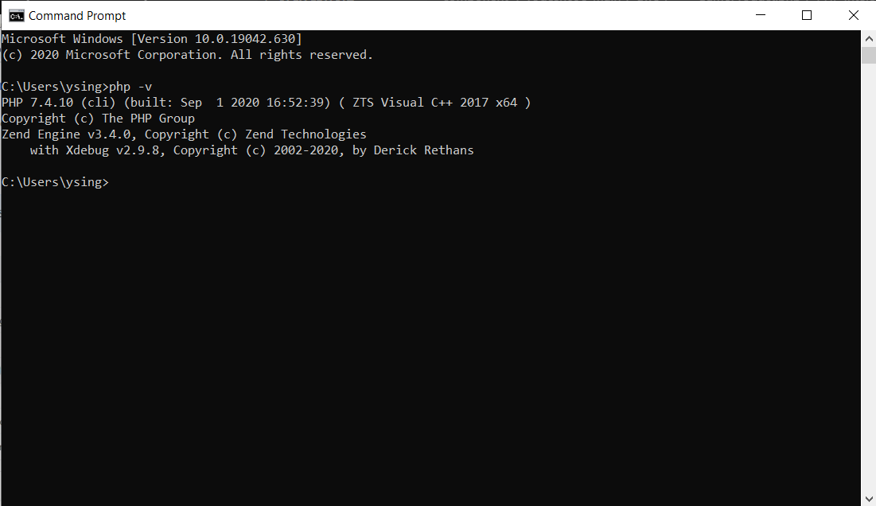

(2 marks)

Git account created and used: ‘replace with URL of GitHub repository’
(2 marks)
https://github.com/comp-bkt/component-1-yogesh098.git

Remaining marks are awarded for completion of the short PHP exercise
(3 marks)

