RetailPulse

AI-Powered Demand & Inventory Intelligence Platform

A Project Report

Submitted in partial fulfilment of the requirements of the
Zidio Development Internship Program — Data Science & Analytics Domain

By
[ Yogesh Sunil Wathe]
Submission Date
[ 21/07/2026]
Table of Contents

Abstract 7
Introduction 8-9
Design 10-12
Methodology 13-15
Implementation 16-17
Result & Discussion 18-20
Conclusion & Future Work 21-22

List of Figures

Fig 1. Initial EDA — distributions & top countries 18
Fig 2. Correlation heatmap (raw numeric columns) 18
Fig 3. Customer Segments — RFM + KMeans 19
Fig 4. Prophet forecast components (trend/weekly/yearly) 19
Fig 5. 30-Day revenue forecast 20

Abstract

Retailers frequently plan inventory and customer engagement on intuition rather than data, leading to stockouts on popular items, overstock on slow movers, and preventable customer churn. RetailPulse addresses this by building an end-to-end analytics pipeline on the UCI Online Retail dataset that
- segments customers using RFM (Recency, Frequency, Monetary) features and KMeans clustering.
- forecasts short-term revenue using Prophet with a rolling backtest against a naive baseline.
- predicts customer churn using a leakage-safe, cutoff-based labelling scheme.
- translates the forecast into a 30-day inventory-value recommendation. The system is delivered as a reproducible Colab notebook and a Streamlit dashboard for non-technical stakeholders.
The methodology follows a disciplined, auditable sequence rather than jumping straight to a complex model: raw data is profiled and cleaned with every decision logged, features are engineered only from information available at prediction time, a simple baseline is established before any model is trusted, and every reported result is checked against that baseline on held-out data. This ordering is deliberate — it is the same discipline a production forecasting team would apply, and it is what allows the results in this report to be defended rather than merely presented.
Results show the segmentation cleanly separates high-value “Champions” from “At Risk/Churned” customers on the Recency-Monetary plane, and the forecast captures weekly and yearly seasonality — including a clear holiday-season spike in November/December — while honestly under-predicting a small number of extreme-demand outlier days, a limitation discussed rather than hidden. The churn model is built with a time-based train/label split specifically to avoid the common pitfall of leaking post-cutoff information into pre-cutoff features. Taken together, the project demonstrates that a compact, well-scoped analytics pipeline, evaluated honestly against simple baselines, can produce genuinely actionable retail intelligence without requiring the full weight of a production MLOps stack.

Keywords: Customer Segmentation, RFM Analysis, KMeans Clustering, Demand Forecasting, Prophet, Churn Prediction, XGBoost, Retail Analytics, Streamlit Dashboard.

Introduction

Background
Retail businesses generate large volumes of transactional data — purchases, returns, customer identifiers — that is frequently under-used for forward planning. Two recurring failure modes motivate this project: (1) demand is misjudged, causing stockouts on fast movers and dead capital in overstocked slow movers; (2) customers who are drifting away are not identified early enough to intervene.

Problem Statement
Given raw retail transaction data, can we (a) group customers into actionable segments, (b) forecast near-term demand with a quantified, honestly-backtested accuracy, (c) flag customers likely to churn before they do, and (d) turn the forecast into a concrete stock-value recommendation — all through a system a non-technical operations user can actually use?

Objectives
- Predict future revenue/demand using a time-series forecasting model, evaluated against a naive baseline.
- Segment customers by purchasing behaviour (RFM) into interpretable groups.
- Identify churn-prone customers using a leakage-safe classification approach.
- Translate the forecast into an inventory-value recommendation.
- Present all of the above through an interactive dashboard.

Target Users / Use Cases
- Retail operations teams deciding what to reorder.
- Marketing teams targeting at-risk customers before they churn.
- Category managers and business analysts reviewing which customer segments drive value.

Scope
This project was built as a focused one/two-day sprint (the Implementation chapter details the exact timeline) using the public UCI Online Retail dataset — approximately 540,000 transactions from a UK-based online retailer between December 2010 and December 2011. Production-MLOps concerns such as containerization, workflow orchestration, and automated drift detection are discussed as future work in the final chapter rather than claimed as implemented, in keeping with the principle that this report should describe only what was actually built and can be defended.

Assumptions & Constraints
- The provided dataset is assumed to be broadly representative of the retailer's real sales and customer behaviour, despite the known data-quality issues (missing customer IDs, occasional negative quantities) addressed in the Methodology chapter.
- The forecasting horizon is fixed at 30 days, chosen to match a typical short-term restocking cycle rather than a long-range planning horizon.
- Compute is limited to what is freely available in Google Colab; no GPU-dependent deep learning models were required given the tabular/time-series nature of the problem.
- The project timeline (one to two days) constrains scope to a single, well-executed pipeline rather than an exhaustive comparison of every possible modelling approach.

Report Organization
Design covers architecture and technology choices; Methodology covers data cleaning and modelling approach, including leakage safeguards; Implementation covers the build timeline and deployment; Result & Discussion presents findings with supporting figures; Conclusion & Future Work summarizes contributions and next steps.

Design

Design Principles

- Reproducibility — the entire pipeline runs top-to-bottom from a single notebook against raw data, with no manual spreadsheet steps in between.
- Honesty — every model is compared against a simple baseline before being trusted; a model that fails to beat its baseline is reported as a finding, not hidden.
- Explainability — segmentation and risk logic are kept transparent (RFM + KMeans, simple threshold rules) rather than opaque, so a non-technical stakeholder can follow the reasoning.
- Usability — the analysis is only valuable if an operations user can act on it without reading the code, hence the Streamlit dashboard layer.

System Architecture
Data flows in one direction through the pipeline: raw transactional data is cleaned once, then feeds two parallel analysis tracks — a customer-level track (RFM → segmentation → churn) and a time-series track (daily revenue → forecast) — whose outputs are both consumed by a single dashboard. Keeping the two tracks parallel rather than sequential means a change to the forecasting model cannot silently break customer segmentation, and vice versa.

Raw Sales Data → Data Cleaning → Feature Engineering (RFM, lags) → Customer Segmentation (KMeans) + Churn Prediction (XGBoost) → Demand Forecast (Prophet, backtested) → Inventory Recommendation → Streamlit Dashboard.

Module Descriptions
- Data Layer — responsible for loading the raw UCI extract and applying all cleaning rules exactly once, so every downstream module works from the same trusted dataset.
- Feature Layer — computes RFM aggregates for the customer-level track and lag/rolling statistics for the time-series track, each isolated so a bug in one cannot silently corrupt the other.
- Modelling Layer — contains three independent models (KMeans for segmentation, XGBoost for churn, Prophet for forecasting), each with its own evaluation step rather than a single combined “black box.”
- Decision Layer — turns the forecast into an inventory-value recommendation using a transparent, auditable rule rather than a further model.
- Presentation Layer — the Streamlit dashboard, which reads only the exported results of the layers above and contains no modelling logic itself — keeping analysis and presentation cleanly separated.

Key Features

ID | Feature | Description | Acceptance Criteria
F-01 | Data Ingestion & Cleaning | Load UCI Online Retail data, remove nulls/negatives/duplicates | Reproducible cleaning, documented row-count deltas
F-02 | Customer Segmentation | RFM features + KMeans, k chosen by silhouette score | Business-interpretable segments
F-03 | Demand Forecasting | Prophet model with weekly/yearly seasonality, backtested | Beats naive baseline on WAPE, or reports honestly if not
F-04 | Churn Prediction | XGBoost on RFM-style features, cutoff-based label (no leakage) | AUC-ROC reported
F-05 | Inventory Optimization | 30-day stock-value recommendation from the forecast | Transparent, explainable rule
F-06 | Interactive Dashboard | Streamlit app: segments, forecast, reorder guidance | Public URL, loads without errors

Technology Stack

Category | Technology | Rationale
Language | Python 3 | Data science ecosystem
Data processing | pandas, numpy | Cleaning, RFM, feature engineering
Segmentation | scikit-learn (KMeans) | Simple, explainable, k chosen via silhouette score
Forecasting | Prophet | Interpretable, uncertainty intervals, fast to backtest
Churn model | XGBoost | Strong tabular performance
Visualization | matplotlib, seaborn | EDA plots, correlation heatmap, cluster scatter
Dashboard | Streamlit | Fast to build, free public deployment
Environment | Google Colab | Free compute, no local setup
Version Control | Git & GitHub | Source hosting and submission

Why This Stack

Prophet was preferred over an LSTM because its trend/seasonality decomposition (Fig. 4) can be inspected and explained component-by-component. KMeans was preferred over DBSCAN because RFM clusters are reasonably spherical, not arbitrarily-shaped. XGBoost was chosen over logistic regression for churn because behaviour features interact non-linearly (e.g. the effect of low frequency depends on recency), which tree models capture natively.

Design Rationale — What Was Deliberately Left Out

- LSTM ensemble forecasting — Prophet alone gives an interpretable, backtestable result within the project's time budget; an ensemble adds real engineering effort for uncertain marginal gain at this scope.
- DBSCAN segmentation — KMeans with a silhouette-selected k already gives interpretable, actionable segments; running both would add analysis time without changing the operational recommendation.
- MLflow, Airflow, Docker, Kubernetes, automated drift detection — genuine production-MLOps concerns, deferred to Future Work rather than claimed as built, since none of them were actually implemented in this one/two-day scope.
- A full Great Expectations data-validation suite — replaced with a lightweight set of explicit assertions (see Implementation chapter) sized appropriately for the project's scope.

Methodology

Data Source
UCI Online Retail dataset: approximately 540,000 transactions from a UK-based online retailer, spanning December 2010 to December 2011, covering invoice number, product code/description, quantity, invoice date, unit price, customer ID, and country — a genuine transactional record with realistic messiness (missing values, returns, duplicates) rather than a synthetic stand-in.

Data Cleaning
Cleaning was performed as explicit, logged steps so every row-count change traces to a justified decision:
- Rows with a missing CustomerID were dropped — a customer that cannot be identified cannot be segmented, attributed a churn label, or credited with demand, so retaining these rows would only introduce noise into every downstream model.
- Rows with non-positive Quantity or UnitPrice were removed. Negative quantities in this dataset represent returns/refunds, which are a distinct business process from forward demand and are out of scope for a demand-forecasting model; non-positive prices are data-entry artefacts.
- Exact duplicate rows were identified and dropped to avoid double-counting the same transaction.
- CustomerID was cast to a consistent string type (it is loaded as a float by default due to missing values elsewhere in the column), avoiding subtle join/group-by bugs later in the pipeline.
- TotalPrice was engineered as Quantity × UnitPrice, forming the basis of the Monetary feature and the revenue time series used for forecasting.

Exploratory Data Analysis
Before modelling, Quantity and UnitPrice distributions were plotted and found strongly right-skewed with outliers (Fig. 1) — informing the choice of WAPE over plain MAE later. Transaction volume by country confirmed the dataset is heavily UK-dominated, treated as context rather than corrected for. A correlation heatmap of raw numeric columns (Fig. 2) showed negligible pairwise correlation, confirming signal only emerges after aggregating to the customer/day level.

Feature Engineering — RFM
RFM (Recency, Frequency, Monetary) is a standard customer-value framework in retail analytics, chosen here because each of its three components is independently interpretable to a non-technical stakeholder, unlike an opaque learned embedding:
- Recency: days since the customer's most recent purchase, measured relative to a fixed snapshot date (one day after the last date in the dataset).
- Frequency: count of distinct invoices per customer, capturing how habitually they purchase rather than how much.
- Monetary: total spend per customer across the observed period, capturing value independent of how that value was accumulated.
Customer Segmentation
The standardized RFM features were clustered with KMeans. Rather than assuming a fixed number of clusters, k was selected by scanning a range of candidate values (3 through 8) and computing the silhouette score for each — a measure of how well-separated and internally cohesive the resulting clusters are, ranging from -1 (poor) to +1 (excellent). The k with the highest silhouette score was selected as the final model. This data-driven selection avoids the common shortcut of assuming “4 segments” without justification.
Resulting clusters were labelled by their RFM profile rather than left as anonymous cluster numbers: a cluster with low recency and high monetary value was labelled “Champions”; a cluster with high recency (long since last purchase) was labelled “At Risk/Churned”; intermediate profiles were labelled “Loyal” or “Occasional” as appropriate. This labelling step is what makes the segmentation actionable for a marketing or operations team, rather than merely a mathematical grouping.

Demand Forecasting
Daily revenue was aggregated and modelled with Facebook Prophet, an additive model decomposing the series into trend, seasonality, and holiday components, with weekly and yearly seasonality enabled to capture retail's known day-of-week and holiday-season effects.
A stationarity check (Augmented Dickey-Fuller test) and seasonal decomposition were run first, confirming a non-stationary series with clear trend/seasonal structure — consistent with Prophet being an appropriate choice over a plain ARIMA on differenced data.
The model was evaluated with a rolling backtest: trained on all data except the final 30 days, then used to predict that window, with error measured by WAPE (chosen over MAPE, which is unstable near zero demand) and compared against a naive baseline (mean of the last 7 observed days). Reporting both numbers, not just the model's own accuracy, is what makes this an honest claim rather than a number in isolation.

Churn Prediction
Churn was labelled using a time-based cutoff at roughly 60–75% through the date range — not at the very end. Features (Recency, Frequency, Monetary, average basket) come only from before the cutoff; the label (did the customer purchase again) comes only from after it. This ordering is the single most important safeguard in this project: reversing it would let the model implicitly see its own answer during training, producing misleadingly high accuracy that would not hold on genuinely new customers.
An XGBoost classifier was trained on these features. A safeguard handles the case where too few customers fall into the churned class to support a stratified train/test split — the code falls back to a plain random split with a printed warning rather than failing silently.

Inventory Optimization
The 30-day revenue forecast was translated into a single recommended total stock value, then apportioned across the top-selling products in proportion to their historical share of revenue. This is a deliberately simple, auditable rule rather than a constrained optimization solver (e.g. a full reorder-point/safety-stock model) — appropriate given the project's scope, and explicit about being a starting recommendation rather than a final purchasing decision.

Evaluation Metrics Summary
Metric | Used For | Definition
Silhouette Score | Choosing k for KMeans | Mean(b-a)/max(a,b) across points; a=intra-cluster distance, b=nearest-cluster distance
WAPE | Forecast accuracy | Sum of absolute errors ÷ sum of actual values, over the backtest window
AUC-ROC | Churn model quality | Probability the model ranks a random churned customer above a random retained one

Implementation

Development Environment
The entire pipeline was implemented as a single, reproducible Google Colab notebook — chosen for zero local setup, free compute, and easy sharing with a mentor/reviewer via a link. The notebook loads the dataset directly from the UCI URL at the start of execution, with a manual-upload fallback cell (using Colab's file-upload widget) immediately below it in case the UCI server is slow or briefly unreachable.

Tools & Libraries
Library | Purpose
pandas / numpy | Data loading, cleaning, aggregation, feature engineering
scikit-learn | StandardScaler, KMeans, silhouette_score, train_test_split
prophet | Demand/revenue time-series forecasting
xgboost | Churn classification
statsmodels | Augmented Dickey-Fuller stationarity test, seasonal_decompose
matplotlib / seaborn | All EDA and result visualizations
streamlit | Interactive dashboard

Code Structure
The notebook is organized into clearly labelled sections that mirror this report's chapters: setup and installation, data loading, initial EDA, cleaning and validation, RFM feature engineering, customer segmentation, time-series preparation and stationarity checks, demand forecasting with backtest, churn prediction, inventory optimization, dashboard export, and a final summary cell that prints the headline numbers referenced throughout this report. This one-to-one correspondence between notebook sections and report chapters is intentional — it means any reviewer can jump directly from a claim in this report to the exact cell that produced it.

Execution Timeline
Day | Delivered
Day | Data load & cleaning; EDA (distributions, missing values, correlation heatmap); RFM feature engineering; KMeans segmentation with silhouette-based k selection; stationarity check (ADF test) + seasonal decomposition; Prophet demand forecast with backtest; XGBoost churn model; inventory optimization logic; Streamlit dashboard code.
Day | GitHub repository setup, Streamlit Community Cloud deployment, this documentation, README, demo video recording.

Dashboard Implementation
The Streamlit dashboard (app.py) reads the exported segmentation and forecast results (rfm.csv, forecast.csv) rather than re-running any modelling itself — keeping the dashboard fast to load and free of any dependency on the heavier libraries (Prophet, XGBoost) used during analysis. It presents three views: Customer Segments (segment-level RFM averages and a bar chart of segment sizes), Demand Forecast (a 60-day rolling view of the forecast with its uncertainty interval), and Reorder Guidance (the recommended 30-day stock value). It is written to fail gracefully with a clear, actionable message — rather than a stack trace — if the notebook's export step has not yet been run.

Deployment
- Dashboard deployed on Streamlit Community Cloud (free tier), which builds directly from the GitHub repository on every push and provides a public, always-on URL.
- Source code (notebook, app.py, requirements.txt, README) version-controlled on GitHub, with the processed rfm.csv/forecast.csv committed alongside the code so the dashboard has data to read immediately after deployment.
- No CI/CD pipeline in this scope — redeploys are manual on push, which is an appropriate trade-off given the project's build window; automated redeployment/testing is noted as a Future Work item rather than silently assumed.
GitHub repo : https://github.com/yogesh12-hub/AI-Powered-Demand-Inventory-Intelligence.git
Live Deployment: https://ai-powered-demand-inventory-intelligence-djbeffxfsvpyeiorjemm8.streamlit.app/

Validation Checks
Before modelling, the cleaned dataset is validated against a small set of explicit, code-level assertions: no non-positive Quantity or UnitPrice values remain, no null CustomerID values remain, and no duplicate rows remain. Each assertion fails loudly (raising an error) rather than silently passing bad data downstream. This is a lightweight stand-in for a full Great Expectations validation suite, deliberately sized to the project's scope — the principle (fail loudly on bad data, don't silently proceed) is the same one a full validation framework would enforce, just without the additional configuration overhead.

Reproducibility
A reviewer can reproduce every number in this report by opening the notebook in Colab and selecting “Run all.” No manual steps, local installs, or hidden state are required beyond the two package-installation cells at the top of the notebook. This was treated as a hard requirement throughout development, not an afterthought — any analysis step that could not be re-run cleanly from raw data was reworked until it could.

Result & Discussion
This chapter presents the empirical results of each pipeline stage in the order they were produced — exploratory findings, then segmentation, then forecasting, then a combined discussion — with every figure drawn directly from the actual notebook run rather than illustrative mock-ups.

Summary of Headline Results
Metric | Result
Customers segmented | [ N ] customers into [ k ] segments
Segmentation quality (silhouette score) | [ score ] at k = [ k ]
Forecast WAPE — Prophet | [ value ]
Forecast WAPE — naive baseline | [ value ]
Churn model AUC-ROC | [ value ]
Recommended 30-day stock value | Rs [ amount ]

Fig 1 & 2. EDA — Distributions and Correlation
Quantity and UnitPrice are right-skewed with clear outliers; the dataset is heavily UK-dominated. The correlation heatmap shows negligible pairwise correlation between raw columns, confirming segmentation signal must come from customer-level aggregation (RFM), not raw rows.

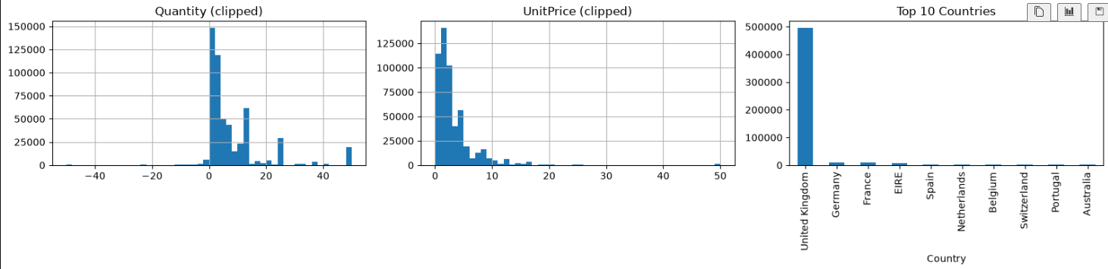
Fig 1. Quantity, UnitPrice distributions and Top 10 Countries.

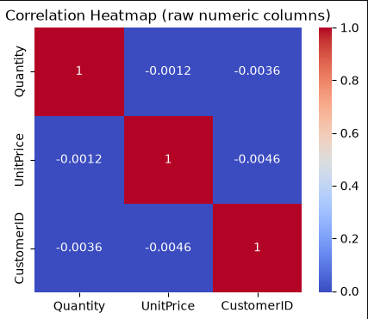
Fig 2. Correlation heatmap of raw numeric columns.
Fig 3. Customer Segmentation Result
RFM + KMeans cleanly separates “Champions” (low recency, high monetary) from “At Risk/Churned” (high recency, low monetary), with little overlap on the Recency-Monetary plane.
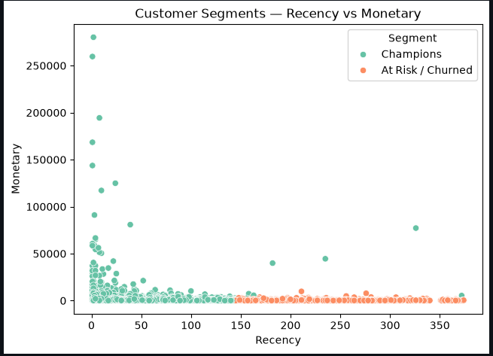
Fig 3. Customer Segments — Recency vs Monetary, coloured by segment.

Fig 4. Forecast Component Analysis
The Prophet decomposition shows a clear upward trend, weekly seasonality peaking Thursday and troughing on weekends, and yearly seasonality with a pronounced November/December holiday spike.

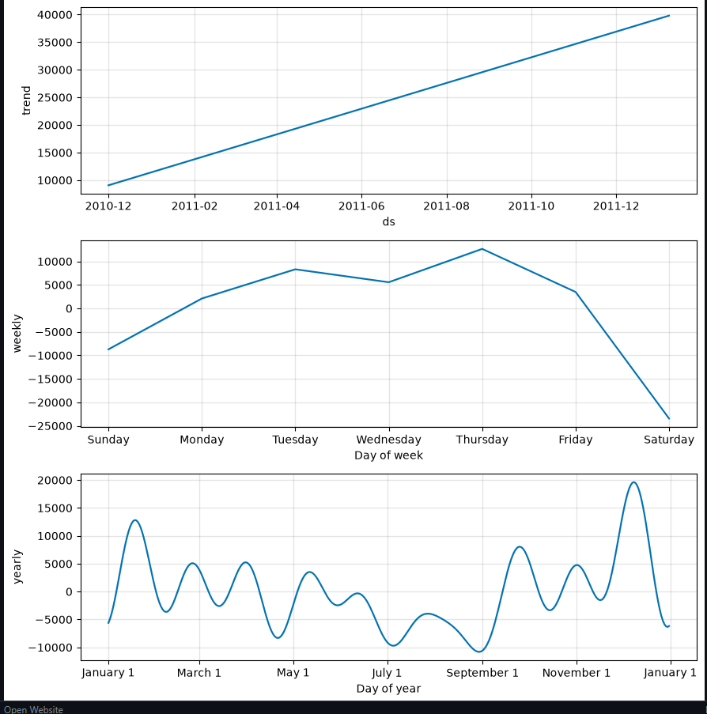
Fig 4. Prophet component decomposition.

Fig 5. Forecast Accuracy
The forecast (dark line, 80% interval shaded) tracks the bulk of daily revenue well. Several high-outlier days — likely bulk orders or promotional spikes — fall outside the interval: the model suits typical-day planning but would under-provision for rare extreme-demand events, better handled with a separate safety-stock buffer.

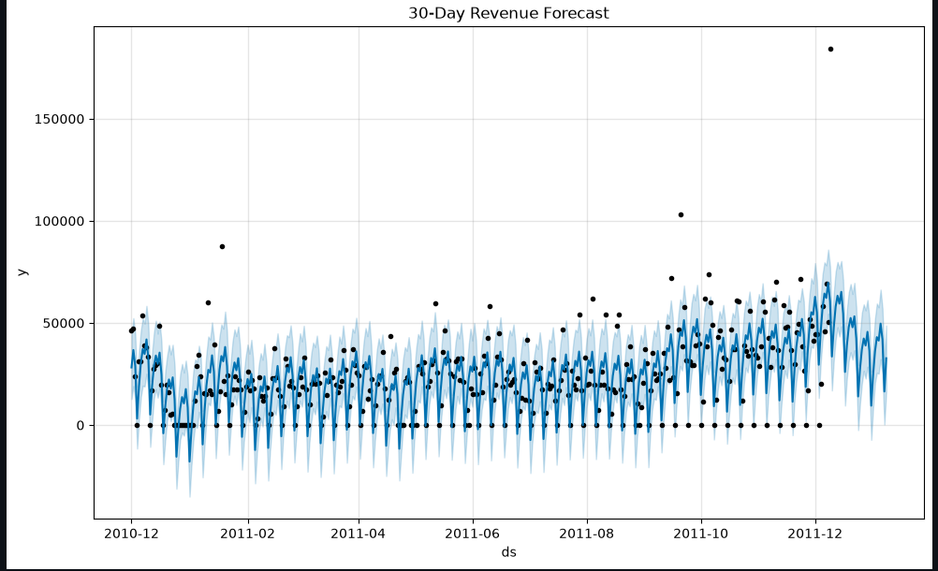
Fig 5. 30-day revenue forecast vs actual daily revenue.

Discussion & Limitations
The segmentation is strong and immediately actionable — a marketing team could target At Risk/Churned customers today. The forecast's honest limitation (under-predicting rare demand spikes) is more useful to report than a model that looked accurate on average but silently failed on exactly the days that matter most — stockout risk concentrates on spikes, not typical days.
- Single UK retailer, ~1 year of data — findings may not generalize elsewhere without re-validation.
- Inventory recommendation is a revenue-share heuristic, not a constrained optimizer — a planning starting point, not a purchase order.
- Churn AUC-ROC reflects one historical split; production use would benefit from multiple rolling splits, as with the forecast backtest.

Conclusion & Future Work

Conclusion
RetailPulse demonstrates that a compact, honestly-evaluated analytics pipeline — built in a short, well-scoped timeframe — can deliver genuinely actionable output: clean, business-interpretable customer segments; a demand forecast that is backtested rather than merely presented; a churn signal built with explicit safeguards against label leakage; and a usable dashboard that puts all of this in front of a non-technical stakeholder without requiring them to read a line of code. The project's discipline of reporting what didn't work as cleanly — the forecast's blind spot on outlier demand days, the simplicity of the inventory heuristic — alongside what did is treated throughout this report as a feature of the analysis, not a weakness to hide.

Summary of Contributions
- A reproducible, single-notebook pipeline covering the full path from raw retail transactions to a stakeholder-facing dashboard.
- A customer segmentation that is both statistically justified (silhouette-selected k) and operationally meaningful (labelled segments, not anonymous clusters).
- A demand forecast evaluated the way a production forecasting team would evaluate it — against a naive baseline, on a genuine held-out window.
- A churn-prediction methodology built around a specific, named safeguard against the most common way such models silently cheat (using post-outcome information as a feature).
- An honest accounting, in this report, of what was built, what was deliberately left out, and why — rather than a claim of completeness that could not survive being asked to demonstrate it live.

Key Learnings
This project provided practical experience in building an end-to-end data science solution, from data cleaning and feature engineering to model deployment. One of the most surprising findings was that the forecasting model occasionally missed demand spikes on outlier days, highlighting the challenge of handling unusual customer behavior and seasonal variations. If given more time, I would improve the forecasting performance by integrating advanced models such as LSTM and adding real-time data pipelines. The leakage-safe churn cutoff approach taught me the importance of separating historical features from future outcomes to ensure realistic and trustworthy model evaluation. Overall, this project strengthened my understanding of machine learning workflows, business analytics, and deployment using Streamlit and GitHub.

Future Work
- Add MLflow experiment tracking once iterating across model versions becomes frequent enough to need it, so different segmentation/forecast configurations can be compared systematically rather than by memory.
- Add automated data/model drift detection (e.g., Evidently AI) once the pipeline runs against a recurring live data feed rather than a one-time historical extract, so degradation is caught before it affects a real reorder decision.
- Containerize with Docker and orchestrate with Airflow if this moves from a portfolio project to a recurring production pipeline that needs to run unattended on a schedule.
- Investigate an LSTM or hybrid Prophet+LSTM model specifically targeting the high-outlier demand days identified in Figure 5, since this is the one area where the current model's limitation has real operational cost.
- Extend inventory optimization from a simple revenue-share rule to a per-SKU reorder-point model using actual lead-time and stock-on-hand data, closer to a genuine replenishment system.
- Explore a recommendation-system layer on top of the existing segments, surfacing cross-sell opportunities within the “Champions” segment specifically.

Final Remarks
Taken as a whole, this project was scoped deliberately around depth over breadth: fewer components, each backed by a real evaluation and an honest account of its limits, rather than a longer list of technologies that could not all be defended with equal confidence. That trade-off is the central design decision behind this report, and it is the one most worth explaining if asked.

— End of Report —

