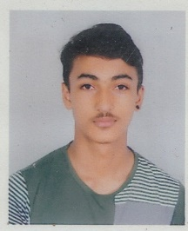Name: yogesh bhattarai

Age: 17

Gender: Male

Temporary address: kumaripati, lalitpur

Permanent address: Ilam

Father’s name: Govinda bhattarai

Mother’s name: Jiwan bhattarai

Phone number: 9804924462

Email address: [yogeshbhattarai073@gmail.com](mailto:yogeshbhattarai073@gmail.com)

Educational qualifications

|  |  |  |  |
| --- | --- | --- | --- |
| Level | Institution | Grade | Remarks |
| S.L.C | Prajna sadan | A | pass |
| Plus 2 | United academy | B+ | pass |
| Bachelors | Virinchi college | Currently studying |  |

Skills

* Microsoft office package
* Fluent English speaking and writing
* Data entry