MiniProject -1

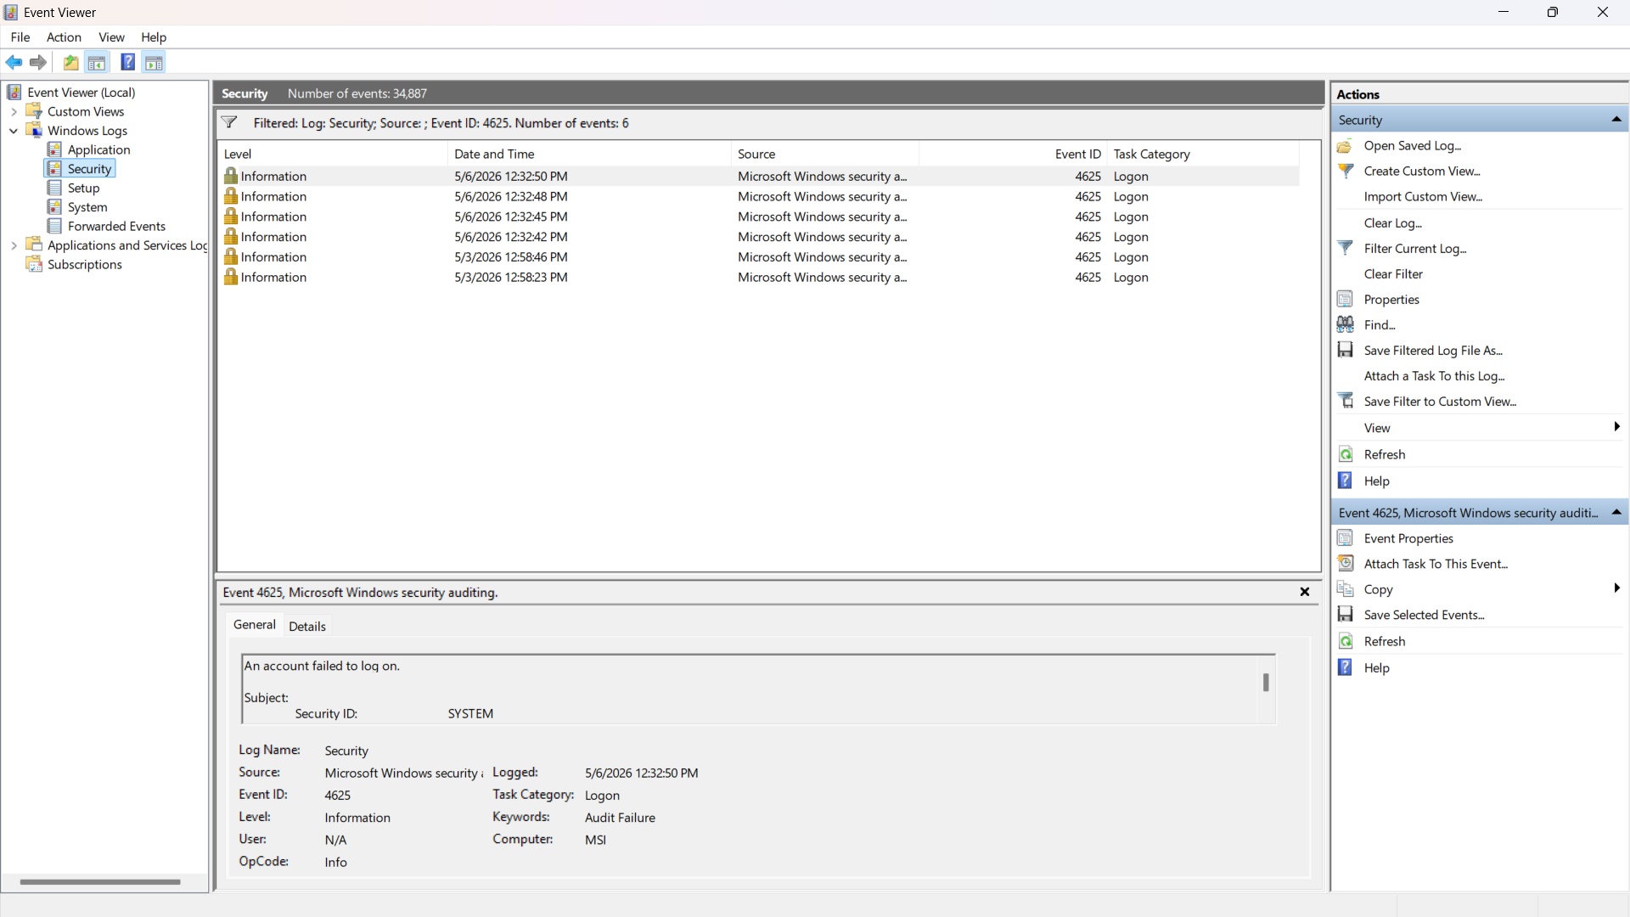

SOC Alert Simulation Report

1. Incident Overview

During monitoring of system security logs, multiple failed login attempts were detected on a Windows machine, indicating a potential unauthorized access attempt.

2. Objective

To simulate and detect suspicious login activity by analyzing security events and understanding how SOC alerts are generated.

3. Methodology

A controlled simulation was performed by generating multiple failed login attempts on a Windows system. The logs were monitored and analyzed using Windows Event Viewer under Security logs.

4. Observations

* A total of **6 failed login attempts** were recorded.
* All events correspond to **Event ID 4625 (Failed Login)**.
* The events are marked as **Audit Failure**.
* Multiple attempts occurred within a short time interval.

5. Identified Issue

The repeated failed login attempts indicate a **brute force attack pattern**, where multiple incorrect passwords are used to try to gain access to the system.

6. Affected System

* System Type: Windows Machine
* Computer Name: MSI
* Log Source: Windows Security Logs

7. Evidence

* Event ID: 4625 (Audit Failure)
* Number of Attempts: 6
* Log Message: “An account failed to log on”
* Source: Microsoft Windows Security Auditing
* Timestamp: Multiple entries within a short duration

8. Impact Analysis

* Risk of unauthorized access
* Potential account compromise if attack succeeds
* Indicates vulnerability to password-based attacks

9. Response Strategy

* Temporarily lock the affected account
* Enforce strong password policies
* Enable Multi-Factor Authentication (MFA)
* Monitor login activity continuously
* Investigate repeated failed login attempts

10. Conclusion

The analysis confirms a simulated **brute force attack scenario** based on repeated failed login attempts (Event ID 4625). This demonstrates how SOC analysts detect and respond to suspicious authentication activity in real-world environments.

MiniProject – 2

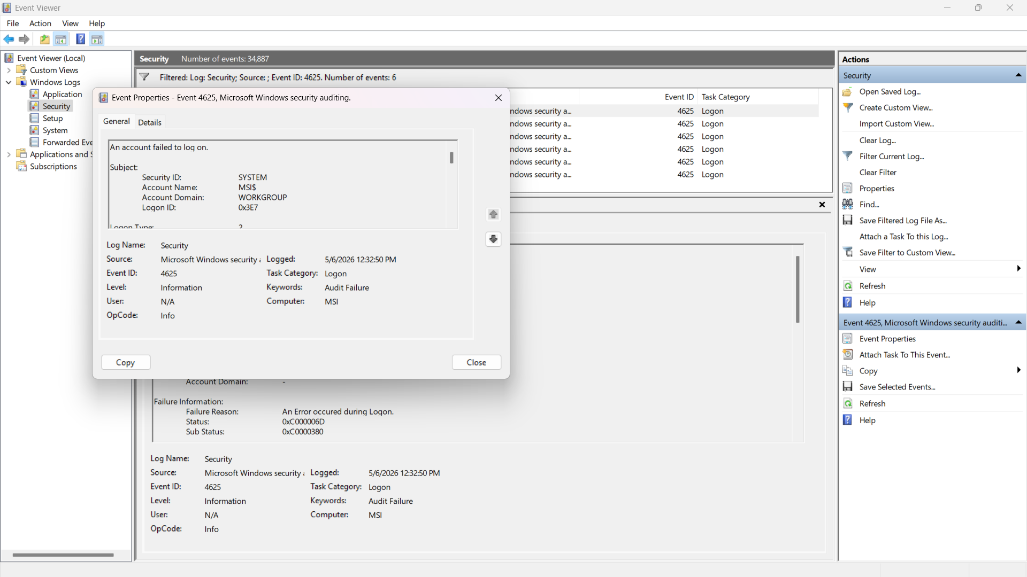

SOC Alert Simulation Report
1. Incident Overview
During continuous monitoring of system security logs, multiple failed login attempts were identified on a Windows system. These repeated failures suggest a potential unauthorized access attempt targeting the system.

2. Objective
To simulate suspicious login activity and analyze Windows Security Logs in order to understand how Security Operations Center (SOC) alerts are triggered and investigated.

3. Methodology
A controlled simulation was conducted by intentionally generating multiple failed login attempts on a Windows machine. The generated logs were monitored using Windows Event Viewer, specifically under:
Event Viewer → Windows Logs → Security
Relevant events were filtered and analyzed for suspicious patterns.

4. Observations
- A total of 6 failed login attempts were detected
- All events correspond to Event ID: 4625 (Failed Logon)
- Events are categorized under Audit Failure
- Login attempts occurred within a short time span
- The system account involved: SYSTEM / MSIS
- Status Codes observed:
  - 0xC000006D (Bad credentials)
  - 0xC0000380 (Authentication failure detail)

5. Identified Issue
The repeated failed login attempts indicate a Brute Force Attack Pattern, where an attacker tries multiple password combinations to gain unauthorized access.

6. Affected System
- System Type: Windows Machine
- Computer Name: MSI
- Log Source: Microsoft Windows Security Logs
- Event Viewer Path: Security Logs

7. Evidence
- Event ID: 4625
- Event Type: Audit Failure
- Number of Attempts: 6
- Log Message: “An account failed to log on”
- Source: Microsoft Windows Security Auditing
- Timestamp: Multiple entries within a short interval

8. Impact Analysis
- Increased risk of unauthorized system access
- Possibility of account compromise if attack succeeds
- Exposure to password-based attacks (Brute Force)
- Indicates weak authentication or lack of protection mechanisms

9. Response Strategy
To mitigate such threats, the following actions are recommended:
- Enable Account Lockout Policy after multiple failed attempts
- Enforce Strong Password Policies
- Implement Multi-Factor Authentication (MFA)
- Monitor logs using SIEM tools for real-time alerts
- Block suspicious IP addresses (if applicable)
- Conduct regular security audits and log analysis

10. Conclusion
The simulation successfully demonstrates a brute force attack scenario, identified through multiple failed login attempts (Event ID 4625). This highlights how SOC analysts detect suspicious authentication behavior and respond proactively to prevent security breaches.

