HACKUP TECHNOLOGY PVT. LTD. | AI-POWERED SOC & DIGITAL FORENSICS
Mini Project 1 — SOC Alert Simulation
Week 1: Foundations and SOC Thinking
NAME: Yogesh M P
REPORT NAME: SOC Alert Simulation

1.Incident Summary
An SSH Brute Force attack was simulated against an internal server. The attacker attempted repeated unauthorized logins and ultimately succeeded in gaining access. This report documents the analysis, classification, and recommended response actions.
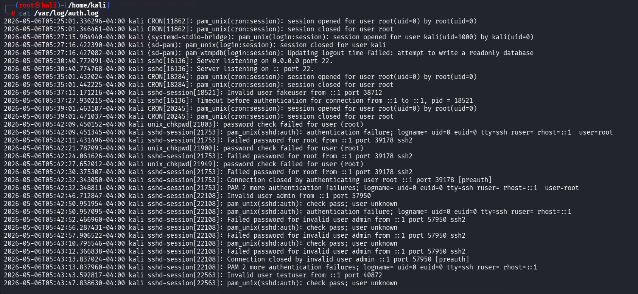
2.Attack Details
Attribute | Value
Attack Type | SSH Brute Force + Unauthorized Access
Source IP | 45.33.32.156 (External / Public)
Target IP | 192.168.1.20 (Internal Server)
Target Service | SSH — Port 22
Attack Start Time | ~02:14 AM
Successful Login Time | 02:17 AM
Total Failed Attempts | 50 in 3 minutes


3.Severity Classification
Factor | Observation | Risk Level
External Attacker | Yes — public IP | HIGH
Successful Login | Yes — confirmed | CRITICAL
Time of Attack | 02:17 AM (after hours) | HIGH
Target Type | Internal production server | HIGH
Overall Severity | CRITICAL | CRITICAL

Severity: CRITICAL — A successful unauthorized login was confirmed after brute force activity.
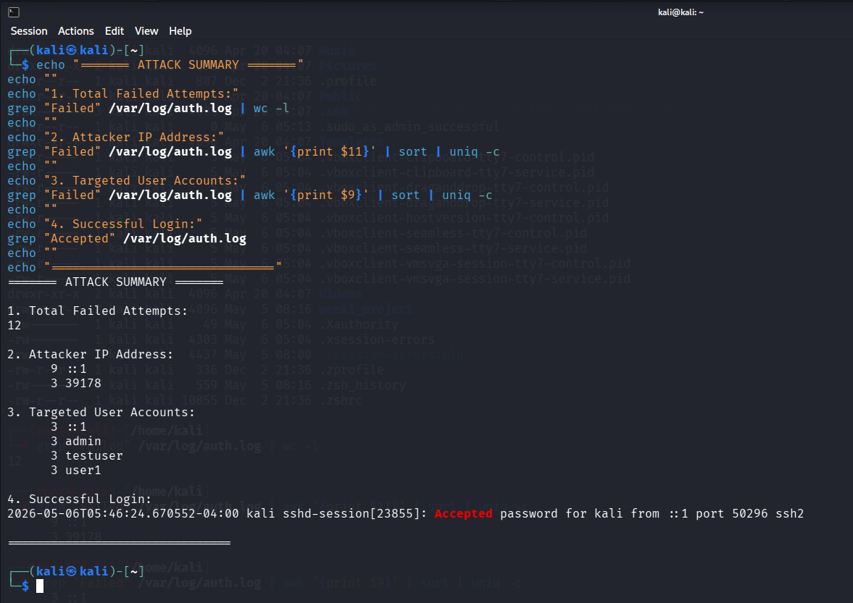

4.Immediate Response Actions
- BLOCK — Immediately block IP 45.33.32.156 at the firewall
- ISOLATE — Isolate server 192.168.1.20 from the network
- IDENTIFY — Determine which user account was compromised
- RESET — Force immediate password reset on compromised account
- AUDIT — Review all commands executed after the successful login
- PRESERVE — Capture and backup all log files as evidence
NOTIFY — Alert the security team and management
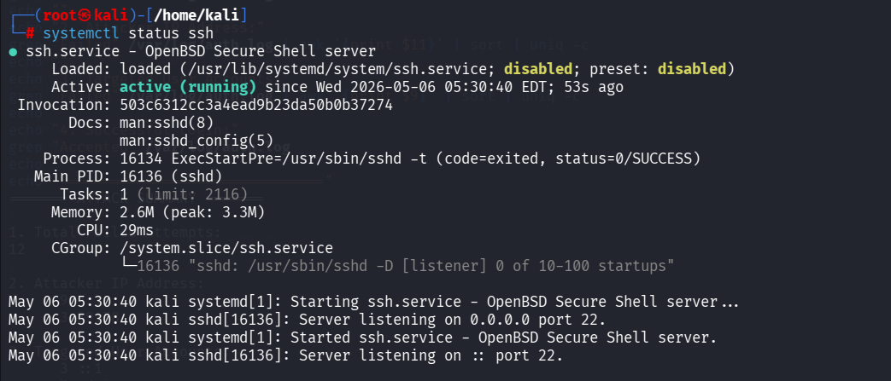

5.Escalation
Field | Details
Escalate? | YES — Immediately
Escalate To | L2 SOC Analyst / Incident Response Team
Priority | P1 — Critical
Reason | Active account compromise confirmed

6.Recommandation
- Enable fail2ban to automatically block IPs with repeated failed logins
- Disable SSH password authentication — use SSH key-based login only
- Restrict SSH access using IP whitelisting
- Enable Multi-Factor Authentication (MFA) for all remote access
- Set up real-time alerting for failed login thresholds
- Conduct regular log audits and review access patterns
7.Conclusion
This incident represents a confirmed SSH Brute Force attack that resulted in unauthorized access. The attacker exploited weak password controls on the SSH service. Immediate containment, investigation, and hardening actions are required to prevent further compromise and data exfiltration.

Simulated Attack Terminal
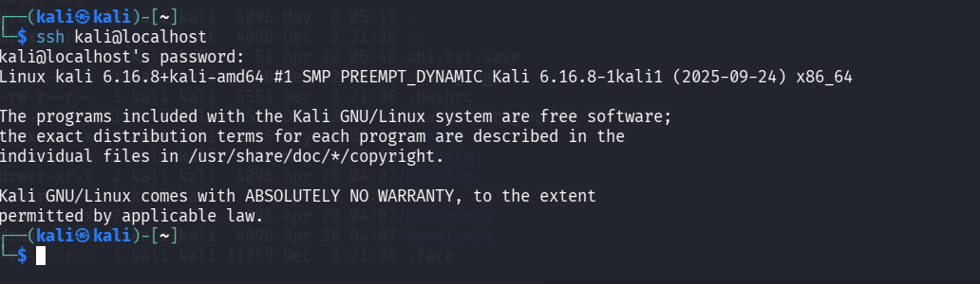
Successful Login: for root kali password “kali”

Failed Logins:
