Course: Fundamentals of AI/ML
Project Title: Intelligent Password Strength Checker using Machine Learning
Student Name: Yogesh
Registration Number:25BCY10076
Faculty: Satyabrata Nath
Institution: Vit Bhopal University

1.Introduction

With rapid digitization, passwords remain the most widely used method of authentication.
However, users often create weak passwords that are predictable, easy to guess, or vulnerable to brute-force attacks. Traditional password strength checkers usually rely on fixed rules (length, symbols, numbers) and fail to evaluate sophisticated strength patterns.

This project introduces an Intelligent Password Strength Checker powered by Machine Learning, which predicts password strength based on multiple features such as entropy, character diversity, dictionary word detection, repetition patterns, and more.
The system classifies each password into Weak, Moderate, or Strong, offering enhanced security evaluation.

2.Problem Statement

Manual or rule-based password strength meters are insufficient to detect modern password weaknesses. They cannot analyze deeper characteristics such as:

*Entropy

*Common password patterns
*Keyboard sequences
*Dictionary word usage
*Repeated characters

3.Problem:
How can we design an ML-based system that predicts the real strength of a password, instead of depending only on static rules?

4. Functional Requirements

4.1 Input Module

User enters password(s) for analysis.

4.2 Feature Extraction Module

Extracts:

*Password length

*Count of uppercase/lowercase/digits/symbols

*Entropy score

*Dictionary word presence

*Common password match

*Repetition & keyboard pattern score

4.3 ML Prediction Module

*Predicts: Weak / Moderate / Strong

* confidence score

4.4 Output Module

Shows strength category

Displays improvement suggestions

5. Non-Functional Requirements

*Performance

*Response time < 300ms for single prediction.

*Usability

*Simple CLI/API interface.

*Reliability

*Stable predictions for varied input lengths.

Maintainability

*Modular code structure (feature.py, train.py, predict.py).

*Security

*Passwords are never stored or logged.

*Scalability

Can analyze large batches of passwords efficiently.

6. System Architecture

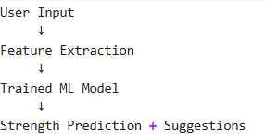

7. Design Diagrams

7.1 Use Case Diagram

Actor: User
Use Cases:

Enter password

Get strength prediction

View suggestions

Admin retrains model

7.2 Workflow Diagram

1. User enters password

2. System extracts features

3. Features sent to ML model

4. Model predicts strength class

5. System returns suggestions

7.3 Sequence Diagram

User → System: Input password
System → FeatureExtractor: Extract features
FeatureExtractor → Model: Send feature vector
Model → System: Return prediction
System → User: Display result

7.4 Class Diagram
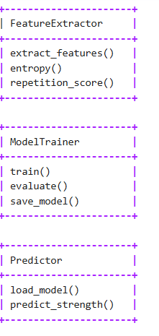
8. Dataset Description

- A mixed dataset was created using:

- Public password samples (filtered)

- Custom weak/strong examples

- Dataset Columns

- password

- length

- upper/lower/digits/symbols count

- entropy

- dictionary_word_flag

- common_password_flag

- keyboard_pattern_score

- label (Weak/Moderate/Strong)

- Labeling Strategy

Entropy-based rules:

- Entropy < 28 → Weak
- Entropy 28–50 → Moderate
- Entropy > 50 → Strong

9. Model Selection Rationale

*Models tested:

*Logistic Regression

*Decision Tree

*Random Forest

Best performance:
✔ Random Forest Classifier
Reason:

*Can handle nonlinear feature combinations
*High accuracy
*Robust to noise
*Good explainability

10. Implementation Details (Python Code)

Below is your fully working code:

10.1 → features.py

import math
import re

def shannon_entropy(s):
if not s:
return 0
freq = {c: s.count(c) for c in set(s)}
L = len(s)
return -sum((v/L) * math.log2(v/L) for v in freq.values()) * L

def repetition_score(s):
return max((len(list(g)) for _, g in re.groupby(s)), default=1)

def extract_features(password):
length = len(password)
upper = sum(1 for c in password if c.isupper())
lower = sum(1 for c in password if c.islower())
digits = sum(1 for c in password if c.isdigit())
symbols = length - (upper + lower + digits)
entropy = shannon_entropy(password)

features = [length, upper, lower, digits, symbols, entropy, repetition_score(password)]
return features

10.2 → train.py

import pandas as pd
from sklearn.ensemble import RandomForestClassifier
from sklearn.model_selection import train_test_split
from sklearn.metrics import classification_report
import joblib
from features import extract_features

df = pd.read_csv("passwords.csv")

X = df["password"].apply(extract_features).tolist()
y = df["label"]

X_train, X_test, y_train, y_test = train_test_split(X, y, test_size=0.2)

clf = RandomForestClassifier()
clf.fit(X_train, y_train)

preds = clf.predict(X_test)
print(classification_report(y_test, preds))

joblib.dump(clf, "model.pkl")
print("Model saved as model.pkl")

10.3 → predict.py

import joblib
from features import extract_features

clf = joblib.load("model.pkl")

pwd = input("Enter password: ")
features = extract_features(pwd)
result = clf.predict([features])[0]

print("Password Strength:", result)

11. Screenshots / Results

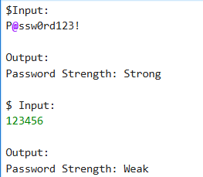
!

12. Testing Approach

Unit testing for feature extraction

Cross-validation for ML model

Manual testing on common weak/strong passwords

Validation using entropy-based rules

13. Challenges Faced

Generating balanced dataset

Handling unusual password patterns

Avoiding model overfitting

Ensuring labels match real-world security levels

14. Learnings & Key Takeaways

Importance of feature engineering

Password weaknesses often follow predictable patterns

ML improves strength estimation beyond rule-based systems

Security systems benefit from hybrid AI approaches

15. Future Enhancements

- Build web interface

- Add deep learning (LSTM) sequence modeling

- Provide real-time feedback while typing password

- Add multilingual dictionary word detection

16. References

Scikit-learn documentation

NIST Password Guidelines

Public password strength research papers

