**Hello World Program**

namespace ConsoleApp1

{

internal class Program

{

static void Main(string[] args)

{

Console.WriteLine("Hello, World!");

}

}

}

**Program to take input from user and Greet**

namespace ConsoleApp1

{

internal class Program

{

static void Main(string[] args)

{

Console.WriteLine("Enter your name");

Console.WriteLine("Hello " + Console.ReadLine());

}

}

}

**Debugging the following code snippet**

namespace ConsoleApp1

{

internal class Program

{

static void Main(string[] args)

{

int[] arr = {1,2,3,4,5};

for(int i = 0; i <=5; i++)

{

Console.Write(arr[i]);

}

}

}

}

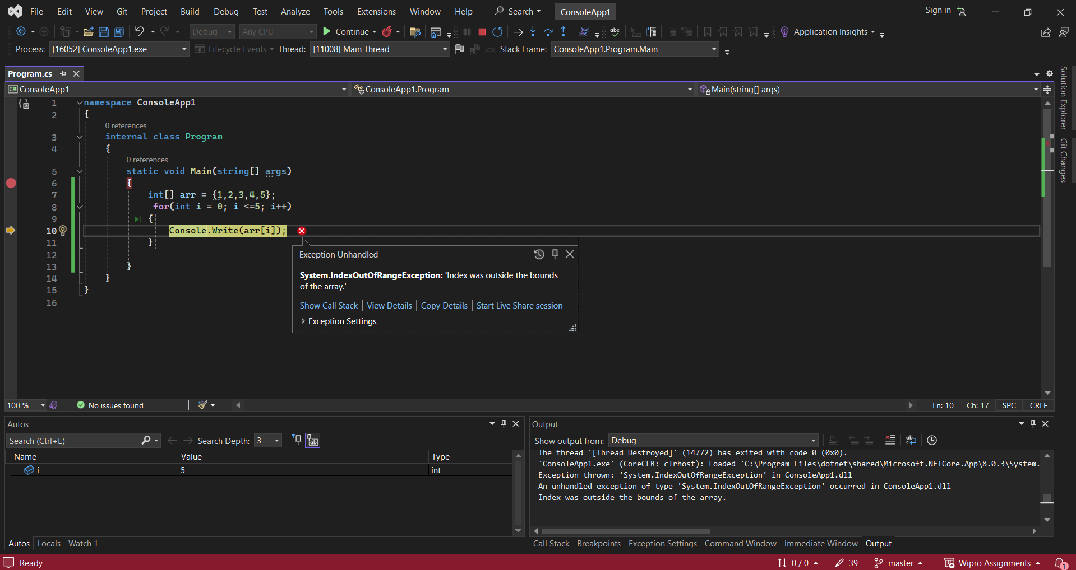

After debugging the error found was, when i =5 arr[i] throws index out of bounds error as it contains only 5 elements and the index starts from 0.

**Final Corrected code**

namespace ConsoleApp1

{

internal class Program

{

static void Main(string[] args)

{

int[] arr = {1,2,3,4,5};

for(int i = 0; i < 5; i++)

{

Console.Write(arr[i]);

}

}

}

}