Submitted by: Yogesh mainali

190345

Student management system

Contents

Introduction 2

Features 2

Interface of the program 2

Adding data to the table 3

Updating data 4

Deleting data 5

Reset the program 6

Searching for data 7

Sorting data 8

Error Handling 8

Unit testing 9

Conclusion 10

# Introduction

The program has been fully coded in python as a frontend and MySQL as a backend for data storing purpose. The main purpose of this program is it helps in searching, sorting, storing, creating modifying as well as deleting data that are stored in the database.

# Features

There are various features that have been specifically designed for the sole purpose of storing data in a very organized manner.

# Interface of the program

The program above uses MySQL as a backend for storing the database

# Adding data to the table

Data can be added to the table easily.

# Updating data

Information such as show above can be easily updated with the help of a simple button press.

# Deleting data

Unwanted or unnecessary information can also be deleted from the database.

# Reset the program

# Searching for data

# Sorting data

# Error Handling

# Unit testing

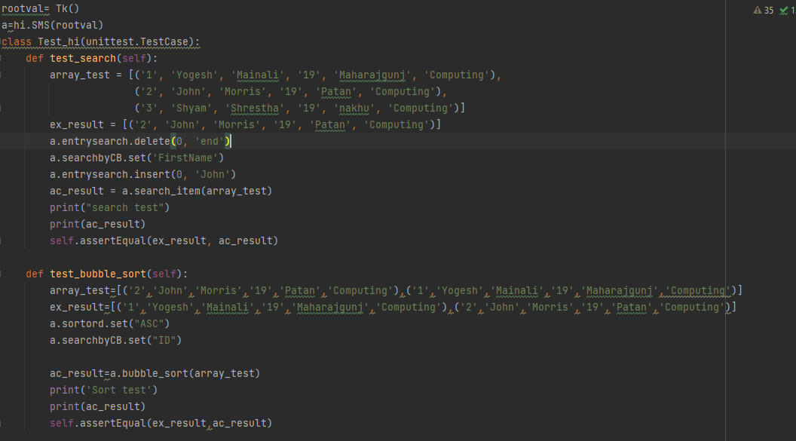

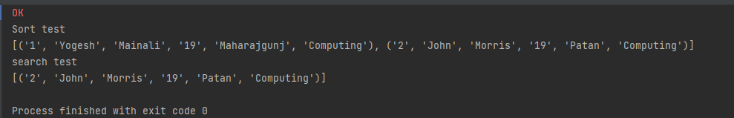

# Appendix

