CS236 DBMS PROJECT
ysing012@ucr.edu

SETUP

1. Install SBT and JDK 1.8 (Highly recommended using SDKMAN)
curl -s “https://get.sdkman.io” | bash
sdk install sbt

2. Install Intellij and Scala plugin

3. Setup scala and spark on Intellij on Ubuntu 16.04 and above

4. Create SBT-based Scala Project

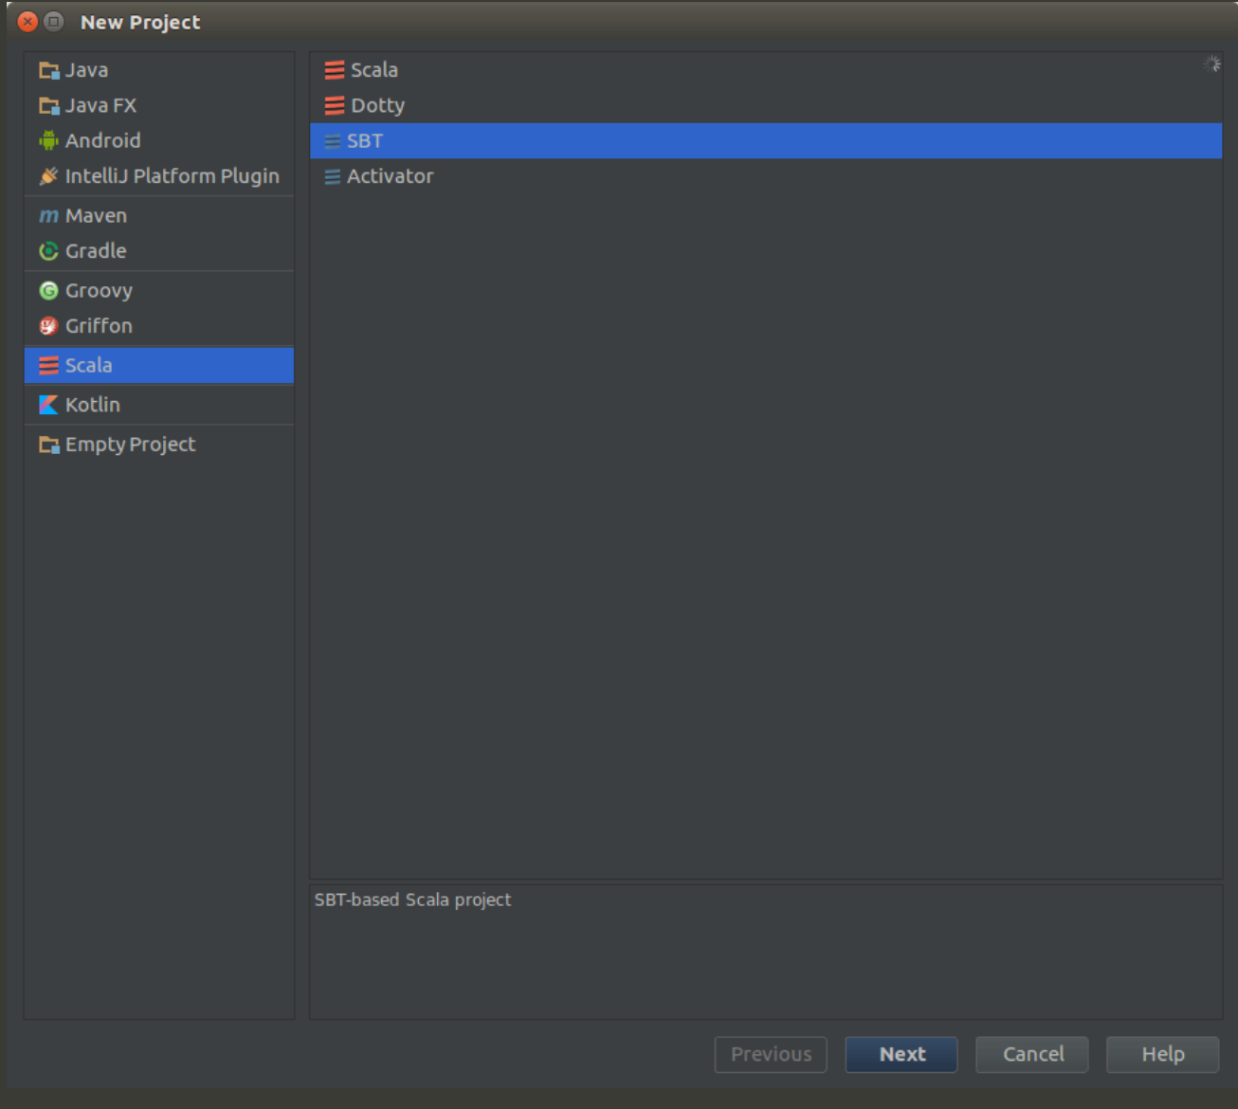

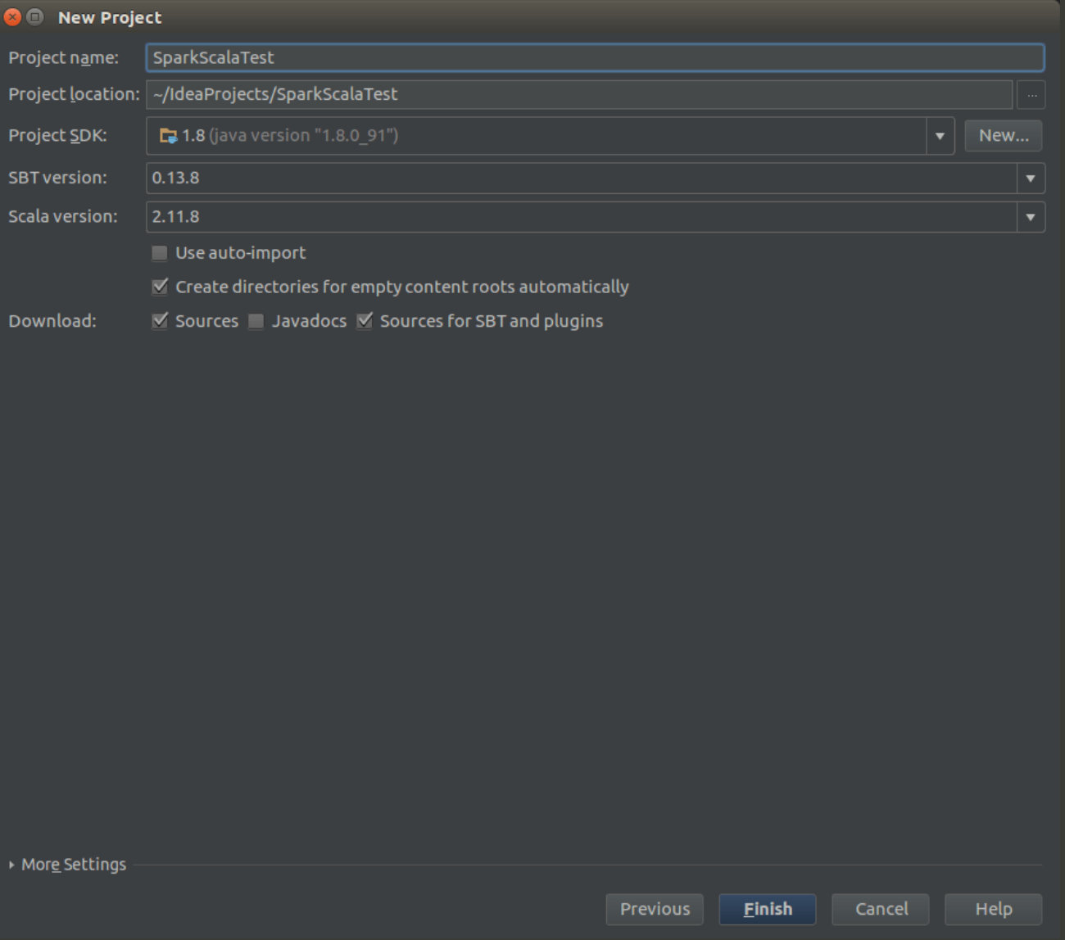

5. Add Spark libraries to the project. To do that update the content on build.sbt
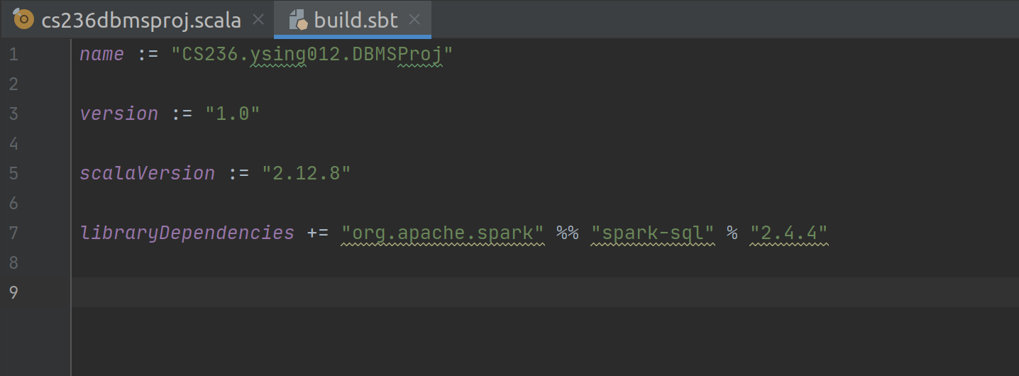

6. Update base variable src>main>scala>cs236dbmsproj to your project location. Make sure entire dataset is loaded in that location.

6. Run spark program. Click on project configuration

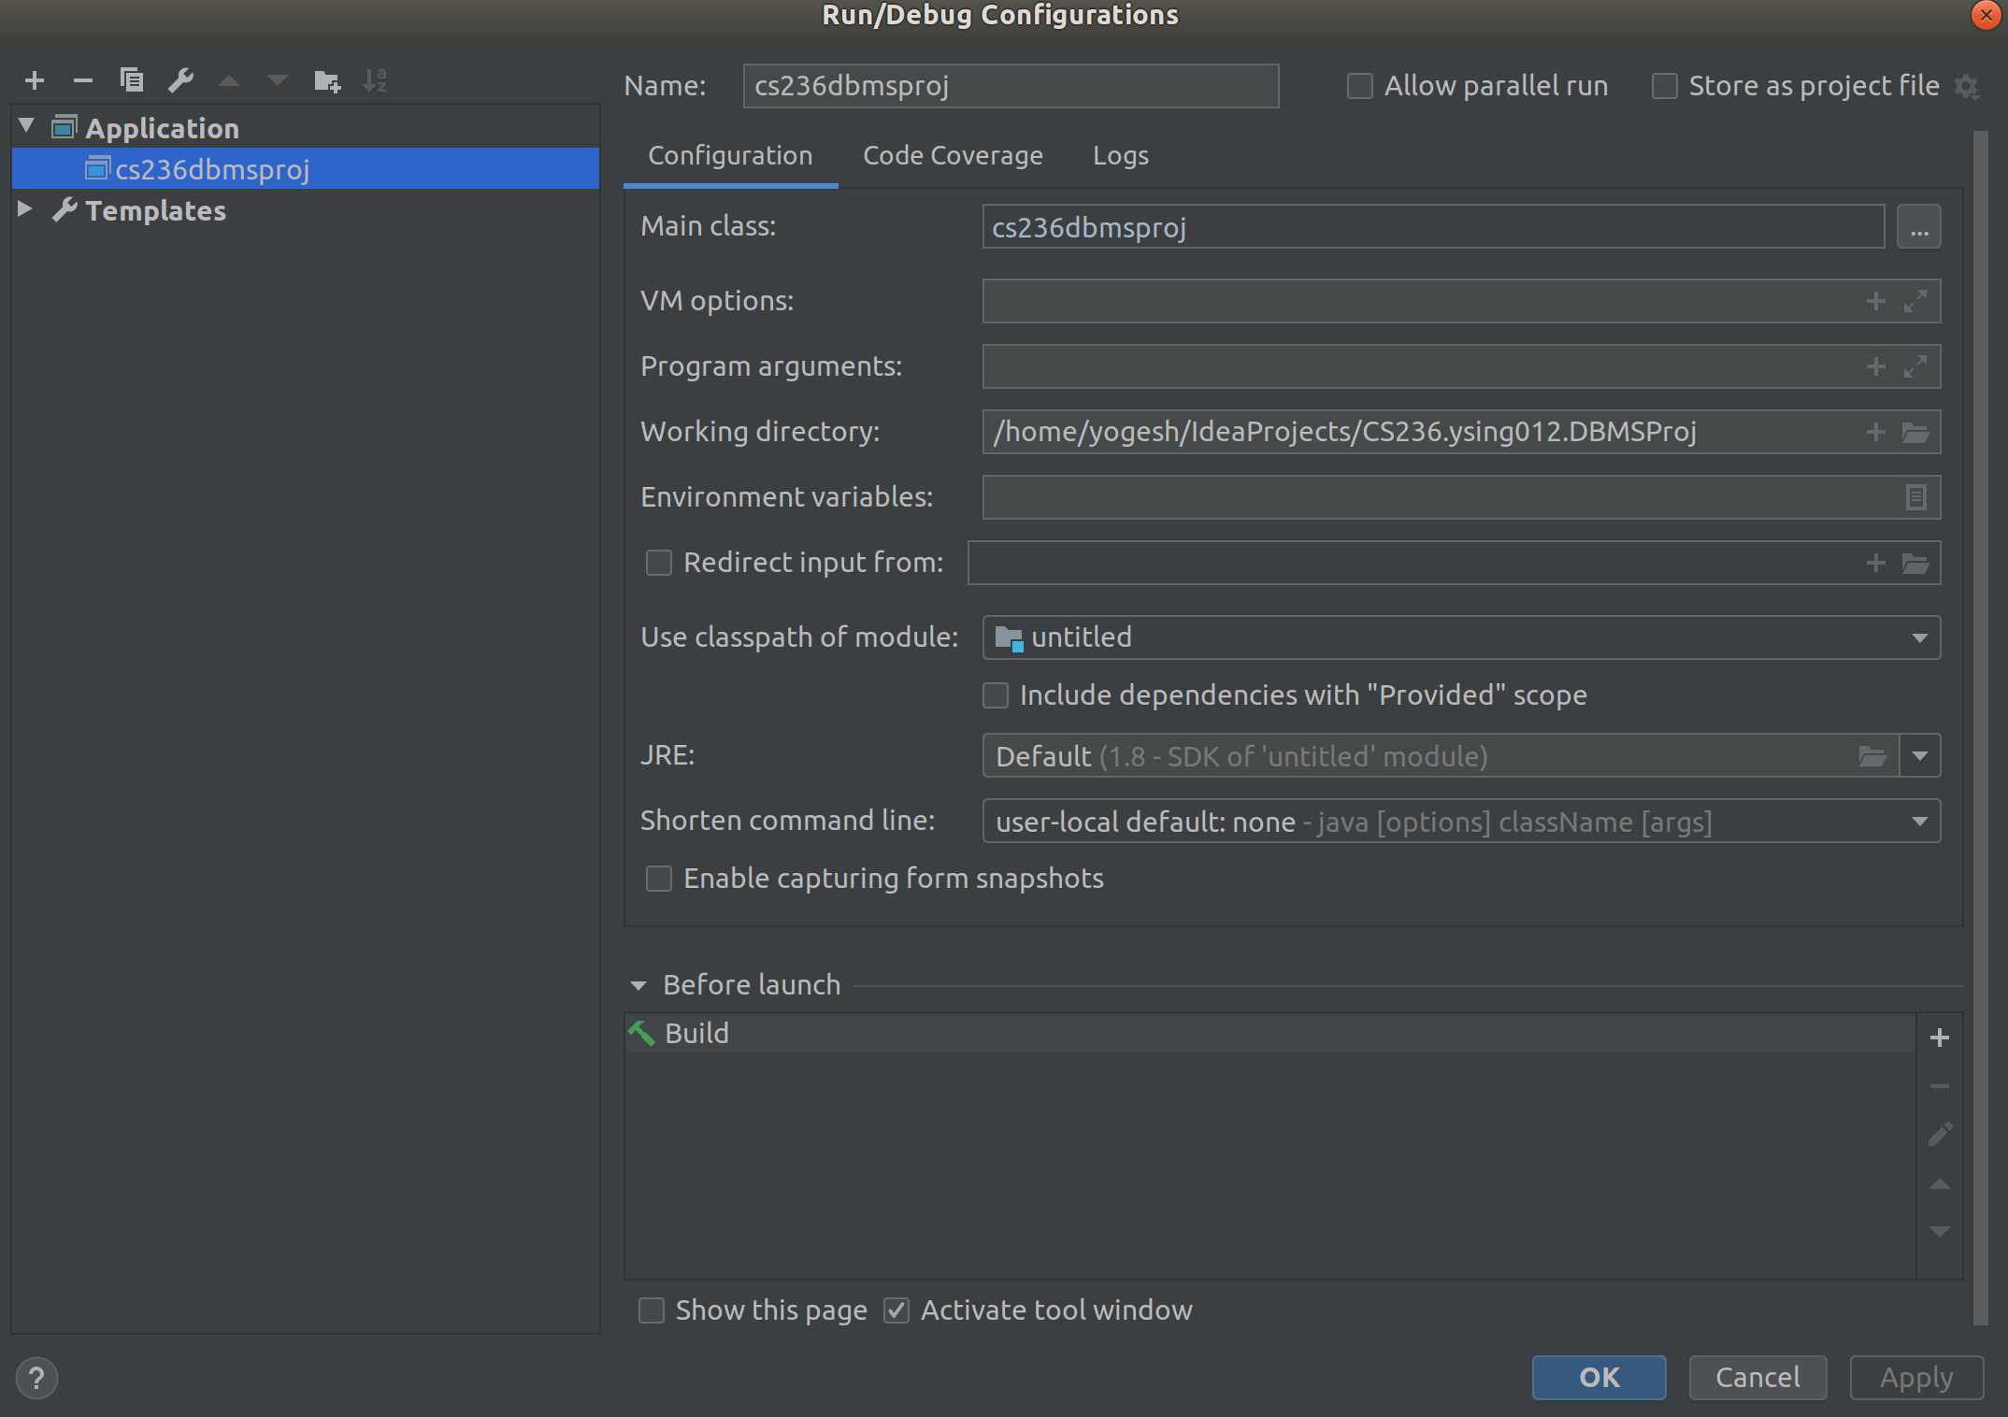

PROJECT

1. Read dataset using spark.read imported from SparkSession

2. Filter values of US States for task 1 using spark.sql imported from SparkSession as well.

3. Computing precipitation
- Fetched PRCP into separate dataframe.
- Divided the column into two using substring function imported from spark.sql.functions and further stored them into two data frames: Precipitation integer dataframe PRCP_I and Precipitation letter data frame PRCP_L_DF
- Merge these two columns with project data view using joins
- Run update query based on their corresponding letter value. For example:
- Cast these columns to double datatype
- Run update query on Precipitation integer value 99.99 and update them to be 0.00
- Multiplied the two columns using sql mult aggregate function.
- Finally stored the multiplied value in project data view.

4. Run sql aggregate function avg and grouped them according to month to deduce average precipitation by month for each state.

5. Deduce months with highest and lowest precipitation using max and min functions and stored them as data frame along with USAF.

6. Also computed month name in accordance with values in YEARMODA

6. Computed difference after joining the above mentioned data frames for the final task.

7. Total time to compute the operation calculated using System.nanoTime() was 16 seconds.

