Project Title:
Custom Web Application Firewall (WAF) for Attack Detection using Python and Flask
Tools Used:
- Python 3.13
- Flask (Web Framework)
- Jinja2 (for HTML templating)
- Browser (e.g., Chrome)
- Text Editor (VSCode / Notepad++)
- OS: Windows
- Objective:
To develop a simple Web Application Firewall using Flask that inspects incoming HTTP requests and blocks common web attacks like SQL Injection, Cross-Site Scripting (XSS), Command Injection.

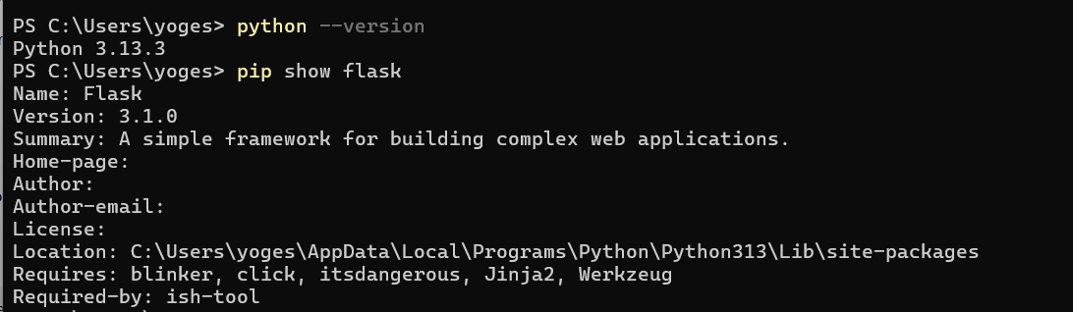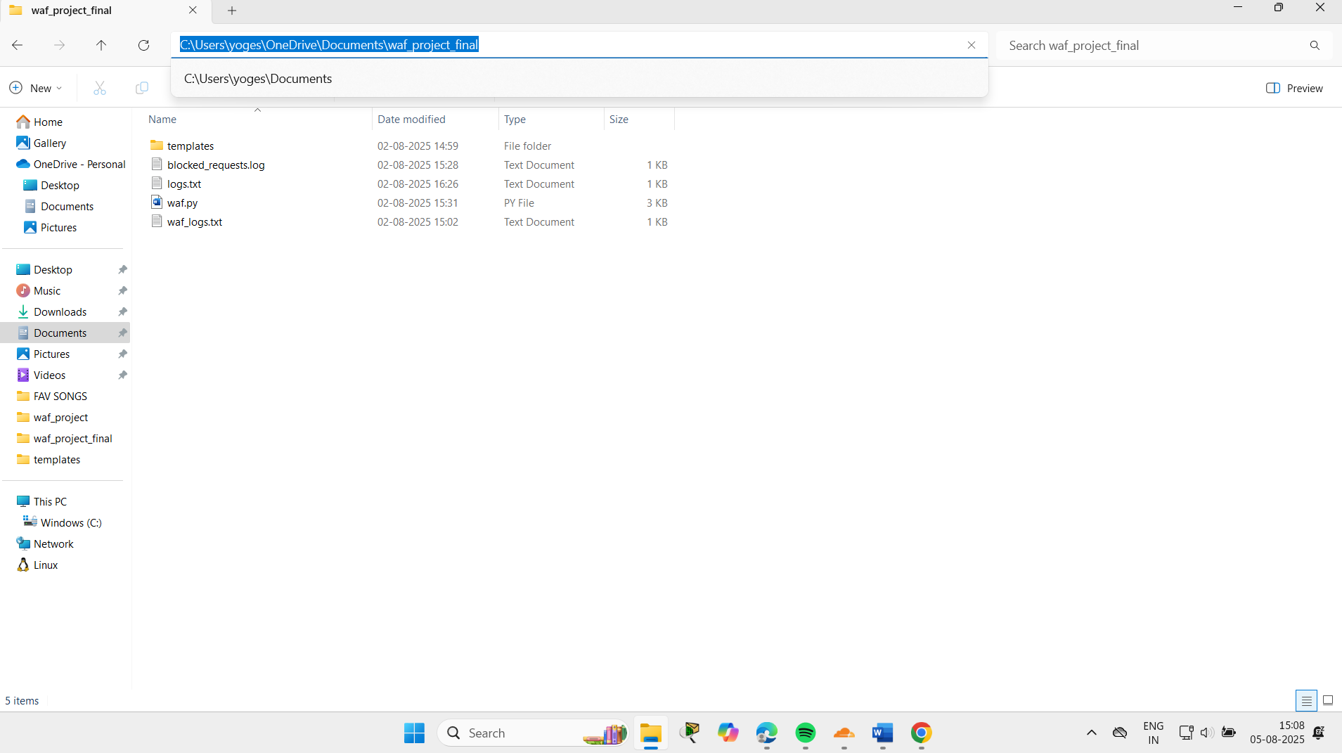

waf.py
- Accepts HTTP POST input
- Filters for attack patterns
- Logs malicious requests to blocked_requests.log
- Python backend code with attack filtering logic.

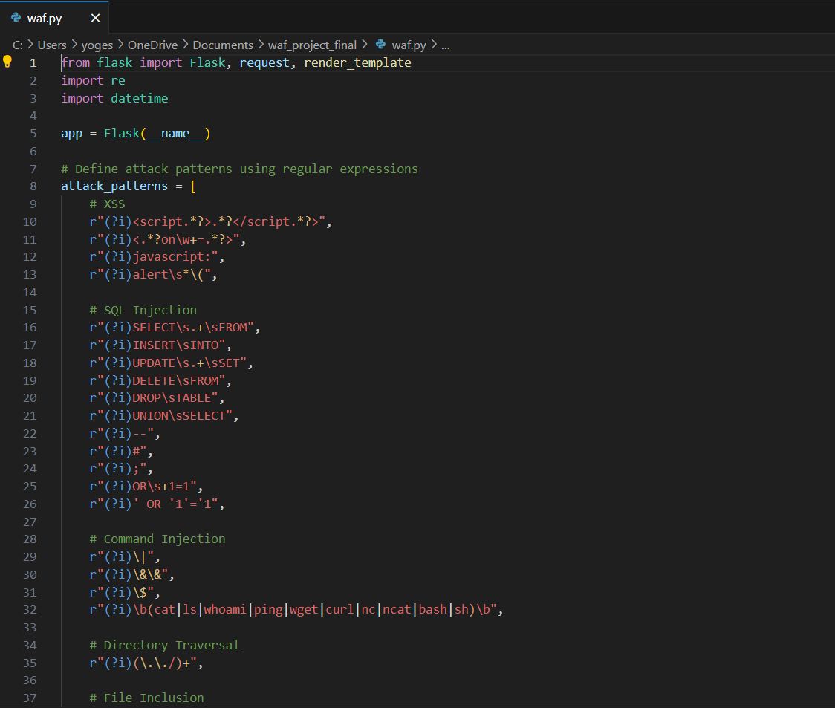
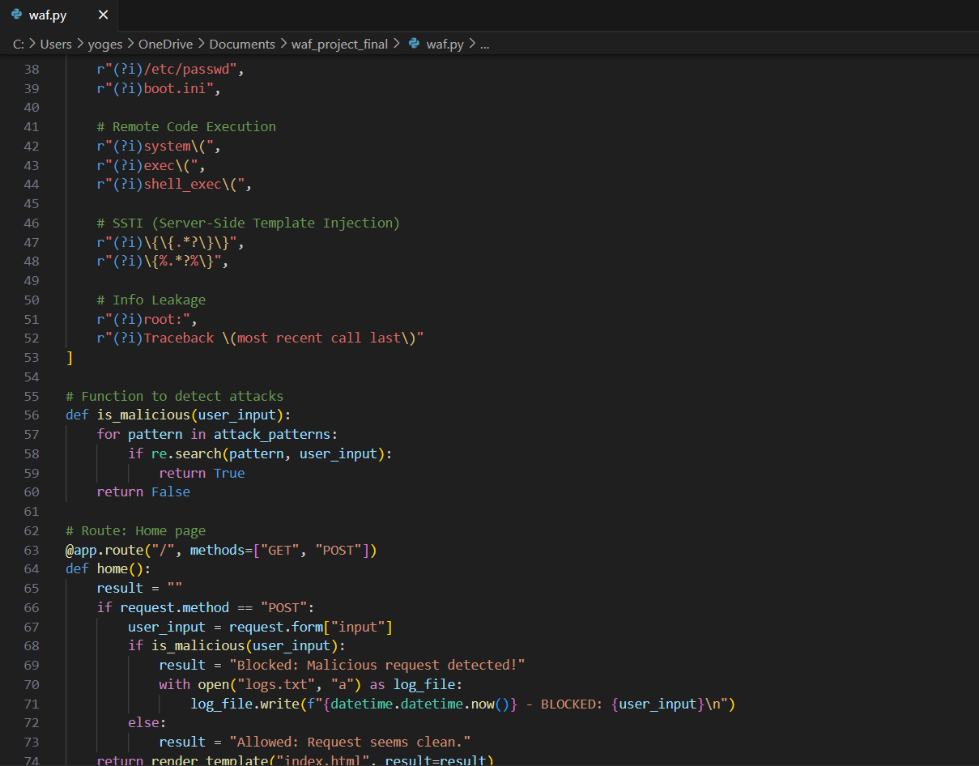
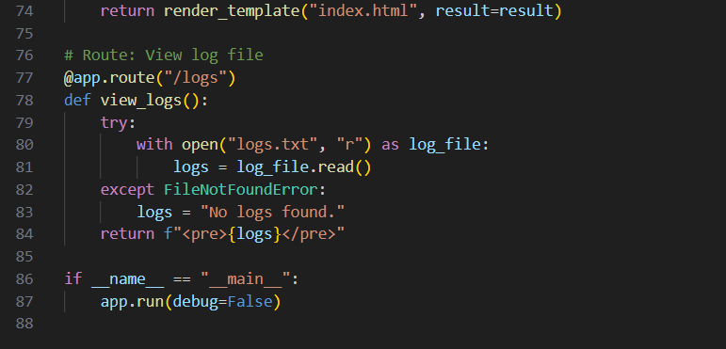
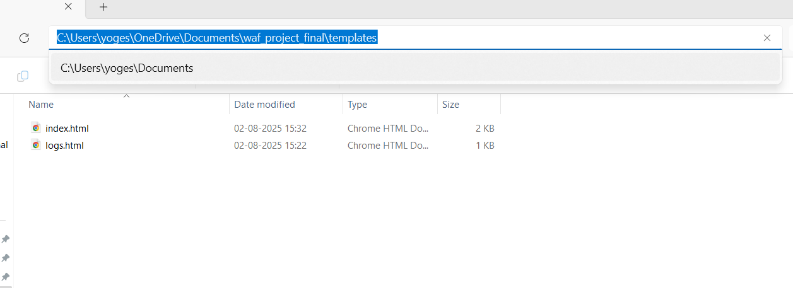

index.html
- Form for user input
- Styled response output
- “View Logs” button for admins
- HTML front-end code using Jinja2 template.
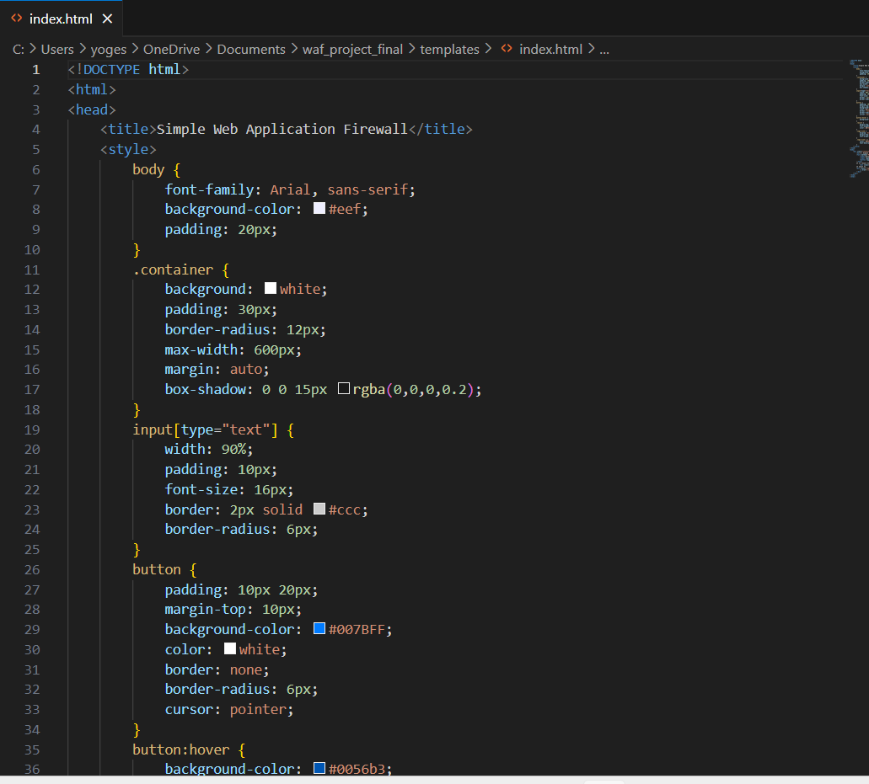
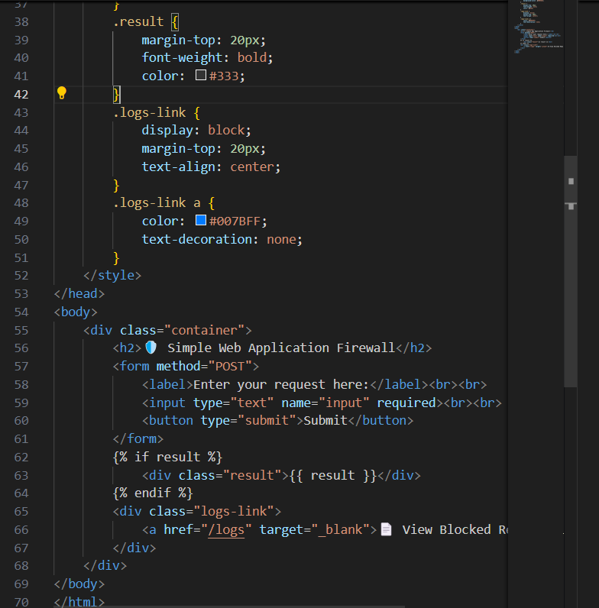

logs.html
- Displays WAF-blocked request logs line by line using Jinja2 loop ({% for log in logs %})
- Styled with scrollable <pre> tag for better log visibility
- Includes a navigation link to return to the main page
- Logs are shown in a readable format using Flask backend data

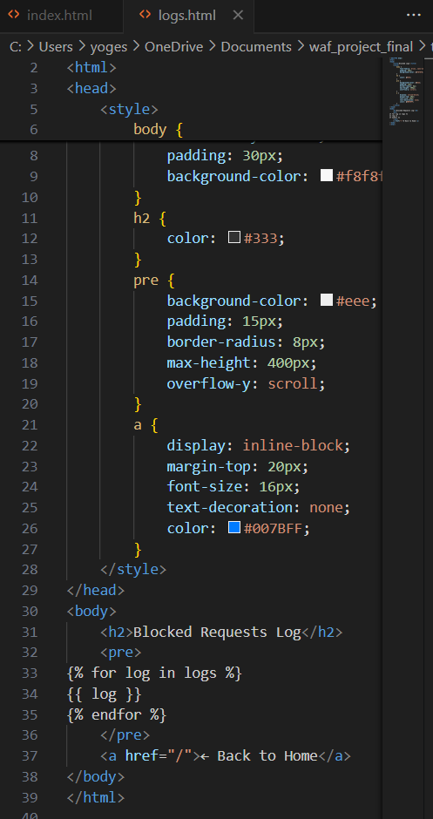
Log file that stores all blocked malicious requests with timestamp
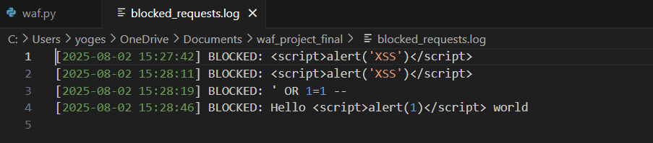
Navigate to Project Directory
Open Command Prompt and run:
cd "C:\Users\yoges\OneDrive\Documents\waf_project_final"
and Launch the Flask Web Application
:python waf.py

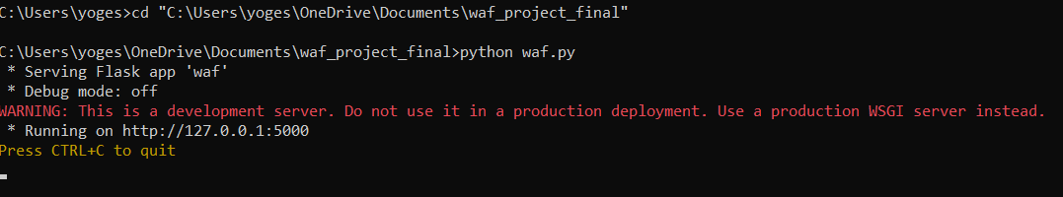
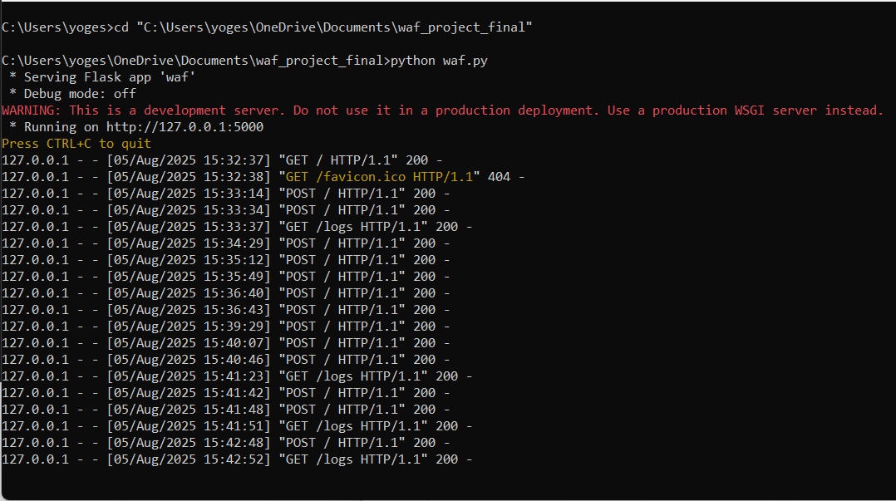
Access the Web Interface
Open your browser and visit: http://127.0.0.1:5000

Normal Request (Allowed):

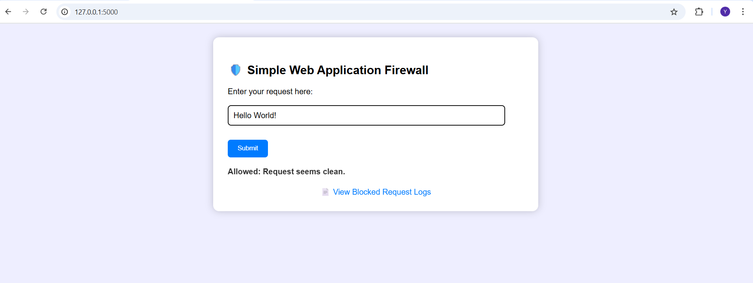
Attack-like Inputs (Should Be Blocked by WAF):
These will help test if your WAF is working.

SQL Injection:
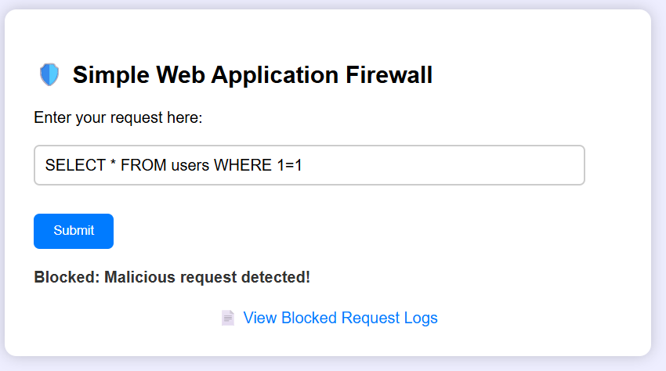
XSS (Cross-site scripting):
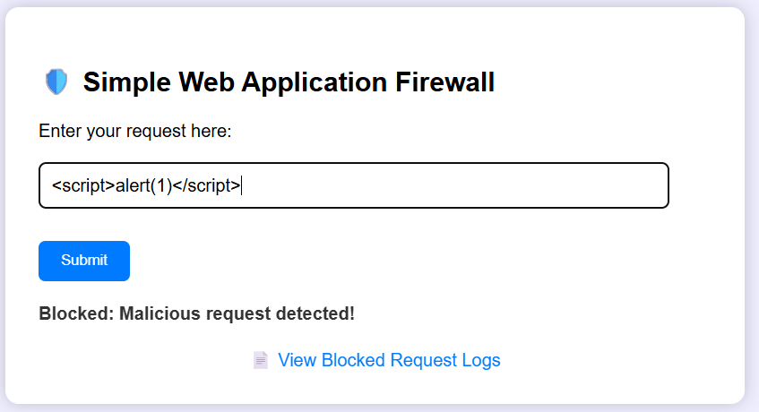
Path Traversal:
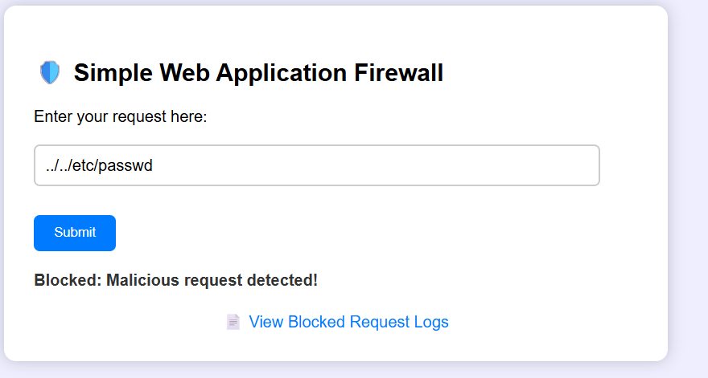
Encoded URL attack:
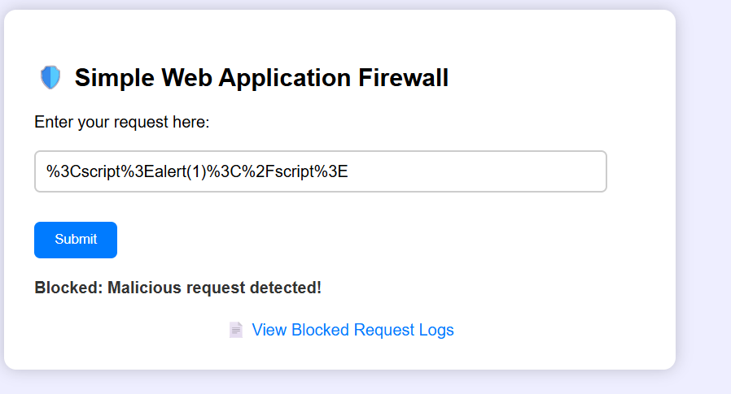

View Blocked Logs
- Action: Clicked “View Blocked Logs” to view previously blocked attacks.
Logged and displayed all malicious requests that were blocked by the WAF.

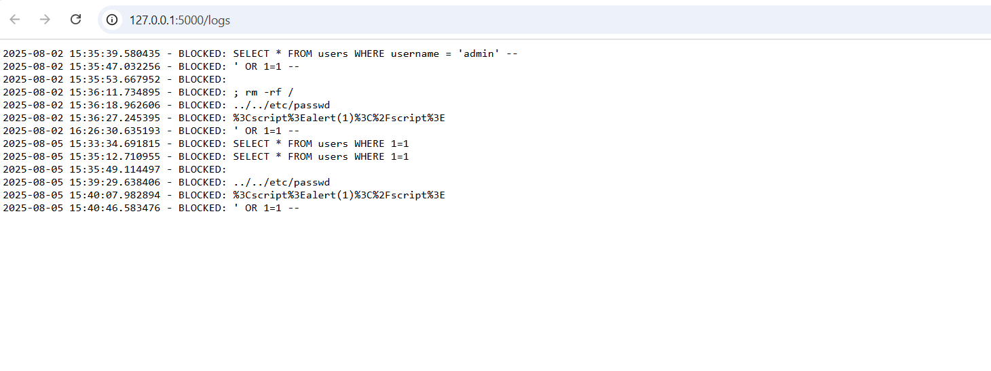
Conclusion:
This project showcases a fundamental implementation of a Web Application Firewall using Python and Flask. It effectively detects and blocks simple web-based attacks, logs incidents, and provides a web interface for monitoring.
It Demonstrates a foundational WAF implementation—a critical defense layer in modern cybersecurity architecture. While simple, it reflects how application-layer firewalls operate and highlights the importance of input validation and intrusion detection.

