Project Title:
"Network Traffic Analysis Using Wireshark: Monitoring ICMP, HTTP, FTP, DNS, and Nmap Scans"

Objective
To capture, analyze, and interpret various network protocols (ICMP, HTTP, FTP, DNS, and Nmap scanning) using Wireshark on Windows Server while Kali Linux generates the traffic in a VMware host-only network.

• Tools Used:
- Kali Linux (Attacker)
- Windows Server (Sniffer)
- Wireshark
- VMware Workstation (Host-only network)

Lab Setup:
- Host Machine: Windows Server with Wireshark installed
- Virtual Machines:
  - Kali Linux: Attacker/Simulator
  - Windows Server: Packet capture using Wireshark
- Network: VMware Host-Only (VMnet1 used)
- IP Addresses:
  - Kali Linux: 192.168.76.133
  - Windows Server(Ethernet1): 192.168.76.132

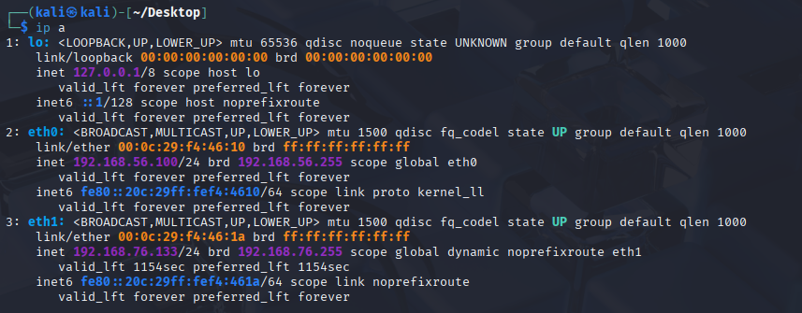

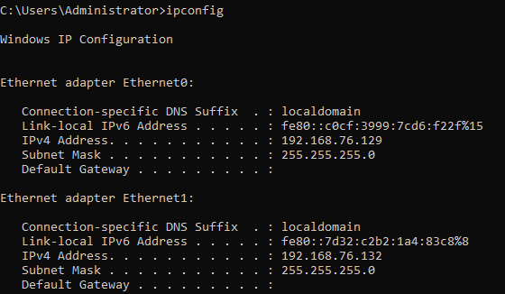
1. ICMP (Ping) Traffic
Ping uses the ICMP protocol to test connectivity. Wireshark captures Echo Request and Echo Reply, confirming successful communication.
Objective:
To generate and capture ICMP traffic between Kali Linux and Windows Server using ping, and analyze it using Wireshark. Steps Performed:
- From Kali Linux, pinged the Windows Server:ping 192.168.76.132
- From Windows Server, pinged Kali Linux: ping 192.168.76.133
- On Windows Server, opened Wireshark and started capturing packets on the Host-Only Adapter.

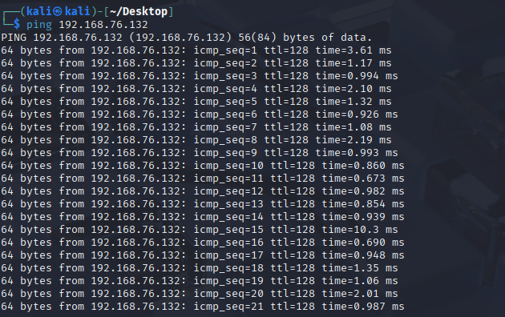
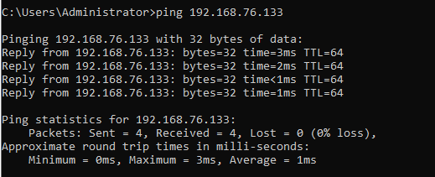

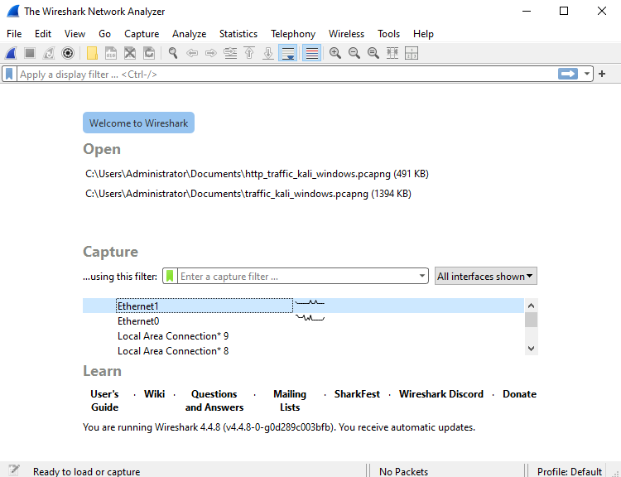

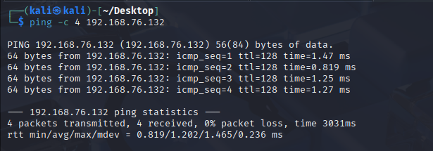
- Applied the following Wireshark filter to isolate ICMP traffic: icmp
Observations in Wireshark:
- ICMP Echo Request (Type 8) packets sent from one machine.
- ICMP Echo Reply (Type 0) packets received from the other.
- Successful round-trip communication observed between the two systems.

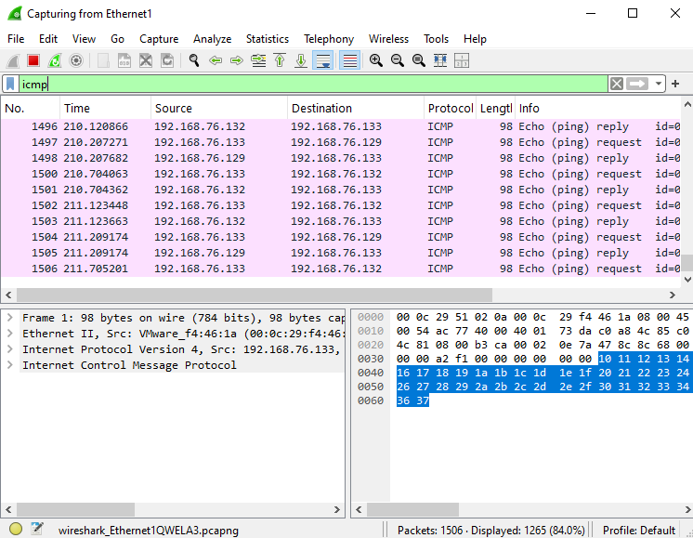
2.DNS Traffic Analysis
Objective:
To analyze DNS traffic by sending name resolution queries from Kali Linux and Windows Server to a target IP, and capture the generated traffic using Wireshark.
Steps Performed:
- Opened Wireshark on Windows Server and started packet capture on the Host-Only Network Adapter.
- From Kali Linux, ran the following DNS query using nslookup:nslookup google.com 192.168.76.132
  - This attempted to resolve "google.com" using the Windows Server (192.168.76.132) as the DNS server.
Similarly, from Windows Server, ran:nslookup google.com 192.168.76.133
- This attempted to resolve "google.com" using Kali Linux (192.168.76.133) as the DNS server.

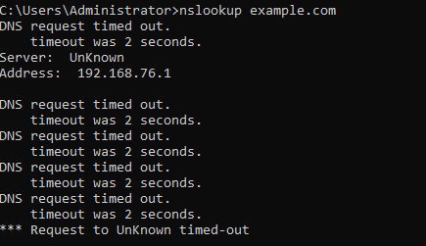
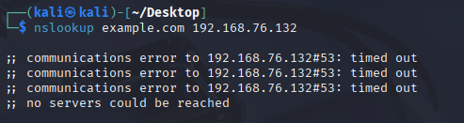
In Wireshark, applied the following display filter to view only DNS-related packets:dns
Observations in Wireshark:
- DNS request packets were observed going from the client (Kali or Windows Server) to the target IP.
- However, there were no DNS responses captured because neither Kali nor Windows Server was configured as a DNS server.

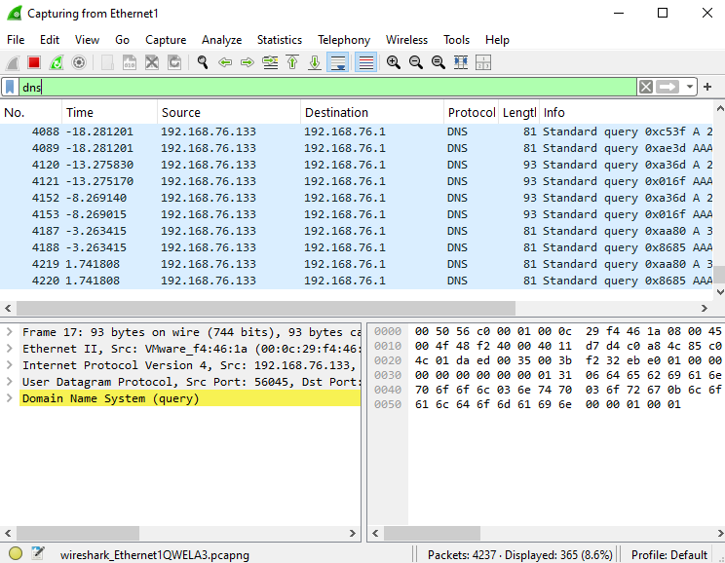

3.HTTP Traffic Analysis
Objective:
To simulate and analyze HTTP traffic between Kali Linux (acting as a web server) and Windows Server (acting as the client), and to observe the HTTP packet exchange using Wireshark.
Steps Performed:
- Started Packet Capture in Wireshark:
  - Wireshark was opened on the Windows 10 system.
  - Started capturing traffic on the Host-Only Network Adapter (connected to the same virtual network as Kali and Windows Server).
- Started a Simple HTTP Server in Kali Linux:
  - Navigated to a directory containing an index.html file or created a sample file.
  - Ran the following command: python3 -m http.server 80
  - This started an HTTP server listening on port 80 (default for web traffic).
  - Output shown:Serving HTTP on 0.0.0.0 port 80 (http://0.0.0.0:80/) ...

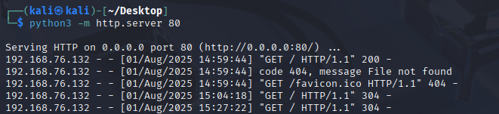
Accessed the Web Page from Windows Server:
- Opened Command Prompt or any web browser.
- Accessed the Kali Linux server by its IP address:http://192.168.76.133
- The page displayed:This is a test HTTP page from Kali.

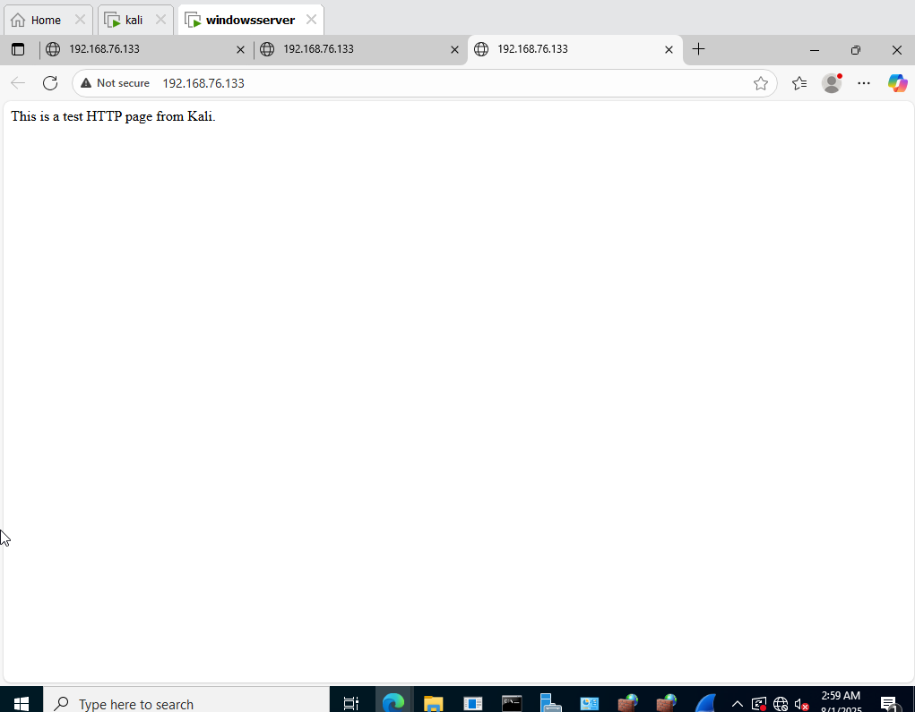
Filtered HTTP Traffic in Wireshark:
  - Applied the display filter:http
  - Observed the HTTP GET request from Windows Server and the corresponding HTTP 200 OK response from Kali Linux.
Observations in Wireshark:
- HTTP GET request from Windows Server to Kali Linux’s IP (192.168.76.133).
- HTTP response headers from Kali’s Python web server.
- The TCP three-way handshake followed by HTTP request-response cycle is clearly visible.
- This confirms successful communication over port 80 using the HTTP protocol.
This setup demonstrates a basic HTTP server-client model. Using python3 -m http.server, a simple web server was simulated, and Wireshark effectively captured the HTTP packet exchange, validating real-time web communication.

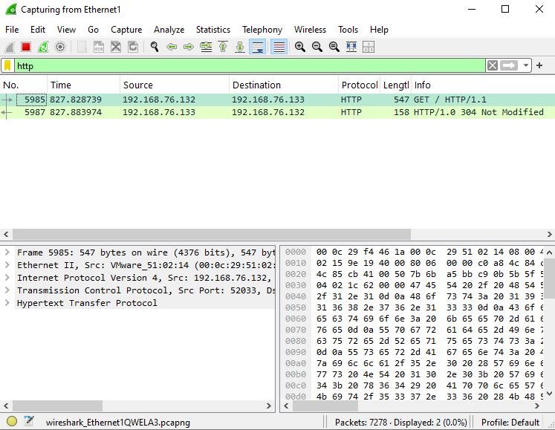
4.Nmap Scan Traffic Analysis
Objective:
To generate network traffic using Nmap from Kali Linux by scanning Windows Server and analyze the scan results and packet behavior using Wireshark on Windows 10.
Performed Nmap Scan from Kali Linux:
- On Kali Linux terminal, the following command was executed to scan Windows Server (192.168.76.129):

- This command performs a TCP SYN scan (-sS) on all 65535 ports (-p-) of the target.

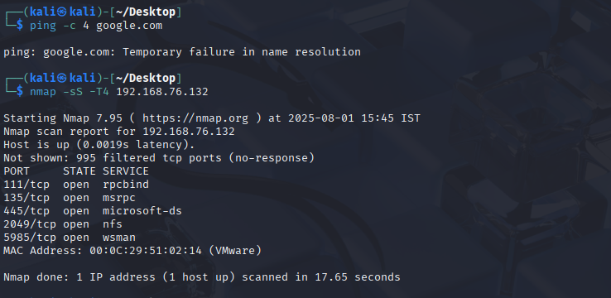
- Filtered Nmap Traffic in Wireshark:
  - In Wireshark, the display filter below was applied to observe Nmap scan traffic:
  - This filter shows only TCP SYN packets — typical of a SYN scan.
  - Additional filters like ip.addr == 192.168.76.129 help isolate relevant traffic.

Observations in Wireshark:
- Numerous TCP SYN packets from Kali Linux (attacker) to various ports on Windows Server.
- In response, either:
  - TCP SYN-ACK → Port is open.
  - TCP RST → Port is closed.
- This TCP behavior confirms a stealthy SYN scan, as Nmap doesn’t complete the TCP handshake.

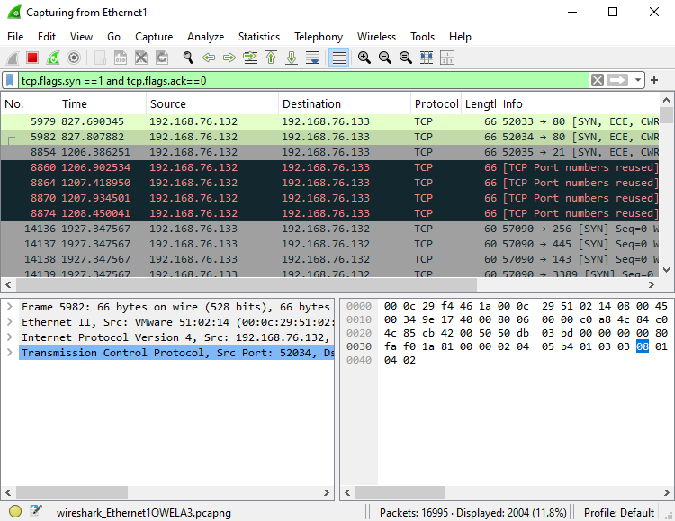
5.FTP Traffic (Simulated on Kali)
On Kali:

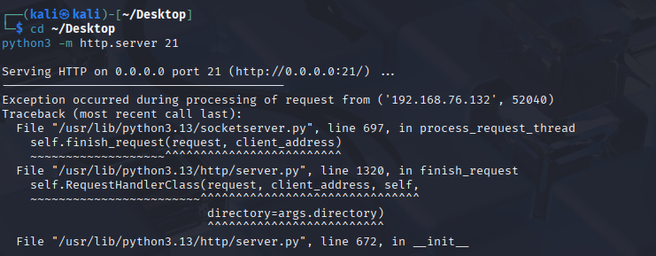
On Windows Server (cmd):
- From Windows Server, the Kali Linux FTP server was accessed using the ftp command:ftp 192.168.76.133
  - Logged in as anonymous user (default for public FTP access).
  - The test file was listed successfully, confirming file availability.

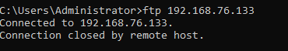
Additional filters like ip.addr == 192.168.76.133 help isolate relevant traffic.
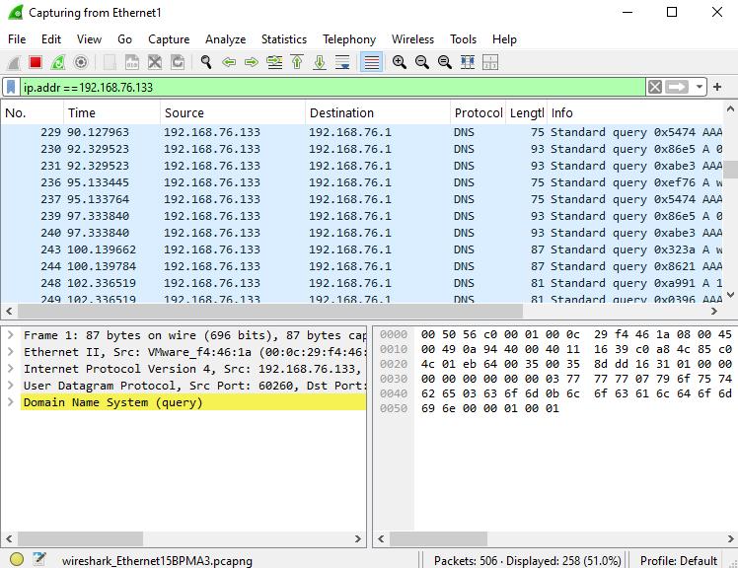
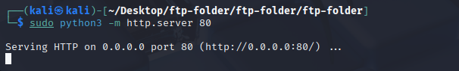
FTP File Transfer Observation
To simulate FTP traffic:
- On Kali Linux, a file named test.txt was created using:
echo "This is a test file for FTP simulation" > test.txt
On the Windows Server, I opened a browser or FTP client and accessed:
ftp://192.168.76.133/test.txt
- The browser or client displayed the file contents:
“This is a test file for FTP simulation”

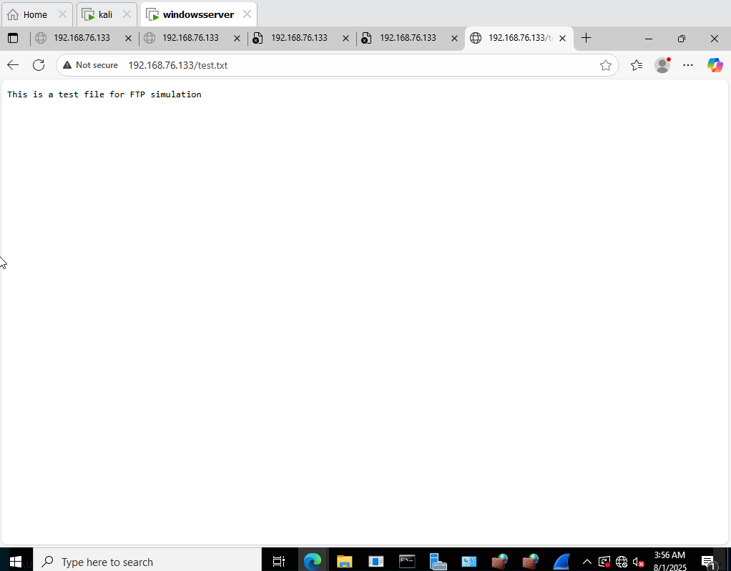
FTP Traffic Capture and Analysis using Wireshark
In this step of the project, we analyzed FTP (File Transfer Protocol) traffic between a Windows Server (Client) and Kali Linux (Server).
- On Kali Linux, a test file was shared using an FTP server.
- On Windows Server, the FTP client was used to connect and retrieve the file.
- During this operation, Wireshark was used on the Windows Server to capture network traffic.
Wireshark Display Filter Used:ftp
Key Observations:
- The packet capture clearly showed the FTP control connection and file retrieval commands.
- Since FTP is an unencrypted protocol, all command and data exchanges appeared in plaintext.
- The filter helped isolate relevant packets for easier analysis.

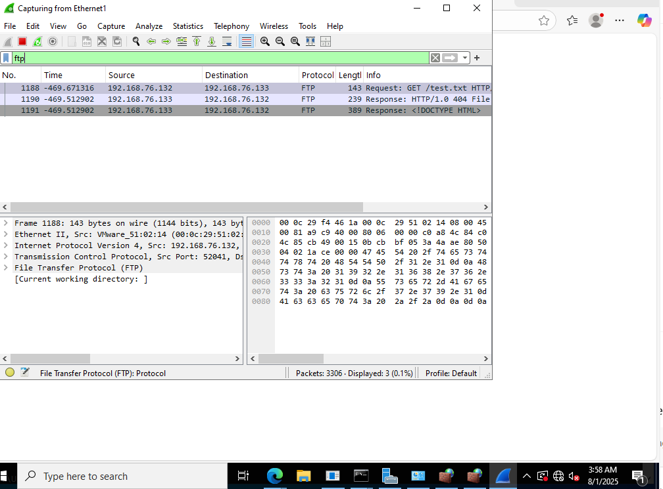

Conclusion
we successfully demonstrated the process of capturing, analyzing, and understanding different types of network traffic using Wireshark in a controlled lab environment. The simulation involved multiple types of network protocols commonly used in real-world scenarios, including:
- ICMP (used for ping)
- DNS (for name resolution)
- HTTP (web traffic)
- FTP (file transfer)
- Nmap (network scanning and reconnaissance)

