1. Run **entropyCRsfs.exe,** application will open:

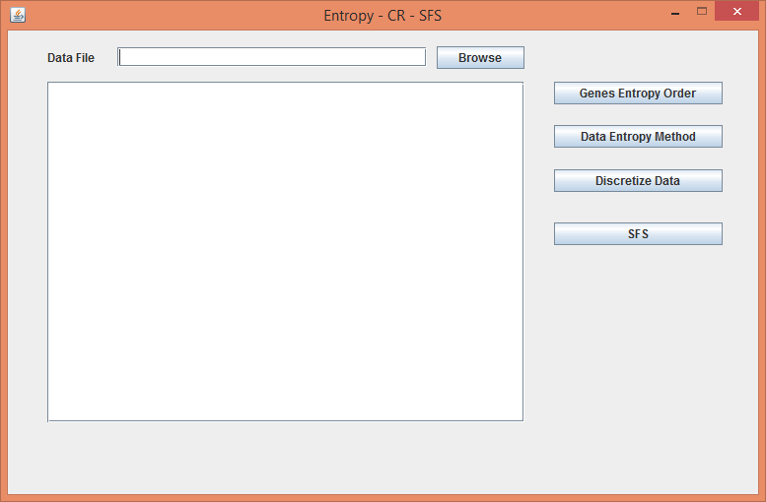

1. Click on “**Browse**” button, open dialog box will open, select the required file and click on “**Open**”

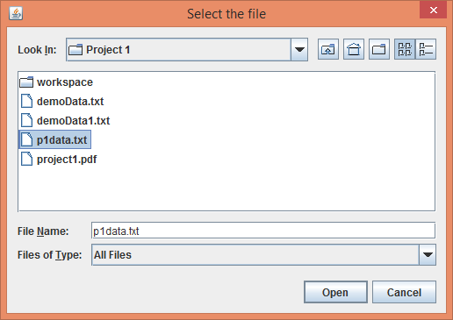

1. Valid file will be loaded in the table and displayed as shown below. To order the genes in descending order based on their gain click on “**Genes Entropy Order**”. The ordered genes will to written to **GenesEntropyOrder.txt**  file.

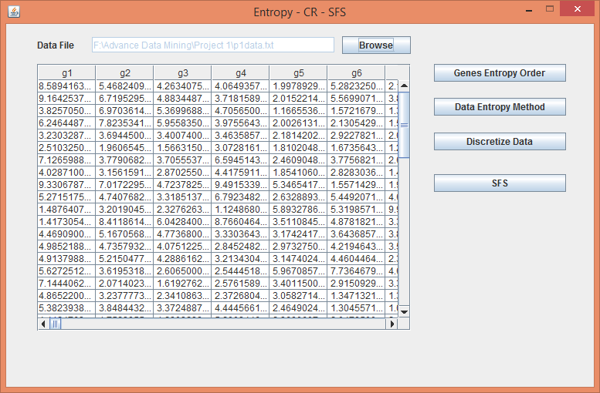

A confirmation message will be displayed after ordering:

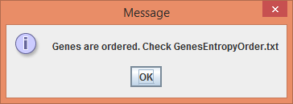

1. Click on “**Data Entropy Method**” to select the k number of genes and ordering them based on their respective gains. User will be asked to enter the value of k:

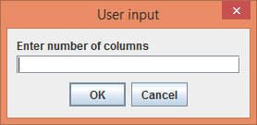

After ordering, the data will be written to **DataEntropyMethod.txt.** A confirmationmessage will be displayed:

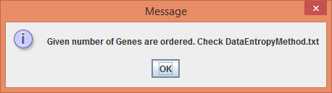

1. Click on “**Discretize Data**” to discretize data for k number of genes. User will be asked to provide the number of columns and then the discretized data will be written to **DiscretizedDataEntropyMethod.txt.** A confirmation message will be displayed.

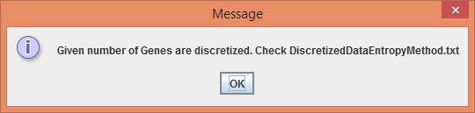

1. Click on “**SFS**” to get the features using CR-SFS method. In order to use this, user must have discretized the data according to point 5. Feature sets will be selected and written to **TopKgeneSetSFS.txt**. A confirmation message will be displayed:

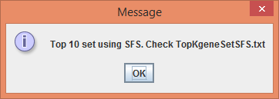

**NOTE:** All these txt files will be created in the directory from where **entropyCSsfs.exe** is running.