Garden Manager App For Viewing status and Controlling Parameters through actuators

Architecture Diagram

Sensor 1
DHT22
Sensor n
Soil Temperature Sensor
Sensor 2
Soil Moisture Sensor
(Field Gateway)
–
Raspberry Pi
Actuator n
Actuator 2
Actuator 1
Third Party API for weather data
Cloud Gateway (or Private Server)

InfluxDB for database
Graffana/Chronograf for visualization
Telegraf for collecting metrics and
kapacitor for generating alerts based
on thresholds

Deployment Diagram on field
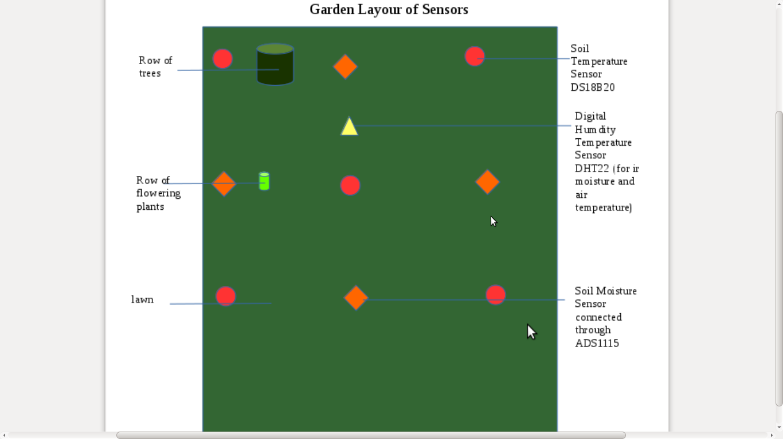

Screenshot of dashboards to setup platform

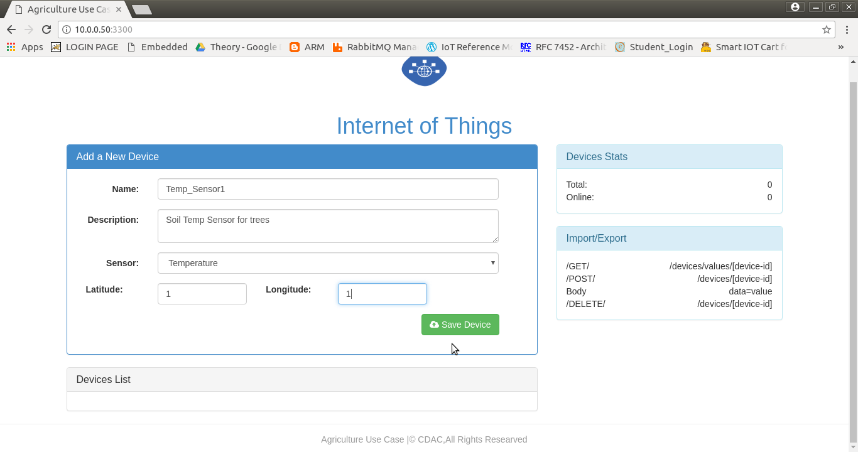

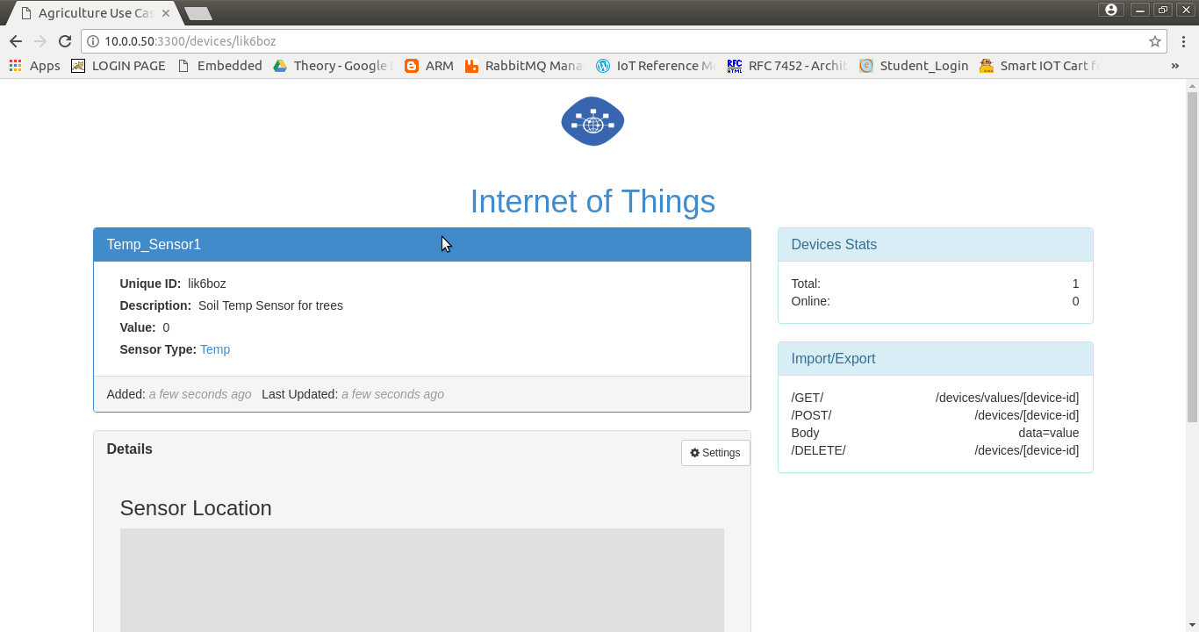

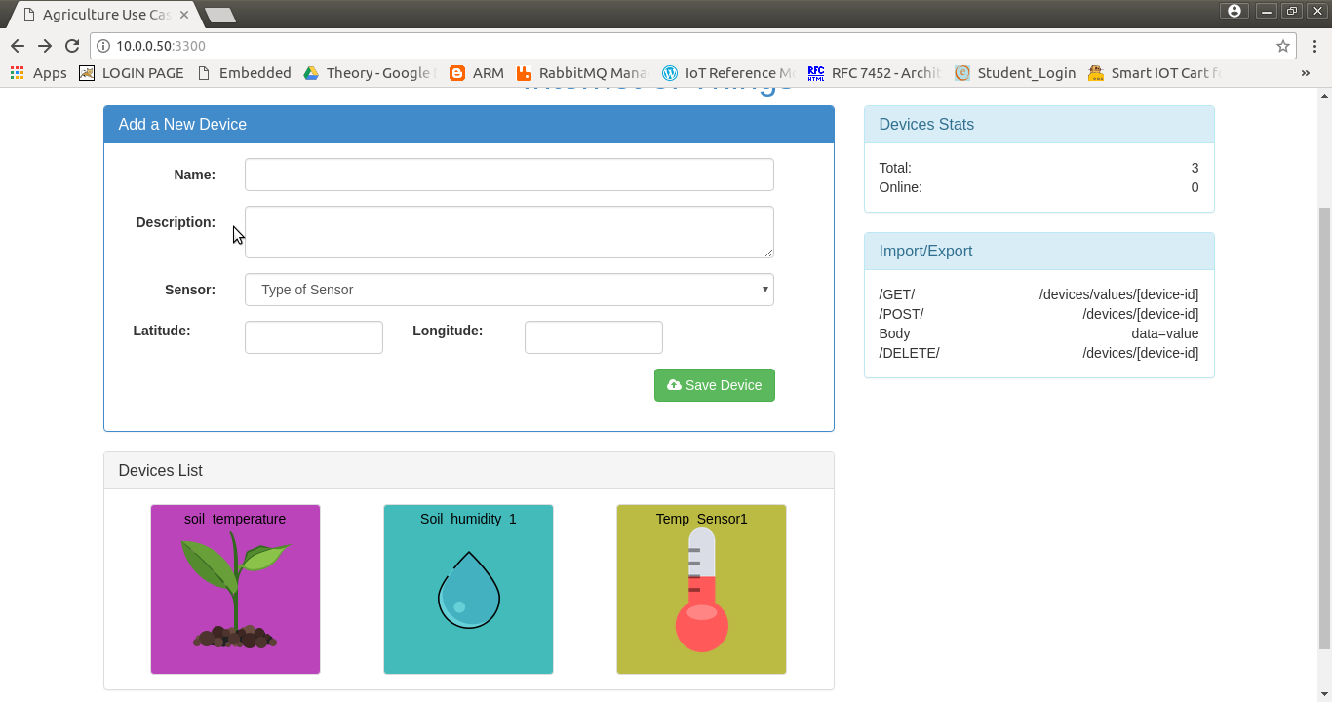

Weather prediction third party Integration:

We use https://developer.worldweatheronline.com/api/ to develop third party app integration

Q2:

Healthcare IOT

Wearable
Sensors
For
Capturing
Parameters
Like
BP
Pulse rate
etc
Field
Gateway
(Like
Mobile
Device)
Low power protocols like BLE
Storage for saving
Data when gateway is unavailable
Cloud Gateway with
connection to
cloud platformfor analytics
And warning/detection
Of probable health
issues
Cloud Infrastructure for anaytics and UI for stakeholders
UI for patient for normal
Stats and warnings
UI for family/friends for
Slightly severe conditions
UI for doctors and
healthcare professionals
For getting history and severe conditions

