#ssh into the instance

Type flowing command

$ **curl http://169.254.169.254/latest/meta-data/**

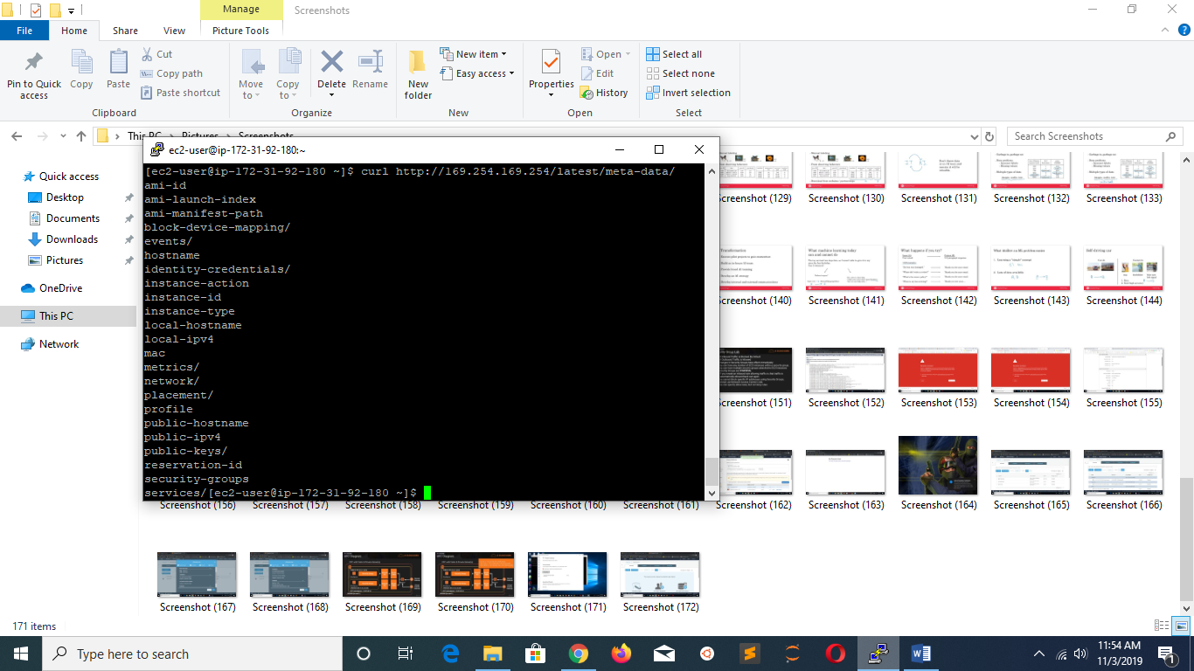

#to get ami id

$ **curl http://169.254.169.254/latest/meta-data/ami-id**