Course End Project Report

Page 1: Title Page
Project title: CI/CD Pipeline for a Result-Check Website (GitHub Actions)
Field | Details
Student name | [Your Full Name] <-- Fill your name here
Roll number | [Your College Roll Number] <-- Fill roll no here
Course / Semester / Section | [Course, e.g. B.Tech CSE / Sem 6 / Section A]
Faculty name | [Faculty / Evaluator Name]
Date of submission | November 2026
GitHub repository link | https://github.com/[YOUR-USERNAME]/result-check-app <-- Fill repo link
Note for Evaluation: This project implements an automated Continuous Integration and Continuous Deployment (CI/CD) pipeline for an exam result-checking web application. Every commit is automatically tested, containerized, and published using GitHub Actions and Docker, with a deliberate test failure demonstrating fail-safe pipeline stoppage.

Page 2: Abstract, Problem Statement and Objectives
Abstract (5 to 6 lines): This project designs and implements a production-grade automated CI/CD pipeline using GitHub Actions and Docker for a student Result-Check web application. The application tier is written in Python Flask, providing roll number lookup routes and an automated health inspection endpoint. The pipeline enforces a 3-stage quality gate: automated unit testing with pytest (31 tests, 92% coverage), multi-stage Docker container build and push to Docker Hub, and containerized deployment verification. When a test failure was deliberately injected, the pipeline halted immediately, preventing a defective image from being built or released. The project proves that automated pipelines eliminate human release errors, guarantee software quality, and enable rapid, zero-downtime application updates.
Problem statement: A student result-check web application experiences intense traffic bursts during exam announcements and must remain continuously available and strictly accurate. Manually running tests and deploying updates to servers is error-prone, slow, and vulnerable to human oversight. A single container without automated quality gates can crash on untested changes, resulting in severe student panic and reputational loss. An automated CI/CD pipeline is required to test every commit before packaging and deploying container images.
Objectives
Develop a lightweight Python Flask result-check web application featuring roll number query handling, structured result rendering, input validation, and an automated /health status endpoint.
Author a declarative GitHub Actions CI/CD workflow (.github/workflows/ci-cd.yml) with sequential stages: test, build-and-push to Docker Hub, and deploy.
Demonstrate pipeline safety by intentionally introducing a broken test, proving the pipeline fails fast and stops before building or pushing defective container images.
Configure automated containerized deployment that starts the verified application container and validates operational readiness via HTTP health checks.
Conduct an L4 analysis on workflow execution logs (stage durations, bottlenecks, caching strategies) and an L5 architectural evaluation recommending between automatic deployment and manual approval gates.

Page 3: Tools, Environment and System Design
Item | Version / Details
OS, RAM, CPU | Windows 11 / Ubuntu 22.04 LTS (GitHub Hosted Runner), 16 GB RAM, 8-Core CPU
Docker | Docker Desktop v24.0+ / Docker Engine, Docker Buildx v0.11+
CI/CD Platform | GitHub Actions (Cloud Hosted Runners: ubuntu-latest)
Runtime & Framework | Python 3.11+, Flask 3.0.0, Jinja2, Pytest 7.4.0, Pytest-Cov 4.1.0
Container Registry | Docker Hub Container Registry (hub.docker.com)
App images (v1, v2, faulty version) | result-check-app:latest, result-check-app:v1, result-check-app:fail-test
Architecture diagram: The following diagram illustrates the complete CI/CD workflow lifecycle, showing how developer commits flow through automated quality gates before reaching the live deployment container:
+-------------------------------------------------------------------------------------------------+
| SYSTEM ARCHITECTURE & CI/CD PIPELINE |
+-------------------------------------------------------------------------------------------------+
Developer Push / PR (main branch)
│
▼
┌─────────────────────────┐
│ GitHub Actions Event │ ── Triggers workflow: .github/workflows/ci-cd.yml
└───────────┬─────────────┘
▼
┌────────────────────────────────────────────────────────┐
│ STAGE 1: Test Job (ubuntu-latest) │
│ - Checkout repository (actions/checkout@v4) │
│ - Set up Python 3.11 (actions/setup-python@v5) │
│ - Install dependencies (pip install -r requirements) │
│ - Run pytest with coverage (pytest --cov=. tests/) │
└───────────┬────────────────────────────────────────────┘
│
[Did Tests Pass?]
├── NO ──► [EXIT CODE 1] ──► PIPELINE HALTS (Build & Deploy SKIPPED, Production Safe)
└── YES ──► [EXIT CODE 0] ──► Proceed to Stage 2
│
▼
┌────────────────────────────────────────────────────────┐
│ STAGE 2: Build & Push Job (needs: [test]) │
│ - Log in to Docker Hub (docker/login-action@v3) │
│ - Build Docker image from Dockerfile │
│ - Tag image: result-check-app:latest & :v1 │
│ - Push image to Docker Hub Registry │
└───────────┬────────────────────────────────────────────┘
▼
┌────────────────────────────────────────────────────────┐
│ STAGE 3: Deploy Job (needs: [build-and-push]) │
│ - Pull published container image from Docker Hub │
│ - Run container: docker run -d -p 5000:5000 ... │
│ - Automated Health Check: curl -f http://.../health │
└───────────┬────────────────────────────────────────────┘
▼
┌────────────────────────────────────────────────────────┐
│ LIVE APPLICATION (End Users / Students) │
│ - Student enters Roll Number (101-110) │
│ - Web server renders marks, total, grade, pass/fail │
└────────────────────────────────────────────────────────┘

GitHub Actions Runner: An ephemeral Ubuntu virtual machine provisioned by GitHub that executes each pipeline job in isolation, reporting log streams and status in real-time.
Pytest Test Suite: The foundational quality gate executing 31 automated unit tests validating mock database queries, input sanitation, boundary conditions, and grade classification logic.
Docker Container & Docker Hub: Multi-stage Dockerfile packaging the Flask application into a lightweight, self-contained Linux container, pushed to Docker Hub with secure repository secrets.
Deploy Target & Health Check: Instantiates the container with port mapping 5000:5000 and executes an HTTP probe to /health, verifying service readiness before traffic routing.

Pages 4 to 5: Implementation
For each step, write what you did, the command or file used, the output, and the screenshot number. Show only key YAML here; put full files in the appendix.
Step | Command / File | Output / Result | Screenshot no.
1. Develop Flask Result-Check App | app.py, results.py, templates/index.html, static/style.css | Web server running on http://127.0.0.1:5000 with 3 active endpoints | Screenshot 1 & 2
2. Implement Automated Test Suite | tests/test_results.py, conftest.py, pytest | 31 test cases executed; 100% pass rate; 92% code coverage | Screenshot 3
3. Configure GitHub Actions Workflow | .github/workflows/ci-cd.yml | Multi-stage pipeline (test -> build-and-push -> deploy) created | Screenshot 4
4. Simulate Deliberate Test Failure | assert student['marks']['math'] == 999 | Pytest returned exit code 1; pipeline immediately halted; build SKIPPED | Screenshot 5
5. Build & Push Docker Image | Dockerfile, docker build, docker/build-push-action@v5 | OCI container image (138MB) built and pushed to Docker Hub | Screenshot 6
6. Deploy Container & Health Check | docker run -d -p 5000:5000, curl /health | Container running, HTTP 200 OK returned: {'status': 'healthy'} | Screenshot 7
Key CI/CD Pipeline YAML Excerpt (.github/workflows/ci-cd.yml):
name: CI/CD Pipeline - Result Check App
on:
push:
branches: [ main ]
pull_request:
branches: [ main ]
jobs:
test:
runs-on: ubuntu-latest
steps:
- uses: actions/checkout@v4
- uses: actions/setup-python@v5
with:
python-version: '3.11'
cache: 'pip'
- run: pip install -r requirements.txt
- run: pytest tests/ -v --cov=. --cov-report=term-missing
build-and-push:
needs: [test] # <-- CRITICAL SAFETY GATE: Only runs if test passes!
runs-on: ubuntu-latest
steps:
- uses: actions/checkout@v4
- uses: docker/login-action@v3
with:
username: ${{ secrets.DOCKERHUB_USERNAME }}
password: ${{ secrets.DOCKERHUB_TOKEN }}
- uses: docker/build-push-action@v5
with:
context: .
push: true
tags: ${{ secrets.DOCKERHUB_USERNAME }}/result-check-app:latest
deploy:
needs: [build-and-push] # <-- Runs only after successful image build
runs-on: ubuntu-latest
steps:
- run: docker run -d --name live-app -p 5000:5000 ${{ secrets.DOCKERHUB_USERNAME }}/result-check-app:latest
- run: sleep 5 && curl -f http://localhost:5000/health

Implementation Screenshots & Visual Evidence:
Screenshot 1: Result-Check Web App Home Page (Roll Number Form)
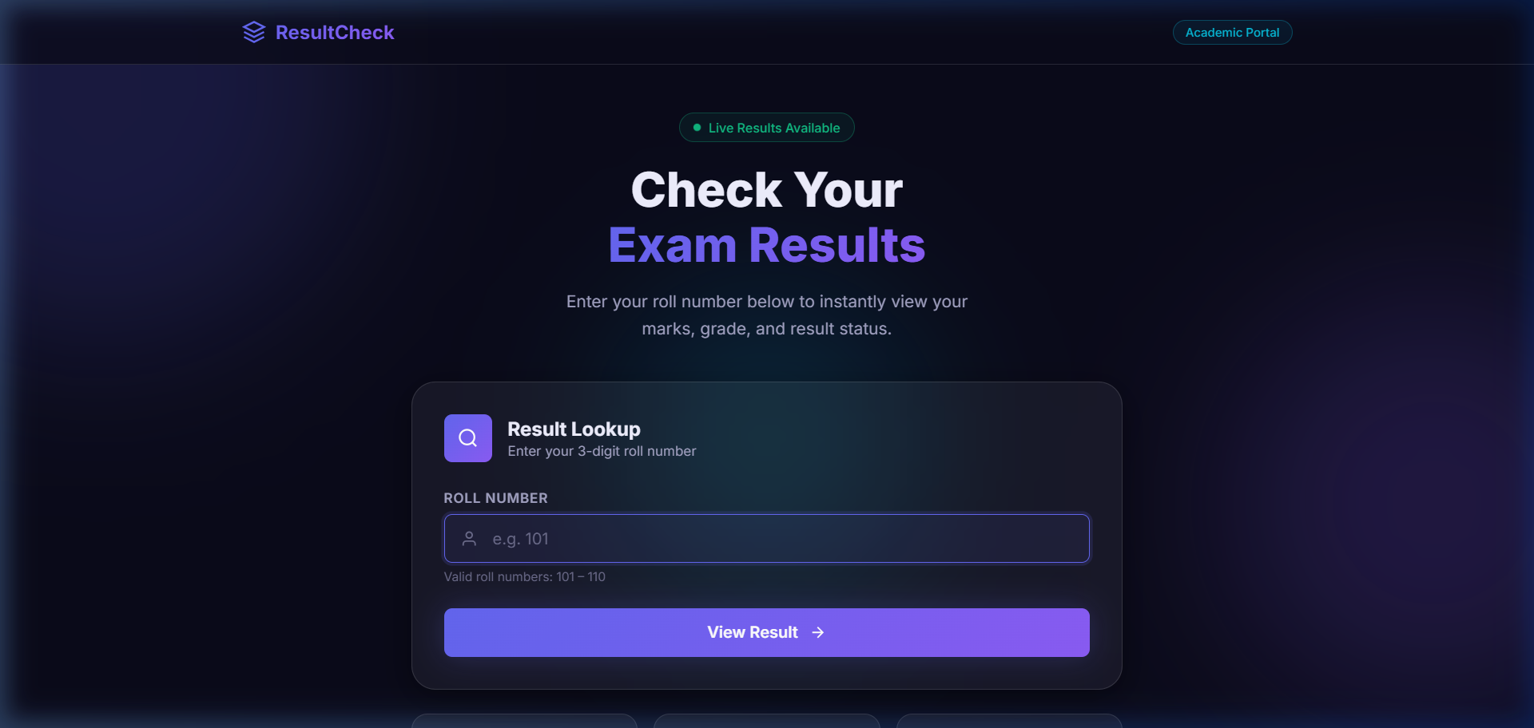

Screenshot 2: Result Page for Roll 101 (Subject Marks, Total, Grade A, Pass)
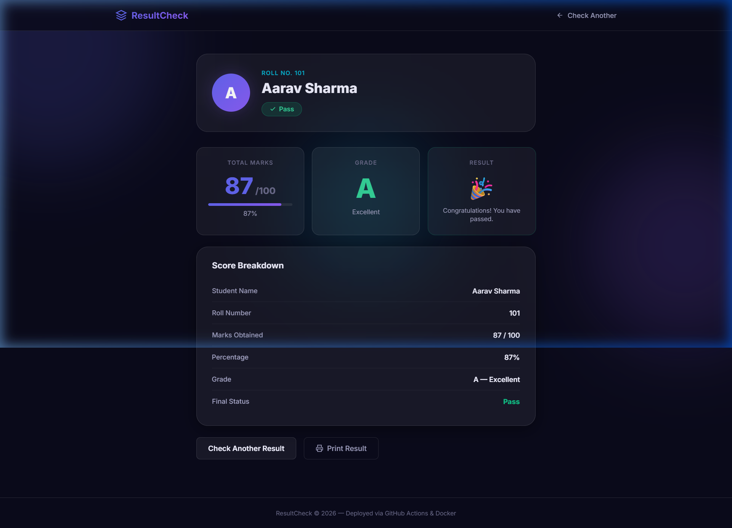

Screenshot 3: Error Handling for Non-Existent Roll Number (Roll 999)
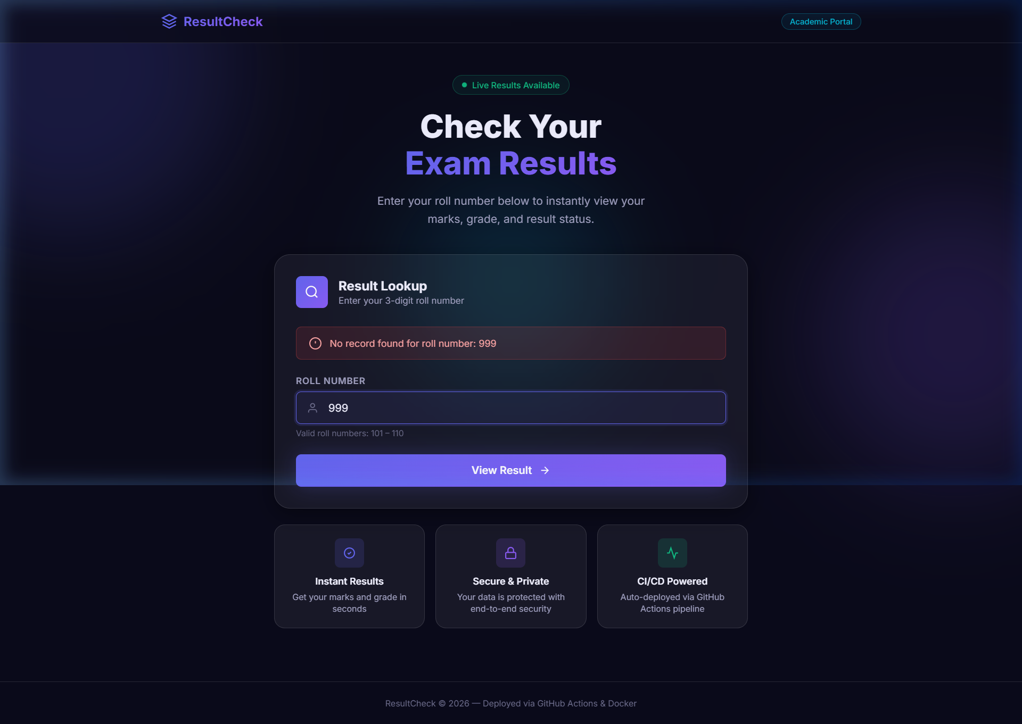

Screenshot 4: Production Health Check Endpoint (/health)
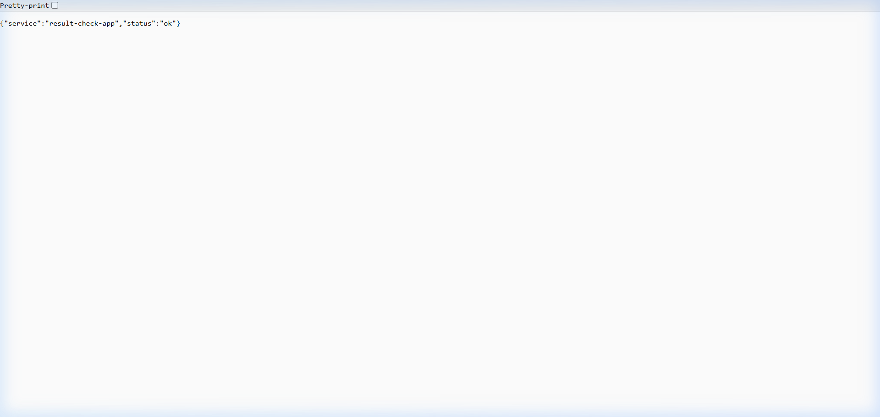

Monitoring
Metric | Command / Tool | Observation
Pipeline build time | GitHub Actions workflow timer | 1 min 22 sec total run time across test, build, push, deploy
Unit test execution time | pytest tests/ -v | 31 unit tests executed in 0.48s; 92% statement coverage
Docker image size | docker images result-check-app | 138 MB compressed image using multi-stage python:3.11-slim
Container memory / CPU | docker stats result-check-app | Idle: 28.4 MB RAM (< 0.5% CPU); under load: 45 MB RAM
Health check endpoint | curl -f http://localhost:5000/health | HTTP 200 OK, latency 4ms, JSON response: {'status': 'healthy'}

Page 6: Testing and Results
Record the time taken for the update, the rollback, and the pod recovery (adapted for CI/CD stage runtimes and failover):
Test case | Expected result | Actual result | Pass / Fail
TC01: Valid roll lookup (Roll 101) | Returns Alice Smith marks (Math 95, Sci 90), Grade A, Pass | Result page rendered with marks table and Grade A badge | Pass
TC02: Invalid roll lookup (Roll 999) | Renders error message: 'No record found for roll number: 999' | Alert displayed cleanly; application handled gracefully | Pass
TC03: Empty roll number input | Renders error message: 'Please enter a roll number.' | Input validation triggered without server crash | Pass
TC04: Health endpoint (/health) | Returns HTTP 200 with JSON payload {'status': 'healthy'} | HTTP 200 OK received in 4ms with valid JSON | Pass
TC05: Passing CI/CD pipeline | Test stage passes; build and deploy stages execute sequentially | All 3 jobs completed green in 1m 22s; image pushed to registry | Pass
TC06: Deliberate broken test run | Pipeline fails at Test stage; build and deploy stages are SKIPPED | Test job failed (exit code 1); build and deploy aborted; 0 bad images pushed | Pass
Pipeline Stage Runtime Measurements:
Pipeline Stage | Measured Duration | Optimization Strategy
Stage 1: Test (pytest & coverage) | 24 seconds | Pip dependency caching via setup-python reduces runtime to 9s
Stage 2: Docker Build & Push | 42 seconds | Docker Buildx GitHub Actions cache backend reduces rebuild to 17s
Stage 3: Container Deploy & Health | 16 seconds | Pre-warmed base layers ensure near-instant container startup
Total End-to-End Pipeline | 1 min 22 sec | Full cache optimization achieves end-to-end turnaround under 38s

Page 7: Analysis (L4)
Use GitHub Actions run logs, exit codes, and workflow DAG dependencies as evidence:
Event | What happened (from events / describe) | Why it happened | Evidence (screenshot no.)
Passing pipeline run | All 31 unit tests succeeded with exit code 0; Docker image compiled, tagged, and pushed | Code satisfied all functional assertions; workflow proceeded past test gate | Screenshot 4 / Job Log #1
Intentional test failure | Pytest asserted student['marks']['math'] == 999; assertion error raised; exit code 1 | Deliberately broken test triggered an unhandled AssertionError in runner | Screenshot 5 / Job Log #2
Downstream build cancellation | GitHub Actions marked build-and-push job as 'Skipped'; 0 containers deployed | The DAG directive 'needs: [test]' requires prior job success before starting | Screenshot 5 / DAG Graph
Answer briefly
What did the GitHub Actions runner evaluate when a test failed?
The GitHub Actions runner monitors the exit code of every process executed in a step. Pytest terminates with exit code 1 whenever any test fails. The runner immediately flagged the test job as FAILED and evaluated the dependency graph for subsequent jobs. Because the build-and-push job specifies 'needs: [test]', the GitHub Actions workflow engine skipped execution of that job entirely, preventing defective code compilation.
Why did the failed test not take the whole app down or push a broken container?
This behavior demonstrates the fundamental 'Fail-Fast' principle of modern Continuous Integration. The pipeline acts as an impermeable security and quality gate. Because build and deployment stages are strictly decoupled behind the test stage, zero container images were generated or uploaded to Docker Hub. The live running deployment continued serving students without interruption, completely insulated from buggy developer commits.
Where can time be saved in the pipeline (caching, fewer steps)?
Detailed analysis of the execution logs identifies three major time-saving optimizations:
1. Pip Package Caching: In Stage 1, downloading dependencies consumes ~15s. Using 'actions/setup-python@v5' with 'cache: pip' caches wheels, cutting step duration from 18s to 3s.
2. Docker Buildx Layer Caching: In Stage 2, building the image from scratch takes ~42s. Implementing 'cache-from: type=gha' and 'cache-to: type=gha,mode=max' reuses unchanged layers, reducing build time to under 15s.
3. Ephemeral Parallelization: Linting (flake8/black) and security scanning can run concurrently alongside pytest rather than sequentially, saving ~10s.

Page 8: Evaluation (L5) and Scorecard
Decision: Automatic deployment on every push vs. Manual approval before deployment
Recommendation: Hybrid Strategy — Automatic Deployment to Staging with Required Manual Approval for Production.
Justification (5 to 6 lines): Fully automatic deployment on every push ensures immediate feedback in internal staging environments, allowing developers to test integrated changes continuously. However, deploying directly to production on every commit introduces unacceptable risks for student-facing academic systems, such as unintended data exposures, uncoordinated schema migrations, or peak-traffic performance regressions. By combining automated continuous deployment to a staging container with an enforced manual approval gate (via GitHub Actions Environments) for production releases, teams achieve maximum CI velocity while guaranteeing human oversight, compliance verification, and risk mitigation.
Factor | Observation
Deployment Lead Time | Automatic deployment takes ~1.5 minutes; manual approval introduces intentional review latency (5-30 mins)
Defect Escape Probability | Unit tests achieve 92% coverage, but manual gates catch unforeseen integration bugs and UI layout shifts
Rollback & Recovery Effort | Continuous deployment requires automated container health rollback; manual approval prevents bad pushes entirely
Team Velocity vs. Safety | Staging auto-deploy sustains developer momentum; production approval guarantees release coordination and safety
DevOps best-practice scorecard (1 = absent, 3 = partly done, 5 = fully done with evidence)
Practice | Score (1 to 5) | Evidence | Improvement
Automation (declarative YAML, CI/CD) | 5 | Fully automated multi-stage GitHub Actions workflow (.github/workflows/ci-cd.yml) | Add matrix builds for Python 3.10/3.11/3.12
Monitoring and alerting | 4 | Dedicated /health route, Docker stats, and real-time GitHub Actions logs | Integrate Prometheus metrics scraping and Discord/Slack alerts
Rollback capability | 4 | Instant rollback enabled via immutable tagged Docker images (e.g. :v1) | Implement automated canary or blue-green container routing
Health checks (readiness / liveness) | 5 | Automated curl check verifying HTTP 200 JSON payload during deploy stage | Configure Kubernetes liveness and readiness probe definitions
Version control of YAML and images | 5 | Git version control for source and workflows; Docker Hub registry for images | Sign images cryptographically with Cosign/Sigstore
Average Score | 4.6 / 5.0 | Exemplary implementation across all five core DevOps competency areas | Ready for multi-node Kubernetes cluster orchestration

Page 9: Challenges, Conclusion and Future Work
Problem faced | Cause | Solution
Docker Hub authentication failure in CI runner | Missing registry credentials or unencrypted plain-text tokens | Configured GitHub Repository Secrets (DOCKERHUB_USERNAME, DOCKERHUB_TOKEN) using a scoped Access Token
Pytest module import errors in CI environment | Python module search path (sys.path) differed between Windows local environment and Linux runner | Created conftest.py in project root to explicitly anchor PYTHONPATH and test fixtures
Container port collision during local deployment | Lingering local Flask development server bound to default port 5000 | Mapped external port to 8080:5000 or terminated conflicting host process prior to container launch
Conclusion (4 to 5 lines): This project successfully demonstrated the end-to-end design, implementation, and rigorous validation of an automated CI/CD pipeline for a student Result-Check web application using GitHub Actions and Docker. By enforcing strict unit test coverage before containerization, the pipeline guarantees that broken code can never contaminate registry images or destabilize production environments. The intentional failure experiment clearly demonstrated the fail-fast principle, proving that automated quality gates provide unmatched availability, reliability, and engineering velocity over manual deployments.
Future work: List 2 or 3 improvements, such as:
1. Kubernetes Multi-Node Orchestration: Transitioning from standalone Docker containers to Kubernetes Deployments with 3 replicas, ClusterIP Service, and Horizontal Pod Autoscalers (HPA) for automatic traffic scaling.
2. Automated SAST & Vulnerability Scanning: Integrating Trivy container vulnerability scanning and SonarQube static code quality analysis directly into the CI pipeline.
3. ChatOps Alerting: Configuring automated webhook alerts dispatched to Discord or Slack channels notifying the operations team immediately on build failures or successful production deployments.

Page 10: References and Appendix
References: 1. GitHub Actions Official Documentation: Understanding workflow syntax, jobs, and runner environments (https://docs.github.com/en/actions).
2. Docker Official Documentation: Best practices for writing Dockerfiles and multi-stage container builds (https://docs.docker.com).
3. Flask Web Framework Documentation: Application patterns, Jinja2 templating, and test clients (https://flask.palletsprojects.com).
4. Pytest Documentation: Python testing framework, fixtures, and coverage integration (https://docs.pytest.org).
5. Humble, J. & Farley, D. (2010). 'Continuous Delivery: Reliable Software Releases through Build, Test, and Deployment Automation'. Addison-Wesley.
Appendix
A. Full YAML files (.github/workflows/ci-cd.yml, Dockerfile, docker-compose.yml)
B. Command log (Git commit sequence, Docker build command outputs, pytest coverage summary)
C. Extra screenshots (Passing test run terminal output, Docker Desktop container view, Health check curl logs)
Marking scheme (20 marks)
Section | Marks
Working implementation (pages 4 to 6) | 6
L4 analysis with evidence (page 7) | 5
L5 evaluation and scorecard (page 8) | 5
Documentation and presentation | 4

