

Word Template for Computer-Aided Design and Applications Journal
John C. Gotti¹ , Jessie A. James² and Donald L. Corleone³

¹City University of New York, gotti@cityuny.edu
²Texas State University, Jessie@tsu.edu
³DLC and Associates, don@dlc.com

Corresponding author: John C. Gotti, gotti@cityuny.edu

Abstract. This document outlines the necessary details to prepare a paper for the journal Computer-Aided Design and Applications. Authors are requested to follow all formatting instructions encoded into this MS Word file. To simplify the task of document preparation, simply enter your paper into this file by substituting equivalent titles and paragraphs of instructions with your technical text.

Keywords: select at least three words or phrases that best describe your paper.
DOI: https://doi.org/10.14733/cadaps.2022.aaa-bbb

INTRODUCTION
This template file contains all relevant information to process papers into the right format for the journal CAD and Applications. Please do not change the preset styles. Either type your paper directly into this file, substituting appropriate paragraphs and headings, or bring in your text in a plain format and then change it to the appropriate style by simply selecting the intended style from the menu in the MS-Word toolbar.
The following sections summarize the parameters used in the various pre-set styles. You should never really have to deal with these parameters directly, but only select one of the pre-formatted styles. But for completeness of documentation this information is given here, so that future managers of this template may more easily make selective changes to some of the styles.
In general, a first paragraph (style Paragraph_first) after a title, figure, or table is not indented; but subsequent paragraphs following ordinary paragraphs (style Paragraph_following) have their first line indented by 0.25 inches.

PAGE SETUP
Each page is set up by this MS Word template; however, in case settings get lost, here are the details:
- Paper size: 7.5" by 10.3"
- Top and bottom margins: 1"
- Left and right margins: 0.6"
- Headers and footers are 0.5" from the edge
- Column format: one column
Page numbers have been included already and will be adjusted when the paper is desk-edited for publication. Please do not remove or edit the page numbers!
Throughout the whole paper the font Sans Serif is used. The header block of each paper is preformatted with a header figure and two extra lines of text. This is followed by a 12-point bold title, which should be no longer than one line, or at most two, if it is absolutely necessary. Only well known abbreviations are allowed, such as NURBS, STL or IGES. The initial letters of each word should be capitalized, except for: the, a, and, or, for, in, from, etc.
Authors and affiliations are again in 9-point Sans Serif – as is most of the paper. Authors and affiliations are separated by a single blank line. Please add the ORCID hyper-link to the ORCID icons.
This is followed by the abstract, which both carry their own built-in spacing from the previous text elements. The abstract is indented on both sides by 0.5". It should be kept short and concise.
The abstract block also carries the Keywords and the DOI entries, separated from the abstract by a single blank line.

main text
The main text is in one-column format and is all based on 9-point Sans Serif. Throughout the paper, ordinary text should be placed left and right justified.
The main text consists primarily of paragraphs and headings, and these all carry their own spacing to the previous text elements; they also call for the most likely subsequent paragraph style. Of course, this can, be overridden by simply selecting an item and pulling down a different style from the tool-bar menu. Main headings are all in BOLD CAPITALS. They should be consecutively numbered, starting with 1 (which is done automatically with the style 1 HEADING_1).

Subsection Headings Use the Capitalization Rules of the Main Title
The heading of a subsection should also be in 9-point Sans Serif bold, flush left, however, only the initial letters should be capitalized. Note that for subsections and for sub-subsections the words the, a, and, in, for, etc are not capitalized, unless they are the first words.

Sub-subsections use mostly lower case
Sub-subsections can be used to give the document additional hierarchical structure. But deep hierarchies should be avoided. Don’t use more than three hierarchical levels of headings. Sub-subheadings have only the initial letters capitalized. This applies to all sub-subsections, e.g. 3.1.1.1 or 3.1.1.1.1, etc. -- if you absolutely must use them.

Figures and Tables
The insertion of figures and tables requires special attention. First, each figure must be inserted where it belongs, as close to the figure reference as possible. Second, the selection of the file type makes a big difference in the file size of your paper. Please use the following formats:
- Bitmaps: JPG
- Line drawings: any line drawing format, e.g. PS, EPS, WMF, PNG.
Please do not scan line drawings as bitmaps! It takes a very large file to get adequate quality!
Third, the image resolution does not have to be high for good quality publishing. As a rule of thumb, no need to go higher than 300 pixels per inch. Finally, and most importantly, please scale the image down to the size of your MS Word document, with 100% paper size window, before inserting the picture. That is:
- estimate the image size in your MS Word document;
- scale the image down using an image processing software, e.g. MS Photo Editor;
- save the scaled-down image into a temporary folder; and
- insert the scaled-down picture into your paper.

An MS Word document can be as large as 10 MB, but still convey no more than 1 MB worth of information, if the figures are improperly processed! Figures should be inserted centered. In order to save space, you may want to insert them side-by-side if they are logically linked together. Color as well as black and white images are accepted. Each figure (group) must include a caption set in 9-point Sans Serif. The caption is to be centered if it is short, otherwise left and right justified. Figure numbering and referencing should be done sequentially, e.g. Figure 1, Figure 2, etc. for single figures, and Figure 1(a), Figure 1(b), etc. for figures with multiple parts. Put a blank line before and after the figure.

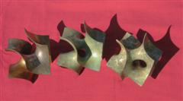

Figure 1: Short, centered caption, terminated with a full stop.

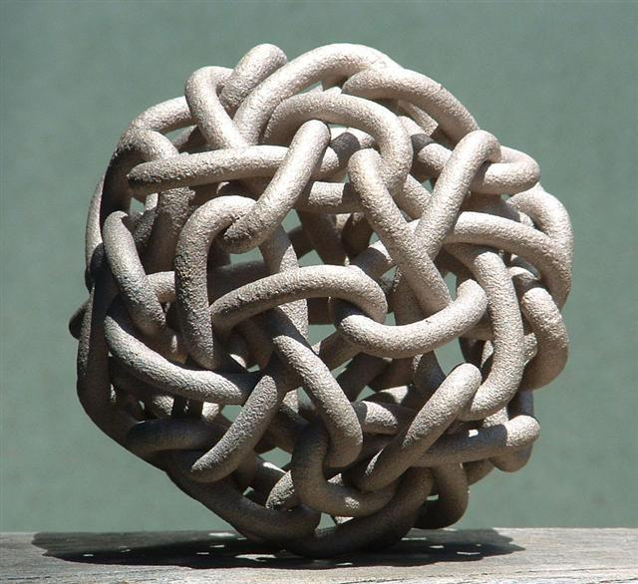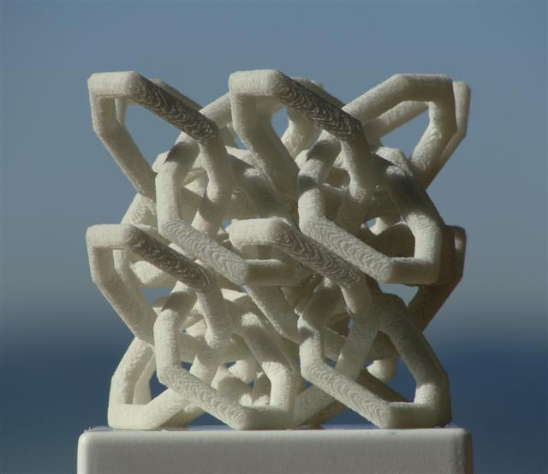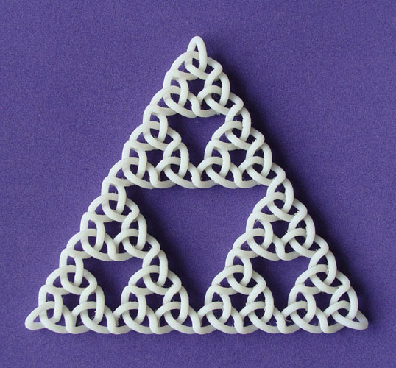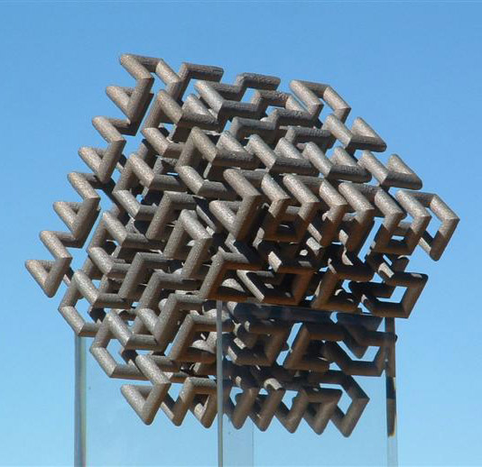

Figure 2: Here is a longer caption that is left/right justified. It has multiple components that are referred to from left to right. Knotty Sculptures: (a) Hilbert Cube, (b) Dodeca-Pentafoil, (c) Recursive Trefoil Knot, and (d) Lattice of Figure-8 Knots.

Tables should be inserted close to their reference, centered, and captioned, just like figures. Table captions are the same as figure captions, e.g. Table 1, Table 2, etc. or Table 1(a), Table 1(b), etc. Table captions should be in 9-point Sans Serif. Cell entries can be centered or left/right justified. Please follow the same format as for figures. Put a blank line before and after the table.

Date | Code | Amount
3/10/2004 | HS_129 | 234.44
3/11/2004 | LL_78 | 12.98

Table 1: Again, short captions should be centered under each table.

Mathematics
Math typesetting should be done by Math Type. Style settings (define) for Math Type are as follows:
- Primary font: Euclid
- Greek and math fonts: Euclid symbol and Euclid extra
- Italic variables and italic lower-case Greek

Size settings (define) are these:
- Full 9pt
- Sub/super 6pt
- Sub-sub/super 4pt
- Symbol 16pt
- Sub-symbol 10pt
- User 1 75%
- User 2 150%
Symbols and shorter expressions can be placed within the text, e.g. 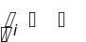. More complex expressions should be placed in a new line in display style:
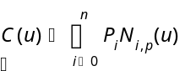 (8.1)
All equations must be centered and numbered according to the section they appear. They should be referenced just like figures, e.g. Equation (8.1).

References and Citations
References should be listed alphabetically at the end of the paper. The listing as well as the citations should be done by numbers in brackets, e.g. [1]. Block references are allowed in the form [3-6]. Single and block references can be combined, e.g. [1],[3],[5-9],[15]. The typesetting of references should follow the format given at the end of this document. They should be published materials accessible to the public with reasonable effort and without significant expense. References to be avoided are:
- private communications;
- technical reports, unless they are available, e.g. downloadable from a web site;
- proprietary information/documents;
- dissertations, unless they can be obtained for free, e.g. downloadable from a web site;
- all non-English publications; and
- non-archival speeches and presentations.
References can include the usual material, e.g. journal articles, conference papers (refereed or non-refereed), and books or book chapters. In addition to these, acceptable references also include web sites, e-papers, accessible government documents, e.g. patents, and all audio-visual materials, e.g. VR simulation, that are available to the public either electronically or in hard copy format, e.g. on a CD.

Footnotes
Please avoid using footnotes. If an explanation is required for an abbreviation or a special term, do it within the text. The footers in this template are reserved for journal citation purposes.

Each author should have an ORCID (http://orcid.org). Please insert the ORCID link into the icons next to your name. Also, please list the ORCID links for each authors as listed below.

John C. Gotti, http://orcid.org/[ORCID]
Jessie A. James, http://orcid.org/[ORCID]
Donald L. Corleone, http://orcid.org/[ORCID]

REFERENCES
- Adams, S.-H.; Yang, M.-Y.: A study on a generalized parametric interpolator with real-time jerk-limited acceleration, Computer-Aided Design, 36(1), 2004, 27-36. http://doi.org/10.1016/S0010-4485(03)00066-6
- Bates, J.; Ding, M.-S.; Park, J.: A Study on Rapid Prototyping Techniques, TR UMCP-97-003, University of Massachusetts, Boston, MA, 1997, http://www.um.edu/~bates.html.
- Debra, N. L.: Principles of Mechanical Design, Oxford University Press, New York, NY, 1990.
- Eaton, J. A.: Layered Manufacturing Methods for Reconstructing Bone Structures, Ph.D. Thesis, University of Minnesota, Twin Cities, MN, 1998.
- Hepworth, A. I.; Nysetvold, T.; Bennett, J.; Phelps, G.; Jensen, C. G.: Scalable integration of commercial file types in multi-user CAD, Computer-Aided Design & Applications, 11(4), 2014, 459-467. http://doi.org/10.1080/16864360.2014.881190
- Jewelspace, http://www.jewelspace.net, Caligari Software.

Please follow the format shown above. That is:
- author names are listed by last name;
- multiple authors are separated by a semi-colon;
- after the last author’s name place a colon;
- list the title and the journal separated by a comma; and
- the journal details are Volume (Issue), Year, Pages.
For books, thesis, etc, please list the title, publisher, place and year of publication.

