

Title:

Word Template for CADxx Extended Abstracts
Authors:
John C. Gotti, gotti@cityuny.edu, City University of New York
Jessie A. James, Jessie@tsu.edu, Texas State University
Donald L. Corleone, don@dlc.com, 3DLC and Associates
Keywords:
Rapid Prototyping, FDM, Z-Printer, Surface Finish, Dimensional Accuracy, Process Optimization

DOI: 10.14733/cadconfP.2021.xxx-yyy

Introduction:
This template file is to be used for preparing the annual International Computer-Aided Design Conference 5-page extended abstracts. Please do not change the preset styles. Either type your extended abstract directly into this file, substituting appropriate paragraphs and headings, or bring in your text in a plain format and then change it to the appropriate style by simply selecting the intended style from the menu in the MS-Word toolbar.
The following sections summarize the parameters used in the various pre-set styles. You should never really have to deal with these parameters directly, but only select one of the pre-formatted styles. In general, a first paragraph after a title, figure, or table is not indented; but subsequent paragraphs following ordinary paragraphs have their first line indented by 0.25 inches.

Page Setup:
Each page is set up by this MS Word template. In case settings get lost, here are the details:
- Paper size: 7.5" by 10.3"
- Top and bottom margins: 1"
- Left and right margins: 0.6"
- Column format: one column
Throughout the whole extended abstract the Lucida Bright 9-point font is used. Only well-known abbreviations are allowed, such as NURBS, STL or IGES.

Main Sections:
The main sections are formatted in one-column format. Throughout the extended abstract, ordinary text should be placed left and right justified. The main text consists primarily of paragraphs and headings, and these all carry their own spacing to the previous text elements; they also call for the most likely subsequent paragraph style. Main headings are all underlined but not numbered, with 10 points extra space above. A typical arrangement of the main sections of the extended abstract may be as follows:
- Introduction. One-to-two paragraphs at the most. Outline the problem domain and prior approaches.
- Main Idea. Present the main idea behind your solution and contribution.
- Conclusions. One simple paragraph should do it. Note that there is a difference between a summary and conclusions. Be clear what you want to say to round off your extended abstract.
- Acknowledgements. You may want to acknowledge sponsorships or special assistance of colleagues. This section should be kept very short.
- References. Select only the most appropriate references.
- Appendix. Should be avoided in an extended abstract.

Subsection Headings
The heading of a subsection should be flush left and italicized, with no extra space above. Sub-subsections should not be used.

Figures and Tables:
Where required, each figure must be inserted as close to the text reference as possible. Please use only the following image formats:
- Bitmaps: JPG
- Line drawings: any line drawing format, e.g. PS, EPS, WMF.
Figures should be inserted centered. In order to save space, you may want to insert them side-by-side if they are logically linked together. Color as well as black and white images are accepted. Each figure (group) must include a caption set in Lucida Bright 9-point. The caption is to be centered if it is short, otherwise left and right justified. Figure numbering and referencing should be done sequentially, e.g. Fig. 1., Fig. 2., etc. for single figures, and Fig. 1(a)., Fig. 1(b)., etc. for figures with multiple parts. Put a blank line before and after the figure.

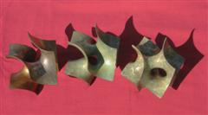

Fig. 1: Short, centered caption, terminated with a full stop.

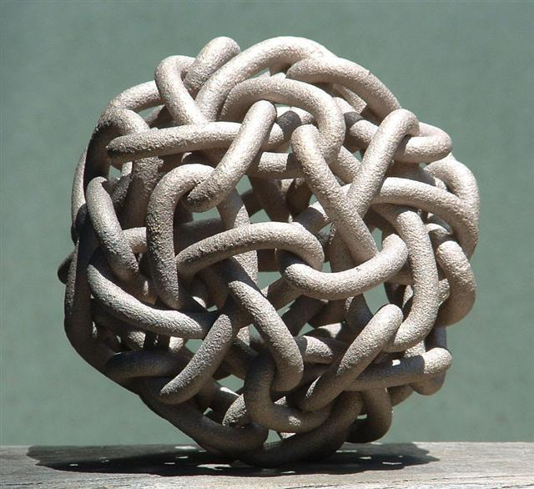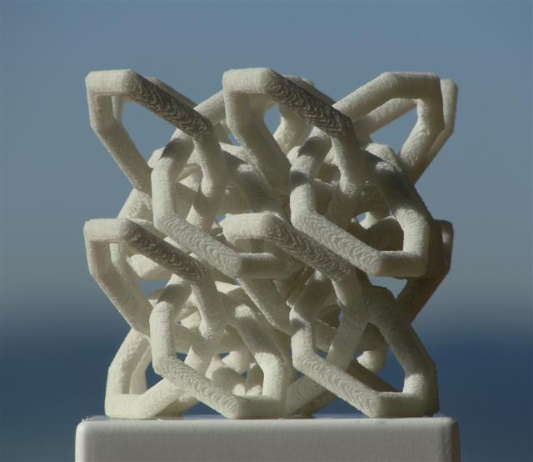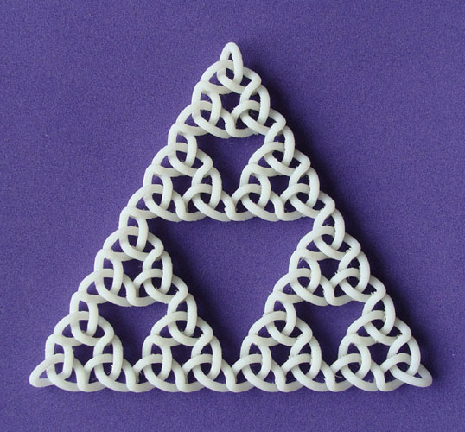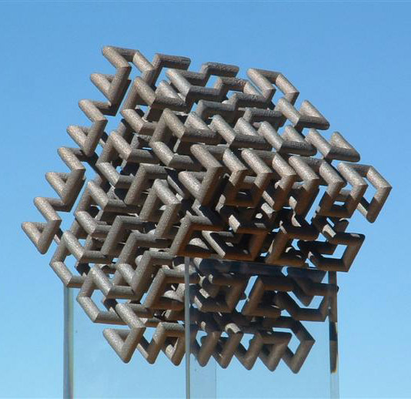

Fig. 2: Here is a longer caption that is left/right justified. It has multiple components that are referred to from left to right. Knotty Sculptures: (a) Hilbert Cube, (b) Dodeca-Pentafoil, (c) Recursive Trefoil Knot, and (d) Lattice of Figure-8 Knots.

Any tables should be inserted close to their text reference, centered, and captioned. Table captions are Tab. 1., Tab. 2., etc. or Tab. 1(a)., Tab. 1(b)., etc. Table captions should be in 9-point Lucida Bright. Any table format is acceptable as long as the entries are clearly visible and the content is understandable. Cell entries can be centered or left/right justified. Please follow the same format as for figures, i.e. the table caption is not bold, italics, etc, and it is abbreviated to Tab. Put a blank line before and after the table.

Date | Code | Amount
3/10/2004 | HS_129 | 234.44
3/11/2004 | LL_78 | 12.98

Tab. 1: Again, short captions should be centered under each table.

Mathematics:
Math typesetting should be done by Math Type or equivalent. Style settings (define) for Math Type are as follows:
- Primary font: Euclid
- Greek and math fonts: Euclid symbol and Euclid extra
- Italic variables and italic lower-case Greek

Size settings (define) are these:
- Full 9pt
- Sub/super 6pt
- Sub-sub/super 4pt
- Symbol 16pt
- Sub-symbol 10pt
- User 1 75%
- User 2 150%
Symbols and shorter expressions can be placed within the text, e.g. 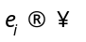. More complex expressions should be placed in a new line in display style:
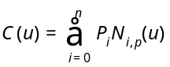 (8.1)
All equations must be centered and numbered according to the section they appear. They should be referenced just like figures, e.g. Eqn. (8.1).

References and Citations:
References should be listed alphabetically at the end of the extended abstract. The listing as well as the citations should be done by numbers in brackets, e.g. [1]. Block references are allowed in the form [3-6]. Single and block references can be combined, e.g. [1],[3],[5-9],[15]. The typesetting of references should follow the format given at the end of this document. They should be published materials accessible to the public with reasonable effort and without significant expense. References to be avoided are:
- private communications;
- technical reports, unless they are available, e.g. downloadable from a web site;
- proprietary information/documents;
- dissertations, unless they can be obtained for free, e.g. downloadable from a web site;
- all non-English publications; and
- non-archival speeches and presentations.
References can include the usual material, e.g. journal articles, conference papers (refereed or non-refereed), and books or book chapters. In addition to these, acceptable references also include web sites, e-papers, accessible government documents, e.g. patents, and all audio-visual materials, e.g. VR simulation, that are available to the public either electronically or in hard copy format, e.g. on a CD.

Footnotes:
Please avoid using footnotes. If an explanation is required for an abbreviation or a special term, do it within the text.

References:
- Adams, S.-H.; Yang, M.-Y.: A study on a generalized parametric interpolator with real-time jerk-limited acceleration, Computer-Aided Design, 36(1), 2004, 27-36. https://doi.org/10.1016/S0010-4485(03)00066-6
- Bates, J.; Ding, M.-S.; Park, J.: A Study on Rapid Prototyping Techniques, TR UMCP-97-003, University of Massachusetts, Boston, MA, 1997, http://www.um.edu/~bates.html.
- Hepworth, A. I.; Nysetvold, T.; Bennett, J.; Phelps, G.; Jensen, C. G.: Scalable integration of commercial file types in multi-user CAD, Computer-Aided Design & Applications, 11(4), 2014, 459-467. https://doi.org/10.1080/16864360.2014.881190
- Debra, N. L.: Principles of Mechanical Design, Oxford University Press, New York, NY, 1990.
- Eaton, J. A.: Layered Manufacturing Methods for Reconstructing Bone Structures, Ph.D. Thesis, University of Minnesota, Twin Cities, MN, 1998.
- Jewelspace, http://www.jewelspace.net, Caligari Software.

Please follow the format shown above. That is:
- author names are listed by last name;
- multiple authors are separated by a semi-colon;
- after the last author’s name place a colon;
- list the title and the journal separated by a comma;
- the journal details are Volume (Issue), Year, Pages; and
- add the full DOI link if it is available.
For books, thesis, etc, please list the title, publisher, place and year of publication.

IMPORTANT NOTE: WE ARE REQUIRED BY CROSSREF TO INCLUDE HYPERLINK INTO EVERY REFERENCE THAT HAS DOI LINKING. PLEASE GO TO:
http://www.crossref.org/SimpleTextQuery/

REGISTER YOUR E-MAIL, CUT AND PASTE THE LIST OF REFERENCES INTO THE BOX, GET THE DOI LINKS AND PASTE THEM INTO YOUR PAPER! THE LINKS SHOULD LOOK LIKE THIS, I.E. USE HTTPS AND DROP THE DX:

https://doi.org/10.1080/16864360.2014.881190

