PhD Defence

21st January, 11am, Dept. of Tech, SPPU, Pune

# A day before

# On the day, before 11am

# During

# Post

# Monday

# Notes

## FEM

* Useful for problems with complicated geometries, loadings, and material properties where analytical solutions cannot be obtained
* Dof : 6, number of parameters needed to fix an entity in space.
* Obtain a set of algebraic equations to solve for unknown (first) nodal quantity (displacement/temperature etc.)
* Secondary quantities (stresses and strains) are expressed in terms of nodal values of primary quantity Object
* Elements

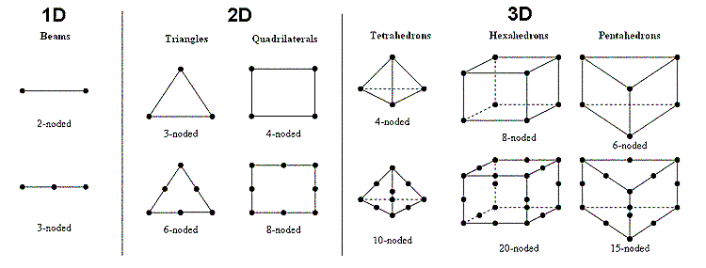

* Basic Equation
$Mass×acceleration+Damping×velocity +Stiffness×displacement=External force$

$M\frac{d^{2}x}{dt^{2}}+C\frac{dx}{dt}+Kx=F(t)$

$Inertia force+Damping force +Internal resistance force=External force$

$\left[\begin{aligned} k1 -k2 \\ -k1 k2\end{aligned}\right]\left\{\begin{aligned}δ_{1} \\ δ_{2}\end{aligned}\right\}=\left\{\begin{aligned}F_{1} \\ F_{2}\end{aligned}\right\}$

* Stress Tensor

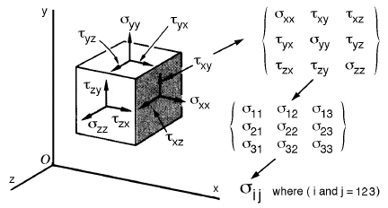

Plane Stress: load on thickness, sigma_z and shear tau_xz and tau_yz are assumed zero

Plane Strain: loads in xy, epsilon_z &shear strains gamma_xz and gamma_yz are assumed zero

Von mises stress: failure condition.

Principal stresses are combination of normal and shear stresses

Linear Static:

Displacements, strains, stresses, and reaction forces under the effect of applied loads are calculated.

Nonlinearity:

Geometry (shape changes)

Material (non-elastic)

Contact

# Questions

1. Can you start by summarising your thesis?

2. Now, can you summarise it in one sentence?

3. What is the idea that binds your thesis together?

4. What motivated and inspired you to carry out this research?

5. What are the main issues and debates in this subject area?

6. Which of these does your research address?

7. Why is the problem you have tackled worth tackling?

8. Who has had the strongest influence in the development of your subject area in theory and practice?

9. Which are the three most important papers that relate to your thesis?

10. What published work is closest to yours? How is your work different?

11. What do you know about the history of [insert something relevant]?

12. How does your work relate to [insert something relevant]?

13. What are the most recent major developments in your area?

14. How did your research questions emerge?

15. What were the crucial research decisions you made?

16. Why did you use this research methodology? What did you gain from it?

17. What were the alternatives to this methodology?

18. What would you have gained by using another approach?

19. How did you deal with the ethical implications of your work?

20. How has your view of your research topic changed?

21. How have you evaluated your work?

22. How do you know that your findings are correct?

23. What are the strongest/weakest parts of your work?

24. What would have improved your work?

25. To what extent do your contributions generalise?

26. Who will be most interested in your work?

27. What is the relevance of your work to other researchers?

28. What is the relevance of your work to practitioners?

29. Which aspects of your work do you intend to publish – and where?

30. Summarise your key findings.

31. Which of these findings are the most interesting to you? Why?

32. How do your findings relate to literature in your field?

33. What are the contributions to knowledge of your thesis?

34. How long-term are these contributions?

35. What are the main achievements of your research?

36. What have you learned from the process of doing your PhD?

37. What advice would you give to a research student entering this area?

38. You propose future research. How would you start this?

39. What would be the difficulties?

40. And, finally… What have you done that merits a PhD?

