First Wikipedia article on Midsurface

Computer-aided Design (CAD) models of thin-walled solids such as sheet metal/plastic parts are often reduced dimensionally to their corresponding midsurfaces for quicker Computer-aided Engineering (CAE) analysis, while still maintaining fairly accurate results. Midsurface can be envisaged as a surface lying midway of a thin-walled solid, mimicking its shape. In CAE analysis, instead of using expensive 3D elements, 2D elements are used on the midsurface for fairly accurate results in lesser computations/time.

One of the major impediments in the development of the algorithm for automatic computation of the midsurface, is the lack of its precise deﬁnition [^1]. Expectations vary, making it hard to develop a formal logic (Figure 1). As seen in Figure 1b, one may want a gradual change between the two midsurface patches at the site of a step, whereas, others may choose to either mimic (Figure 1c) or ignore the step (if within certain limit) and just follow the bigger face (Figure 1d) or just two separate patches representing two diﬀerent thicknesses (Figure 1e).

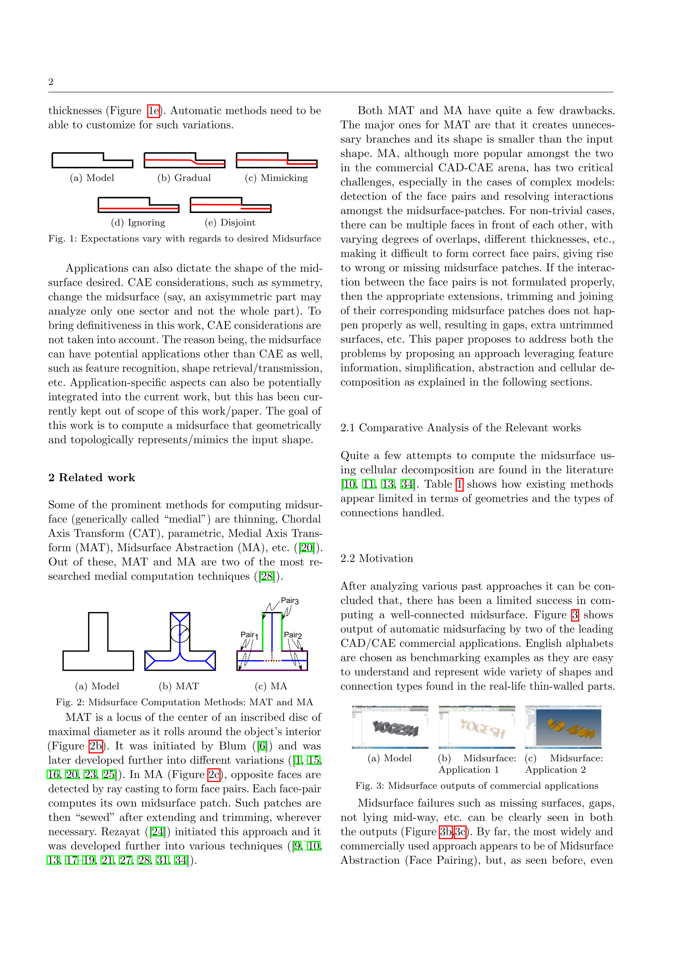

Midsurface is a special case of a more generic structure called “Medial Object”. Medial Axis Transform ([MAT](https://en.wikipedia.org/wiki/Medial_axis)), Chordal Axis Transform (CAT), thinning, Face pairing (Midsurface Abstraction, MA) are some of the methods used for computation of the medial object.



MAT is a locus of the centre of an inscribed disc of maximal diameter as it rolls around the object’s interior (Figure 2b). In MA (Figure 2c), opposite faces are detected by ray casting to form face pairs. Each face-pair computes its own midsurface patch. Such patches are then “sewed” after extending and trimming, wherever necessary.

External References

1. Ramanathan M, Gurumoorthy B (2004) Generating the mid-surface of a solid using 2d mat of its faces. Computer Aided Design and Applications 1:665–674, DOI 10.1080/16864360.2004.10738312

{{AFC submission|d|context|u=Yogeshhkulkarni|ns=118|decliner=SwisterTwister|declinets=20160108205029|ts=20151230105748}} <!-- Do not remove this line! -->

{{AFC comment|1=Still not enough information and sources overall. [[User:SwisterTwister|<font color="green">SwisterTwister</font>]] [[User talk:SwisterTwister|<font color="green">talk</font>]] 20:50, 8 January 2016 (UTC)}}

----

Computer-aided Design (CAD) models of thin-walled solids such as sheet metal/plastic parts are often reduced dimensionally to their corresponding midsurfaces for quicker Computer-aided Engineering (CAE) analysis, while still maintaining fairly accurate results. Midsurface can be envisaged as a surface lying midway of a thin-walled solid, mimicking its shape. In CAE analysis, instead of using expensive 3D elements, 2D elements are used on the midsurface for fairly accurate results in lesser computations/time.

One of the major impediments in the development of the algorithm for automatic computation of the midsurface, is the lack of its precise deﬁnition <ref name="Ramanathan">[http://http://www.tandfonline.com/doi/abs/10.1080/16864360.2004.10738312#.VoO10fl96Uk Ramanathan M, Gurumoorthy B (2004) Generating the mid-surface of a solid using 2d mat of its faces. Computer Aided Design and Applications 1:665–674]</ref>. Expectations vary, making it hard to develop a formal logic.

[[File:WikiMidsurfFig1Expectations.png|thumb|Expectations of Midsurface|center]]

As seen in the Figure, one may want a gradual change between the two midsurface patches at the site of a step, whereas, others may choose to either mimic or ignore the step (if within certain limit) and just follow the bigger face or just two separate patches representing two diﬀerent thicknesses.

Midsurface is a special case of a more generic structure called “Medial Object”. Medial Axis Transform (MAT), Chordal Axis Transform (CAT), thinning, Face pairing (Midsurface Abstraction, MA) are some of the methods used for computation of the medial object.

[[File:WikiMidsurfFig2MedialComputation.png|thumb|Computation of Midsurface|center]]

MAT is a locus of the center of an inscribed disc of maximal diameter as it rolls around the object’s interior. In MA, opposite faces are detected by ray casting to form face pairs. Each face-pair computes its own midsurface patch. Such patches are then “sewed” after extending and trimming, wherever necessary.

==References==

{{reflist}}

<!--- After listing your sources please cite them using inline citations and place them after the information they cite. Please see https://en.wikipedia.org/wiki/Wikipedia:REFB for instructions on how to add citations. --->

*

*

*

*

== Review of "Midsurface" ==

# ToDOs

* Start the article with definition of Midsurface.
* Explain terms like CAD, CAE, thin walled etc and cite wiki pages
  + CAD
  + CAE
  + Thin-walled
  + MAT
  + MA
* Editing
  + '''Knowledge-based engineering''' makes it **Knowledge-based engineering**
  + [[knowledge-based systems]] gives wiki link
  + To add external link in [1] manner, use => <ref>{{cite web|title=Knowledge Based Engineering|url=http://www.technosoft.com/kbe.php|website=http://www.technosoft.com|publisher=Technosoft|accessdate=5 July 2014}}</ref>
  + ==Overview== gives new section
  + ===For CAD=== gives sub section
  + {{external links|date=July 2014}} gives a note box
  + *CADECWorks Solidworks Certified Gold Partner [http://www.Markengg.com] by Mark Design Solutions Pvt Ltd India [http://www.markengg.com Mark Design Solutions] gives external link, without citing
  + [[File:Cad crank.jpg|thumb|Example: 3D CAD model]] to add figure