**Logo/s to be included:**

**Date: 11 March 2023**

**Time:** **4 pm to 5 pm**

**Speaker details**: Dr. Yogesh Haribhau Kulkarni, Principal Architect (CTO Office, Icertis)

**Photo of the speaker (high resolution):**

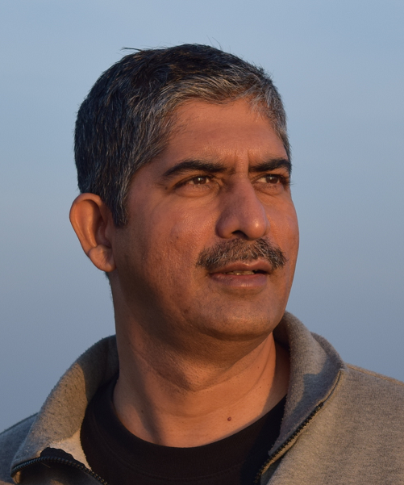

**Title of the talk**: From Zero to ChatGPT

**Abstract:** (word limit only 150)

ChatGPT is next in the series of GPTs (Generative Pre-trained Transformers) coming from OpenAI. They are based on a revolutionary architecture called 'Transformers', initiated by Google. Transformers are based on one of the popular neural network architectures, called 'Encode-Decoder' networks, typically used for Language Modeling (predicting the next word) or Machine Translation.

This talk starts with quick introductions to basic prerequisites such as Artificial Intelligence, Machine Learning, Deep Learning, Natural Language Processing, Word Embeddings, Transformers and then covers the final topic, ChatGPT, what it is, how it works, applications, advantages and disadvantages,