Milind Mulick : Books, Techniques & Tips

Photo: A demo from 'Watercolour Demonstrations' by Milind Mulick. 
To purchase this book online go to the link below.

http://www.jyotsnaprakashan.com/index.php?option=com_zoo&task=item&item_id=513&Item=243

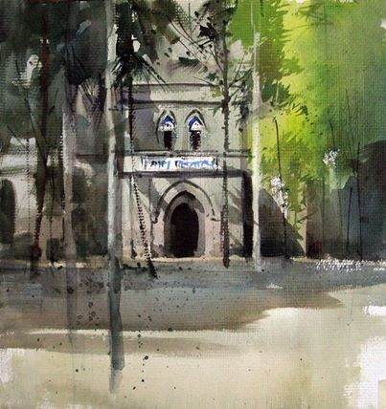

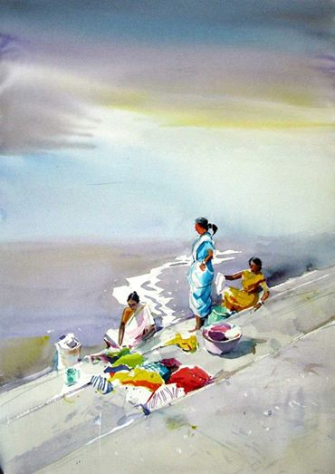

Glazing  
  
To put it simply, glazing means the application of one or more washes upon another which has dried completely. More than three washes can thus be applied, though the brush needs to be moved lightly over the paper so as not to damage the surface or spoil the underlying wash.   
We know that transparency is the hallmark of a good watercolour. The underlying paper is ‘seen’ through a wash. Similarly the first wash is partly seen through the second wash that is applied over it. The result is a third, different tone. This is not the same tone as you will get if the two concerned colours are mixed in a palette and then applied.  
  
Let us now see a painting done using the technique of glazing.   
  
First I applied a variegated wash from top to bottom using lemon yellow and green. I mixed some red at the bottom.  
When this was completely dry, I painted the mountain in cobalt blue (‘coffee’ consistency) with a dash of brown in some places.  
This blue-brown, along with the underlying blue wash has given a unique blueness to the mountain. In places where there was a yellow-green wash, I have added a blue-green wash in some areas. The yellow-green-blue layers on top of each other have given a bright sheen to the fields. When the second wash had dried I used the same blue but slightly thicker (milk), to depict the distant trees. At the same time I painted the embankments in the lower portion of the painting.  
When all this was dry I used thick (cream) blue-green for the foreground coconut trees which have added a feeling of depth. The finer details were added last with a dry brush.  
All the fresh, bright tones in this painting have been possible due to the superimposition of washes. The only precaution required is to move the brush lightly so as not to disturb the underlying layer.  
  
(Watercolour Landscapes Step by Step)

[[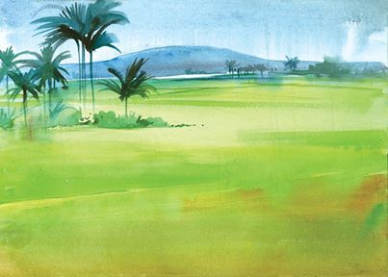](https://www.facebook.com/milindmulickbooks/photos/pcb.296249903865670/296249760532351/?type=1)](https://www.facebook.com/milindmulickbooks/photos/pcb.296249903865670/296249760532351/?type=1)

[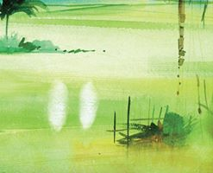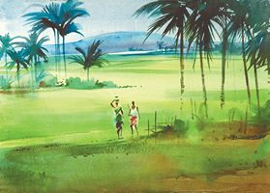](https://www.facebook.com/milindmulickbooks/photos/pcb.296249903865670/296249713865689/?type=1)

Lots of water, lots of colour!  
  
Many of us have begun painting in our school days. We used to take very little paint onto our palette and mix little water into it. This was partly because paints have always been costly.   
  
However if we want transparency, brightness, flow and mixing of colours it is vital to mix up a lot of paint using a lot of water in readiness. Often we need to apply the second layer even before the first has dried. This would be impossible if we ran out of colour midway through.   
  
Also, unless we mix up a lot of paint at a time, we cannot maintain the exact shade we set out with. It becomes very difficult if we keep on opening the tubes every time we run out of colour. We also need to avoid formation of ‘edges’ when a different colour is applied. These edges are absolutely against the 'flowing' nature of a watercolour. So it is better to make it a habit to mix a lot of water when we prepare our palette.

[Photo: Lots of water, lots of colour!

Many of us have begun painting in our school days. We used to take very little paint onto our palette and mix little water into it. This was partly because paints have always been costly. 

However if we want transparency, brightness, flow and mixing of colours it is vital to mix up a lot of paint using a lot of water in readiness. Often we need to apply the second layer even before the first has dried. This would be impossible if we ran out of colour midway through. 

Also, unless we mix up a lot of paint at a time, we cannot maintain the exact shade we set out with. It becomes very difficult if we keep on opening the tubes every time we run out of colour. We also need to avoid formation of ‘edges’ when a different colour is applied. These edges are absolutely against the 'flowing' nature of a watercolour. So it is better to make it a habit to mix a lot of water when we prepare our palette.](https://www.facebook.com/milindmulickbooks/photos/a.292818317542162.1073741828.292813384209322/295717440585583/?type=1&relevant_count=1)

Fast sketches  
  
This method is useful to show only the mood in a still or moving view. Curved and continuous lines are better drawn when they are done fast. Try sometimes fast sketching. Such sketches look exciting. But in case a novice not be able to maintain proportion, the work is meaningless. Start preferably from object drawing. The object being stationary, one can work longer without being disturbed. In case the line drawing is not to one's satisfaction, the painting is not affected. Try figures after you have practised object drawing sufficiently. While doing line drawing, the order should be lines first, and then lines and tones.  
  
(Sketchbook)

[[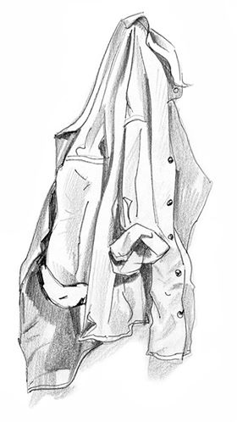](https://www.facebook.com/milindmulickbooks/photos/pcb.294683510688976/294683267355667/?type=1)](https://www.facebook.com/milindmulickbooks/photos/pcb.294683510688976/294683267355667/?type=1)[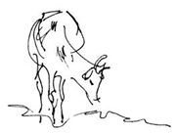](https://www.facebook.com/milindmulickbooks/photos/pcb.294683510688976/294683230689004/?type=1)[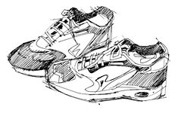](https://www.facebook.com/milindmulickbooks/photos/pcb.294683510688976/294683277355666/?type=1)[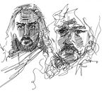](https://www.facebook.com/milindmulickbooks/photos/pcb.294683510688976/294683257355668/?type=1)

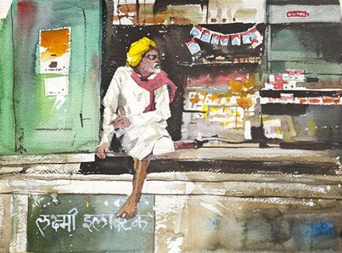

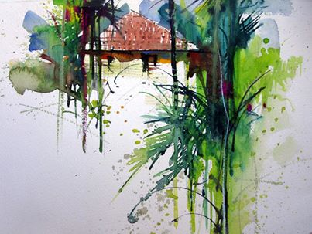

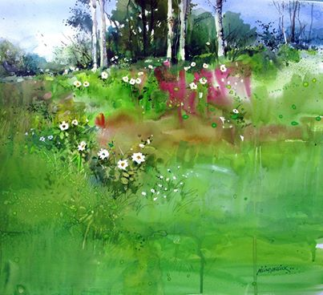

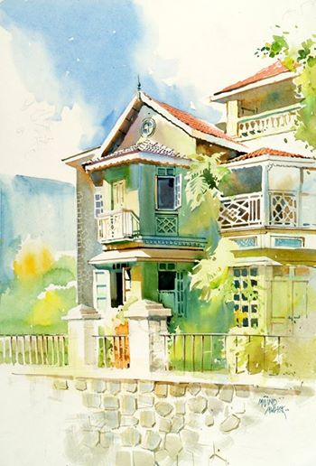

Sketchpens  
  
Sketchpens are characterised by gaudy colours and their speed. Sketchpens are useful to fill in masses after line drawing and hatches. Sketchpens are used to colour what strikes one's mind at once. It is however not possible to accomplish tonal variation as with a pencil.  
  
Sketchpens are thus useful to help one to guess tonal values of colours. One can also carry out experiments of optical colour mixing like the Impressionist painters. (Optical colour mixing is getting the effect of a different colour from juxtaposition of strokes of two or more primary colours.)  
  
As only limited and gaudy shades are available in sketchpens, practising with sketchpens is more stimulating.

[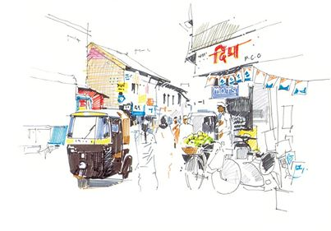](https://www.facebook.com/milindmulickbooks/photos/pcb.294302110727116/294301924060468/?type=1)

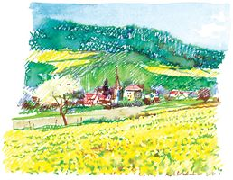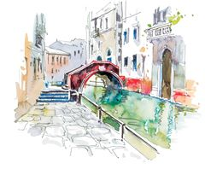

Pen and Pencil  
  
At times, tone and sharp lines are both essential in a painting.  
  
In the painting on the caves at Ellora, the relief of the sculpture is important. I felt that a pencil was thus suitable. The dark tone with which I wanted to depict the depth of the painting would not have been possible with pencil alone and thus I also used pen.  
  
In the other picture, I drew lines initially with a pen and then shaded parts of the picture with a pencil. I soon got the desired effect. Basic shapes are quickly realised with lines. Sharp lines cannot be drawn continuously with a pencil as the point gets blunt. I use a pen also at such times.  
  
(Sketchbook)  
  
<http://jyotsnaprakashan.com/index.php?option=com_zoo&task=item&item_id=46&Itemid=243>

[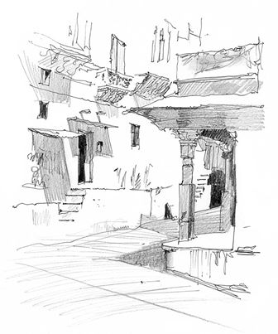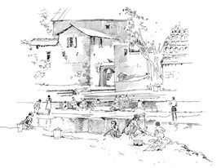](https://www.facebook.com/milindmulickbooks/photos/pcb.293985524092108/293985360758791/?type=1)

[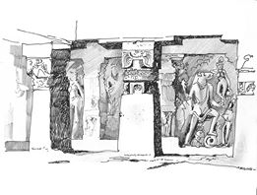](https://www.facebook.com/milindmulickbooks/photos/pcb.293985524092108/293985417425452/?type=1)

Value Balance  
  
Prior to painting, we normally make a pencil drawing. It is known as line composition. Though it may look quite pretty as a drawing, it may not stand out so much after painting. The reason being that we have not been thinking in terms of value composition.   
  
The shapes generated in a painting by tonal values should balance one another. There are three major tones seen in a a painting - dark tones (Black), middle tones (Greys) and light tones (Whites).   
  
The dark of the middle windows and the small dark patches of the left and right doors balance each other. The middle and light tones are not that dispersed. The shapes generated by them are adjacent and complementary.  
  
(from Watercolour by Milind Mulick)

[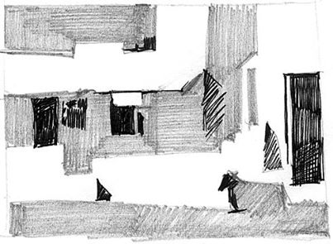](https://www.facebook.com/milindmulickbooks/photos/pcb.293105960846731/293105814180079/?type=1)

[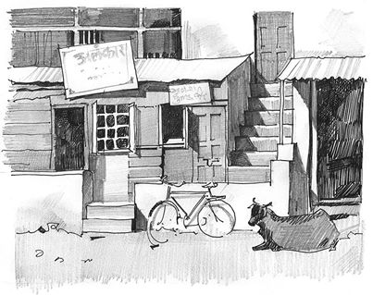](https://www.facebook.com/milindmulickbooks/photos/pcb.293105960846731/293105920846735/?type=1)

Brushwork  
  
What is brushwork? Obviously it is the depiction of forms by using the brush! The further from its tip we hold the brush in our hand, the easier will be the movement. In other words, we will have better control over it.  
  
Generally when we depict grass or tree branches, we should be doing it in single strokes. This is called calligraphic brushwork.  
I prefer doing bold patches rather than delicate detailing, giving importance to the play of light and shadows on the objects. There is not much of tonal variation in such brushwork.  
  
It is worth practising a variety of shapes before going for the actual painting. Once you gain control over brushwork, you would be able to become free with your washes. Even a 'wrong' wash can be corrected by suitable brushwork later, and still keeping the painting under control.  
  
Brushwork involves practice to the eyes too. So it is preferable to go outdoors. Observe how coconut fronds are different from palm, how banyan and mango trees are different, how trees appear in a 'mass' and so on. As you observe carefully and practice, it will show in your brushwork.   
  
(Watercolour Landscapes Step by Step)  
[http://jyotsnaprakashan.com/index.php?option=com_zoo&task=item&item_id=39&Itemid=243](http://l.facebook.com/l.php?u=http%3A%2F%2Fjyotsnaprakashan.com%2Findex.php%3Foption%3Dcom_zoo%26task%3Ditem%26item_id%3D39%26Itemid%3D243&h=MAQEB-apX&enc=AZPPNXJmVhzVhJJBakD0lvy45ovHhMTd8drnoEvcVoDlOLnSfobjRrOX0TAsWM_3feqb0-2iQV6US5uAvrpN40B3hujmEoaGMEK5HYNPEPP1gDgafgjzZx3Qnl3soLQECYBZRcjb1Y9-ktPJ9ccOrbr3&s=1)

[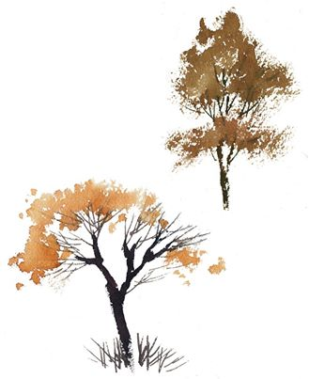](https://www.facebook.com/milindmulickbooks/photos/pcb.295347303955930/295346933955967/?type=1)

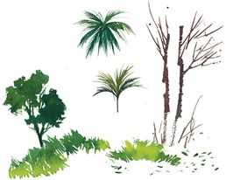

Subtraction  
  
Generally when we set out to paint we are thinking about what we are going to paint. But, without our being fully aware of it, our brush strokes are defining the unpainted areas too. The painted areas are called ‘positive’ whereas the unpainted areas are termed the ‘negative’ spaces.  
  
There is some similarity between painting a watercolour and sculpting from a block of stone. A sculpture can be made in two ways. One is to ‘add’ clay or Plaster of Paris and build up the sculpture step by step. On the other hand, when sculpting from stone or similar material we chip off progressively till we get the final stage. To put it differently we finish the sculpture by ‘subtracting’ from the original block.  
  
To extend this analogy, when we paint we ‘subtract’ the white of the paper. Often, the centre of attraction of a painting is a white space or light area ‘left out’ while painting darker tones around it. Thus, it is defined by what is around it. So, what is left out becomes more important than what is painted.

[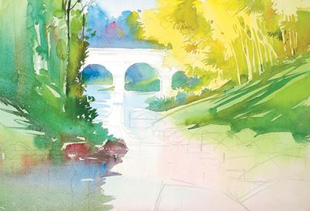](https://www.facebook.com/milindmulickbooks/photos/pcb.298527180304609/298526960304631/?type=1)

[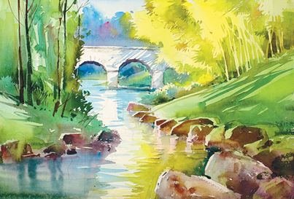](https://www.facebook.com/milindmulickbooks/photos/pcb.298527180304609/298526983637962/?type=1)

