Sentiment Analysis of Twitter posts

By Yogesh H. Kulkarni

This article is based on a [study](https://www.analyticsvidhya.com/blog/2016/07/capstone-project/) published at Analytics Vidhya. This study was done on a set of social interactions limited to the first two days of Chennai Floods in December 2015.

Objectives were:

* Topic analysis to understand the different subjects of interactions
* Grouping similar messages together with emphasis on predominant themes (rescue, food, supplies, ambulance calls)

Following is an attempt to implement the study using Python and its libraries.

# Building Corpus

A typical tweet is mostly a text message within limit of 140 characters. #hashtags convey subject of the tweet whereas @user seeks attention of that user. Forwarding is denoted by ‘rt’ (retweet) and is a measure of its popularity. One can like a tweet by making it ‘favorite’.

About 6000 twits were collected with ‘#ChennaiFloods’ hashtag and between 1st and 2nd Dec 2015. [Jefferson’s GetOldTweets utility](https://github.com/Jefferson-Henrique/GetOldTweets-python) (got) was used in Python 2.7 to collect the older tweets. One can store the tweets either in a csv file or to a database like MongoDb to be used for further processing.

**import** got, codecs  
**from** pymongo **import** MongoClient

client = MongoClient(**'localhost'**, 27017)  
db = client[**'twitter_db'**]  
collection = db[**'twitter_collection'**]  
  
tweetCriteria = got.manager.TweetCriteria().setQuerySearch(**'ChennaiFloods'**).setSince(**"2015-12-01"**).setUntil(**"2015-12-02"**).setMaxTweets(6000)  
  
**def** streamTweets(tweets):  
 **for** t **in** tweets:  
 obj = {**"user"**: t.username, **"retweets"**: t.retweets, **"favorites"**:

t.favorites, **"text"**:t.text,**"geo"**: t.geo, **"mentions"**:

t.mentions, **"hashtags"**: t.hashtags,**"id"**: t.id,

**"permalink"**: t.permalink,}  
 tweetind = collection.insert_one(obj).inserted_id  
got.manager.TweetManager.getTweets(tweetCriteria, streamTweets)

Tweets stored in Mongodb can be accessed from another python script. Following example shows how the whole db was converted to Pandas dataframe.

**import** pandas **as** pd  
**from** pymongo **import** MongoClient  
  
client = MongoClient(**'localhost'**, 27017)  
db = client[**'twitter_db'**]  
collection = db[**'twitter_collection'**]  
df = pd.DataFrame(list(collection.find()))

First few records of the dataframe look as below:



# Data Exploration

Once in dataframe format, it is easier to explore the data. Here are few examples.

* Finding Top 10 hashtags trending during that period:

hashtags = []  
**for** hs **in** df[**"hashtags"**]: *# Each entry may contain multiple hashtags. Split.* hashtags += hs.split(**" "**)  
  
fdist1 = FreqDist(hashtags)  
fdist1.plot(10)

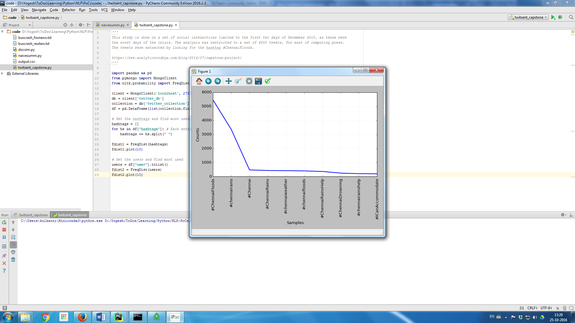

Figure 1: Top 10 Hashtags trending

As seen in the [study](https://www.analyticsvidhya.com/blog/2016/07/capstone-project/) the most used tags were “#chennairains”, “#ICanAccommodate”, apart from the original query tag “#ChennaiFloods”.

* Top 10 users

users = df[**"user"**].tolist()  
fdist2 = FreqDist(users)  
fdist2.plot(10)

As seen from the plot, most active users were “TMManiac” with about 85 tweets, “Texx_willer” with 60 tweets and so on…

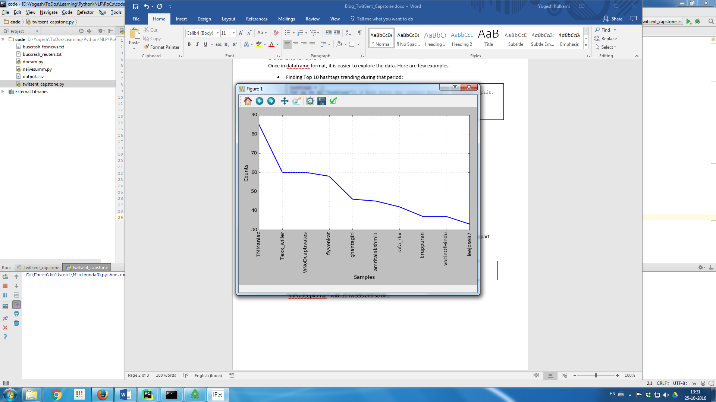

Figure 2: Top 10 Users tweeting

# Text Pre-processing

All tweets are processed to remove unnecessary things like links, non-English words, stopwords, punctuations, etc.

**from** nltk.tokenize **import** TweetTokenizer  
**from** nltk.corpus **import** stopwords  
**import** re, string  
**import** nltk  
  
tweets_texts = df[**"text"**].tolist()  
stopwords=stopwords.words(**'english'**)  
english_vocab = set(w.lower() **for** w **in** nltk.corpus.words.words())  
  
**def** process_tweet_text(tweet):  
 **if** tweet.startswith(**'@null'**):  
 **return "[Tweet not available]"** tweet = re.sub(**r'\$\w*'**,**''**,tweet) *# Remove tickers* tweet = re.sub(**r'https?:\/\/.*\/\w*'**,**''**,tweet) *# Remove hyperlinks* tweet = re.sub(**r'['**+string.punctuation+**']+'**, **' '**,tweet) *# Remove puncutations like 's* twtok = TweetTokenizer(strip_handles=**True**, reduce_len=**True**)  
 tokens = twtok.tokenize(tweet)  
 tokens = [i.lower() **for** i **in** tokens **if** i **not in** stopwords **and** len(i) > 2 **and**

i **in** english_vocab]  
  
 **return** tokens  
  
words = []  
**for** tw **in** tweets_texts:  
 words += process_tweet_text(tw)

The word list generated looks like:

*['time', 'history', 'temple', 'closed', 'due', 'pic', 'twitter', 'havoc', 'incessant', …]*

# Text Exploration

The words are plotted again to find the most frequently used terms. A few simple words repeat more often than others: ’help’, ‘people’, ‘stay’, ’safe’, etc.

*[('twitter', 1026), ('pic', 1005), ('help', 569), ('people', 429), ('safe', 274)]*

These are immediate reactions and responses to the crisis.

Some infrequent terms are *[('fit', 1), ('bible', 1), ('disappear', 1), ('regulated', 1), ('doom', 1)]*.

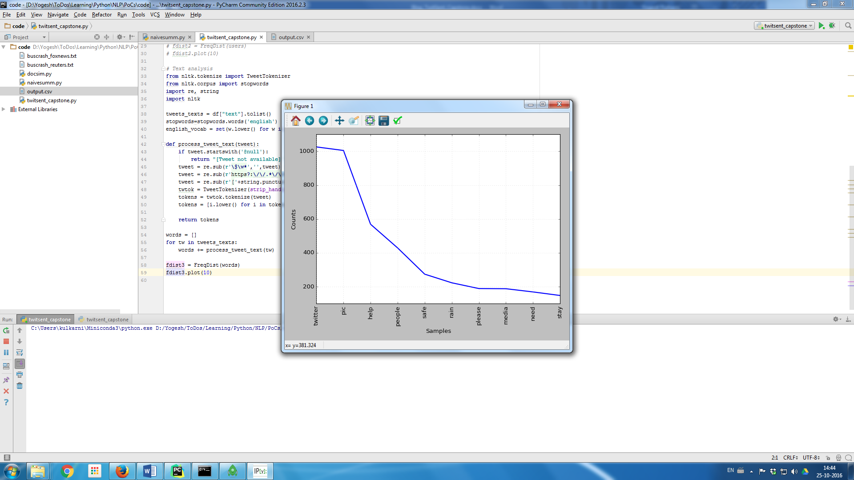

Figure 3: Most frequently used words

Collocations are the words that are found together. They can be bi-grams (two words together) or phrases like trigrams (3 words) or n-grams (n words).

**from** nltk.collocations **import** *  
bigram_measures = nltk.collocations.BigramAssocMeasures()  
finder = BigramCollocationFinder.from_words(words, 5)  
finder.apply_freq_filter(5)  
print(finder.nbest(bigram_measures.likelihood_ratio, 10))

Most frequently appearing Bigrams are:

*[('pic', 'twitter'), ('lady', 'labour'), ('national', 'media'), ('pani', 'pani'), ('team', 'along'), ('stay', 'safe'), ('rescue', 'team'), ('beyond', 'along'), ('team', 'beyond'), ('rescue', 'along')]*

These depict the disastrous situation, like “stay safe”, “rescue team”, even a commonly used Hindi phrase “pani pani” (lots of water).

# Clustering

In such crisis situations lots of similar tweets are generated. They can be grouped together in clusters based on closeness or ‘distance’ amongst them. Artem Lukanin has explained the process in details [here](http://nbviewer.jupyter.org/github/brandomr/document_cluster/blob/master/cluster_analysis_web.ipynb). TF-IDF method is used to vectorise the tweets and then cosine distance is measured to assess the similarity.

Each tweet is pre-processed and added to a list. The list is fed to TFIDF Vectorizer to convert each tweet into a vector. Each value in the vector depends on how many times a word or a term appears in the tweet (TF) and on how rare it is amongst all tweets/documents (IDF). Below is a visual representation of TFIDF matrix it generates.

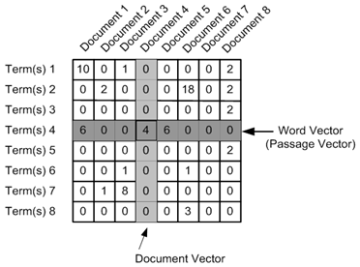

Figure 4 : TF IDF Matrix (http://nbviewer.jupyter.org/github/brandomr/document_cluster/blob/master/cluster_analysis_web.ipynb)

Before using the Vectorizer, the pre-processed tweets are added in the data frame so that each tweets association with other parameters like id, user is maintained.

cleaned_tweets = []  
**for** tw **in** tweets_texts:  
 words = process_tweet_text(tw)  
 cleaned_tweet = **" "**.join(w **for** w **in** words **if** len(w) > 2 **and** w.isalpha()) *#Form sentences of processed words* cleaned_tweets.append(cleaned_tweet)  
df[**'CleanTweetText'**] = cleaned_tweets

Vectorization is done using 1-3 n-grams, meaning phrases with 1,2,3 words are used to compute frequencies, i.e. TF IDF values. One can get cosine similarity amongst tweets/documents as well.

**from** sklearn.feature_extraction.text **import** TfidfVectorizer  
tfidf_vectorizer = TfidfVectorizer(use_idf=**True**, ngram_range=(1,3))  
tfidf_matrix = tfidf_vectorizer.fit_transform(cleaned_tweets)  
feature_names = tfidf_vectorizer.get_feature_names() *# num phrases*

**from** sklearn.metrics.pairwise **import** cosine_similarity  
dist = 1 - cosine_similarity(tfidf_matrix)  
print(dist)

K-means clustering algorithm is used to group tweets into chosen number (say, 3) of groups.

**from** sklearn.cluster **import** KMeans  
num_clusters = 3  
km = KMeans(n_clusters=num_clusters)  
km.fit(tfidf_matrix)  
clusters = km.labels_.tolist()  
df[**'ClusterID'**] = clusters  
print(df[**'ClusterID'**].value_counts())

The output shows 3 clusters, with following number of tweets in respective clusters.

1 5261

2 432

0 307

Most of the tweets are clustered around in group Id =1. Remaining are in group id 2 and id 0.

The top words used in each cluster can be computed by as follows:

*#sort cluster centers by proximity to centroid*order_centroids = km.cluster_centers_.argsort()[:, ::-1]  
**for** i **in** range(num_clusters):  
 print(**"Cluster {} : Words :"**.format(i))  
 **for** ind **in** order_centroids[i, :10]:   
 print(**' %s'** % feature_names[ind])

The result is:

* Cluster 0: Words: show mercy please people rain
* Cluster 1: Words: pic twitter zoo wall broke ground saving guilty water growing
* Cluster 2: Words: help people pic twitter safe open rain share please

# Topic Modelling

Finding central subject in the set of documents, tweets in case here. Following are two ways of detecting topics, i.e. clustering the tweets

## Latent Dirichlet Allocation (LDA)

LDA is commonly used to identify chosen number (say, 6) topics. Refer [tutorial](https://www.analyticsvidhya.com/blog/2016/08/beginners-guide-to-topic-modeling-in-python/) for more details.

**from** gensim **import** corpora, models  
**from** nltk.corpus **import** stopwords  
**from** nltk.stem.wordnet **import** WordNetLemmatizer  
**import** string  
  
stop = set(stopwords.words(**'english'**))  
exclude = set(string.punctuation)  
lemma = WordNetLemmatizer()  
**def** clean(doc):  
 stop_free = **" "**.join([i **for** i **in** doc.lower().split() **if** i **not in** stop])  
 punc_free = **''**.join(ch **for** ch **in** stop_free **if** ch **not in** exclude)  
 normalized = **" "**.join(lemma.lemmatize(word) **for** word **in** punc_free.split())  
 **return** normalized  
texts = [text **for** text **in** cleaned_tweets **if** len(text) > 2]  
doc_clean = [clean(doc).split() **for** doc **in** texts]  
dictionary = corpora.Dictionary(doc_clean)  
doc_term_matrix = [dictionary.doc2bow(doc) **for** doc **in** doc_clean]  
ldamodel = models.ldamodel.LdaModel(doc_term_matrix, num_topics=6, id2word = dictionary, passes=5)  
**for** topic **in** ldamodel.show_topics(num_topics=6, formatted=**False**, num_words=6):  
 print(**"Topic {}: Words: "**.format(topic[0]))  
 topicwords = [w **for** (w, val) **in** topic[1]]  
 print(topicwords)

The output gives us following set of words for each topic.

Topic 0: Words: ['rain', 'stay', 'day', 'stop', 'safe', 'call']

Topic 1: Words: ['help', 'need', 'please', 'know', 'share', 'around']

Topic 2: Words: ['medium', 'national', 'news', 'people', 'take', 'rain']

Topic 3: Words: ['twitter', 'pic', 'safe', 'office', 'hope', 'india']

Topic 4: Words: ['water', 'flooded', 'stuck', 'people', 'help', 'food']

Topic 5: Words: ['safe', 'people', 'road', 'like', 'emergency', 'pray']

It is clear from the words associated with the topics that they represent certain sentiments. Topic 0 is about Caution, Topic 1 is about Help, Topic 2 is about News, etc.

## Doc2Vec and K-means

Doc2Vec methodology available in [gensim](https://radimrehurek.com/gensim/models/doc2vec.html) package is used to vectorise the tweets, as follows:

**import** gensim  
**from** gensim.models.doc2vec **import** TaggedDocument  
  
taggeddocs = []  
tag2tweetmap = {}  
**for** index,i **in** enumerate(cleaned_tweets):  
 **if** len(i) > 2: *# Non empty tweets* tag = **u'SENT_{:d}'**.format(index)  
 sentence = TaggedDocument(words=gensim.utils.to_unicode(i).split(), tags=[tag])  
 tag2tweetmap[tag] = i  
 taggeddocs.append(sentence)

model = gensim.models.Doc2Vec(taggeddocs, dm=0, alpha=0.025, size=20, min_alpha=0.025, min_count=0)  
  
**for** epoch **in** range(60):  
 **if** epoch % 20 == 0:  
 print(**'Now training epoch %s'** % epoch)  
 model.train(taggeddocs)  
 model.alpha -= 0.002 *# decrease the learning rate* model.min_alpha = model.alpha *# fix the learning rate, no decay*

Once trained model is ready the tweet-vectors available in model can be clustered using K-means.

**from** sklearn.cluster **import** KMeans  
dataSet = model.syn0  
kmeansClustering = KMeans(n_clusters=6)  
centroidIndx = kmeansClustering.fit_predict(dataSet)  
topic2wordsmap = {}  
**for** i, val **in** enumerate(dataSet):  
 tag = model.docvecs.index_to_doctag(i)  
 topic = centroidIndx[i]  
 **if** topic **in** topic2wordsmap.keys():  
 **for** w **in** (tag2tweetmap[tag].split()):  
 topic2wordsmap[topic].append(w)  
 **else**:  
 topic2wordsmap[topic] = []  
  
**for** i **in** topic2wordsmap:  
 words = topic2wordsmap[i]  
 print(**"Topic {} has words {}"**.format(i, words[:5]))

The result is the list of topics and commonly used words in each, respectively.

Topic 0 has words ['check', 'valuable', 'time', 'raise', 'insurance']

Topic 1 has words ['accommodate', 'people', 'corrupt', 'lightening', 'speed']

Topic 2 has words ['midst', 'climate', 'worst', 'flooding', 'contact']

Topic 3 has words ['hindu', 'pic', 'twitter', 'sleep', 'suffering']

Topic 4 has words ['rescue', 'team', 'area', 'beyond', 'along']

Topic 5 has words ['pic', 'twitter', 'boat', 'boat', 'stuck']

It is clear from the words associated with the topics that they represent certain sentiments. Topic 0 is about Caution, Topic 1 is about Actions, Topic 2 is about Climate, etc.

# Conclusion

This article shows how to implement [Capstone-Chennai Floods study](https://www.analyticsvidhya.com/blog/2016/07/capstone-project/) using Python and its libraries. With this one can get introduction to various Natural Language Processing (NLP) workflows such as accessing twitter data, pre-processing text, explorations, clustering and topic modelling.

Yogesh H. Kulkarni is a PhD Student doing research in Geometric Modelling. He is also intersected in Data Sciences, especially in Natural Language Processing. Please send in your comments and suggestions about this article to him at yogeshkulkarni@yahoo.com