Yogesh Kulkarni  Address: E1/32, State Bank Nagar, Pashan Pune-8, India.  Cell: 9890251406  DoB: 27 Mar 1973  Email: yogeshkulkarni@yahoo.com | 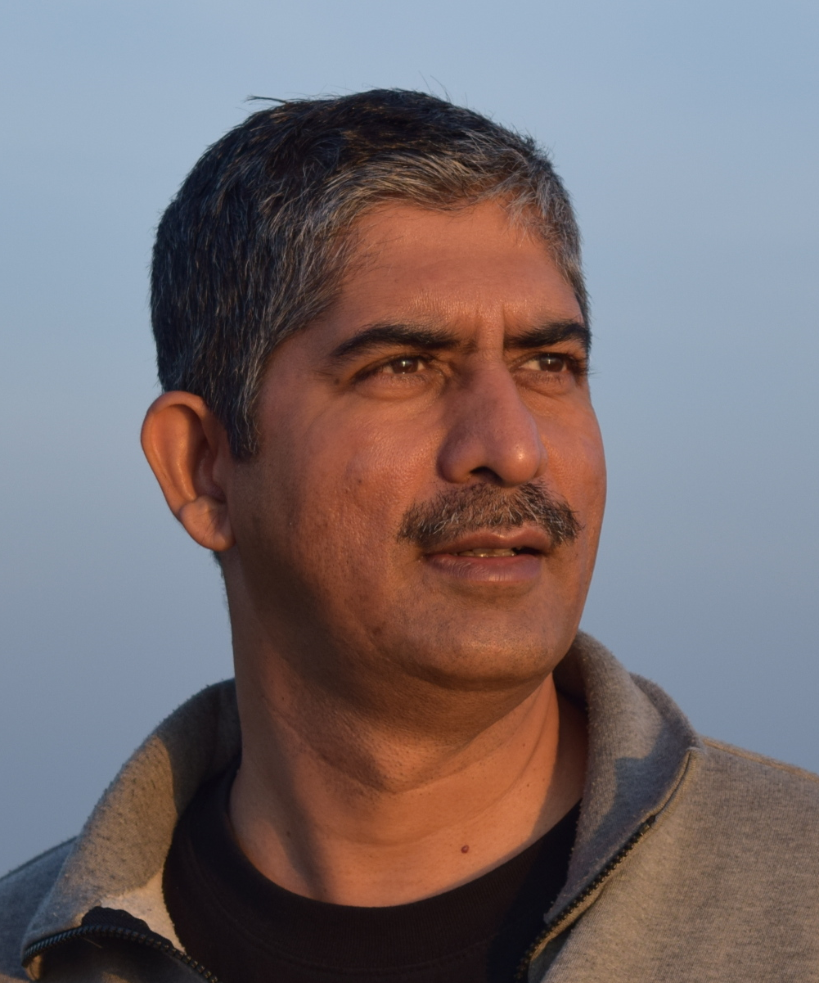

More than 2 decades in CAD/Engineering research-software development. Did PhD in Geometric Modeling. Now working in Machine Leaning and Natural Language Processing.

EDUCATION
PhD (Mech Eng)  Jan 2017  College of Eng, Pune.  5 Intl Journal papers | MS (Mech Eng)  Aug 1996  Kansas State Univ, USA  Distinction, GPA 4/4 | BE (Mech Eng, SW)  Aug 1994  College of Eng, Pune.  Distinction, 73.64% Topper

EXPERIENCE
Principal Architect – CTO Office, Icertis, Pune, India (Jun 19 – Mar 23)
Working in Machine Learning and Natural Language Processing for Contracts Management

Adjunct/Visiting Professor, College of Engineering Pune, India. (Aug 02 – Mar 23)
Working in NLP domain on Large Language Models like GPT.

Data Science Consultant-Instructor, Pune, India. (Oct 16– May 19)
Working in NLP domain on document similarity, topic modeling, summarization, etc.

Doctoral Research Scholar, College of Engineering Pune (CoEP). (Jul 12 – Sep 16)

Software Development Manager, Autodesk India Pvt Ltd, Pune. (Dec 06– Jul 13)
- Sr Developer and Tech Lead for Inventor Plastics, Fusion and 123D
- Leading R&D teams for Consumer Products division with responsibilities such as:
  - Design Reviews, Project Management, Communication-Coordination across sites
  - People Management, Internships, Trainings, Recruitment
  - Team Size: 40+. Verticals: CAD, Cloud, Mobile.
- Overall Site Management responsibility.

Software Engineer - Advanced, Siemens UGS PLM Software, Pune. (Dec 98– Nov 06)
- Sr Developer for I-DEAS Simulation project “Midsurface”.
- Tech Lead for I-DEAS “Shell” Modeling, using ATF (Advanced Topology Foundation).
- Tech Lead at Unigraphics NX for “Part Navigator” and “Trimmed Sheet” (Parasolid).

Project Manager, Sutra Systems, Pune-India, Tokyo-Japan. (Dec 97– Nov 98)
- Sr Developer and Project Manager for Matlab-Simulink Research project
- Sr Developer on-site on Eng Analysis (C++) project.

Software Engineer, Parametric Technology, Boston, USA. (Oct 96– May 97)
- Developer for mechanical assemblies in Pro/Engineer.
- Developer for GUI and network file system for Pro/Intralink.

HONORS
- Topped Univ of Pune in BE Mechanical Engineering (SW- Co-Op).
- Membership of Mensa India (Society for top 2% IQ).
- National Merit Scholarship for consecutive 6 years.
- Recognized PG Teacher (CAD/CAM) at Univ of Pune.
- PMP (Project Management Professional - PMI) Certified.

