**VISUAL STUDIO CODE**

Visual Studio Code is a lightweight but powerful source code editor which runs on your desktop and is available for Windows, macOS and Linux. It comes with built-in support for JavaScript, TypeScript and Node.js and has a rich ecosystem of extensions for other languages (such as C++, C#, Java, Python, PHP, Go) and runtimes (such as .NET and Unity).

**INSTALLATION OF VS CODE:**

**Step 1: Download VS-Code**

Download link: <https://code.visualstudio.com/download>

**Step 2: Installing VS-Code**

1.Double click on the .exe file which is downloaded.

Click Next on the Welcome screen.

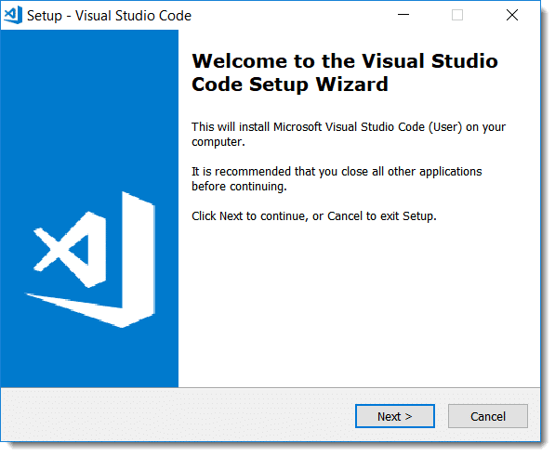

 2. Accept the License Agreement and click Next

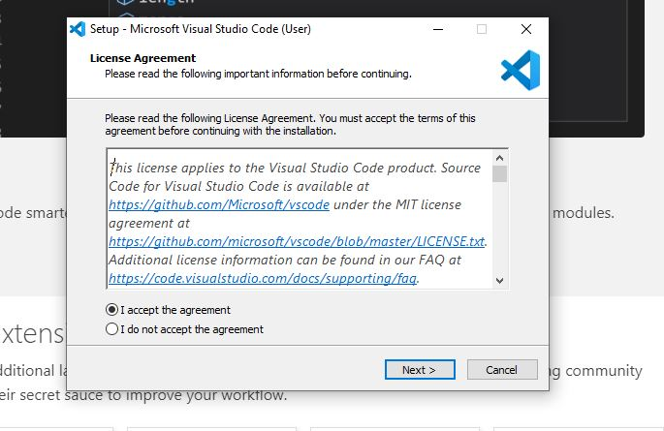

3. Choose Installation Directory and click Next

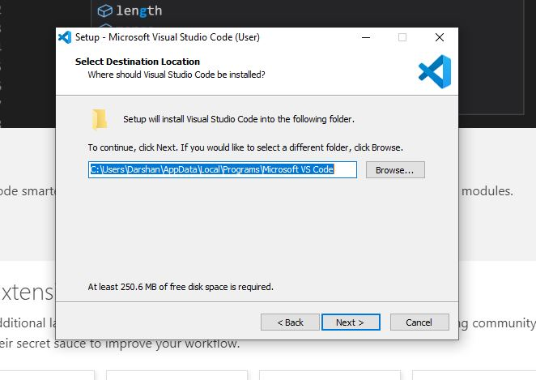

4.**Choose Start Menu Folder:**By Default, the program’s shortcut will be placed in theVisual Studio Code folder but this can be changed from this window. Once done, click on Next.

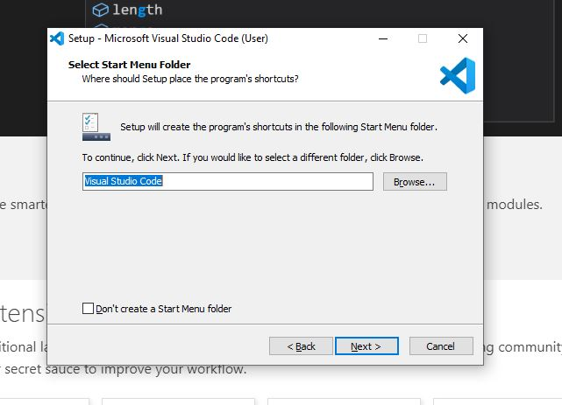

***5)* Choose Additional Options as required and click next**

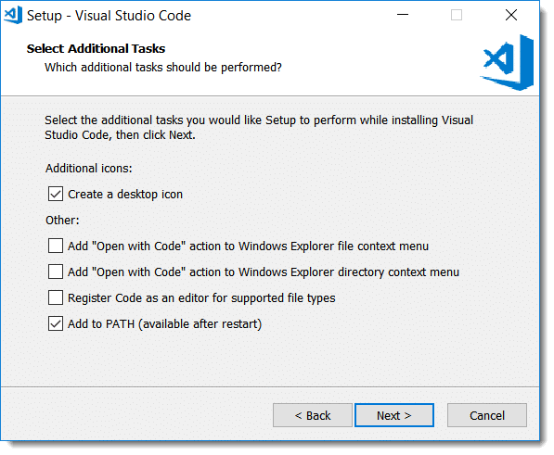

6. Review selected options and click Install.

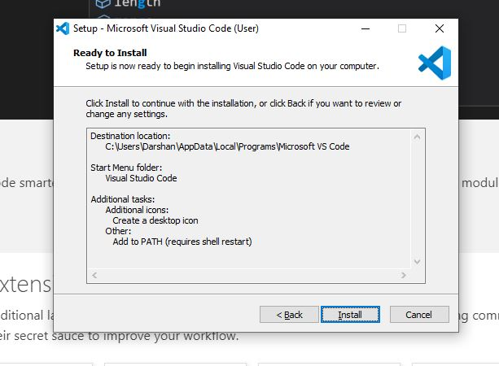

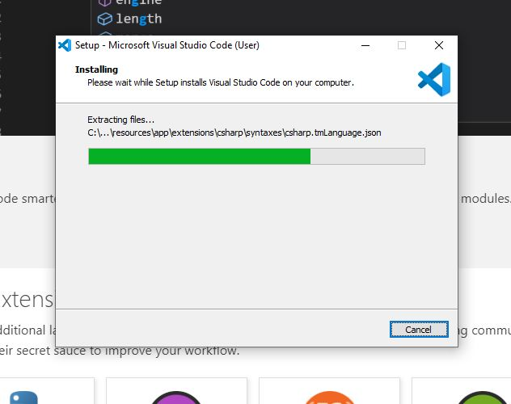

7. Select Launch VS Code and click on Finish

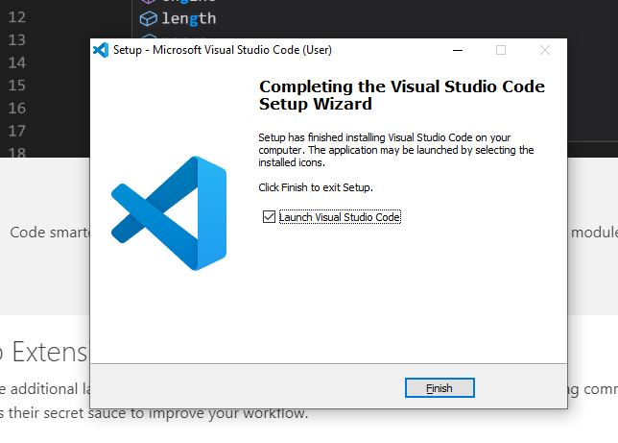

8.Visual Studio Code Main Screen:

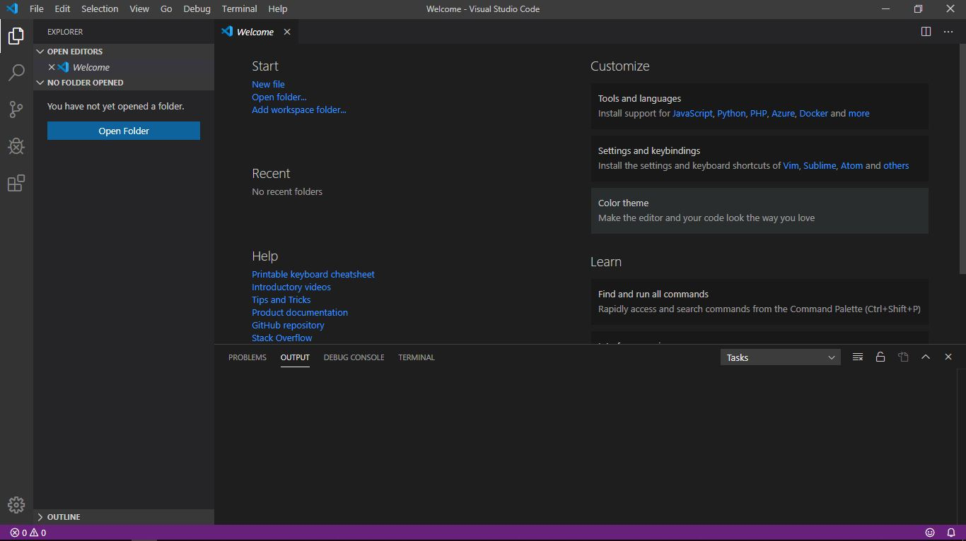

9.Install PlatformIO IDE Extension in VS Code 