Configuring VC-02 device for VAforEA

1. Select a product category
2. Select offline and module as VC-02
3. Product name VAforEA
4. Select language English

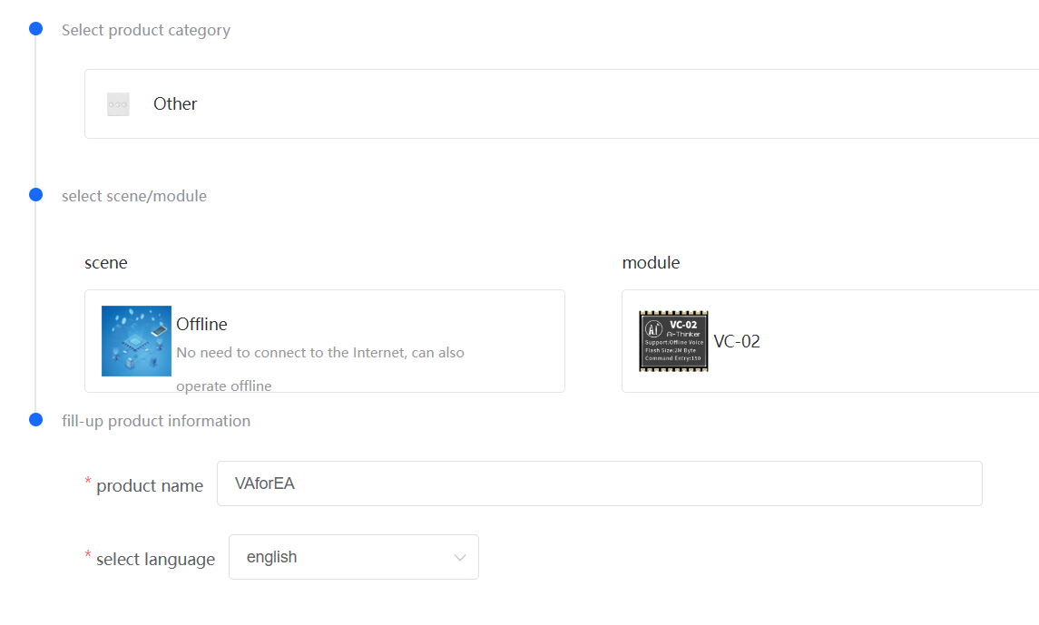

1. Set single mic.
2. Distance 1 to 5 meters.
3. AEC echo cancellation closed
4. Study state noise close

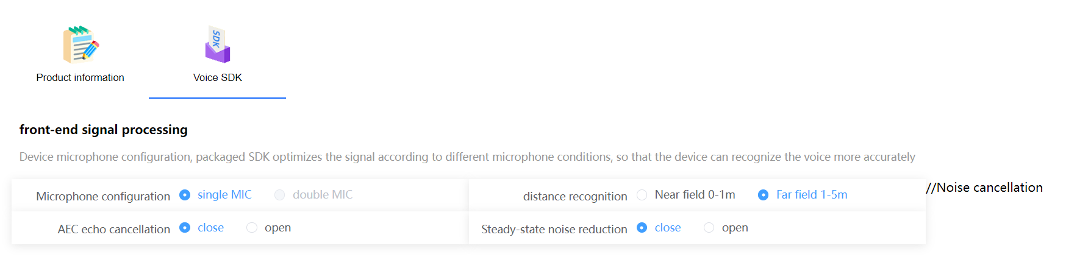

1. Set GPIO pins as shown below

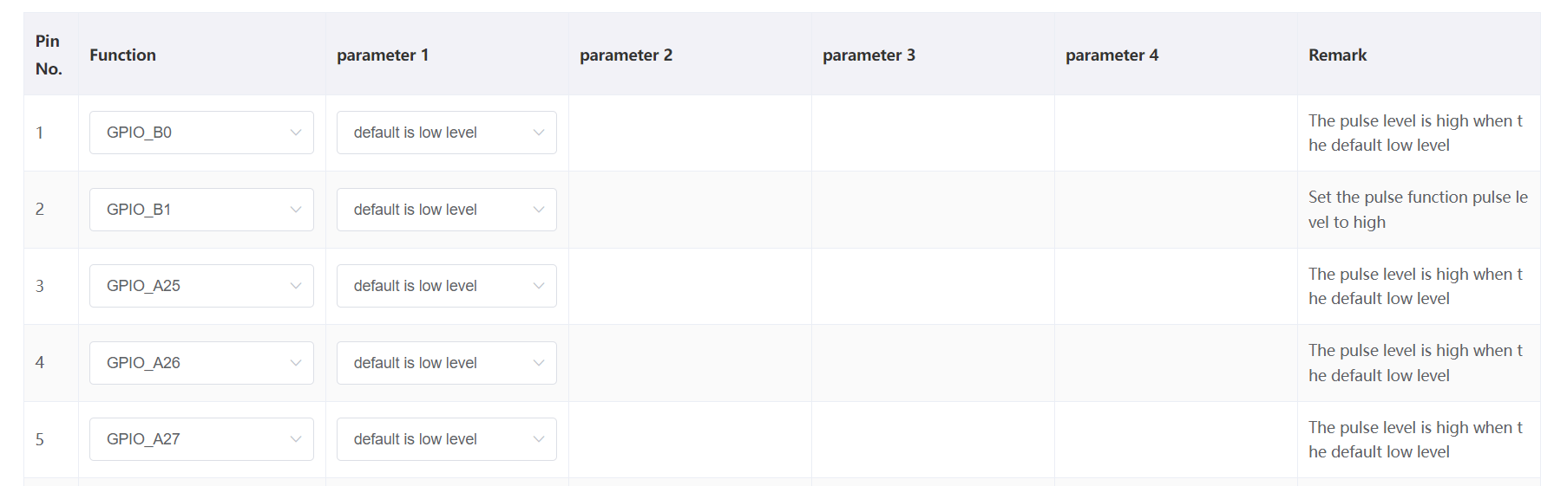

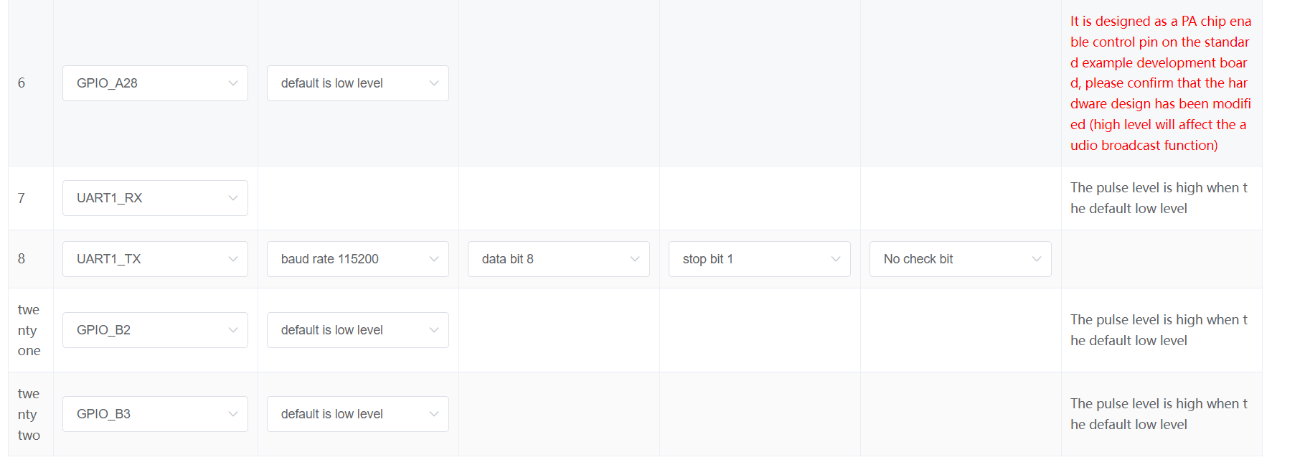

1. Set wake word and wake up sensitive to high

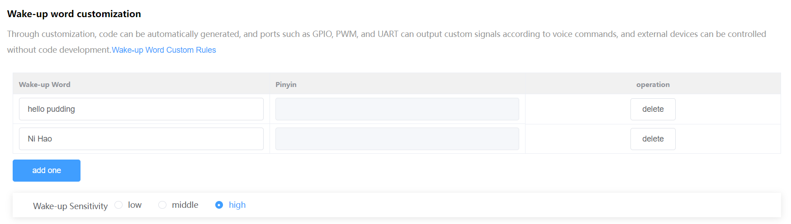

1. Configure the reply wake word

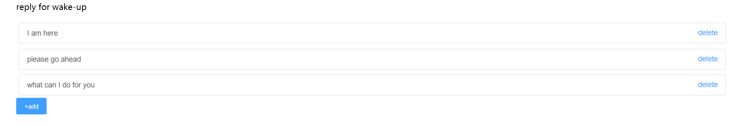

1. Configure voice command as shown below

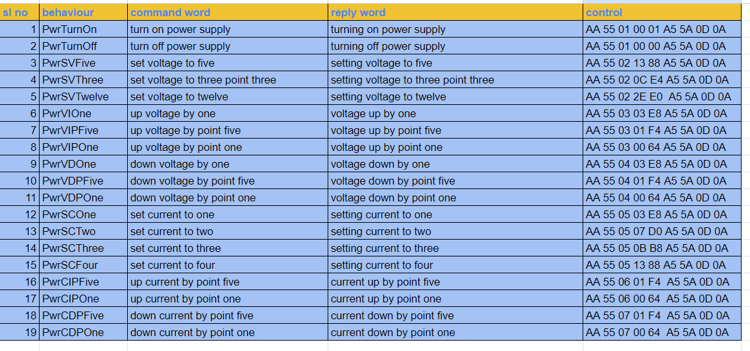

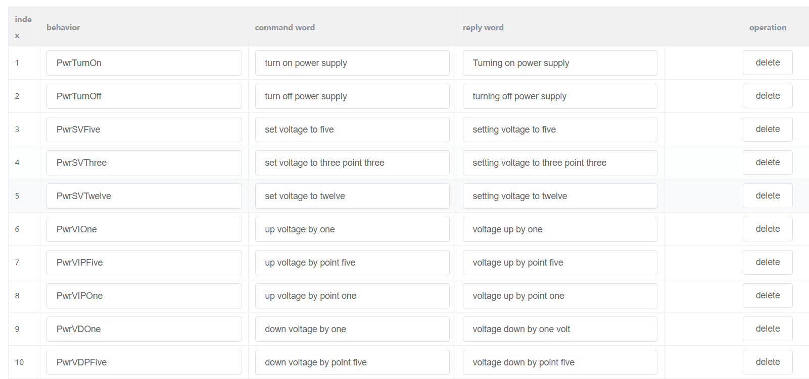

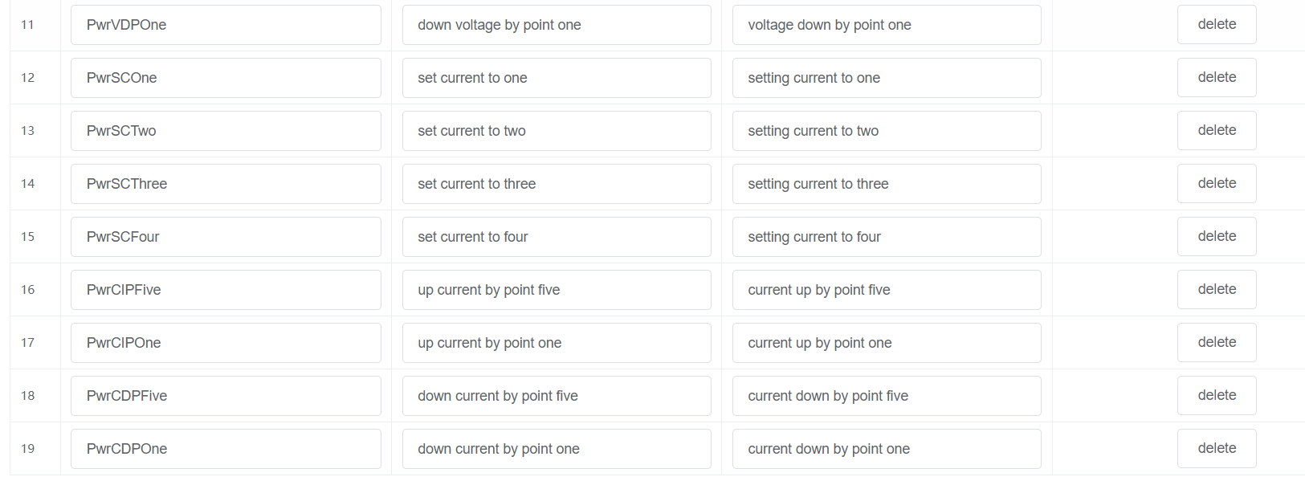

1. For control, configure UART as shown below

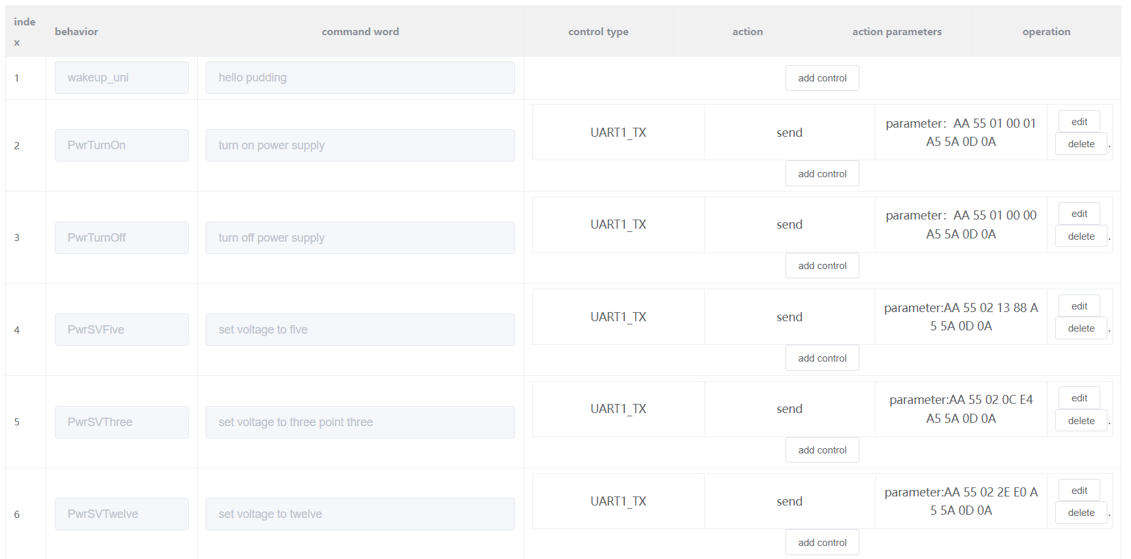

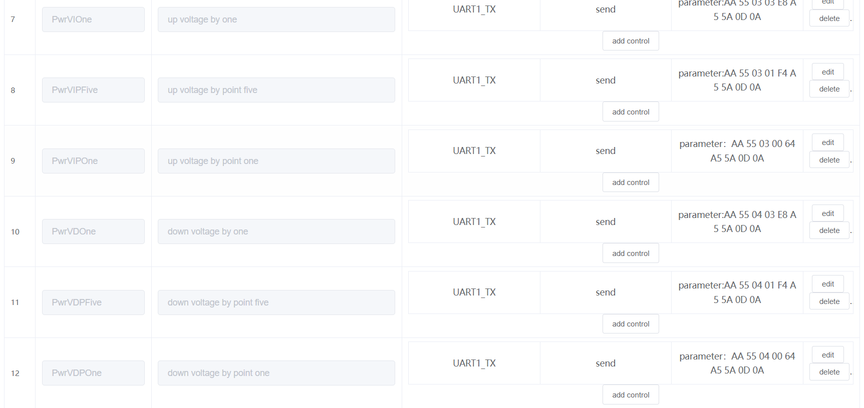

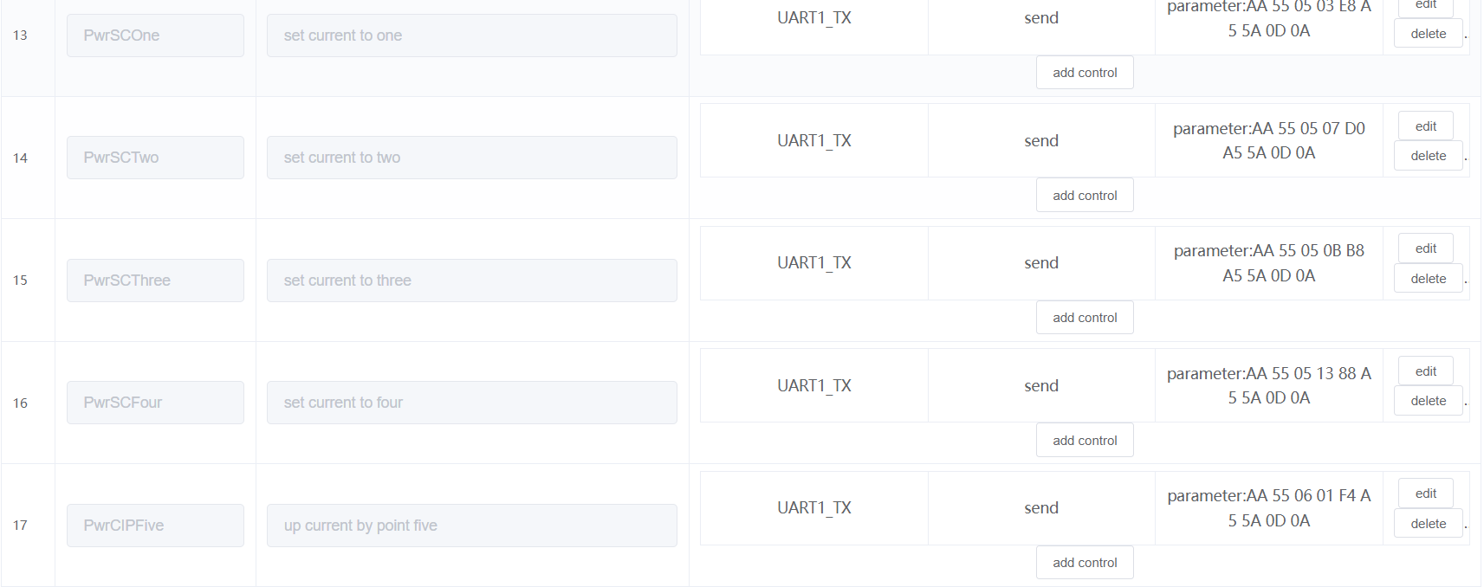

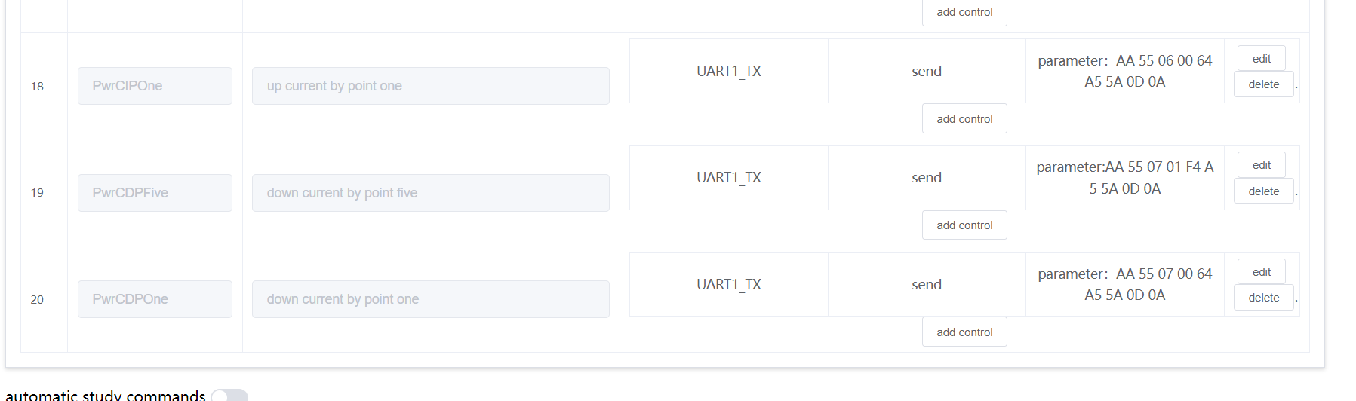

1. Configure wake up free as shown below

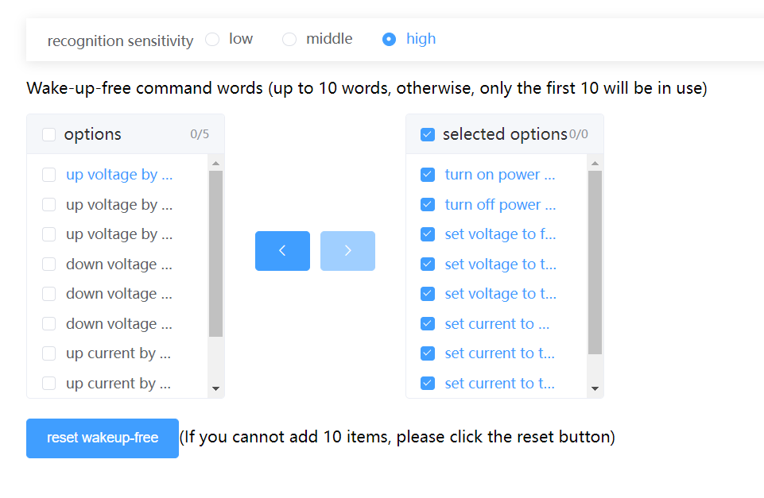

1. Configure speaker as shown below

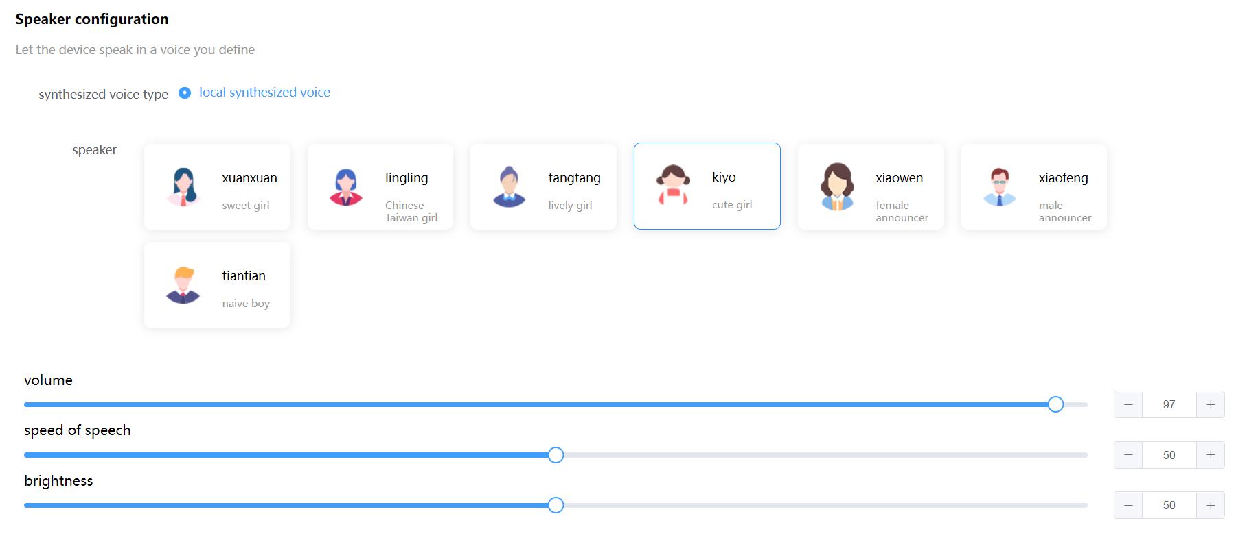

1. Do configure as shown below

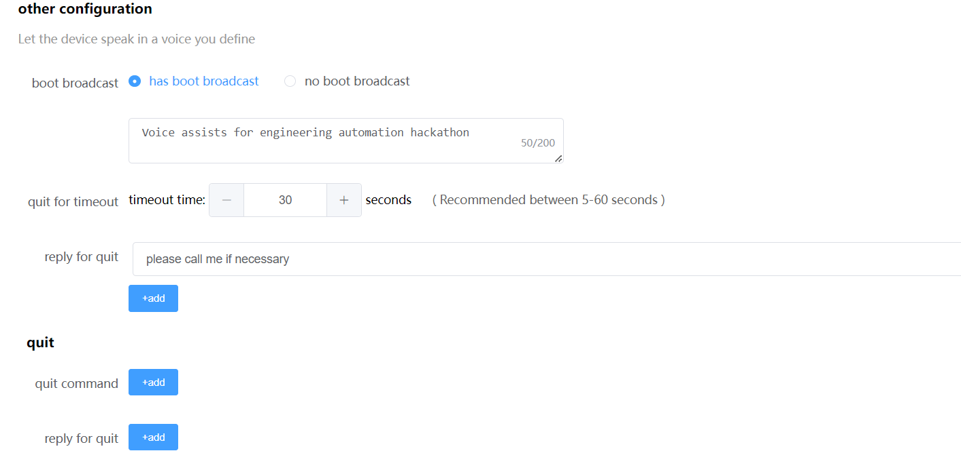

1. Build SDK as shown below.

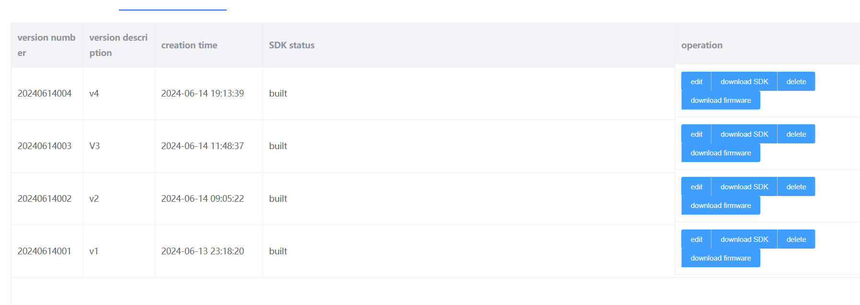

1. Once build completed

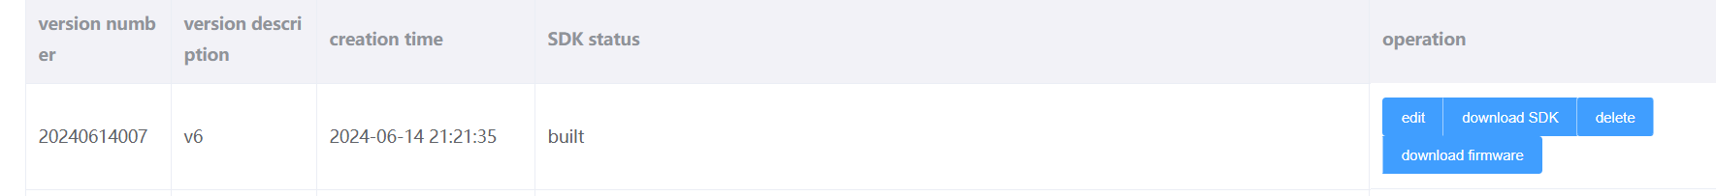

1. Download the firmware
2. Open download tool

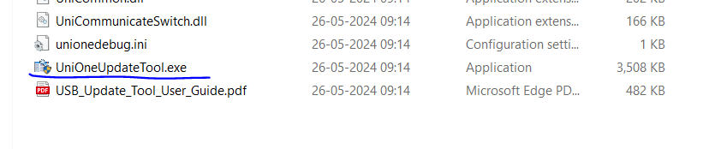

1. Choose uni_app_release_update.bin file, select the COM port and click ok

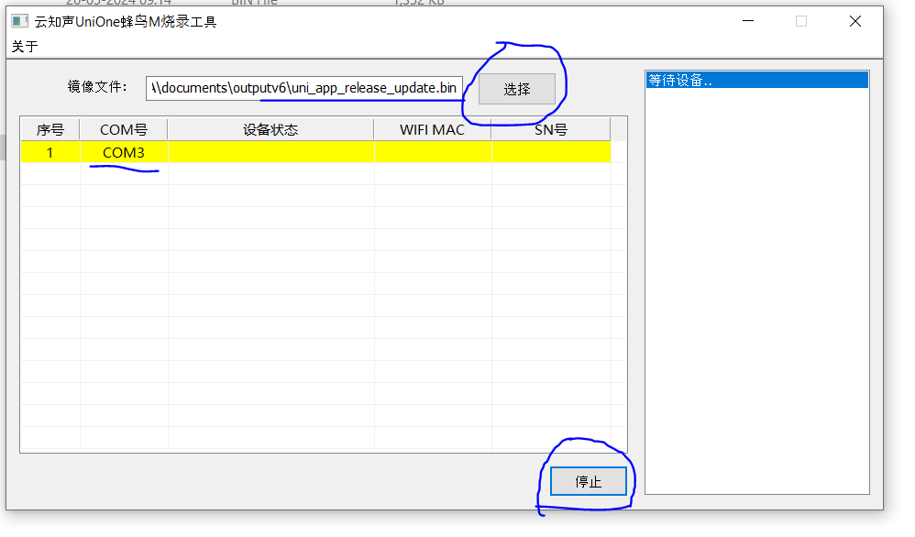

1. Press the reset button
2. Wait for 100% download to complete

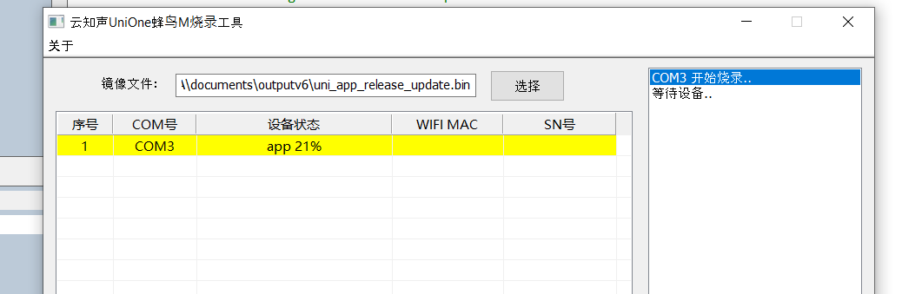

1. If green color means download complete

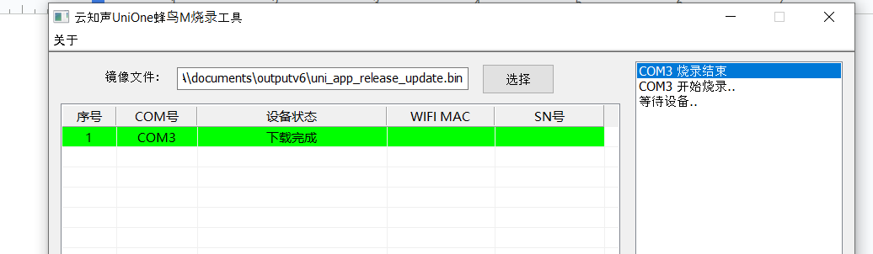

1. UART setup for testing

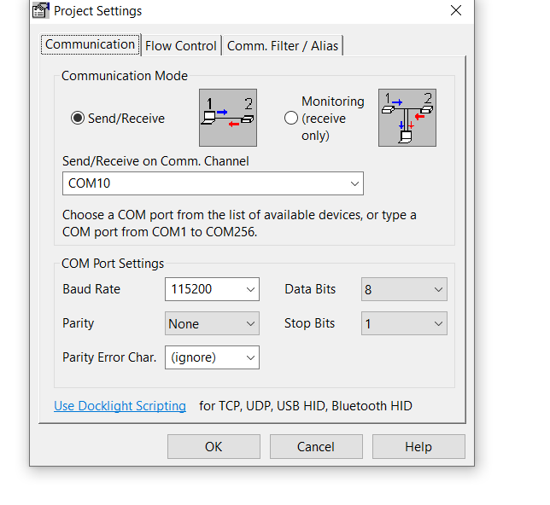

1. UART response

