C Loops

The do-while loop continues until a given condition satisfies. It is also called post tested loop. It is used when it is necessary to execute the loop at least once (mostly menu driven programs).

#include <stdio.h>

do

{

    /\* code \*/

} while (/\* condition \*/);

Flow chart

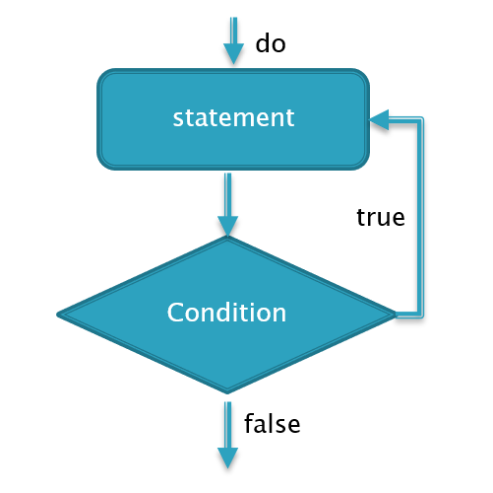

Sample code:

/\* do while example \*/

#include <stdio.h>

int main()

{

    int number = 10;

    do

    {

        printf("number value is %d\n", number);

        number = number - 1;

    } while (number > 5);

    printf("code ends here\n");

    return 0;

}

Output

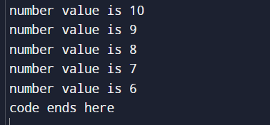

While loop statement

While loop is also known as a pre-tested loop. In general, a while loop allows a part of the code to be executed multiple times depending upon a given Boolean condition. It can be viewed as a repeating if statement. The while loop is mostly used in the case where the number of iterations is not known in advance.

Syntax

#include <stdio.h>

while (/\* condition \*/)

{

    /\* code \*/

}

Flow chart

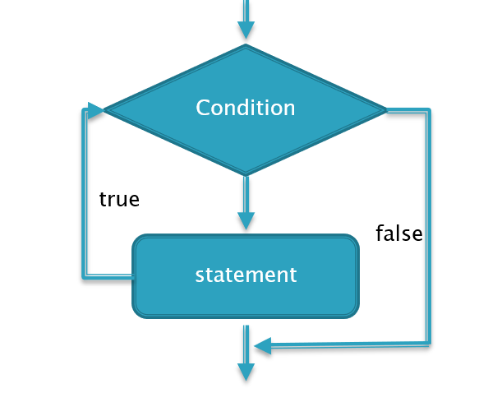

/\* while loop example \*/

#include <stdio.h>

int main()

{

    int number = 1;

    while (number <= 10)

    {

        printf("%d \n", number);

        number++;

    }

    printf("code ends here\n");

    return 0;

}

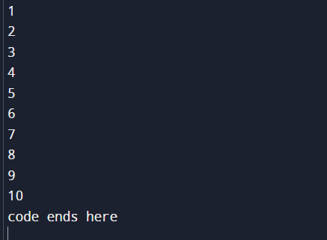

For loop in c

The for loop in C language is used to iterate the statements or a part of the program several times. It is frequently used to traverse the data structures like the array and linked list.

Syntax

#include <stdio.h>

for ( expression1; expression2; expression3)

{

    /\* code \*/

}

Flow chart

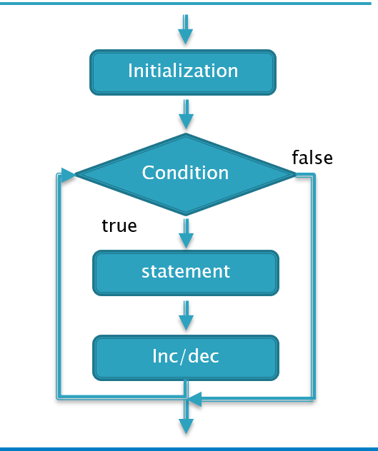

Sample code

/\* for loop example \*/

#include <stdio.h>

int main()

{

    int number = 0;

    for (number = 1; number <= 10; number++)

    {

        printf("%d \n", number);

    }

    printf("code ends here\n");

    return 0;

}

