FinNews - AI : AI-Powered Financial News Simplifier

Project Report
A web-based platform for discovering, simplifying and understanding financial news

Project Name | FinNews AI – Financial News Simplifier
Domain | Artificial Intelligence / Financial Technology / Web Development
Primary Technologies | FastAPI, NewsAPI, Gemini API, HTML, CSS, JavaScript
Application Type | AI-powered web application

Prototype / Project URL : https://finnews-ai-23dc9.web.app
Prototype / Project QR Code :

1. Project Description
FinNews AI is an AI-powered financial news simplification platform designed to help users understand financial developments quickly and clearly. Financial news often contains complex terminology, lengthy explanations and market-specific language that can be difficult for students, beginners and non-expert readers to interpret.
The platform retrieves current financial news through a news API and presents it in a clean, user-friendly interface. When a user selects an article for analysis, the backend processes the article content through a generative AI model and produces structured, reader-friendly information such as a concise summary, simple explanation, key insights, financial terms, sentiment and an explanation of why the news may be relevant.
FinNews AI is intended as an information-understanding tool rather than a personalized investment advisory system. The original article and source remain available so users can verify the complete context.

2. Objectives
- Collect and display relevant, current financial news in one platform.
- Reduce the time required to understand lengthy financial articles.
- Use generative AI to simplify complex financial language.
- Extract key information and explain important financial terminology.
- Provide source attribution and access to the original article.
- Create a clean, responsive and accessible user experience.
- Build a secure backend that protects API credentials and handles service failures.

3. Project Scenarios
Scenario 1: Student / Beginner
A student wants to understand a recent financial development but is unfamiliar with terms such as inflation, interest rates, revenue or market sentiment. The user searches for the topic, opens an article and uses AI Simplify to obtain a short summary, simple explanation, key insights and term definitions.
Scenario 2: User Tracking a Company or Topic
A user wants to quickly follow news related to a company, sector or financial topic. The user searches for the relevant keyword, reviews available articles and opens a selected article to view AI-generated structured insights without having to read every article in full.
Scenario 3: Quick Professional/Research Review
A professional or researcher needs a quick first-level understanding of several financial developments. The user browses current news, selects relevant articles and uses the AI analysis to identify the main facts, terminology and overall tone before referring to the original source for detailed reading.

4. Project Workflow
The project is organized into six milestones. Each milestone represents a major stage in the development of FinNews AI, from requirements and architecture through implementation, integration, testing and final deployment.

Milestone | Stage | Major Activities
Milestone 1 | Requirement Analysis & System Architecture | • Define the problem, target users and core features.  • Design the frontend–backend–AI architecture.  • Select FastAPI, NewsAPI and Gemini API for the core stack.  • Plan API communication, data flow and secure environment configuration.
Milestone 2 | Financial News Retrieval & Backend Development | • Set up the FastAPI development environment and project structure.  • Create backend routes for news search, latest news and article retrieval.  • Integrate NewsAPI and normalize article responses.  • Implement validation, error handling and service-failure handling.
Milestone 3 | AI-Powered News Simplification | • Integrate the Gemini generative AI service.  • Design prompts for concise and article-grounded analysis.  • Generate summary, simple explanation, key insights and financial-term definitions.  • Add sentiment and 'Why This Matters' analysis with clear AI labeling.
Milestone 4 | Frontend & User Interface Development | • Design the homepage, news cards, search interface and article page.  • Create responsive layouts using HTML, CSS and JavaScript.  • Display AI-generated results in clear sections.  • Add loading, empty and error states for a smooth user experience.
Milestone 5 | System Integration, Security & Testing | • Connect frontend requests to FastAPI endpoints.  • Test NewsAPI and Gemini API integration end-to-end.  • Protect API keys using environment variables and secure configuration.  • Test validation, error handling, responsiveness and major user flows.
Milestone 6 | Deployment, Documentation & Final Demonstration | • Prepare the application for local/public deployment.  • Verify configuration, dependencies and production settings.  • Document setup, architecture, API usage and project workflow.  • Perform final acceptance testing and prepare the project demonstration.

5. Detailed Milestones and Activities
Milestone 1: Requirement Analysis & System Architecture
This milestone establishes the foundation of FinNews AI. The problem statement, target audience, functional requirements and overall application architecture are defined before implementation begins.
- Activity 1.1: Identify the need for simplified financial-news understanding and define target users.
- Activity 1.2: Define functional modules such as news discovery, search, article details and AI analysis.
- Activity 1.3: Design the interaction between frontend, FastAPI backend, NewsAPI and Gemini API.
- Activity 1.4: Plan environment variables, API security, validation and error-handling requirements.
Milestone 2: Financial News Retrieval & Backend Development
This milestone focuses on building the backend and establishing reliable access to financial news. The backend acts as the central layer between the user interface and external services.
- Activity 2.1: Set up the FastAPI application and backend folder structure.
- Activity 2.2: Implement endpoints for latest financial news, search and article retrieval.
- Activity 2.3: Integrate NewsAPI and process the returned article data.
- Activity 2.4: Add request validation, exception handling and clear API responses.
Milestone 3: AI-Powered News Simplification
This milestone introduces the main intelligence layer of the application. Gemini is used to transform complex article content into structured, understandable information.
- Activity 3.1: Configure the Gemini API and connect it securely to the backend.
- Activity 3.2: Design prompts that keep the generated response focused on the supplied article.
- Activity 3.3: Generate summaries, simple explanations, key insights and financial-term definitions.
- Activity 3.4: Add sentiment and 'Why This Matters' sections while clearly identifying AI-generated content.
Milestone 4: Frontend & User Interface Development
This milestone converts the backend capabilities into an interactive web experience. The interface is designed so that users can move from discovering an article to understanding it with minimal effort.
- Activity 4.1: Design the homepage, navigation, search and financial-news cards.
- Activity 4.2: Develop the article details and original-source view.
- Activity 4.3: Build the AI analysis result sections and interactive controls.
- Activity 4.4: Add responsive design, loading states, empty states and user-friendly error messages.
Milestone 5: System Integration, Security & Testing
This milestone verifies that all application layers work together correctly and that the project handles common failures safely.
- Activity 5.1: Connect frontend API calls to the FastAPI backend.
- Activity 5.2: Test end-to-end flows from news search to AI analysis.
- Activity 5.3: Protect NewsAPI and Gemini credentials using environment variables and secure server-side handling.
- Activity 5.4: Test invalid requests, API failures, network failures, loading states and responsive behavior.

Milestone 6: Deployment, Documentation & Final Demonstration
The final milestone prepares FinNews AI for presentation and deployment. The goal is to verify that the application is reproducible, documented and ready for demonstration.
- Activity 6.1: Configure the runtime environment and install all required dependencies.
- Activity 6.2: Verify deployment configuration and production readiness.
- Activity 6.3: Prepare project documentation including setup, architecture, APIs and environment configuration.
- Activity 6.4: Conduct final acceptance testing and demonstrate the complete user journey.

6. Exploring the Website's Web Pages
The following pages/features represent the main user journey of FinNews AI. Project screenshots can be inserted under each section during final report formatting.

1) Home / News Discovery Page :
Acts as the entry point of the application. It presents financial news, categories/search controls and navigation to article details.
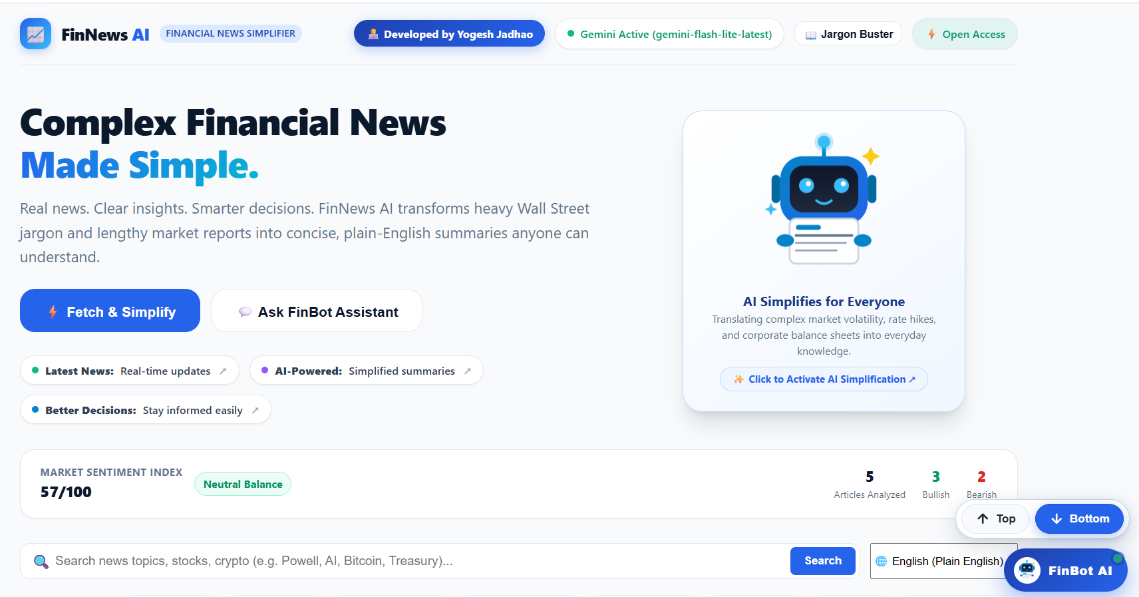
Figure: FinNews AI project Home Page screenshot

2) Search & News Results :
Allows users to search for companies, topics or keywords and review relevant financial articles returned by the backend.
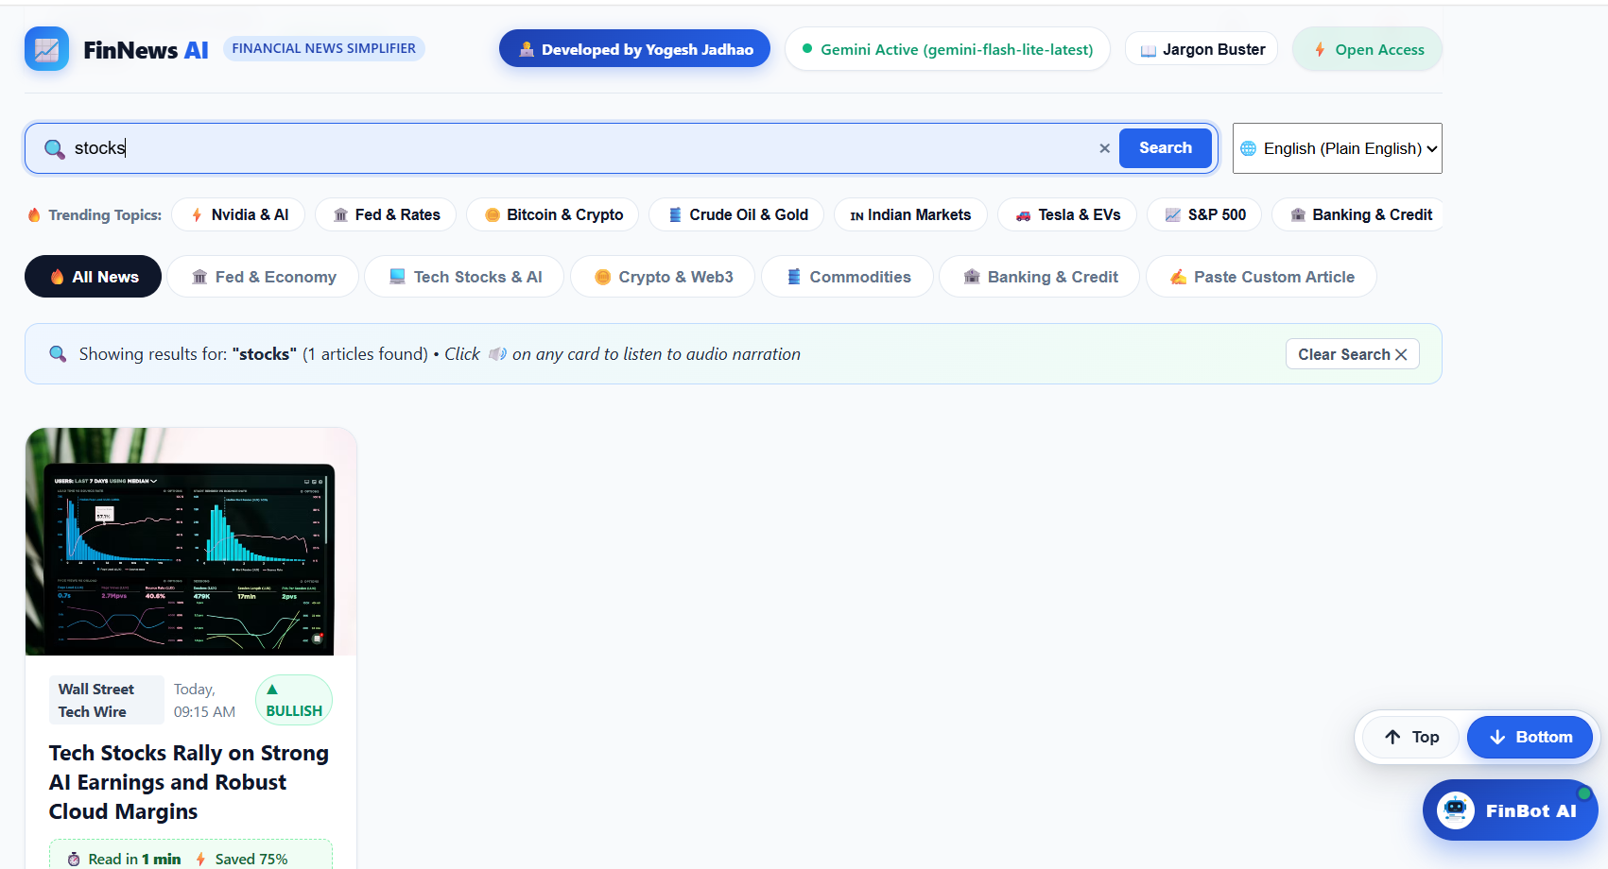
3) Article Details Page :
Displays the selected article information, source attribution and access to the original article.
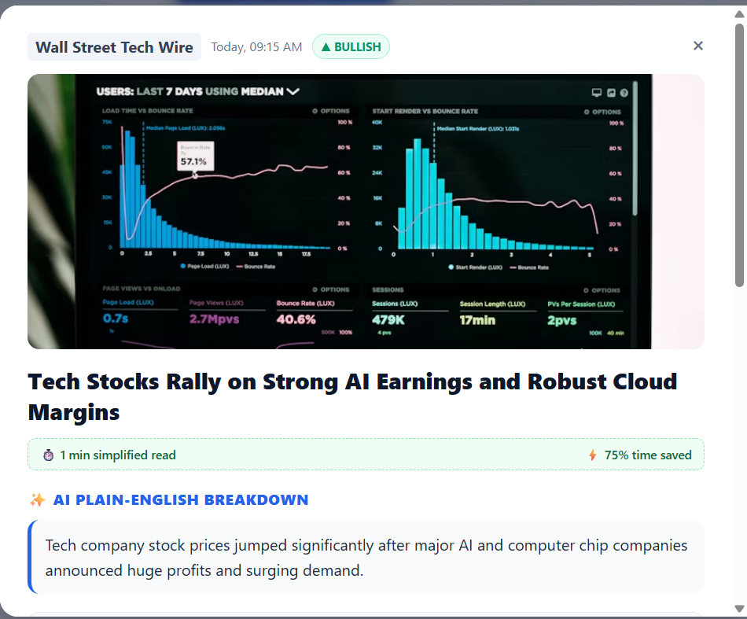

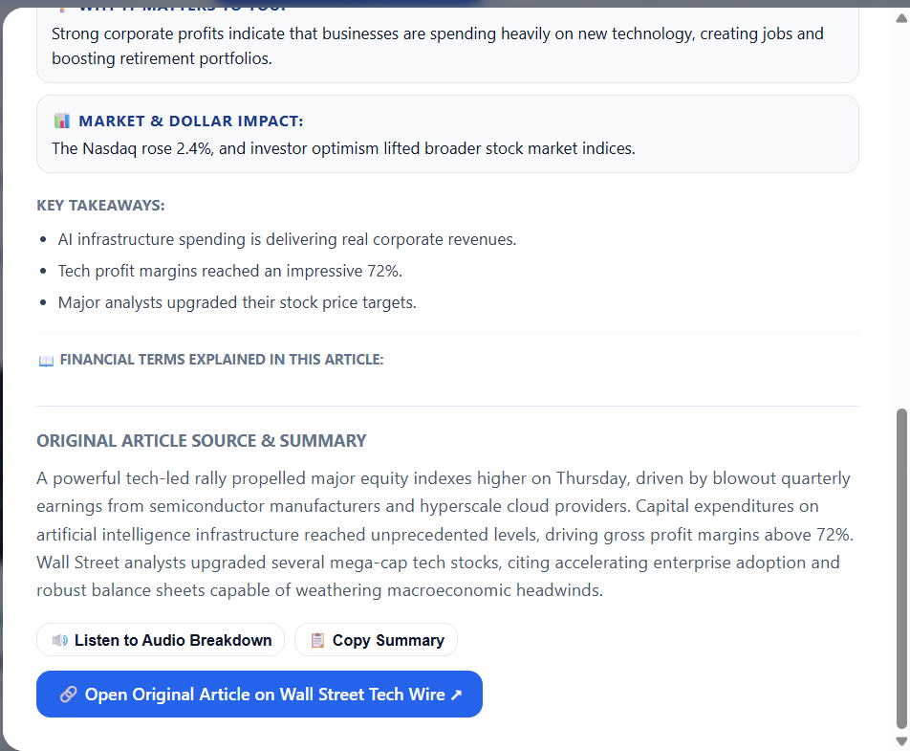
4) AI Simplification / Analysis :
Presents the AI-generated summary, simple explanation, key insights, financial terms, sentiment and why the article matters.
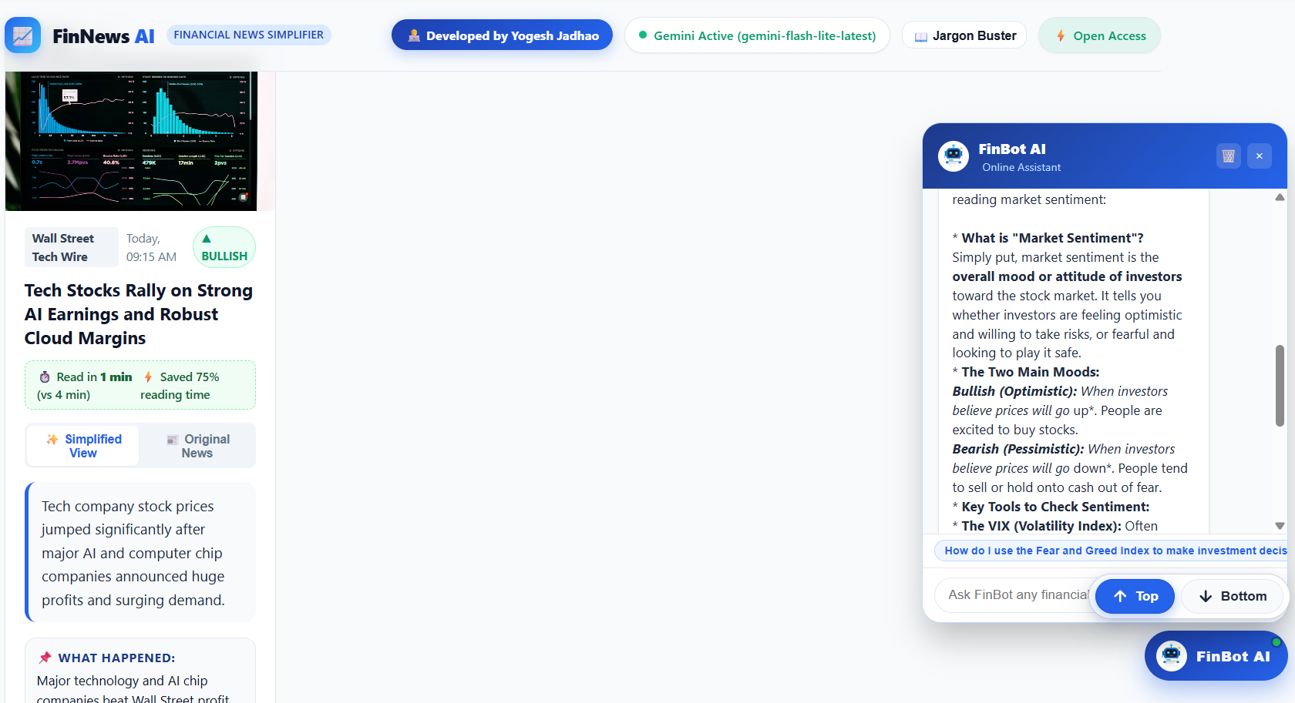
Figure: FinNews AI project AI Simplification screenshot

7. System Architecture
FinNews AI follows a layered architecture in which the frontend communicates with the FastAPI backend, while the backend manages communication with external news and AI services.
Layer | Technology / Component | Responsibility
Presentation | HTML / CSS / JavaScript | User interface, navigation, search, article display and AI-result presentation.
Application | FastAPI | API routing, validation, business logic and communication between frontend and services.
News Service | NewsAPI | Retrieves current/relevant financial news and article metadata.
AI Service | Gemini API | Generates structured, reader-friendly explanations from article content.
Configuration / Data | Environment variables + application data layer | Secure credential management and user/application data handling where implemented.

User → Frontend → FastAPI Backend → NewsAPI / Gemini → FastAPI → Frontend

8. Key Features
- Current financial-news discovery and search.
- Article details with source attribution and original-source access.
- AI-powered concise summarization.
- Beginner-friendly explanation of complex financial information.
- Extraction and explanation of important financial terms.
- Key insights from an article.
- AI-based sentiment analysis.
- Explanation of why an article may be relevant or significant.
- User-oriented features such as saving articles, where implemented.
- Responsive and user-friendly interface.
- Error handling for unavailable or failed external services.
- Secure server-side management of API credentials.

9. Technology Stack
Technology | Role | Purpose
HTML | Frontend | Page structure and semantic content.
CSS | Frontend | Responsive layout, styling and visual presentation.
JavaScript | Frontend | Interaction, API calls and dynamic content.
FastAPI | Backend | API layer, routing, validation and application logic.
NewsAPI | External API | Financial news retrieval.
Gemini API | Generative AI | Article summarization and structured explanation.
Environment Variables | Security | Secure management of API credentials and configuration.

10. Security, Reliability & Responsible AI
- API keys should remain server-side and be loaded through environment variables.
- User input and API requests should be validated before processing.
- External API failures should produce clear user-facing errors rather than fabricated results.
- AI-generated content should be clearly distinguished from the original publisher's content.
- The application should not present AI-generated explanations as personalized investment advice.
- Original source links allow users to verify context and read the complete article.
- Credentials must never be included in screenshots, public repositories or demonstration recordings.

11. Future Scope
- Multilingual financial-news simplification, including Indian languages.
- Personalized news recommendations based on user-selected topics.
- Advanced sentiment and topic trend visualization.
- Integration with additional trusted financial-data sources.
- Article comparison across multiple publishers.
- Company/topic watchlists and notification support.
- Improved AI grounding and evaluation using automated accuracy checks.
- Scalable cloud deployment and performance optimization.

12. Conclusion
FinNews AI demonstrates how generative AI and modern web technologies can be combined to improve access to financial information. By retrieving financial news and converting complex articles into structured, reader-friendly explanations, the platform reduces the effort required to understand financial developments.
The project brings together frontend development, FastAPI backend engineering, external API integration, generative AI, security practices and user-centered design. Its primary value is educational and informational: it helps users understand financial news while keeping the original source available for verification.

13. Final Demonstration Checklist
- Open the FinNews AI homepage.
- Show latest financial news and categories.
- Perform a search for a financial topic or company.
- Open an article and show its original source.
- Run AI Simplify / Analyze.
- Demonstrate summary, simple explanation, key insights, financial terms, sentiment and why it matters.
- Demonstrate additional implemented user features.
- Open VS Code and show the project folder structure.
- Briefly explain the FastAPI backend and NewsAPI integration.
- Show the Gemini integration and database/data layer.
- Show environment-variable configuration without exposing secrets.
- Conclude with the system architecture and project objective.

