A Machine Learning Approach for Automatic Text Categorization – A Case Study for DTIC Collection

Kurt Maly, Steven Zeil, Mohammad Zubair, Naveen Ratkal
maly@cs.odu.edu, zeil@cs.odu.edu, zubair@cs.odu.edu, nratkal@cs.odu.edu
Department of Computer Science
Old Dominion University, Norfolk, VA 23529

Abstract

Automated document categorization has been extensively studied and various techniques for document categorization based on machine learning approaches have been proposed. One of the machine learning techniques, Support Vector Machines (SVMs), is promising for text categorization. However, most of these experimental prototypes, for the purpose of evaluating different techniques, have been restricted to a standard collection such as Reuters. Commercial text categorization systems are not widespread. One reason is uncertainty in how to adapt a machine learning approach to a variety of collections with different characteristics. This paper describes a framework that allows one to evaluate the applicability of SVMs for a document collection, specifically the Defense Technical Information Center (DTIC). In this paper we report on our results applying this framework to the descriptor selection problem.

1. Introduction
Automated document categorization has been extensively studied, and a good survey article [1] discusses various techniques for document categorization with particular focus on machine learning approaches. One of the machine learning techniques, Support Vector Machines (SVMs), is promising for text categorization [2,3]. Dumais et al. [2] evaluated SVMs for the Reuters-21578 collection [4]. They found SVMs to be most accurate for text categorization and quick to train.
The automatic text categorization area has matured and a number of experimental prototypes are available [1]. However, most of these experimental prototypes, for the purpose of evaluating different techniques, have restricted to a standard collection such as Reuters [4]. As pointed out in [1], commercial text categorization systems are not widespread. One of the reasons is uncertainty in how to adapt a machine learning approach to a variety of collections with different characteristics.
This paper describes a framework we have created that allows one to evaluate SVMs for the categorization problem on a collection. Specifically, we evaluate the applicability of SVMs for the Defense Technical Information Center (DTIC). DTIC currently uses a dictionary-based approach to assign DTIC thesaurus descriptors to an acquired document based on its title and abstract. The descriptor assignment is validated by humans and one or more fields/groups (subject categorization) are assigned to the target document. The thesaurus currently consists of around 14K descriptors (i.e., single words or phrases of words). For subject categorization, DTIC uses 25 main categories (fields) and 251 sub-categories (groups). Typically a document is assigned two or three fields/groups. Further, a document is assigned five or six descriptors from the DTIC thesaurus.
The dictionary based approach currently used by DTIC relies on mapping of document phrases to DTIC thesaurus descriptions; it is not efficient because it requires continuous updating of the mapping table. Additionally, it suffers from an unpredictable quality of descriptors that are assigned using this approach. There is a need to improve this process to make it time efficient and to improve the quality of descriptors that are assigned to documents.
We proposed to DTIC an SVM-based process and have developed a framework to evaluate the effectiveness of SVMs for both subject categorization and descriptor selection. In this paper we report on our promising results for the descriptor selection problem.

2. Background
The DTIC collection currently consists of over 300,000 documents for which categorization exists and on the order of 30,000 new incoming documents per year. These incoming documents need to be categorized and descriptors need to be selected for them. The documents in the collection are heterogeneous with respect to format and content type. Content types include technical reports, survey reports, power point presentations, collection of articles, etc. Figure 1 shows some sample cover pages from the DTIC collection, illustrating this heterogeneity. Documents are in PDF format and may be text (normal) PDF or may consist of scanned images.

2.1. SVM Background
Support Vector Machines (SVMs) are a machine
Figure 1. Sample Cover Pages from the DTIC Collection
learning model proposed by V. N. Vapnik [5]. The basic idea of SVM is to find an optimal hyperplane to separate two classes with the largest margin from pre-classified data. After this hyperplane is determined, it can be used for classifying data into two classes based on which side they are located. By applying appropriate transformations to the data space prior to computing the separating hyperplane, SVM can be extended to cases where the border between two classes is non-linear.
As a powerful statistical model with ability to handle a very large feature set, SVM is widely used in pattern recognition areas such as face detection, isolated handwriting digit recognition, and gene classification [6]. Recently SVM has been used for text categorization successfully. T. Joachims [7] classified documents into categories by using SVM and obtained better results than those obtained by using other machine learning techniques such as Bayes and K-NN. Similarly, J.T. Kwok [8] used SVM to classify Reuters newswire stories into categories and obtained better results than using a k-NN classifier. J.T. Kwok also tried to alleviate the synonymy problem, i.e., different descriptors having similar meanings, by integrating SVM with LSI [8].

3. Approach
A common feature set used when applying SVM to text categorization is the words occurring in a training set. The basic idea is that different kind of documents contains different words and these word occurrences can be viewed as clues for document classification. For example, the term “computer” may occur less frequently in a finance document than in a computer science document, but “mortgage” may occur frequently in a finance document. Then when we see many “mortgage” occurrences in a document, it is more likely a finance document. Figure 1 shows an SVM using two words as features. Each point represents a single document. The coordinates in the SVM feature space are the number of occurrences of each word in a document.
There are several ways one can apply SVM to the problem of assigning fields/groups and descriptors to new documents based on learning sets. In one approach we would treat the problems of categorization and descriptor selection as independent problems, each one solved by a distinct SVM. An alternative hierarchical approach would either start with the categorization problem or the descriptor problem and then solve the other as a restricted domain problem. For instance, we could solve the categorization problem first and then, for the resulting specific field/group, solve the descriptor selection problem.
Here, we discuss an “independent” approach and discuss how to resolve inconsistencies that can result when the two problems are solved independently. An equally important task, which is not the focus of this paper, is to study different ways of applying SVMs and possible other machine learning techniques that can result in better quality descriptors and descriptor/subject mapping. The overall approach consists of the following major steps.
Figure 2. Process for training SVM for a Term(descriptor) K
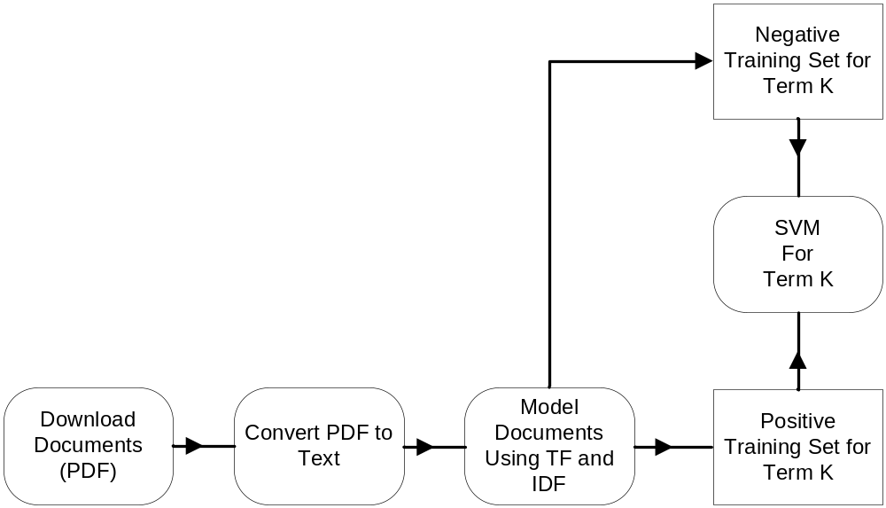
Step 1. We use the existing DTIC collection for the training phase. A collection model (T,IDF) is computed where T is a vector of terms (any words not appearing in a stoplist of extremely common words) and IDF is a vector of corresponding weights. Each weight idf_{i} is the inverse document frequency for the term t_{i}, a commonly used measure of the relative significance of a term [1].
Each document in the training set is represented by a vector obtained by computing the term frequencies (TF) for that document, the number of times a term occurs in the document. The document is then represented by a vector of values c_{i *} idf_{i} , where c_{i} is 1 if the term t_{i} occurs more than 4 times in the document, 0 otherwise. This vector represents a coordinate point in a “document space”.
Using this representation of a document, we train an SVM for each of the 251 fields/groups and each of the 14000 descriptors.
Step 2. We use trained SVMs to identify the subject categories for a document. For each subject category, a distinct SVM is trained to recognize documents in that subject. Each SVM will assign a likelihood factor (varying from 0 to 1) based on the document’s distance from the hyperplane. We sort the assigned categories based on the likelihood factor and select first “k” categories based on a threshold.
Step 3. Similar to Step 2, we identify descriptors, training a distinct SVM to recognize documents that fit that descriptor, sort them, and select “m” descriptors based on a threshold.
Step 4. Note that subject categories identified in Step 2 and descriptors identified in Step 3 may be inconsistent. That is we may have a subject assignment for a new document without its descriptor as identified by the DTIC thesaurus. One straightforward way to resolve this is to use intersection of descriptors identified by the descriptor/subject mapping and the descriptors identified by the SVM. The likelihood factor can then be used to select few fields/groups (around two or three) and five or six descriptors.
As we are using SVM to classify a large number of classes (251 subjects + 14000 descriptors), performance issues must be considered. This is not as time consuming as it might seem. Most of the computation effort lies in the one-time training of the SVMs. When applying a trained SVM to a document, most of the per-document cost is in computing the term vector representation of the document. Once that vector has been computed, the application of each SVM to the document is realized by a single vector dot-product, allowing many SVMs to be applied in a very short time. As part of this work we continue to investigate ways to improve the performance without sacrificing the quality of categorization or of descriptors assignment.
In the remainder of this paper, we focus on Step 3 of the overall process with particular attention on the automated framework that allows collection to be analyzed, trained, processed, and results presented.

4. SVM Based Architecture
The process of identifying a descriptor for a document consists of two phases: the training phase and the assignment phase. In the training phase, we train an SVM for each thesaurus descriptor. Next in the assignment phase, we present a document to all the trained SVMs and select “m” descriptors based on a threshold. We now give details of the two processes.

4.1 Training
Figure 2 illustrates the training process for the SVMs. For each descriptor, we construct a URL and use this URL to search documents from the DTIC collection in that category. For our testing purposes we have conducted this process for a sample of five descriptors. From the search results, we download a subset of the documents that are selected randomly. These documents, which are in PDF format, are converted to text using a commercial OCR product, Omnipage. We compute a IDFs and TFs as described above to obtain a vector representation of each document. These documents form the positive training set for the selected thesaurus descriptor. The negative training set is created by randomly selecting documents from among those documents downloaded for training sets for descriptors other than the selected descriptor.
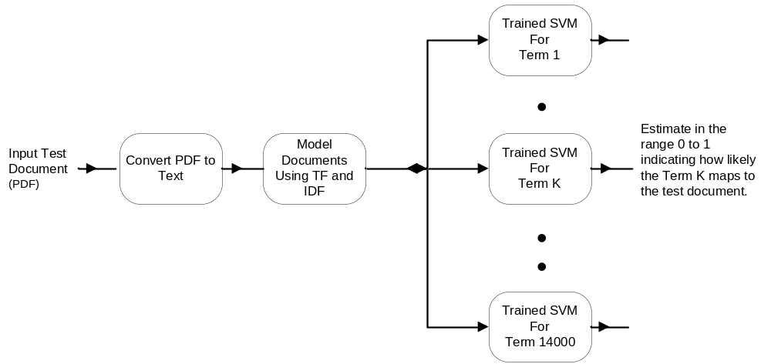
Figure 3. Process for assigning term (descriptors) for a test document
4.2 Assignment
Figure 3 illustrates the assignment phase. The input document is represented using TF and IDF as in the training phase. This document is presented to all the trained SVMs, which in turn output a score in the range from 0 to 1 indicating how likely a test document is to belong to the class of documents associated with the selected descriptor. We can then select the “m” thesaurus descriptors with the highest scores to describe that test document.

5. Results

For testing our approach, we randomly selected five descriptors: “Damage Tolerance”, “Fabrication”, “Machine”, “Military History”, and “Tactical Analysis”. We downloaded 70 documents for each of the five thesaurus descriptors. Out of these 70 documents 50 were used for the positive training set and 20 were used for testing the trained SVM. An additional 50 documents, downloaded as positive instances of other descriptors, were randomly selected for the negative training set.

We use recall and precision metrics that are commonly used by the information extraction and data mining communities. The general definition of recall and precision is:

Recall = Correct Answers / Total Possible Answers

Precision = Correct Answers / Answers Produced

To compute recall and precision typically one uses confusion matrix C, which is a KxK matrix for a K-class classifier [9]. In our case, it is a 5 by 5 matrix and and an element C[i,j] indicates how many documents in class i have been classified as class j. For an ideal classifier all off-diagonal entries will be zeroes, and if there are n documents in a class j, then C[j,j]=n. We summarize our results in the 5 by 5 confusion matrix shown in Figure 4.

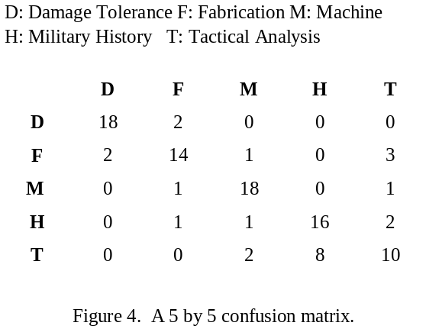

The recall and precision are defined (in terms of that confusion matrix C) as:

Recall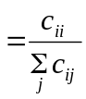
Precision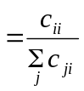

Figure 5 summarizes the recall and precision numbers for the five descriptors. The results indicate that we are getting good recall and precision for four of the descriptors. We are not doing so well for the “Tactical Analysis” category. We suspect that this category is very similar to Military History (H) category and may require a larger training set.

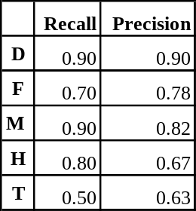

Figure 5. Recall and precision results

6. Conclusion
In this paper, we described a framework to evaluate the effectiveness of SVMs for both the subject categorization and the descriptor selection problem for a DTIC collection. Our preliminary results support our belief that we can use SVMs to improve the existing DTIC process, which uses a dictionary to assign thesaurus descriptors to an acquired document based on its title and abstract. We still need to do more testing to determine if these indications hold for a wider variety of descriptors and to determine the right training sizes for various SVMs. Following our work with the DTIC collection, we hope to apply this framework to other collections.

7. References

[1] Sebastiani, F (2002). “Machine learning in automated text categorization”. ACM Computing Surveys. Vol. 34(1). pp. 1-47.
[2] Dumais, S. T., Platt, J., Heckerman, D., and Sahami, M. (1998). “Inductive learning algorithms and representations for text categorization”, In Proceedings of CIKM-98, 7th ACM International Conference on Information and Knowledge Management (Washington, US, 1998), pp. 148–155.
[3] Joachims, T. (1998). “Text categorization with support vector machines: learning with many relevant features”, In Proceedings of ECML-98, 10th European Conference on Machine Learning (Chemnitz, DE, 1998), pp. 137–142.
[4] Reuters-21578 collection. URL:
http://www.research.att.com/~lewis/reuters21578.htm.
[5] V. N. Vapnik. The nature of Statistical Learning Theory. Springer, Berlin, 1995.
[6] C.J.C. Burges. A tutorial on support vector machines for pattern recognition. Data Mining and Knowledge Discovery, 2(2): 955-974, 1998.
[7] T. Joachims, Learning to Classify Text Using Support Vector Machines. Dissertation, Kluwer, 2002.
[8] J.T. Kwok. Automated text categorization using support vector machine. In Proceedings of the International Conference on Neural Information Processing, Kitakyushu, Japan, Oct. 1998, pp. 347-351.
[9] Kohavi, R., and Provost, F. Glossary of Terms. Machine Learning, 30(2/3):271--274, 1998.

