Gramin Career Setu – A Digital Career-Guidance Bridge for the Youth

A Community Service Project report

submitted in the partial fulfillment of the requirements for

the award of the degree of

Bachelor of Technology
in
Computer Science and Engineering

Submitted by

ANAPARTHI RAKESH KUMAR (25765A0532)
CHORAGUDI SOWMYA (25765A0533)
KAMISETTY YOGESH (25765A0534)
KATRU SRUTHI (25765A0535)
KUPPALA SURYA TEJA (25765A0536)
PILLA BHANU (25765A0537)

Under the guidance of
Mrs. M. Gayathri
Sr. Assistant Professor



Department of Computer Science and Engineering

LAKIREDDY BALI REDDY COLLEGE OF ENGINEERING
(AUTONOMOUS)
Accredited by NAAC with ‘A’ Grade & NBA (Under Tier - I), ISO 9001:2015 Certified Institution
Approved by AICTE, New Delhi and Affiliated to JNTUK, Kakinada
L.B. REDDY NAGAR, MYLAVARAM, NTR Dist, A.P.-521 230.

NOVEMBER 2026

 | LAKIREDDY BALI REDDY COLLEGE OF ENGINEERING  (AUTONOMOUS)  Accredited by NAAC with ‘A’ Grade & NBA (Under Tier - I),  An ISO 21001:2018,14001:2015,50001:2018 Certified Institution  Approved by AICTE, New Delhi and Affiliated to JNTUK, Kakinada  L.B. REDDY NAGAR, MYLAVARAM, NTR DIST., A.P.-521 230.  hodcse@lbrce.ac.in, cseoffice@lbrce.ac.in, Phone: 08659-222 933, Fax: 08659-222931  DEPARTMENT OF COMPUTER SCIENCE & ENGINEERING

Certificate

This is to certify that the community service project entitled “Gramin Career Setu – A Digital Career-Guidance Bridge for the Youth” is being submitted by Anaparthi Rakesh Kumar (25765A0532), Choragudi Sowmya (25765A0533), Kamisetty Yogesh (25765A0534), Katru Sruthi (25765A0535), Kuppala Surya Teja (25765A0536), Pilla Bhanu (25765A0537) in partial fulfillment for the award of B. Tech in Computer Science & Engineering to the Jawaharlal Nehru Technological University Kakinada is a record of bonafide work carried out by them under our guidance.
The results embodied in this project report have not been submitted to any other University or Institute for the award of any degree or diploma.

Period of CSP: From: 15/05/2026 To: 25/06/2026
Name & Address of the Community / Habitation: Bahubalendrunigudem (B B Gudem), Gannavaram Mandal, Krishna District, Andhra Pradesh – 521101
Date of Submission: November 2026

Project guide | Head of the department
Mrs. M. Gayathri | Dr. S. Nagarjuna Reddy
Sr. Assistant Professor | Professor & HOD

Student’s Declaration

I, Anaparthi Rakesh Kumar, a student of B. Tech in Computer Science & Engineering Program, Reg. No. 25765A0532 of the Department of Computer Science & Engineering, Lakireddy Bali Reddy College of Engineering, do hereby declare that I have completed the mandatory community service from 15/05/2026 to 25/06/2026 in Bahubalendrunigudem (B B Gudem), Gannavaram Mandal, Krishna District, Andhra Pradesh under the Faculty Guideship of Mrs. M. Gayathri, Sr. Assistant Professor, Department of Computer Science & Engineering in Lakireddy Bali Reddy College of Engineering.

(Signature and Date)

Faculty Guide

Head of the Department

Principal

Student’s Declaration

I, Choragudi Sowmya, a student of B. Tech in Computer Science & Engineering Program, Reg. No. 25765A0533 of the Department of Computer Science & Engineering, Lakireddy Bali Reddy College of Engineering, do hereby declare that I have completed the mandatory community service from 15/05/2026 to 25/06/2026 in Bahubalendrunigudem (B B Gudem), Gannavaram Mandal, Krishna District, Andhra Pradesh under the Faculty Guideship of Mrs. M. Gayathri, Sr. Assistant Professor, Department of Computer Science & Engineering in Lakireddy Bali Reddy College of Engineering.

(Signature and Date)

Faculty Guide

Head of the Department

Principal

Student’s Declaration

I, Kamisetty Yogesh, a student of B. Tech in Computer Science & Engineering Program, Reg. No. 25765A0534 of the Department of Computer Science & Engineering, Lakireddy Bali Reddy College of Engineering, do hereby declare that I have completed the mandatory community service from 15/05/2026 to 25/06/2026 in Bahubalendrunigudem (B B Gudem), Gannavaram Mandal, Krishna District, Andhra Pradesh under the Faculty Guideship of Mrs. M. Gayathri, Sr. Assistant Professor, Department of Computer Science & Engineering in Lakireddy Bali Reddy College of Engineering.

(Signature and Date)

Faculty Guide

Head of the Department

Principal

Student’s Declaration

I, Katru Sruthi, a student of B. Tech in Computer Science & Engineering Program, Reg. No. 25765A0535 of the Department of Computer Science & Engineering, Lakireddy Bali Reddy College of Engineering, do hereby declare that I have completed the mandatory community service from 15/05/2026 to 25/06/2026 in Bahubalendrunigudem (B B Gudem), Gannavaram Mandal, Krishna District, Andhra Pradesh under the Faculty Guideship of Mrs. M. Gayathri, Sr. Assistant Professor, Department of Computer Science & Engineering in Lakireddy Bali Reddy College of Engineering.

(Signature and Date)

Faculty Guide

Head of the Department

Principal

Student’s Declaration

I, Kuppala Surya Teja, a student of B. Tech in Computer Science & Engineering Program, Reg. No. 25765A0536 of the Department of Computer Science & Engineering, Lakireddy Bali Reddy College of Engineering, do hereby declare that I have completed the mandatory community service from 15/05/2026 to 25/06/2026 in Bahubalendrunigudem (B B Gudem), Gannavaram Mandal, Krishna District, Andhra Pradesh under the Faculty Guideship of Mrs. M. Gayathri, Sr. Assistant Professor, Department of Computer Science & Engineering in Lakireddy Bali Reddy College of Engineering.

(Signature and Date)

Faculty Guide

Head of the Department

Principal

Student’s Declaration

I, Pilla Bhanu, a student of B. Tech in Computer Science & Engineering Program, Reg. No. 25765A0537 of the Department of Computer Science & Engineering, Lakireddy Bali Reddy College of Engineering, do hereby declare that I have completed the mandatory community service from 15/05/2026 to 25/06/2026 in Bahubalendrunigudem (B B Gudem), Gannavaram Mandal, Krishna District, Andhra Pradesh under the Faculty Guideship of Mrs. M. Gayathri, Sr. Assistant Professor, Department of Computer Science & Engineering in Lakireddy Bali Reddy College of Engineering.

(Signature and Date)

Faculty Guide

Head of the Department

Principal

Certificate from Official of the Community

This is to certify that the following students of Lakireddy Bali Reddy College of Engineering underwent community service in Bahubalendrunigudem (B B Gudem), Gannavaram Mandal, Krishna District, Andhra Pradesh from 15/05/2026 to 25/06/2026: Anaparthi Rakesh Kumar (25765A0532), Choragudi Sowmya (25765A0533), Kamisetty Yogesh (25765A0534), Katru Sruthi (25765A0535), Kuppala Surya Teja (25765A0536), Pilla Bhanu (25765A0537).
The overall performance of these Community Service Volunteers during their community service is found to be ______________________ (Satisfactory/Good).

Authorized Signatory with Date and Seal

Acknowledgements

The satisfaction that accompanies that the successful completion of any task would be incomplete without the mention of people whose ceaseless cooperation made it possible, whose constant guidance and encouragement crown all efforts with success.

We are grateful to our Project Guide, Mrs. M. Gayathri, Sr. Assistant Professor, Computer Science & Engineering, for the guidance, inspiration and constructive suggestions that helped us in the preparation of this project.

At the outset we thank our Head of the Department, Dr. S. Nagarjuna Reddy, and our Honorable Principal, Dr. K. Appa Rao, for the moral support and the excellent facilities provided. We would also like to thank all the teaching and non-teaching staff members of the Computer Science & Engineering department.

We wish to express our warm and grateful thanks to the residents, students and ASHA workers of Bahubalendrunigudem (B B Gudem) village who spent their time talking with us, shared their views and allowed us to show them our work, which helped us in completing our project successfully.

We thank all our friends who helped us sharing knowledge to complete the task in-time.

ANAPARTHI RAKESH KUMAR (25765A0532)
CHORAGUDI SOWMYA (25765A0533)
KAMISETTY YOGESH (25765A0534)
KATRU SRUTHI (25765A0535)
KUPPALA SURYA TEJA (25765A0536)
PILLA BHANU (25765A0537)

Contents

Topic | Page No.
Chapter 1: Executive Summary | 12
Chapter 2: Overview of the Community | 13
Chapter 3: Community Service Part | 14
Chapter 4: Activity Log | 16
4.1 Activity Log for the First Week | 16
4.2 Weekly Report (Week 1) | 17
4.3 Activity Log for the Second Week | 18
4.4 Weekly Report (Week 2) | 19
4.5 Activity Log for the Third Week | 20
4.6 Weekly Report (Week 3) | 21
4.7 Activity Log for the Fourth Week | 22
4.8 Weekly Report (Week 4) | 23
4.9 Activity Log for the Fifth Week | 24
4.10 Weekly Report (Week 5) | 25
4.11 Activity Log for the Sixth Week | 26
4.12 Weekly Report (Week 6) | 27
Chapter 5: Outcomes Description | 28
5.1 Details of the Socio-Economic Interaction | 28
5.2 Problems Identified in the Community | 30
5.3 Short-term and Long-term Action Plan | 31
5.4 Community Awareness Programmes | 32
5.5 Report of the Mini-Project Work | 33
Chapter 6: Recommendations and Conclusions | 39
Annexure A: Question Guide | 40
Photos & Video Links | 42
Annexure B: PO and SDG Mapping | 46

CHAPTER 1: EXECUTIVE SUMMARY
This Community Service Project was carried out in Bahubalendrunigudem (B B Gudem), a village in Gannavaram Mandal of Krishna District, Andhra Pradesh, with about 1,790 residents in 541 households. Farming is the main livelihood and a large share of the workforce works as agricultural labour. Many young people here finish 10th class, Intermediate or ITI without a clear idea of which careers are open to them, how to apply for a job or an exam online, or how to prepare a resume.
Over six weeks, from 15 May 2026 to 25 June 2026, our team of six visited the village, spoke with students, unemployed youth, residents and ASHA workers, explained the problem and gave simple guidance. Based on these conversations we built a free, mobile-friendly website, Gramin Career Setu, in Telugu and English. It offers a skill quiz, step-by-step career roadmaps, job roles with links to the official sites, a resume builder, government schemes and scholarships, and a page for village workshops. We showed the working prototype to students and villagers, explained what it already does and what is still being completed, and advised everyone to verify current notifications on the official websites.
Learning objectives and outcomes:
1. To understand the career-awareness and digital-access needs of rural youth by listening to them directly.
2. To help young people see the career paths open to them after 10th, Intermediate, ITI or a degree.
3. To explain how to apply for jobs and exams online, and how to avoid agents and fake job offers.
4. To design and build a simple, offline-friendly Telugu and English web solution for a real community problem.
5. To develop communication, teamwork and responsible reporting skills while working with a village community.
The project gave us a working prototype and a clear plan for the next phase, which is wider testing and a formal before-and-after survey to measure the change it makes.

CHAPTER 2: OVERVIEW OF THE COMMUNITY

2.1 About the community
Bahubalendrunigudem, also written B B Gudem (pincode 521101), is a village in Gannavaram Mandal of Krishna District, Andhra Pradesh. It lies about 6 km from Gannavaram town and spreads over roughly 324 hectares of flat, well-irrigated land. The village has about 1,790 residents living in 541 households, and a literacy rate of about 70.6 percent.
Like many villages of the Krishna delta region, the community is closely knit. People know one another, festivals and family occasions bring them together, and elders are respected. During our visits we found residents welcoming and willing to talk about their children’s studies, their worries about work and the help they would like to have. Community values such as respect, cooperation and honesty were visible in the way neighbours supported one another.
ASHA workers act as an important link between the village and public services, and they move through the homes regularly. We met them in the village on our first day, and their familiarity with families helped us reach people and explain our purpose.
2.2 Socio-economic conditions
The local economy is largely agricultural. More than 58 percent of the workforce works as agricultural labourers, with others engaged in cultivation, small shops, daily-wage work and jobs in Gannavaram and nearby towns. Farm work is seasonal, so income can be uncertain, and many families look to education and a steady job as the way to improve their position.
Schools and colleges are available within reach, and the literacy rate shows steady progress, but young people often depend on parents, teachers and friends for career advice. Information on jobs, exams, schemes and scholarships is spread over many websites, mostly in English, and some families have only a shared smartphone and a limited data plan. This gap between available opportunities and the information that reaches the village is the need our project addresses.
Note: Village figures (population, households, literacy, workforce and area) are taken from the village profile data compiled for this report.

CHAPTER 3: COMMUNITY SERVICE PART

During the six-week Community Service Project in Bahubalendrunigudem, our team worked on three connected activities: listening to the community, building a solution from what we heard, and sharing it back with the villagers.
Activities undertaken
1. Community visits and interaction. We walked through the village and spoke with students, unemployed youth, parents, other residents and ASHA workers. We did not hand out forms; instead we asked questions in simple Telugu, listened to their answers and noted the main points. A structured question guide (Annexure A) helped us cover the topics: education, career awareness, job search, digital access, resume making and what help people want.
2. Explaining the problem and giving guidance. We explained in plain words why career information is hard to find, how an online application works, what a resume is and why it matters, and how to recognise fake job offers. We encouraged people to use official websites and to search for current information themselves.
3. Building the solution. Based on what we learned, we built Gramin Career Setu, a Telugu and English website that works on a basic smartphone and keeps working offline once opened. It brings together a skill quiz, career roadmaps, job roles, a resume builder, schemes and scholarships, and workshops.
4. Showing the prototype to the community. We demonstrated the prototype to students and villagers, explained that it is a working prototype with some parts still being finished, and asked what they would change.
5. Testing and documentation. We tested the site on mobile and slow connections, wrote automated tests, and recorded our work day by day in this report.
Values, life skills and technical skills acquired
Through this work we developed empathy, respect for the community and a sense of social responsibility. We learned to communicate with people of different ages and education levels, to listen before suggesting solutions, to work as a team of six, and to report honestly what we did and did not do. Technically, we gained experience in building an offline-capable web application, designing a secure backend, writing automated tests, and designing for low-end devices and weak networks.
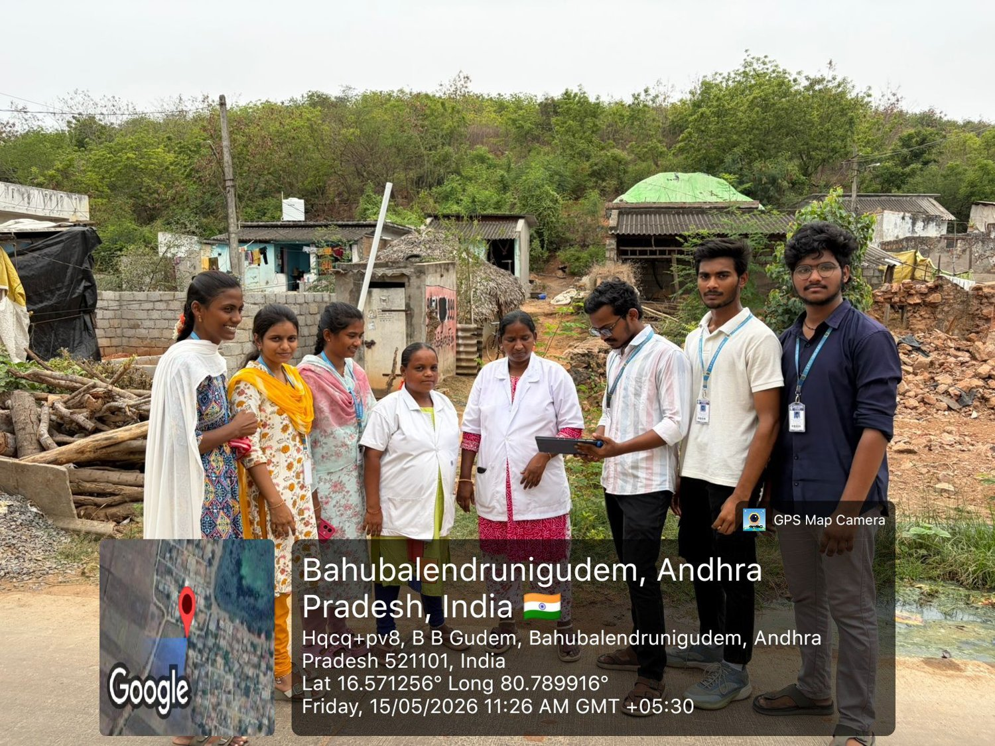
Figure: Team with ASHA workers in Bahubalendrunigudem (15/05/2026)
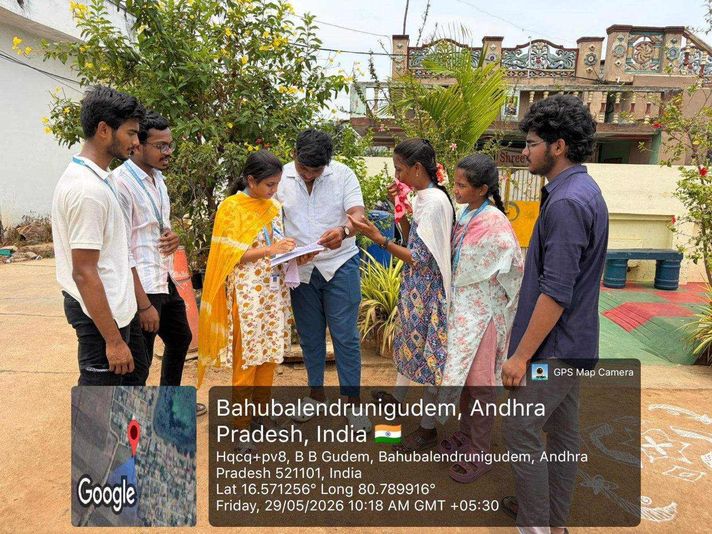
Figure: Explaining the project to villagers and youth (29/05/2026)

CHAPTER 4: ACTIVITY LOG
ACTIVITY LOG FOR THE FIRST WEEK

Day & Date | Brief description of the daily activity | Learning Outcome | Person In- Charge Signature
Day – 1  15/05/2026 | Reached the village, met residents and ASHA workers, and explained the purpose of our Community Service Project. | Learned how to introduce a project respectfully to a community. | ANAPARTHI RAKESH KUMAR
Day – 2  16/05/2026 | Spoke with students and unemployed youth about their studies, plans and difficulties in finding jobs. | Improved listening and interviewing skills. | CHORAGUDI SOWMYA
Day – 3  18/05/2026 | Talked with parents and elders about how families choose a career for their children and where they get information. | Understood the role of family in career decisions. | KAMISETTY YOGESH
Day – 4  19/05/2026 | Asked how people use smartphones for study and job search, and explained what an online application and a resume are. | Learned to explain technical ideas in simple words. | KATRU SRUTHI
Day – 5  20/05/2026 | Compiled and discussed our notes from the visits and grouped the main problems we heard. | Improved organising information and finding patterns. | KUPPALA SURYA TEJA
Day – 6  21/05/2026 | Reviewed the findings with our guide and planned a Telugu and English career website as the solution. | Practised project planning and dividing work. | PILLA BHANU

WEEKLY REPORT
WEEK – 1 (From Dt: 15/05/2026 to Dt: 21/05/2026)

Objective of the Activity Done:
To visit Bahubalendrunigudem, introduce the project to the community, and understand how students, unemployed youth and residents find information about careers.

Detailed Report:
In the first week we reached the village on 15 May and walked through it with the help of local residents. We introduced ourselves and explained that we are students of the Computer Science & Engineering department carrying out our Community Service Project. We spoke with students, young people who are looking for work, parents and ASHA workers, and noted what they told us.
People were keen to talk about education and work, and the road from a qualification to a job was unclear to many of them. The conversations pointed to the same needs: knowing which careers follow a qualification, how to apply online, and how to be sure an offer is genuine. By the end of the week we had grouped these into three problems: information is scattered, there is no clear next step, and there is little help with online applications and resumes. We shared our plan with our guide and decided to build a Telugu and English website as our solution.
Learning from the week: building trust comes first. People spoke more openly once we explained who we were and why we had come, and once we listened without hurrying. We also saw how differently a farming family, a student and an ASHA worker look at the same problem, and we kept all three views in mind while planning the solution.
Work completed during the week:
• Day 1 (15/05/2026): Reached the village, met residents and ASHA workers, and explained the purpose of our Community Service Project.
• Day 2 (16/05/2026): Spoke with students and unemployed youth about their studies, plans and difficulties in finding jobs.
• Day 3 (18/05/2026): Talked with parents and elders about how families choose a career for their children and where they get information.
• Day 4 (19/05/2026): Asked how people use smartphones for study and job search, and explained what an online application and a resume are.
• Day 5 (20/05/2026): Compiled and discussed our notes from the visits and grouped the main problems we heard.
• Day 6 (21/05/2026): Reviewed the findings with our guide and planned a Telugu and English career website as the solution.

ACTIVITY LOG FOR THE SECOND WEEK

Day & Date | Brief description of the daily activity | Learning Outcome | Person In- Charge Signature
Day – 7  22/05/2026 | Listed job roles, schemes and scholarships from official websites, noting the official link for each. | Learned to judge the reliability of sources. | ANAPARTHI RAKESH KUMAR
Day – 8  23/05/2026 | Returned to the village for follow-up conversations with students and villagers about the help they need. | Gained confidence in speaking with the community. | CHORAGUDI SOWMYA
Day – 9  25/05/2026 | Matched job roles to qualification levels such as 10th, Intermediate, ITI and degree. | Improved analysis and data organisation. | KAMISETTY YOGESH
Day – 10  26/05/2026 | Designed the structure of the website: quiz, roadmap, job roles, resume builder and schemes. | Learned to design for rural users and basic phones. | KATRU SRUTHI
Day – 11  27/05/2026 | Built the first version of the skill quiz and the job list. | Gained hands-on web development experience. | KUPPALA SURYA TEJA
Day – 12  28/05/2026 | Reviewed the first version as a team and noted improvements. | Practised giving and accepting feedback. | PILLA BHANU

WEEKLY REPORT
WEEK – 2 (From Dt: 22/05/2026 to Dt: 28/05/2026)

Objective of the Activity Done:
To collect reliable, official information on jobs, schemes and scholarships, return to the village for follow-up conversations, and design the structure of the solution.

Detailed Report:
In the second week we went through official government and recruitment websites to list job roles by qualification, with links to the official sites rather than copies of notifications. On 23 May we returned to the village and spoke again with students and villagers to clarify their questions and to ask what kind of help they would actually use.
Back in college we designed how the site should work: a short quiz, a step-by-step roadmap for each career goal, a list of job roles that matches the person’s education, and a resume builder. We decided to keep the site light, in Telugu and English, and usable offline. We built a first version of the quiz and the job list and reviewed it within the team.
Learning from the week: official sources matter. Checking every role and link against government and recruitment websites showed us how much online information is repeated, out of date or copied, which is exactly the confusion young people face. We decided that our website would never copy notification details and would always point to the official page.
Work completed during the week:
• Day 7 (22/05/2026): Listed job roles, schemes and scholarships from official websites, noting the official link for each.
• Day 8 (23/05/2026): Returned to the village for follow-up conversations with students and villagers about the help they need.
• Day 9 (25/05/2026): Matched job roles to qualification levels such as 10th, Intermediate, ITI and degree.
• Day 10 (26/05/2026): Designed the structure of the website: quiz, roadmap, job roles, resume builder and schemes.
• Day 11 (27/05/2026): Built the first version of the skill quiz and the job list.
• Day 12 (28/05/2026): Reviewed the first version as a team and noted improvements.

ACTIVITY LOG FOR THE THIRD WEEK

Day & Date | Brief description of the daily activity | Learning Outcome | Person In- Charge Signature
Day – 13  29/05/2026 | Visited the village to explain the idea to youth and villagers and listen to their reactions. | Learned to present an idea to a non-technical audience. | ANAPARTHI RAKESH KUMAR
Day – 14  30/05/2026 | Built the roadmap generator that shows steps according to the person’s education and goal. | Strengthened problem-solving and logic skills. | CHORAGUDI SOWMYA
Day – 15  01/06/2026 | Built the resume builder that produces a PDF resume on a phone. | Understood how document generation works. | KAMISETTY YOGESH
Day – 16  02/06/2026 | Added the Telugu and English language switch and offline support. | Learned about localisation and offline-first design. | KATRU SRUTHI
Day – 17  03/06/2026 | Added the pages for government schemes, scholarships and village workshops. | Improved content organisation skills. | KUPPALA SURYA TEJA
Day – 18  04/06/2026 | Tested all features together and fixed the problems found. | Practised testing and debugging. | PILLA BHANU

WEEKLY REPORT
WEEK – 3 (From Dt: 29/05/2026 to Dt: 04/06/2026)

Objective of the Activity Done:
To explain the idea to the community, collect reactions, and build the core features of Gramin Career Setu.

Detailed Report:
On 29 May we went back to the village to explain what we were building and why. We described the quiz, the roadmap and the resume tool in simple words and listened to people’s reactions and suggestions. People’s interest in what to do after their qualification confirmed that a step-by-step roadmap was the right feature to build.
During the rest of the week we built the roadmap generator, which shows a step-by-step path for a chosen goal based on the person’s education, the resume builder that produces a PDF, the language switch between Telugu and English, offline support, and the schemes and scholarships pages. At the end of the week we tested the features together and fixed the problems we found.
Learning from the week: speaking to the community before the product was ready kept us focused on real needs. We also learned to turn what we heard into features, such as the education-based roadmap, within a few days, and to test each feature before moving to the next.
Work completed during the week:
• Day 13 (29/05/2026): Visited the village to explain the idea to youth and villagers and listen to their reactions.
• Day 14 (30/05/2026): Built the roadmap generator that shows steps according to the person’s education and goal.
• Day 15 (01/06/2026): Built the resume builder that produces a PDF resume on a phone.
• Day 16 (02/06/2026): Added the Telugu and English language switch and offline support.
• Day 17 (03/06/2026): Added the pages for government schemes, scholarships and village workshops.
• Day 18 (04/06/2026): Tested all features together and fixed the problems found.

ACTIVITY LOG FOR THE FORTH WEEK

Day & Date | Brief description of the daily activity | Learning Outcome | Person In- Charge Signature
Day – 19  05/06/2026 | Built the backend with sign-in and role checks for applications and workshop registration. | Learned the basics of secure application design. | ANAPARTHI RAKESH KUMAR
Day – 20  06/06/2026 | Checked the security rules: anonymous requests, wrong roles and invalid tokens. | Understood why access control matters. | CHORAGUDI SOWMYA
Day – 21  08/06/2026 | Reviewed the content and removed details that change with each notification, linking to official pages instead. | Learned the value of accurate, honest information. | KAMISETTY YOGESH
Day – 22  09/06/2026 | Wrote automated tests for the data, the pages and the security rules. | Gained experience in automated testing. | KATRU SRUTHI
Day – 23  10/06/2026 | Improved the layout for small screens and made the text easier to read. | Learned responsive and accessible design. | KUPPALA SURYA TEJA
Day – 24  11/06/2026 | Tested on a mobile phone and a slow connection and reduced the image sizes. | Understood performance on low-bandwidth networks. | PILLA BHANU

WEEKLY REPORT
WEEK – 4 (From Dt: 05/06/2026 to Dt: 11/06/2026)

Objective of the Activity Done:
To make the solution secure, accurate and reliable on basic phones and weak networks.

Detailed Report:
In the fourth week we strengthened the system behind the website. We built the backend with sign-in, role checks and limits on repeated requests, so that applying for a job or registering for a workshop needs a signed-in user. We reviewed the content and removed details that change with every notification, such as age limits, fees and cut-offs, and instead pointed users to the official notification.
We wrote automated tests that check the data, the pages and the security rules, and fixed the issues they exposed. We also improved the layout for small screens and tested the pages on a mobile phone and a slow connection. The aim was that a student with a basic phone should be able to open the site, follow a roadmap and make a resume without help.
Learning from the week: reliability is part of being helpful. A site that fails on a weak network or shows wrong information would harm the people it is meant to help, so we treated testing, security and accuracy as part of the service and not as extras.
Work completed during the week:
• Day 19 (05/06/2026): Built the backend with sign-in and role checks for applications and workshop registration.
• Day 20 (06/06/2026): Checked the security rules: anonymous requests, wrong roles and invalid tokens.
• Day 21 (08/06/2026): Reviewed the content and removed details that change with each notification, linking to official pages instead.
• Day 22 (09/06/2026): Wrote automated tests for the data, the pages and the security rules.
• Day 23 (10/06/2026): Improved the layout for small screens and made the text easier to read.
• Day 24 (11/06/2026): Tested on a mobile phone and a slow connection and reduced the image sizes.

ACTIVITY LOG FOR THE FIFTH WEEK

Day & Date | Brief description of the daily activity | Learning Outcome | Person In- Charge Signature
Day – 25  12/06/2026 | Prepared a short demonstration and guidance notes for students and villagers. | Improved presentation and planning skills. | ANAPARTHI RAKESH KUMAR
Day – 26  13/06/2026 | Demonstrated the prototype to students: quiz, roadmap and resume. | Gained experience in teaching and explaining. | CHORAGUDI SOWMYA
Day – 27  15/06/2026 | Showed villagers and parents how to read job roles and open the official websites. | Improved communication across age groups. | KAMISETTY YOGESH
Day – 28  16/06/2026 | Gave guidance on applying online, checking official sources and avoiding agents who ask for money. | Learned to give practical, responsible advice. | KATRU SRUTHI
Day – 29  17/06/2026 | Collected suggestions from students and villagers and noted them for improvement. | Practised collecting and recording feedback. | KUPPALA SURYA TEJA
Day – 30  18/06/2026 | Applied the quick suggestions to the website and updated the instructions. | Learned to improve a product from user input. | PILLA BHANU

WEEKLY REPORT
WEEK – 5 (From Dt: 12/06/2026 to Dt: 18/06/2026)

Objective of the Activity Done:
To demonstrate the working prototype to students and villagers, give guidance on applying online, and gather suggestions.

Detailed Report:
In the fifth week we prepared a short demonstration and took it to the village. We showed students how the quiz suggests career areas and how the roadmap explains each step. We showed villagers and parents how to look at job roles and open the official website, and how to prepare a resume on a phone.
We were open about the status: the website is a working prototype, some parts are still being completed, and it is meant to guide people towards the official sources, not to replace them. We also advised everyone to check current notifications online, to avoid agents who ask for money, and to ask the team if they were unsure. We noted their suggestions and applied the quick ones the same week.
Learning from the week: explaining is different from building. Demonstrating on a real phone to people of different ages showed us which parts of the site were easy to follow and which needed simpler explanation, and it taught us patience and clear speaking.
Work completed during the week:
• Day 25 (12/06/2026): Prepared a short demonstration and guidance notes for students and villagers.
• Day 26 (13/06/2026): Demonstrated the prototype to students: quiz, roadmap and resume.
• Day 27 (15/06/2026): Showed villagers and parents how to read job roles and open the official websites.
• Day 28 (16/06/2026): Gave guidance on applying online, checking official sources and avoiding agents who ask for money.
• Day 29 (17/06/2026): Collected suggestions from students and villagers and noted them for improvement.
• Day 30 (18/06/2026): Applied the quick suggestions to the website and updated the instructions.

ACTIVITY LOG FOR THE SIXTH WEEK

Day & Date | Brief description of the daily activity | Learning Outcome | Person In- Charge Signature
Day – 31  19/06/2026 | Made a follow-up visit to the village to check how people found the demonstration. | Strengthened community relationships. | ANAPARTHI RAKESH KUMAR
Day – 32  20/06/2026 | Refined the Telugu wording and fixed small issues found in testing. | Improved attention to detail and language quality. | CHORAGUDI SOWMYA
Day – 33  22/06/2026 | Started writing the project report and organised the photos and screenshots. | Improved technical writing skills. | KAMISETTY YOGESH
Day – 34  23/06/2026 | Prepared a before-and-after survey kit with forms and a tally sheet for the next phase. | Learned how to plan a proper impact measurement. | KATRU SRUTHI
Day – 35  24/06/2026 | Ran the final tests and completed the report with our guide’s suggestions. | Practised quality checks and documentation. | KUPPALA SURYA TEJA
Day – 36  25/06/2026 | Held a closing conversation with the community, thanked the participants and explained the next steps. | Learned about sustainability and follow-up. | PILLA BHANU

WEEKLY REPORT
WEEK – 6 (From Dt: 19/06/2026 to Dt: 25/06/2026)

Objective of the Activity Done:
To improve the solution from the feedback, prepare for the next phase of measurement, and complete the project report.

Detailed Report:
In the final week we made a follow-up visit, refined the Telugu wording and the instructions, and made final fixes. We prepared a before-and-after survey kit, with forms and a tally sheet, so that the impact of the website can be measured properly in the next phase with real, collected answers.
We completed the documentation, ran the final tests and held a closing conversation with the community to thank everyone who helped us. We explained the plan for the next phase: wider testing, more village sessions and a formal survey. The village residents, students and ASHA workers had given us their time and honest opinions, and we left with a clear picture of what is needed to take the project further.
Learning from the week: finishing well means planning what comes next. We documented what worked and what did not, and prepared the tools for a proper measurement of impact, so that the next phase of the project can be judged on real evidence.
Work completed during the week:
• Day 31 (19/06/2026): Made a follow-up visit to the village to check how people found the demonstration.
• Day 32 (20/06/2026): Refined the Telugu wording and fixed small issues found in testing.
• Day 33 (22/06/2026): Started writing the project report and organised the photos and screenshots.
• Day 34 (23/06/2026): Prepared a before-and-after survey kit with forms and a tally sheet for the next phase.
• Day 35 (24/06/2026): Ran the final tests and completed the report with our guide’s suggestions.
• Day 36 (25/06/2026): Held a closing conversation with the community, thanked the participants and explained the next steps.

CHAPTER 5: OUTCOMES DESCRIPTION
5.1 Details of the socio-economic interaction with the community
To understand the community, we visited Bahubalendrunigudem and spoke directly with students, young people looking for work, parents, other residents and ASHA workers. We did not give anyone a form to fill. Handing out and collecting forms costs time and money, and many people are more comfortable explaining things in their own words. So we sat and talked in simple Telugu, asked our questions one at a time, noted the key points in our notebooks, and let people ask us questions in return.
Our conversations were guided by a structured question guide of 50 questions (given as Annexure A). It covers eight areas: background of the person, career awareness, education and skills, employment, digital access, resume making, feedback on the proposed website, and open comments. We did not ask every question to every person; we chose the ones that suited each person’s situation and kept the conversation natural.
While talking, we also explained the problem we were working on: young people often do not know which careers are open to them, how to apply for a job or exam online, or how to make a resume. We explained each of these in simple words, gave guidance, and encouraged people to search for current information online and to rely on official websites. Villagers and students were interactive, asked questions about education and jobs, and many wanted to know where they could find correct information.
Note on the scope of this phase: this project phase is an informal community interaction and a prototype demonstration. We have not carried out a formal survey with counted responses, so this report does not give percentages or totals from the village. A formal before-and-after survey is planned for the next phase (Chapter 6).
Published data that frames the problem
To place what we heard in context, we used published national and state data. These sources describe rural India in general, not Bahubalendrunigudem itself, so we use them only as background.
• ASER 2024 (rural India, ages 14–16): 89.1 percent reported a smartphone at home and 82.2 percent could use one, but only 31.4 percent of those able to use one owned one. Access at home, ability to use and personal ownership are therefore different things.
• TRAI / PIB, April–June 2024: rural internet subscribers were 45.12 per 100 population, compared with 112.48 in urban areas, which shows that rural digital access needs care.
• PLFS, July 2023–June 2024 (MoSPI / PIB): for people aged 15 and above, the all-India unemployment rate was 3.2 percent and the labour force participation rate was 60.1 percent (male 78.8, female 41.7), which gives the national labour-market setting.
• Economic Survey 2023–24, Chapter 8 (Ministry of Finance): discusses youth employment and female labour-force participation using PLFS and other official data.
Sources: asercentre.org/aser-2024; pib.gov.in (PRID 2057970 and PRID 2063567); indiabudget.gov.in, Economic Survey 2023–24, Chapter 8.

5.2 Problems identified in the community
From our conversations in the village, and the published data above, we identified the following problems that stand between young people and a suitable career.
1. Scattered career information. Details about jobs, exams, schemes and scholarships are spread over many websites, mostly in English. Young people do not know where to start or which site to trust.
2. No clear next step. After 10th class, Intermediate, ITI or a degree, students do not clearly see which careers are open to them, what each requires and how long it takes. Parents and teachers guide as best they can, but their information may be incomplete.
3. Difficulty applying online. Many young people need help to fill and submit online applications for jobs and exams, to upload documents and to track deadlines.
4. No resume and little preparation. Many have never made a resume, and do not know what it should contain.
5. Risk of fake offers and agents. Without a trusted source, families can be misled by agents or messages that ask for money in return for a job.
6. Digital access limits. A smartphone may be shared in the family, data can be costly, and the signal can be weak. A solution has to be light, work offline and speak Telugu.
7. Gaps in language and confidence. English-only content puts people off, and older residents and first-generation learners need very simple, step-by-step help, ideally with voice or demonstration support.

5.3 Short-term and long-term action plan
Short-term plan (next three to six months)
1. Run regular village sessions, in Telugu, where students and parents learn to use the quiz, the roadmap and the resume builder.
2. Train a few local students or volunteers as digital helpers who can support others in the village.
3. Keep the website’s job roles, schemes and scholarship links up to date by checking the official pages each term.
4. Run the before-and-after survey with real forms and record the results.
5. Improve the Telugu wording and add voice guidance in the next version.
Long-term plan (one year and beyond)
1. Set up a small digital help point in the school, panchayat office or library with a shared device and internet access.
2. Expand the roadmaps and job roles to cover local trades, agriculture-based enterprises and nearby industry.
3. Work with the local school, college and panchayat, so that the website is maintained by the community.
4. Work with the education and skill-development departments and NGOs to extend the sessions to neighbouring villages.
5. Review the impact every year and improve the programme based on measured results.
These plans can be proposed to the village panchayat, the school management, the college and development agencies for support.

5.4 Community awareness programmes conducted and their outcomes
Based on the problems we identified, we conducted the following awareness activities in Bahubalendrunigudem. They were informal group and one-to-one conversations with demonstrations on a phone or laptop.
1. Career-awareness conversations
Purpose: to help students and youth see the career paths available after their qualification. Outcome: participants were interested and asked questions, and we pointed them to the roadmap and the official websites.
2. Guidance on applying online
Purpose: to explain how an online application works, why the official notification matters and how to keep documents ready. Outcome: participants followed the explanation and asked questions.
3. Resume awareness
Purpose: to explain what a resume is and show how to make one on a smartphone. Outcome: people watched how the resume builder works and asked questions.
4. Safety against fake offers
Purpose: to advise families to verify job offers on official websites and not to pay agents. Outcome: participants listened closely and asked questions about how to check an offer.
5. Prototype demonstration to students and villagers
Purpose: to show the working prototype of Gramin Career Setu and ask for suggestions. We told participants plainly that the prototype is not fully complete, that it is a guide towards official sources, and that they should also search for current information online. Outcome: students and villagers were interactive, asked questions and gave suggestions, which we noted for improvement.
Outcomes are described qualitatively. Measured change will be reported after the formal survey in the next phase.

5.5 Report of the mini-project work done w.r.t. the village
Title: Gramin Career Setu – A Digital Career-Guidance Bridge for the Youth of Bahubalendrunigudem.
1. Introduction
Young people in villages have access to phones but not always to clear, trustworthy and simple career guidance. Gramin Career Setu (“Rural Career Bridge”) is a free, mobile-friendly website in Telugu and English that helps a student see the careers open to them, understand the steps, find job roles with official links, and prepare a resume. It works offline once opened and can be installed on a phone like an app.
2. Objectives
• To help young people see career paths after 10th, Intermediate, ITI or a degree.
• To explain, step by step, what to do, how to do it, how long it takes and where to check officially.
• To help young people create a resume and know the steps for applying online.
• To use only honest, verifiable information and avoid invented vacancies or numbers.
3. Methodology
We followed three steps. First, we listened to the community through conversations. Second, we built the website in small parts and tested each one. Third, we showed it to students and villagers, asked for suggestions and improved it. The site uses plain HTML, CSS and JavaScript on the phone, a light Node.js server, and a Spring Boot backend with a database for sign-in and applications, so that it stays fast on basic devices.
4. Design principles
• Telugu first, with English alongside, so that language is never a barrier.
• No invented vacancies. The job list shows role types and links to the official sites. Age limits, fees and cut-offs are not copied, since they change with every notification.
• Private by default. A student’s details stay on their own phone, and applying or registering needs a sign-in.
• Light and offline. Images were reduced to about a third of their original size, and the main pages are saved on the phone when first opened.
5. Features and screenshots
Home page
The home page introduces the site in Telugu and gives quick routes to choosing a career path, viewing jobs and making a resume.
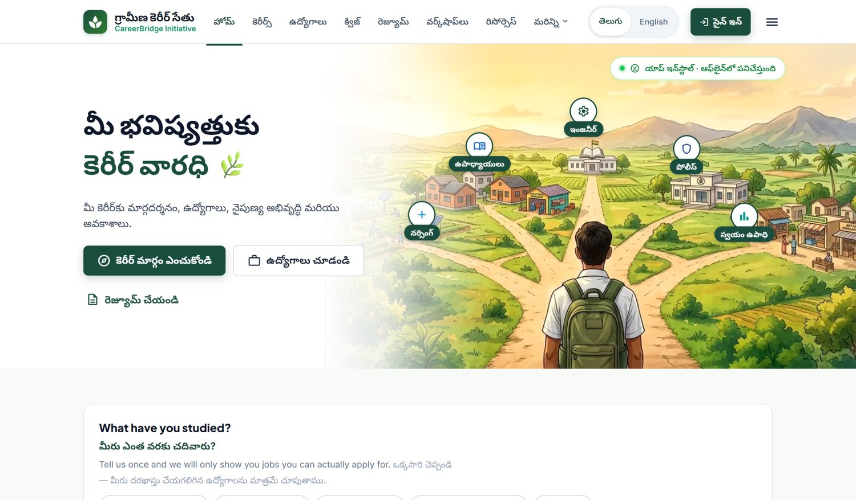
Figure 1: Home page
Skill quiz
A short quiz of five questions asks about comfort with subjects and interests, and suggests career areas that may suit the student.
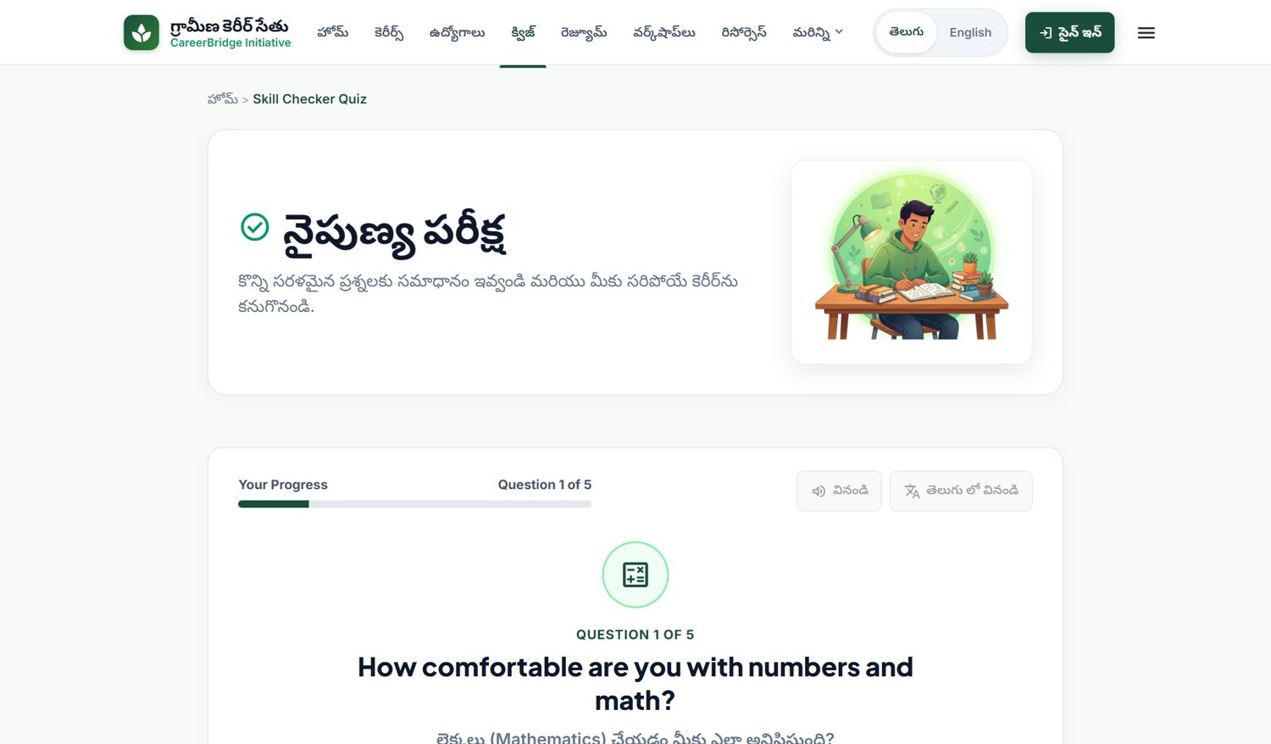
Figure 2: Skill checker quiz
Career roadmap: choosing education and goal
The student selects what they have studied and what they want to become. The roadmap then shows a plan for that person. An honest note at the top explains what is realistic, for example that the police cannot be joined directly after 10th class.
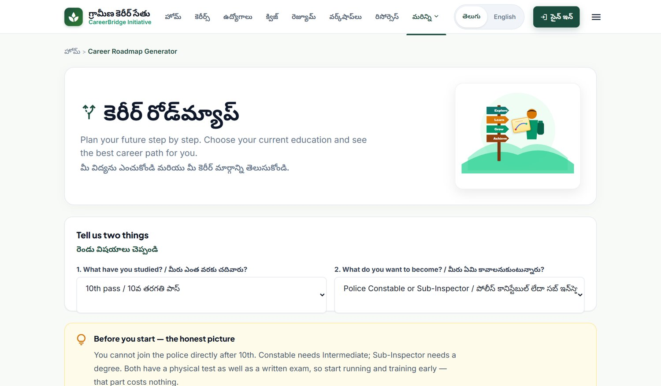
Figure 3: Career roadmap generator
Career roadmap: step-by-step flow
The path is shown as numbered steps, starting from where the student is today. Each step explains what it is, how to do it, how long it takes and which official website to check. Seven goals are covered: police, doctor, teacher, government exams, ITI trades, BPO and services, and own business.
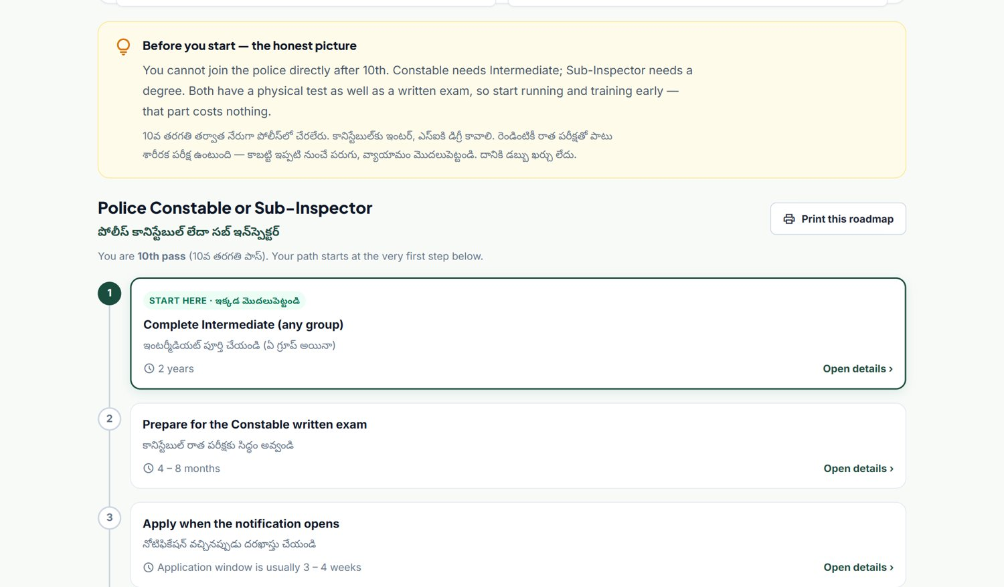
Figure 4: Roadmap steps for a 10th-pass student who wants to join the police
Job roles
The job page lists 35 role types, which can be filtered by education and category. Each links to the official site. The page states clearly that these are job types the student can aim for and not live vacancies.
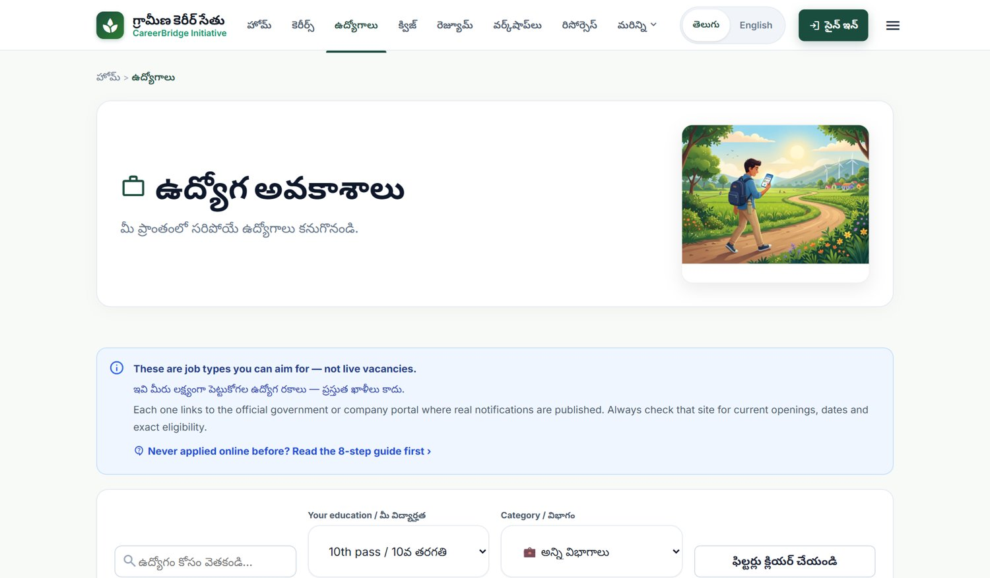
Figure 5: Job roles page
Resume builder
A simple step-by-step form collects personal details, education, skills and projects, shows a live preview and produces a PDF resume. Telugu resumes are created through the phone’s print-to-PDF function so that the script is displayed correctly.
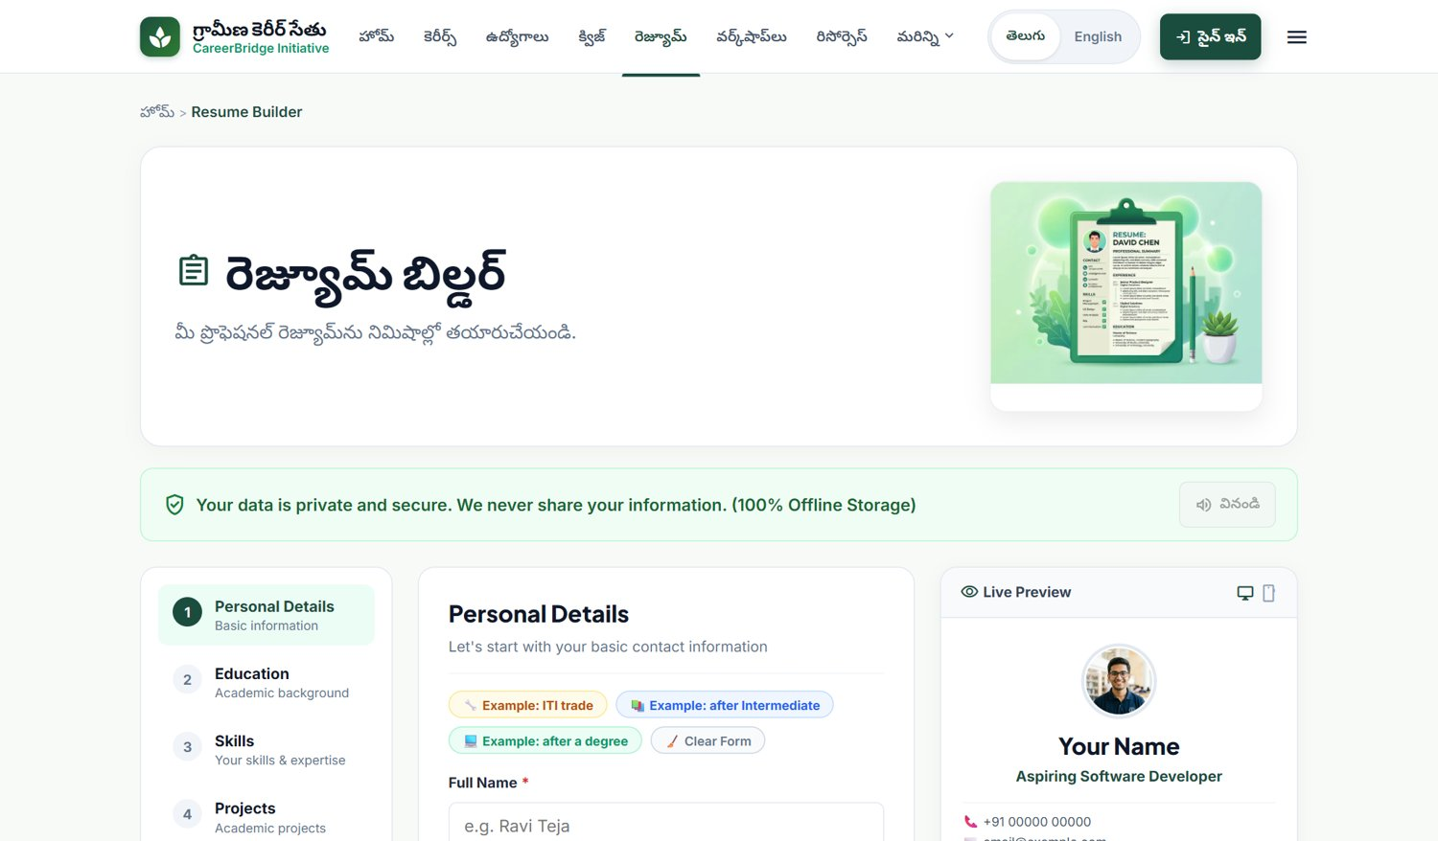
Figure 6: Resume builder
Schemes and scholarships
Government support is gathered in one place, grouped by category, such as skill development, financial support, employment and entrepreneurship, with a note on who may benefit.
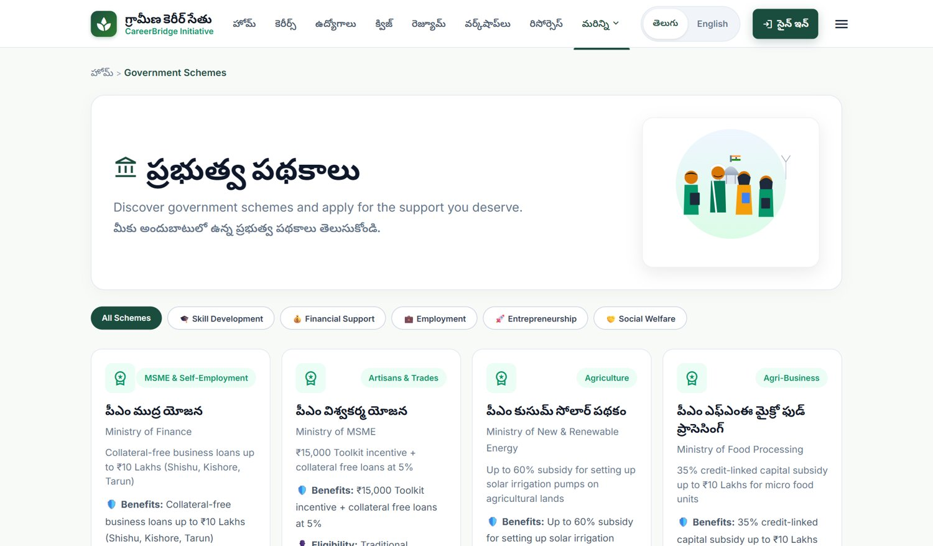
Figure 7: Government schemes page
Village workshops
The page lists topics for free village sessions and shows sessions only when they are really scheduled. It does not show invented dates.
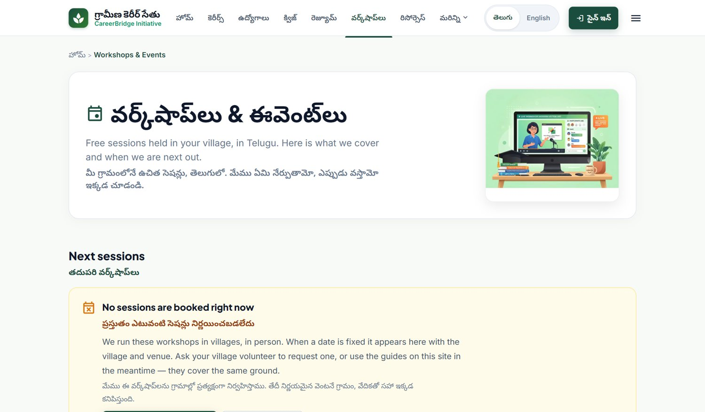
Figure 8: Workshops and events page
6. Testing and quality
The project has 44 automated tests that check, among other things, that job data matches its source file, that no invented employers or phone numbers appear, that roadmaps do not contain changing figures, that pages work in both languages, and that data endpoints need a sign-in. The backend was also checked while running: requests without sign-in are refused, signed-in requests are accepted, a student cannot reach admin pages, a forged token is refused, and repeated rapid requests are limited.
7. Current status and limits
Gramin Career Setu is a working prototype. The main pages, the quiz, the roadmaps, the job roles, the resume builder, the schemes and the language switch are available. Some parts are still being finished and need wider testing with users. The impact dashboard in the site is intentionally empty until real survey counts are entered. The site guides people to official sources and does not replace them.
8. Impact and use for the village
Students and villagers who saw the prototype were interactive and asked questions about it. The site gives them, in their own language and on their own phone, a clear picture of what to do after their qualification, a way to prepare a resume, and a reminder to verify every offer on the official website.

CHAPTER 6: RECOMMENDATIONS AND CONCLUSIONS OF THE MINI PROJECT

Recommendations:
1. Continue and widen the village sessions. Regular, hands-on sessions in Telugu with real phones help the most, especially for women, older residents and first-generation learners. Local volunteers could lead them, following models such as India’s Internet Saathi programme.
2. Set up a digital help point. A shared device with internet access at the school, panchayat office or library would help people who do not have their own smartphone or data.
3. Improve connectivity and affordability. The local authorities and telecom providers should look at signal quality and affordable data packs, since slow or costly internet limits online learning and applications.
4. Keep information accurate and official. The job roles, schemes and links must be checked every term against the official sites. People should be advised to always read the official notification before applying.
5. Train local youth as digital helpers. Trained local students can give peer support, keep the website updated and help neighbours apply online.
6. Work with schools, the college and development agencies. Partnerships with the school, the panchayat, the education and skill-development departments and NGOs can bring funds, trainers and long-term support.
Conclusions:
Through this project we saw, close up, the gap between the opportunities that exist and the information that reaches a village. By listening first and then building, we created Gramin Career Setu, a free Telugu and English website that explains careers step by step, helps young people prepare a resume, and points them to the official sources. Students and villagers who saw it were interested and interactive.
Scope of this phase and next steps. This report covers the first phase of the project: community interaction, building the prototype and showing it to the community. We did not run a formal survey, so we do not claim measured results. In the next phase we plan to test the prototype with more users, run the before-and-after survey using forms and the tally sheet we have prepared, record the real answers, and improve the site from the results. A formal measurement of impact, together with continued support from the college and community, will show how much the project helps young people in Bahubalendrunigudem.
The project has also helped us as students. We learned to listen to a community, to build for people with limited devices and data, and to report what we did honestly. We thank the people of Bahubalendrunigudem for their time and trust.

ANNEXURE A: QUESTION GUIDE USED FOR THE COMMUNITY CONVERSATIONS
The following 50 questions guided our conversations with students, youth, parents, residents and ASHA workers (see Section 5.1). Questions were selected according to each person’s situation.
No. | Section | Question
1 | Background | Which category best describes you?
2 | Background | What is your age group?
3 | Background | What is your highest educational qualification?
4 | Background | What is your current situation?
5 | Background | Which language do you prefer for career information?
6 | Background | How far do you travel for college, work or training?
7 | Background | Who usually helps you make education or career decisions?
8 | Background | What is the main source of income in your household?
9 | Career awareness | Can you name at least three career paths available after your current qualification?
10 | Career awareness | Do you know the qualifications required for the career you want?
11 | Career awareness | Which career sectors have you heard about?
12 | Career awareness | Have you received career guidance from a school, college or counsellor?
13 | Career awareness | Do you understand the difference between a job, apprenticeship, vocational training and self-employment?
14 | Career awareness | What information would help you choose a career?
15 | Career awareness | How confident are you about choosing a career that suits your interests?
16 | Education and skills | Which skills do you most want to improve?
17 | Education and skills | Have you attended a skill-development or vocational programme?
18 | Education and skills | What prevents you from joining a training programme?
19 | Education and skills | How do you prepare for competitive examinations or job tests?
20 | Education and skills | Do you have a quiet place and enough time to study at home?
21 | Employment | What is your biggest difficulty when searching for a job?
22 | Employment | Have you missed an application deadline because you received information late?
23 | Employment | How do you check whether a job advertisement is genuine?
24 | Employment | Have you or someone you know encountered a fake job offer or agent asking for money?
25 | Employment | How important is it to find work close to your village or home?
26 | Employment | What makes it difficult for young people to work outside the locality?
27 | Employment | What kind of employment would you prefer?
28 | Employment | How do household responsibilities or income needs affect your career plans?
29 | Digital access | Which device can you personally use for study or job applications?
30 | Digital access | How reliable is mobile internet where you live?
31 | Digital access | Can you afford enough data for online learning and applications?
32 | Digital access | How confident are you at filling an online form without help?
33 | Digital access | Have you created and used an email account for education or employment?
34 | Digital access | Can you scan, resize and upload certificates or photographs?
35 | Digital access | Could you use a career website if it explained each step in simple Telugu?
36 | Resume | Have you prepared a resume or CV before?
37 | Resume | Can you create or download a PDF resume using a smartphone?
38 | Resume | Which parts of a resume would you need help preparing?
39 | Resume | Would you use a free resume tool that works on a smartphone?
40 | Project feedback | Would one website combining jobs, career guidance, a quiz and resume creation be useful?
41 | Project feedback | Which Gramin Career Setu features would you use most?
42 | Project feedback | Would you try a career-interest quiz that suggests possible career areas?
43 | Project feedback | How important is Telugu guidance on a career website?
44 | Project feedback | Would offline access to saved career information help when internet is unavailable?
45 | Project feedback | What would make you trust job information on the website?
46 | Project feedback | Would you attend a free village-level demonstration on using the website and applying online?
47 | Project feedback | What support would help someone unfamiliar with smartphones use the website?
48 | Open feedback | What is the one career-related problem you most want this project to solve?
49 | Open feedback | What would make it easier for young people in this area to continue education or training?
50 | Open feedback | What one change would you suggest for Gramin Career Setu?

PHOTOS & VIDEO LINKS
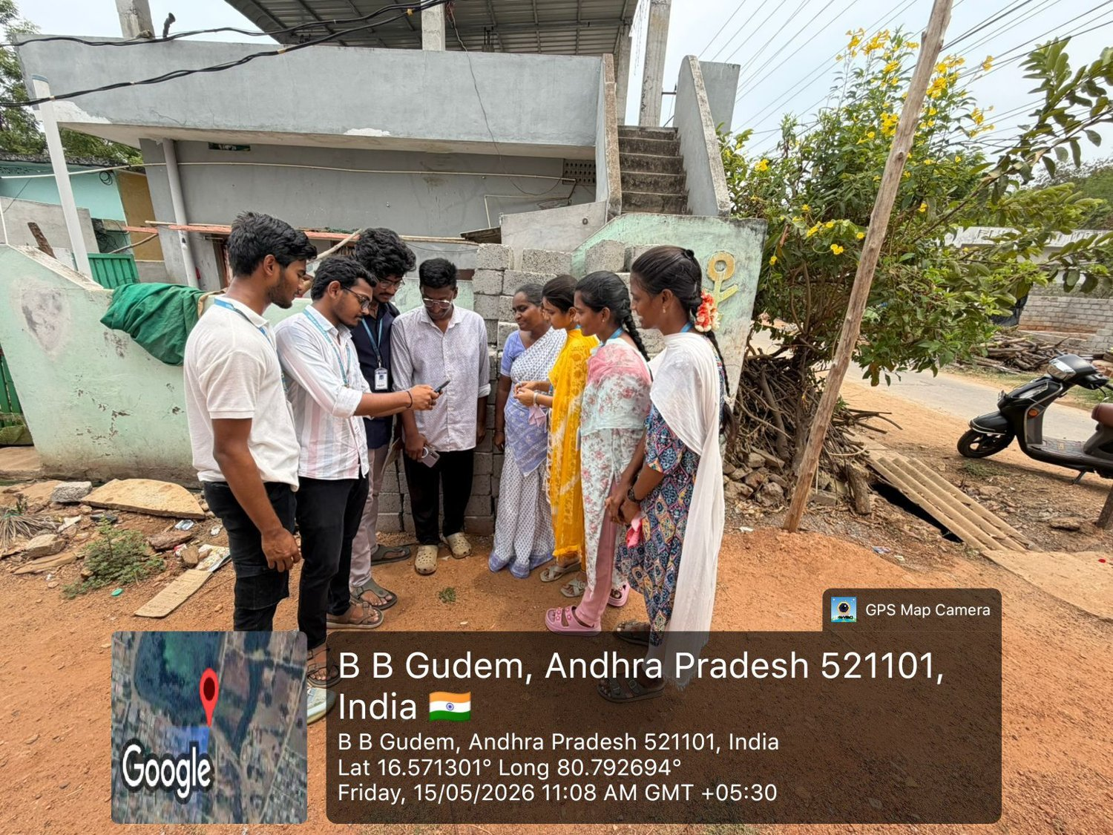
Photo: 15/05/2026 – Team talking with residents of Bahubalendrunigudem
Photo: 15/05/2026 – Team with ASHA workers during the village visit
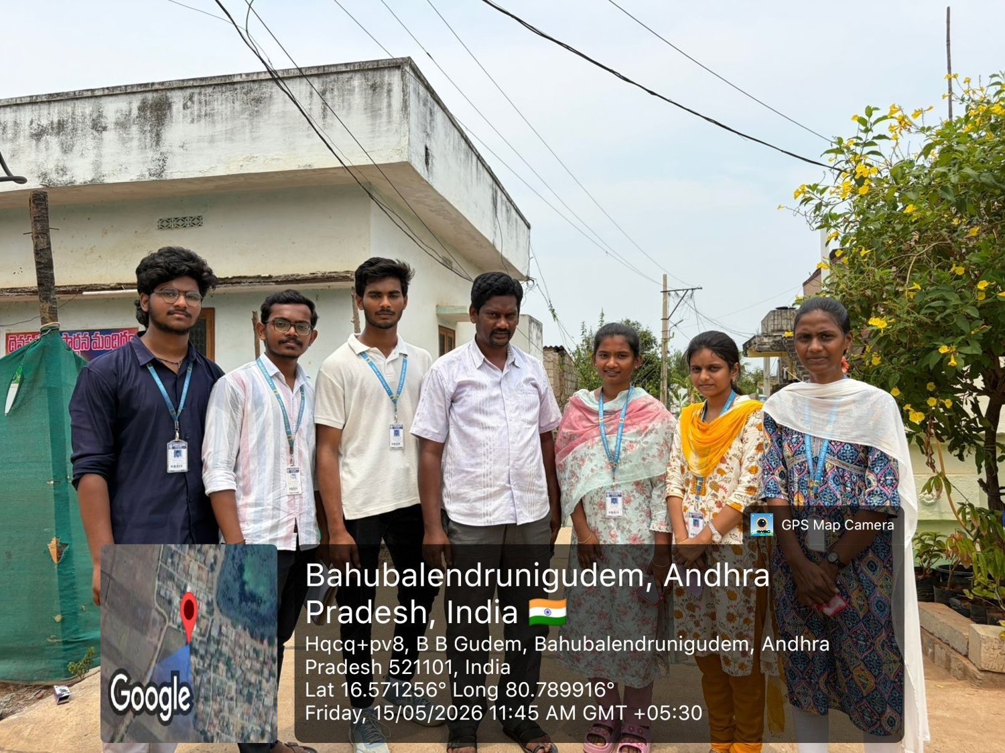
Photo: 15/05/2026 – Team with villagers during the first-day visit
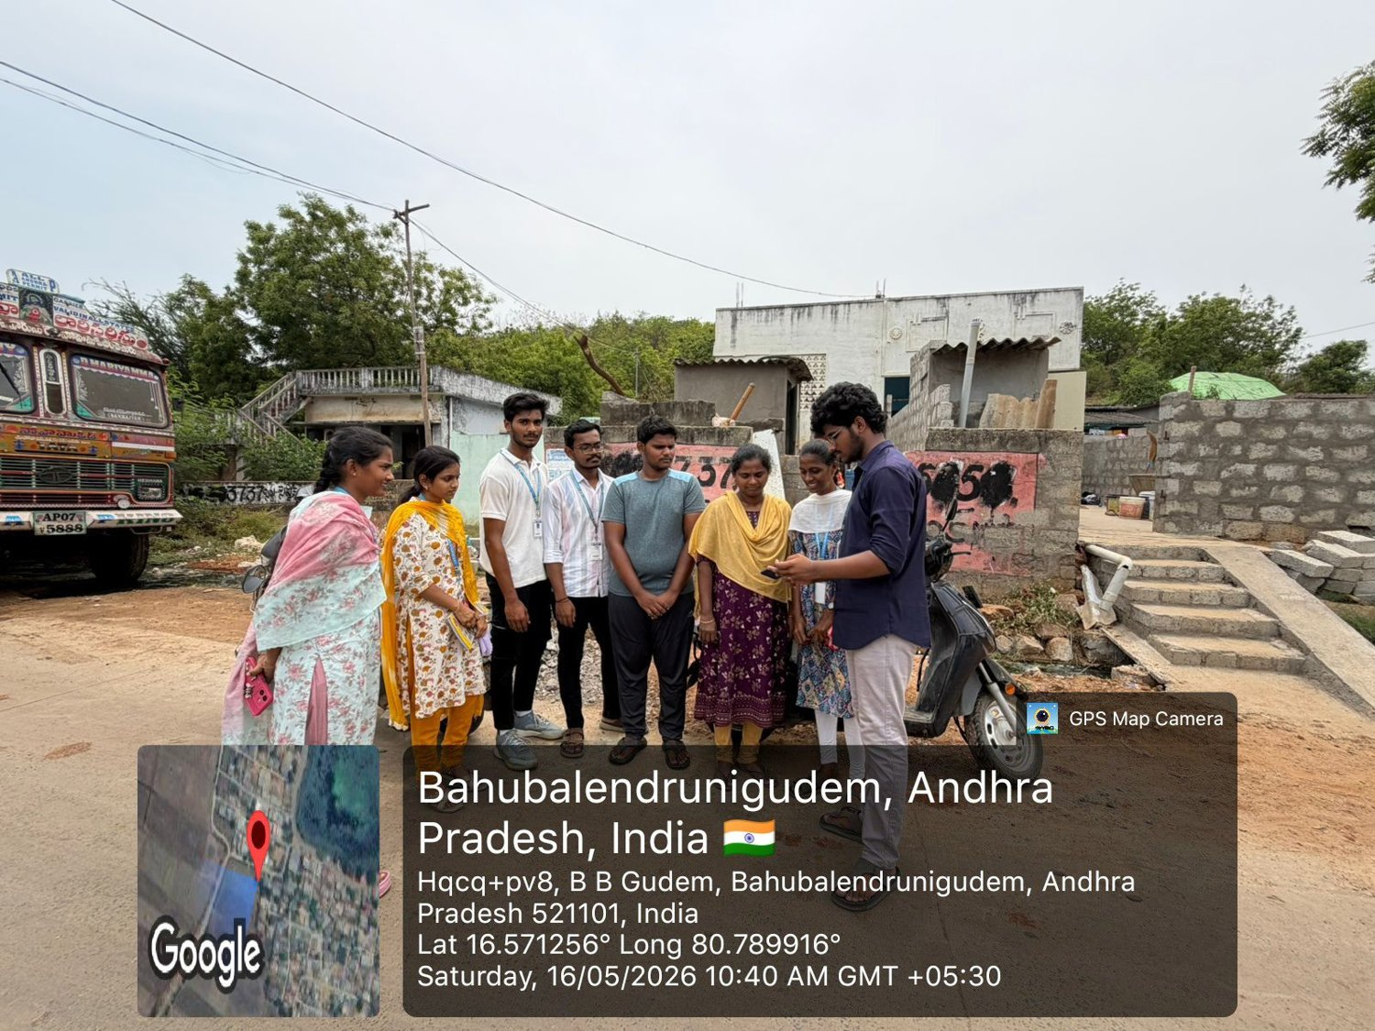
Photo: 16/05/2026 – Conversation with students and youth
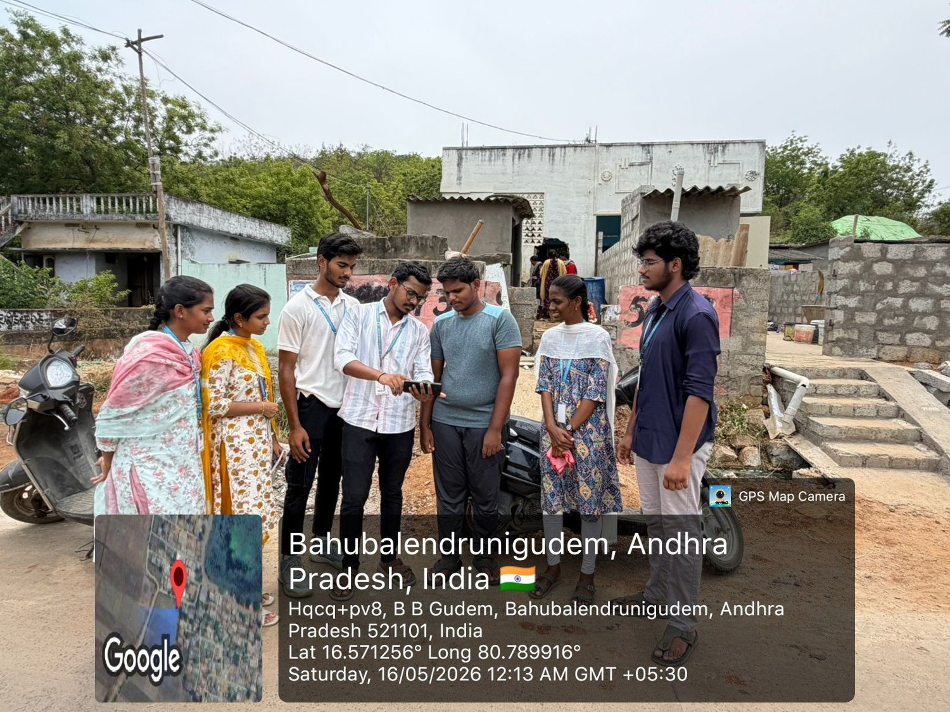
Photo: 16/05/2026 – Explaining the problem to young people and residents
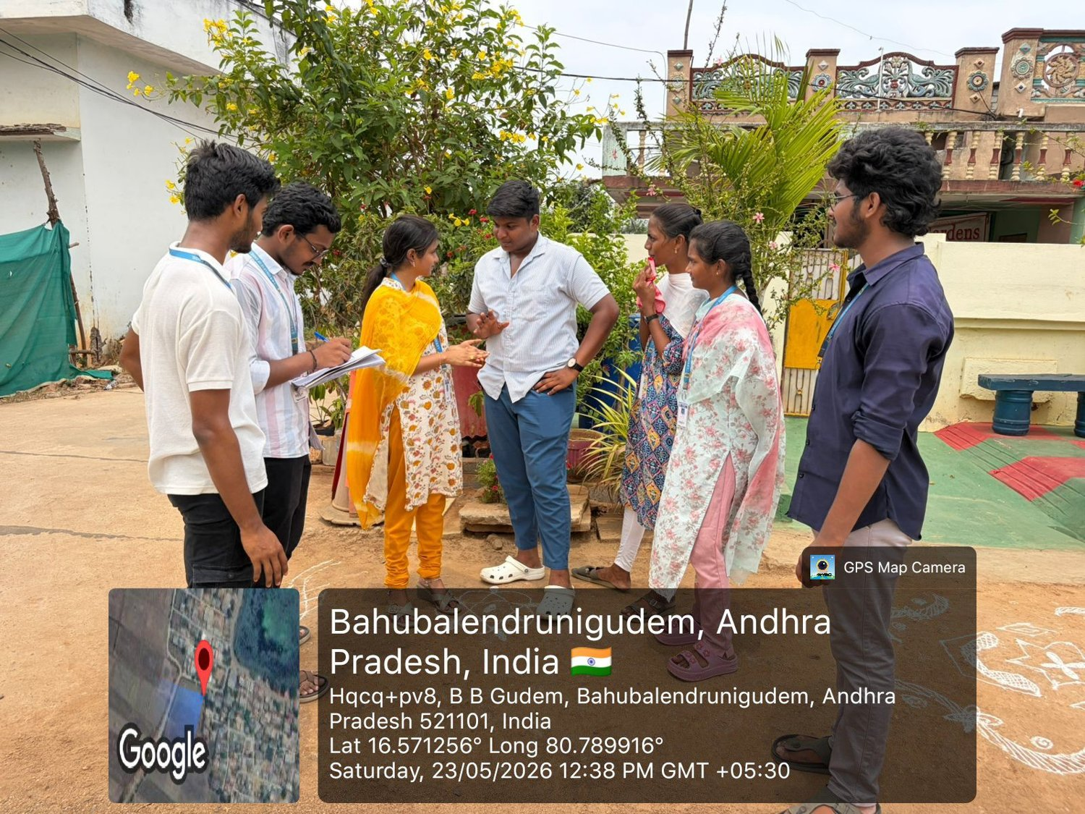
Photo: 23/05/2026 – Follow-up conversation and noting responses
Photo: 29/05/2026 – Explaining the project idea to villagers and youth
Project website: Gramin Career Setu (prototype) – screenshots are given in Chapter 5, Section 5.5.

ANNEXURE B: PROGRAM OUTCOME (PO) AND SDG MAPPING
Project Title: Gramin Career Setu – A Digital Career-Guidance Bridge for the Youth
Student Name(s): Anaparthi Rakesh Kumar, Choragudi Sowmya, Kamisetty Yogesh, Katru Sruthi, Kuppala Surya Teja, Pilla Bhanu
Roll No(s): 25765A0532, 25765A0533, 25765A0534, 25765A0535, 25765A0536, 25765A0537
Project Supervisor: Mrs. M. Gayathri, Sr. Assistant Professor, Department of CSE
Academic Year: 2026–27
A. Program Outcome Mapping
S. No. | Relevant PO | Mapping / Justification
1 | PO 3  (Design / development  of solutions) | Designed and built a free, mobile-first bilingual (Telugu and English) web application for the youth of Bahubalendrunigudem: a skill quiz, step-by-step roadmaps for seven goals, 35 job-role types with official links, a resume builder with PDF output, a schemes directory and a workshops page. The design answers the real constraints of the village — low-end phones, costly data and limited English — with reduced images and offline caching.
2 | PO 6  (The engineer  and society) | Addresses a social need identified by talking with students, youth, parents, residents and ASHA workers over six weeks: the opportunities exist, but the information does not reach the village. The solution needs no fee and no agent, runs on a phone the student already owns and points every user to the official government website.
3 | PO 8  (Ethics) | Only what was actually done is reported. No formal survey was conducted, so no survey percentages are claimed and the site’s impact dashboard stays empty until real responses exist. The site lists job-role types and official links, never invented vacancies, employers or contact numbers; 44 automated tests fail if fabricated data is introduced.
4 | PO 10  (Communication) | The team of six spoke with the community in Telugu during the village visits and demonstrated the prototype, using the 50-question guide in Annexure A. The work is communicated further through this report, its weekly reports, a project presentation and the documented website, with sources cited.
B. Sustainable Development Goal (SDG) Mapping
S. No. | Relevant SDG | SDG Title | Project Contribution
1 | SDG 4 | Quality Education | Free guidance in Telugu on what to study after 10th class, intermediate, ITI or a degree, with step-by-step roadmaps and a directory of government scholarships and skill-development schemes.
2 | SDG 8 | Decent Work and  Economic Growth | 35 job-role types with their official application routes, a resume builder and self-employment paths, helping young people reach formal work instead of depending on agents.
3 | SDG 10 | Reduced Inequalities | Narrows the rural–urban information gap: built for low-end phones, slow data and Telugu readers, and the village sessions included women, older residents and first-generation learners.

Project Supervisor Signature: ______________________
HOD Signature: ______________________

