Yogesh Kodgire
Data Model, Queries, and Reporting Framework

1. Overview 2
2. Data Model Design 2
2.1 Entities and Schema 2
2.1.1 Entity: Order 2
2.1.2 Entity: Customer 2
2.1.3 Entity: Shipping 2
2.2 Entity Relationship Diagram for given Data Model 3
3. Data Flow Overview 4
4. Data Relationships 4
4.1 PowerBI Data Model 4
5. Derived Fields / calculations Performed in Report view / Outside Transform data 5
6. Database Queries and Corresponding Results 9
7. Requirements for Anticipated Datasets 15
7.1 Enhanced Table Structure / Entities and Schema 15
Customers Table (Existing) 15
Orders Table (Existing - Modified) 15
Order Details Table (New) 15
Products Table (Existing) 16
Shipping Table (New) 16
7.2 Data Flow Overview 16
7.3 Data Relationships 16
7.4 SQL Queries for Reporting Requirements 16
7.4.1. Total Amount Spent and Country for Pending Delivery 16
7.4.2. Customer-wise Transactions, Quantity Sold, and Amount Spent 17
7.4.3. Maximum Purchased Product for Each Country 17
7.4.4. Most Purchased Product by Age Category 17
7.4.5. Country with Minimum Transactions and Sales 17

1. Overview
This document defines the data model for an e-commerce platform, supporting reporting requirements such as total sales, order status tracking, customer segmentation, and product performance analysis. The model includes structured datasets, relationships, and key technical specifications.

2. Data Model Design

2.1 Entities and Schema

2.1.1 Entity: Order
The Order entity captures essential information about a customer's purchase, as outlined below:
Column Name | Data Type | Description | Constraints
order_id | INT | Unique identifier for the order. | PK, AUTO-INCREMENT
item | VARCHAR (100) | Name or description of the ordered item. | NOT NULL
amount | INT | Price of the ordered item. | NOT NULL
customer_id | INT | Foreign key referencing the Customer table. | FK, NOT NULL

2.1.2 Entity: Customer
The Customer entity captures details about the customer:
Column Name | Data Type | Description | Constraints
customer_id | INT | Unique identifier for the customer. | PK, AUTO-INCREMENT
first_name | VARCHAR (100) | First name of the customer. | NOT NULL
last_name | VARCHAR (100) | Last name of the customer. | NOT NULL
age | INT | Age of the customer. | NULLABLE
country | VARCHAR (100) | Country of the customer. | NULLABLE

2.1.3 Entity: Shipping
The Shipping entity captures the shipping details associated with orders:
Column Name | Data Type | Description | Constraints
shipping_id | INT | Unique identifier for the shipping entry. | PK, AUTO-INCREMENT
status | INT | Status of the shipping (e.g., 0 - Pending, 1 - Shipped). | NOT NULL
customer | INT | Foreign key referencing the Customer table. | FK, NOT NULL

2.2 Entity Relationship Diagram for given Data Model

Symbol Information
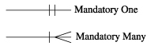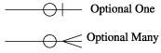
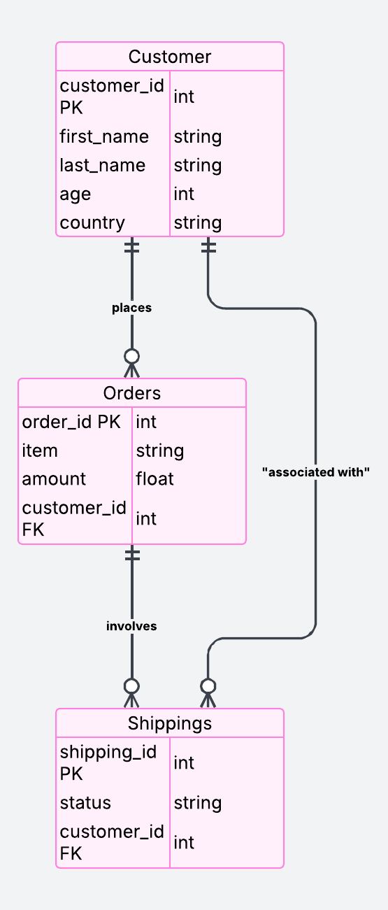
Figure 1 ER Diagram

3. Data Flow Overview
- Source: Data is ingested from the e-commerce platform, CSV uploads, and APIs.
- Staging: Raw data is loaded into staging tables for validation.
- Transformation: Data is cleaned, enriched, and processed.
- Loading: Processed data is inserted into respective tables.

4. Data Relationships
- Customer to Order: One-to-many relationship. One customer can place multiple orders.
- Customer to Shipping: One-to-many relationship. One customer can have multiple shipping records.

4.1 PowerBI Data Model
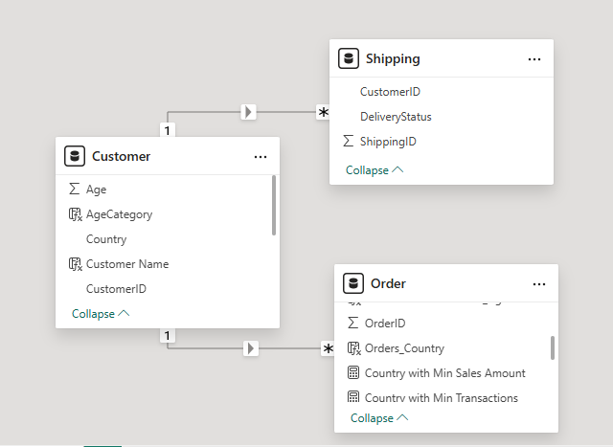

Derived Fields / calculations Performed in Report view / Outside Transform data

Table/Column | Derived From | Logic
Customer / TotalAmountSpent | Amount | TotalAmountSpent = SUM('Order'[Amount])
Customer/ TotalPendingSpend | Amount,  DeliveryStatus | TotalPendingSpend = -- Total Amount Spent for Pending Deliveries (By Country)  CALCULATE(  SUM('Order'[Amount]),  FILTER(Shipping, Shipping[DeliveryStatus] = "Pending")  )
Customer / OrderID | OrderID | TotalTransactions = COUNT('Order'[OrderID])
Order / Country with Min Transactions | Country,  TotalTransactionsByCountry,  MinTransactionsByCountry | Country with Min Transactions =  VAR TotalTransactionsByCountry = COUNTROWS('Order')  VAR MinTransactionsByCountry =  CALCULATE(  MINX(  VALUES('Customer'[Country]),  TotalTransactionsByCountry  )  )  RETURN  CALCULATE(  FIRSTNONBLANK('Customer'[Country], TotalTransactionsByCountry),  FILTER(  ALL('Customer'[Country]),  TotalTransactionsByCountry = MinTransactionsByCountry  )  )
Customer / Customer Name | First,  Last | Customer Name = Customer[First]& " " & Customer[Last]
Order / Product Details | Item | Product Details =  CONCATENATEX(  VALUES('Order'[Item]),  'Order'[Item],  ", "  )
Customer / AgeCategory | Age | AgeCategory =  IF(  Customer [Age] < 30, "Under 30", "30 and Above"  )
Order / MostPurchasedProduct_AgeCategory | Item,  CustomerID,  Age,  OrderID | MostPurchasedProduct_AgeCategory =  VAR AgeCategoryTable =  ADDCOLUMNS (  SUMMARIZE(  'Order',  'Order'[Item],  'Order'[CustomerID]  ),  "Customer_Age", LOOKUPVALUE(Customer[Age], Customer[CustomerID], 'Order'[CustomerID]),  "TotalQty", COUNTROWS('Order')  )  VAR Under30 =  TOPN(1,  SUMMARIZE(  FILTER(AgeCategoryTable, [Customer_Age] < 30),  'Order'[Item],  "TotalQty", COUNT('Order'[OrderID]) -- counting total orders per product  ),  [TotalQty], DESC  )  VAR Above30 =  TOPN(1,  SUMMARIZE(  FILTER(AgeCategoryTable, [Customer_Age] >= 30),  'Order'[Item],  "TotalQty", COUNT('Order'[OrderID])  ),  [TotalQty], DESC  )  RETURN  CONCATENATEX(  UNION(Under30, Above30),  'Order'[Item],  ", ",  'Order'[Item],  ASC  ) -- Ensures only **one** product is returned per age category.
Order / MostPurchasedProduct_PerCountry | Item,  Country,  Order Table | MostPurchasedProduct_PerCountry =  VAR ProductSalesTable =  SUMMARIZE(  'Order',  'Order'[Item],  'Customer'[Country],  "TotalQty", COUNTROWS('Order') -- counting the total orders per product  )  VAR MaxProductSales =  ADDCOLUMNS(  ProductSalesTable,  "MaxQty",  CALCULATE(MAXX(ProductSalesTable, [TotalQty])) -- getting the maximum total quantity per country  )  VAR MostPurchasedProduct =  FILTER(  MaxProductSales,  [TotalQty] = [MaxQty]  )  RETURN  CONCATENATEX(  MostPurchasedProduct,  'Order'[Item],  ", " -- Concatenates product names with commas if there are multiple  )
Order / MostPurchasedProduct_AgeCategory | Item,  CustomerID,  Age,  OrderID | MostPurchasedProduct_AgeCategory =  VAR AgeCategoryTable =  ADDCOLUMNS(  SUMMARIZE(  'Order',  'Order'[Item],  'Order'[CustomerID]  ),  "Customer_Age", LOOKUPVALUE(Customer[Age], Customer[CustomerID], 'Order'[CustomerID]),  "TotalQty", COUNTROWS('Order')  )  VAR Under30 =  TOPN(1,  SUMMARIZE(  FILTER(AgeCategoryTable, [Customer_Age] < 30),  'Order'[Item],  "TotalQty", COUNT('Order'[OrderID]) -- counting total orders per product  ),  [TotalQty], DESC  )  VAR Above30 =  TOPN(1,  SUMMARIZE(  FILTER(AgeCategoryTable, [Customer_Age] >= 30),  'Order'[Item],  "TotalQty", COUNT('Order'[OrderID])  ),  [TotalQty], DESC  )  RETURN  CONCATENATEX(  UNION(Under30, Above30),  'Order'[Item],  ", ",  'Order'[Item],  ASC  ) -- Ensures only **one** product is returned per age category.
Order / TopProductByCountry | Orders_Country,  Item | TopProductByCountry =  VAR ProductTable =  ADDCOLUMNS(  SUMMARIZE('Order', 'Order'[Orders_Country], 'Order'[Item]),  "TotalQty",  CALCULATE(COUNTROWS('Order'), ALLEXCEPT('Order', 'Order'[Orders_Country], 'Order'[Item]))  )  VAR TopProduct =  TOPN(1, ProductTable, [TotalQty], DESC) -- top product per country instead of globally.  RETURN  CONCATENATEX(TopProduct, 'Order'[Item], ", ") -- If multiple top products have the same quantity, they will be concatenated.

Database Queries and Corresponding Results

Q1. the total amount spent and the country for the Pending delivery status for each country.
SELECT
c.country,
SUM(o.amount) AS Total_Amount_Spent
FROM Orders o
JOIN Customers c ON o.customer_id = c.customer_id
JOIN Shippings s ON o.customer_id = s.customer
WHERE s.status = 'Pending' -- Filter for pending delivery status
GROUP BY c.country
ORDER BY Total_Amount_Spent DESC; -- Sorting in descending order

Output:
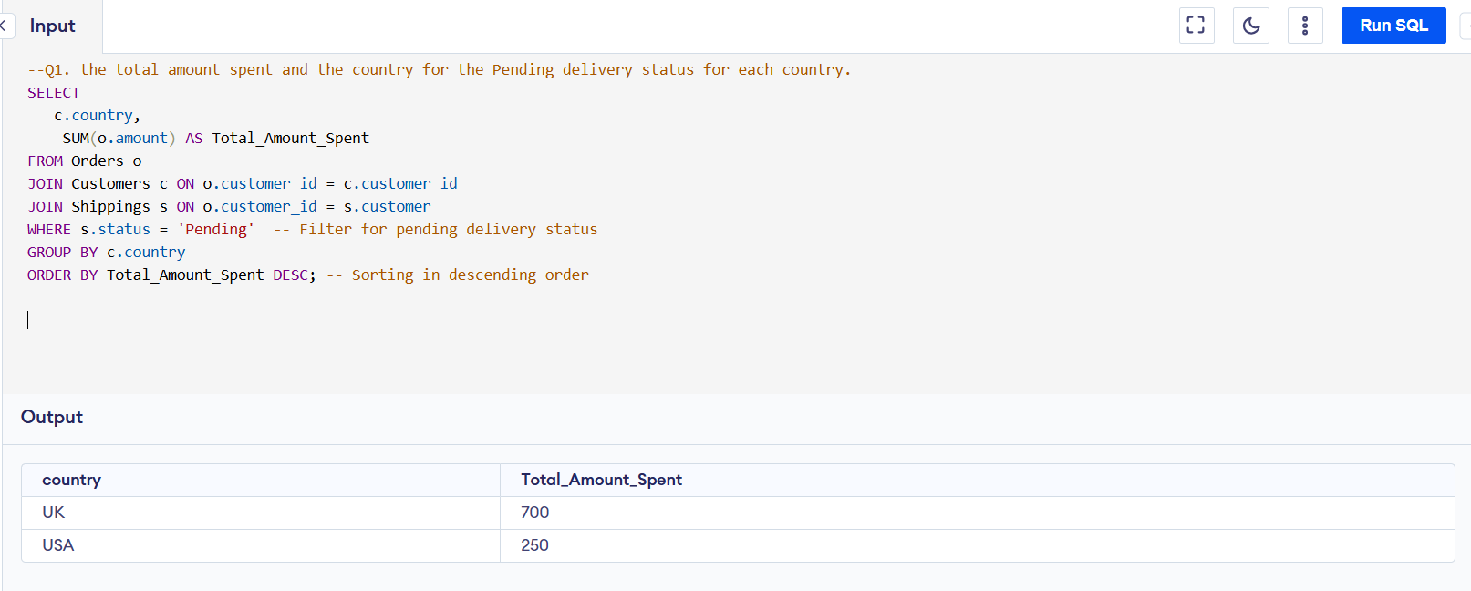
Q2. the total number of transactions, total quantity sold, and total amount spent for each customer, along with the product details.
Ans:

SELECT
c.customer_id, c.first_name, c.last_name,
COUNT(o.order_id) AS Total_Transactions, -- Total number of transactions for the customer
COUNT(o.order_id) AS Total_Quantity_Sold, -- Counting orders as total quantity (each order = one quantity)
SUM(o.amount) AS Total_Amount_Spent, -- Total amount spent by the customer
GROUP_CONCAT(DISTINCT o.item) AS Product_Details -- List of distinct products purchased
FROM Customers c
JOIN Orders o ON c.customer_id = o.customer_id -- Join to get orders placed by the customer
LEFT JOIN Shippings s ON c.customer_id = s.customer -- Join shipping table based on customer_id
WHERE s.status = 'Pending' -- Filter by pending shipping status
GROUP BY c.customer_id, c.first_name, c.last_name
ORDER BY Total_Amount_Spent DESC;

OutPut:

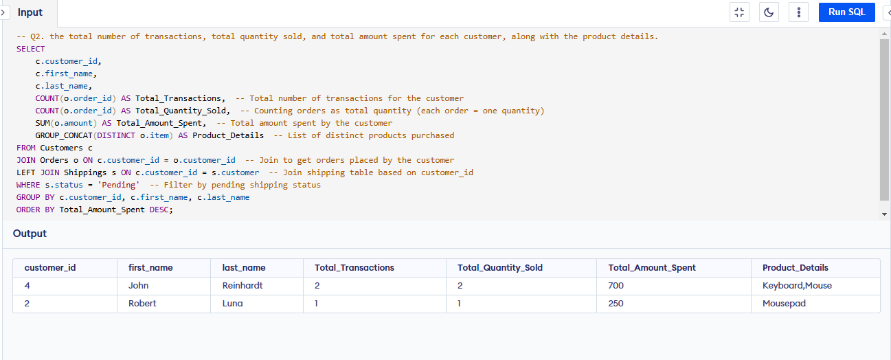

Q3. the maximum product purchased for each country.
Ans:

-- This Query will return only one product per country (even if multiple products have the same count

SELECT country, product AS most_purchased_product, total_transactions
FROM (
SELECT
c.country,
o.item AS product,
COUNT(o.order_id) AS total_transactions,
ROW_NUMBER() OVER (PARTITION BY c.country ORDER BY COUNT(o.order_id) DESC) AS rank
FROM Orders o
JOIN Customers c ON o.customer_id = c.customer_id
GROUP BY c.country, o.item
) ranked
WHERE rank = 1;

OutPut:

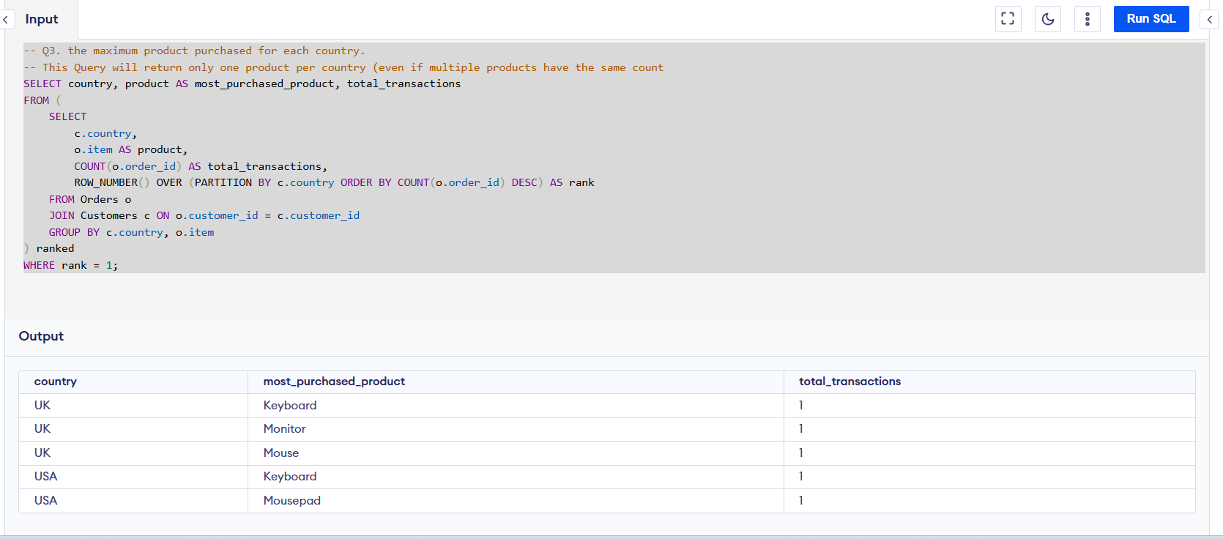

--Keeps multiple products if they have the same max transaction count in a country.
SELECT country, product AS most_purchased_product, total_transactions
FROM (
SELECT
c.country,
o.item AS product,
COUNT(o.order_id) AS total_transactions,
DENSE_RANK() OVER (PARTITION BY c.country ORDER BY COUNT(o.order_id) DESC) AS rank
FROM Orders o
JOIN Customers c ON o.customer_id = c.customer_id
GROUP BY c.country, o.item
) ranked
WHERE rank = 1;

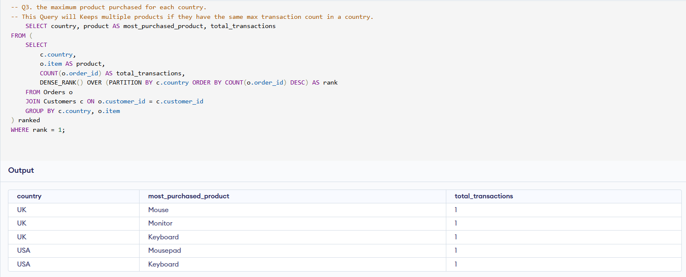

Q4. the most purchased product based on the age category less than 30 and above 30.
Ans:

WITH AgeCategory AS ( -- categorizes customers into two groups based on their age: "Under 30" and "30 and Above"
SELECT
c.customer_id, c.age,
CASE
WHEN c.age < 30 THEN 'Under 30'
ELSE '30 and Above'
END AS age_category
FROM
Customers c
),
-- calculate the total number of transactions (or total sales) for each product within each age category.
ProductSales AS (
SELECT
a.age_category,
o.item,
COUNT(o.order_id) AS total_transactions
FROM
Orders o
JOIN
AgeCategory a ON o.customer_id = a.customer_id
GROUP BY
a.age_category, o.item
),
-- rank the products within each age category based on the total number of transactions in descending order
RankedProducts AS (
SELECT
age_category, item AS product, total_transactions,
ROW_NUMBER() OVER (PARTITION BY age_category ORDER BY total_transactions DESC) AS rn
FROM
ProductSales
)
SELECT
age_category,
product AS most_purchased_product,
total_transactions
FROM
RankedProducts
WHERE
rn = 1; -- filter out the top-ranked product for each age category
OutPut:

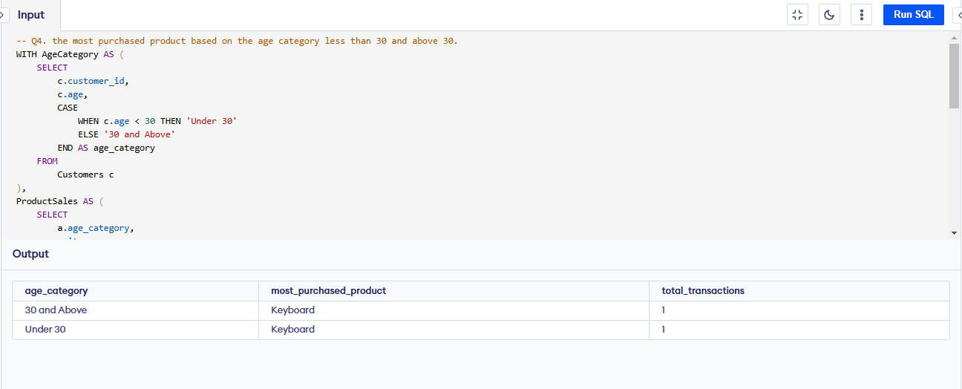

Q5. the country that had minimum transactions and sales amount.
Ans:

WITH CountrySales AS (
SELECT
c.country, COUNT(o.order_id) AS total_transactions,
SUM(o.amount) AS total_sales
FROM
Orders o
JOIN
Customers c ON o.customer_id = c.customer_id
GROUP BY
c.country
)
SELECT
country, total_transactions, total_sales
FROM
CountrySales
ORDER BY
total_transactions ASC, total_sales ASC
LIMIT 2; -- One can change the limit value ans see number of countries with minimum transaction

OutPut:
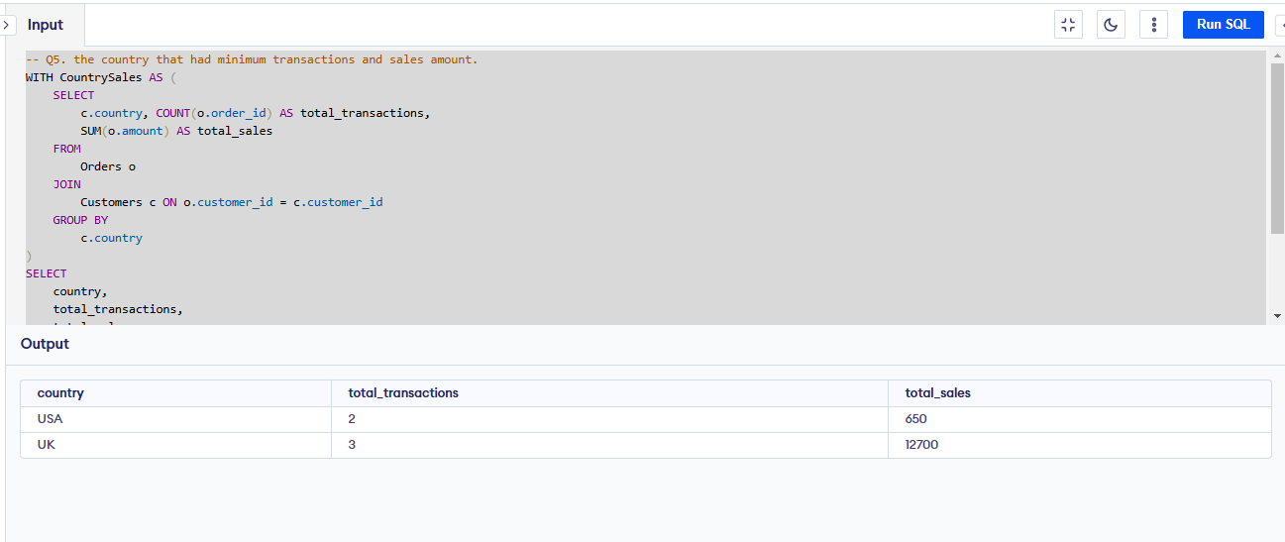

Requirements for Anticipated Datasets

With the current table structure, it's difficult to capture Order Quantity, Order Information (Ordered Date, Price Per Item), and Shipping Details (Shipping Date, etc.). To improve data granularity and enable better reporting, we can introduce additional tables.

7.1 Enhanced Table Structure / Entities and Schema

Customers Table (Existing)
Purpose: Stores customer demographic details.
Column Name | Data Type | Description | Constraints
customer_id | INT (PK) | Unique identifier for each customer. | Primary Key
first_name | VARCHAR (100) | Customer's first name. | NOT NULL
last_name | VARCHAR (100) | Customer's last name. | NOT NULL
age | INT | Customer's age. | NULLABLE
country | VARCHAR (100) | Customer's country. | NOT NULL

Orders Table (Existing - Modified)
Purpose: Captures purchase transactions.
Column Name | Data Type | Description | Constraints
order_id | INT (PK) | Unique identifier for each order. | Primary Key, AUTO-INCREMENT
customer_id | INT (FK) | References Customers (customer_id). | Foreign Key, NOT NULL
order_date | DATETIME | Date and time when the order was placed. | NOT NULL
total_amount | DECIMAL(10,2) | Total order amount. | NOT NULL
status | VARCHAR(20) | Order status (PENDING, SHIPPED, DELIVERED, etc.). | NULLABLE
country | VARCHAR(100) | Country where the order was placed. | NOT NULL

Order Details Table (New)
Purpose: This table will store detailed information about each order item.
Column Name | Data Type | Description | Constraints
order_detail_id | INT (PK) | Unique identifier for each order detail. | Primary Key
order_id | INT (FK) | References Orders (order_id). | Foreign Key, NOT NULL
product_id | INT (FK) | References Products (product_id). | Foreign Key, NOT NULL
quantity | INT | Number of units purchased. | NOT NULL
price | DECIMAL(10,2) | Price per unit. | NOT NULL
total_price | DECIMAL(10,2) | Calculated as (quantity * price) | NOT NULL

Products Table (Existing)
Purpose: Stores information about available products.
Column Name | Data Type | Description | Constraints
product_id | INT (PK) | Unique identifier for each product. | Primary Key
product_name | VARCHAR(100) | Name of the product. | NOT NULL
category | VARCHAR(100) | Product category. | NOT NULL

Shipping Table (New)
Purpose: Captures shipment status of orders.
Column Name | Data Type | Description | Constraints
shipping_id | INT (PK) | Unique identifier for each shipment. | Primary Key
order_id | INT (FK) | References Orders (order_id). | Foreign Key, NOT NULL
status | VARCHAR(20) | Shipping status (PENDING, IN TRANSIT, DELIVERED). | NULLABLE
customer_id | INT (FK) | References Customers (customer_id). | Foreign Key, NOT NULL

7.2 Data Flow Overview
- Source: Data is ingested from the e-commerce platform, CSV uploads, and APIs.
- Staging: Raw data is loaded into staging tables for validation.
- Transformation: Data is cleaned, enriched, and processed.
- Loading: Processed data is inserted into respective tables.

7.3 Data Relationships

- One-to-Many: Customers → Orders (one customer can have multiple orders).
- One-to-Many: Orders → Order Details (one order can have multiple products).
- Many-to-One: Order Details → Products (multiple order details reference a single product).
- One-to-One: Orders → Shipping (each order has one shipping record).

7.4 SQL Queries for Reporting Requirements

7.4.1. Total Amount Spent and Country for Pending Delivery

SELECT country, SUM(total_amount) AS total_spent
FROM Orders
WHERE status = 'PENDING'
GROUP BY country;

7.4.2. Customer-wise Transactions, Quantity Sold, and Amount Spent

SELECT c.customer_id, c.first_name, c.last_name, p.product_name,
COUNT(o.order_id) AS total_transactions,
SUM(od.quantity) AS total_quantity,
SUM(od.total_price) AS total_spent
FROM Customers c
JOIN Orders o ON c.customer_id = o.customer_id
JOIN Order_Details od ON o.order_id = od.order_id
JOIN Products p ON od.product_id = p.product_id
GROUP BY c.customer_id, c.first_name, c.last_name, p.product_name;

7.4.3. Maximum Purchased Product for Each Country

SELECT o.country, p.product_name, SUM(od.quantity) AS total_sold
FROM Orders o
JOIN Order_Details od ON o.order_id = od.order_id
JOIN Products p ON od.product_id = p.product_id
GROUP BY o.country, p.product_name
ORDER BY o.country, total_sold DESC;

7.4.4. Most Purchased Product by Age Category

SELECT

CASE WHEN c.age < 30 THEN 'Under 30'
ELSE '30 and Above' END
AS age_category,

p.product_name, SUM(od.quantity) AS total_sold

FROM Customers c
JOIN Orders o ON c.customer_id = o.customer_id
JOIN Order_Details od ON o.order_id = od.order_id
JOIN Products p ON od.product_id = p.product_id
GROUP BY age_category, p.product_name
ORDER BY age_category, total_sold DESC;

7.4.5. Country with Minimum Transactions and Sales

SELECT country,
COUNT(order_id) AS total_orders,
SUM(total_amount) AS total_sales
FROM Orders
GROUP BY country
ORDER BY total_sales ASC
LIMIT 1;

