-- Q1. the total amount spent and the country for the Pending delivery status for each country.
Ans:
SELECT
c.country,
SUM(o.amount) AS Total_Amount_Spent
FROM Orders o
JOIN Customers c ON o.customer_id = c.customer_id
JOIN Shippings s ON o.customer_id = s.customer
WHERE s.status = 'Pending' -- Filter for pending delivery status
GROUP BY c.country
ORDER BY Total_Amount_Spent DESC; -- Sorting in descending order

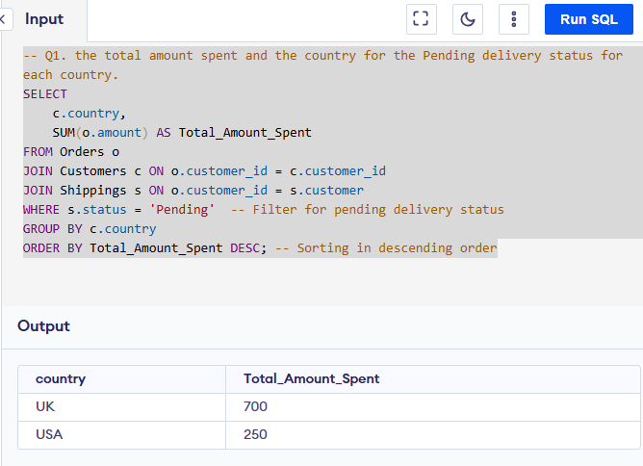

-- Q2. the total number of transactions, total quantity sold, and total amount spent for each customer, along with the product details.
Ans:

SELECT
c.customer_id,
c.first_name,
c.last_name,
COUNT(o.order_id) AS Total_Transactions, -- Total number of transactions for the customer
COUNT(o.order_id) AS Total_Quantity_Sold, -- Counting orders as total quantity (each order = one quantity)
SUM(o.amount) AS Total_Amount_Spent, -- Total amount spent by the customer
GROUP_CONCAT(DISTINCT o.item) AS Product_Details -- List of distinct products purchased
FROM Customers c
JOIN Orders o ON c.customer_id = o.customer_id -- Join to get orders placed by the customer
LEFT JOIN Shippings s ON c.customer_id = s.customer -- Join shipping table based on customer_id
WHERE s.status = 'Pending' -- Filter by pending shipping status
GROUP BY c.customer_id, c.first_name, c.last_name
ORDER BY Total_Amount_Spent DESC;

OutPut:
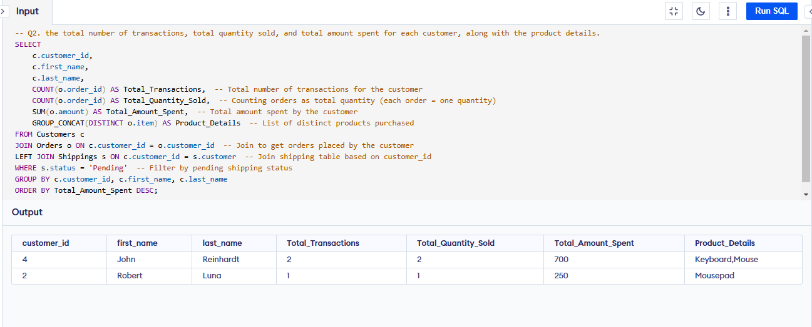
-- Q3. the maximum product purchased for each country.
Ans:
SELECT
c.country,
o.item AS most_purchased_product,
COUNT(o.order_id) AS total_transactions
FROM
Orders o
JOIN
Customers c ON o.customer_id = c.customer_id
GROUP BY
c.country, o.item
ORDER BY
c.country, total_transactions DESC;

OutPut:
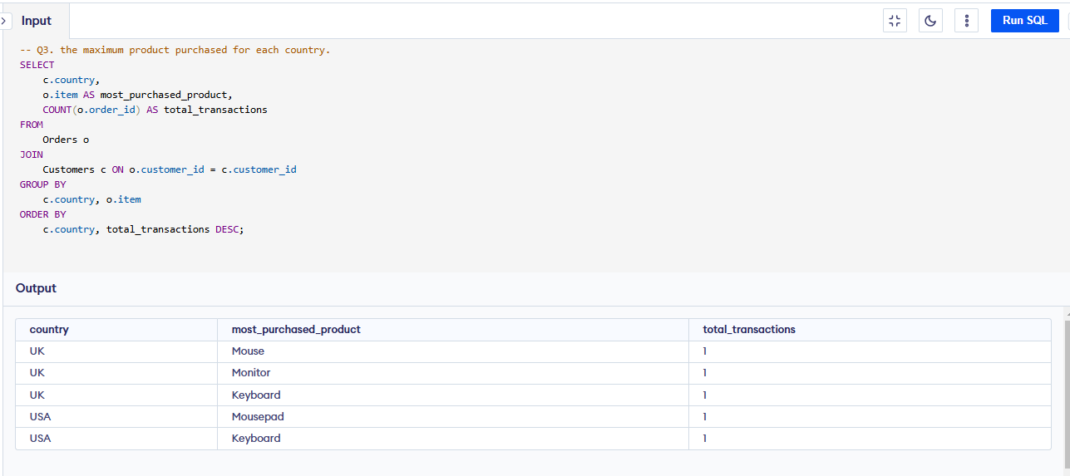

-- Q4. the most purchased product based on the age category less than 30 and above 30.

WITH AgeCategory AS ( -- categorizes customers into two groups based on their age: "Under 30" and "30 and Above"
SELECT
c.customer_id, c.age,
CASE
WHEN c.age < 30 THEN 'Under 30'
ELSE '30 and Above'
END AS age_category
FROM
Customers c
),
-- calculate the total number of transactions (or total sales) for each product within each age category.
ProductSales AS (
SELECT
a.age_category,
o.item,
COUNT(o.order_id) AS total_transactions
FROM
Orders o
JOIN
AgeCategory a ON o.customer_id = a.customer_id
GROUP BY
a.age_category, o.item
),
-- rank the products within each age category based on the total number of transactions in descending order
RankedProducts AS (
SELECT
age_category, item AS product, total_transactions,
ROW_NUMBER() OVER (PARTITION BY age_category ORDER BY total_transactions DESC) AS rn
FROM
ProductSales
)
SELECT
age_category,
product AS most_purchased_product,
total_transactions
FROM
RankedProducts
WHERE
rn = 1; -- filter out the top-ranked product for each age category
OutPut:

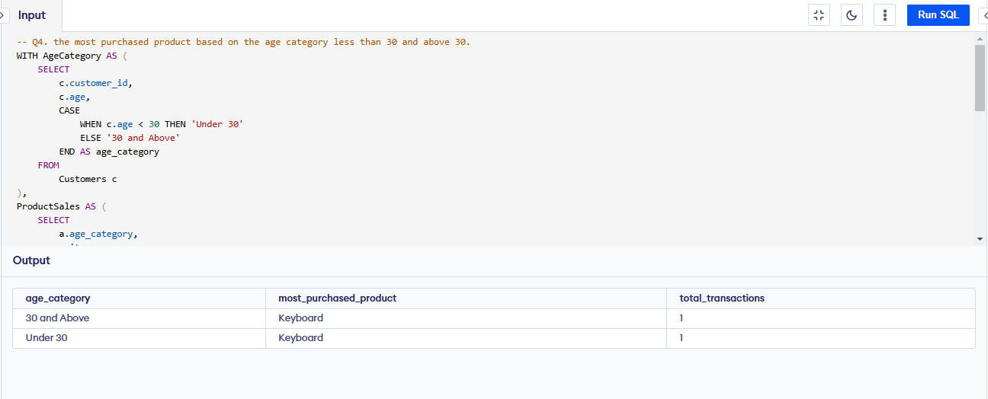

-- Q5. the country that had minimum transactions and sales amount.

WITH CountrySales AS (
SELECT
c.country, COUNT(o.order_id) AS total_transactions,
SUM(o.amount) AS total_sales
FROM
Orders o
JOIN
Customers c ON o.customer_id = c.customer_id
GROUP BY
c.country
)
SELECT
country, total_transactions, total_sales
FROM
CountrySales
ORDER BY
total_transactions ASC, total_sales ASC
LIMIT 2; -- One can change the limit value ans see number of countries with minimum transaction

OutPut:
