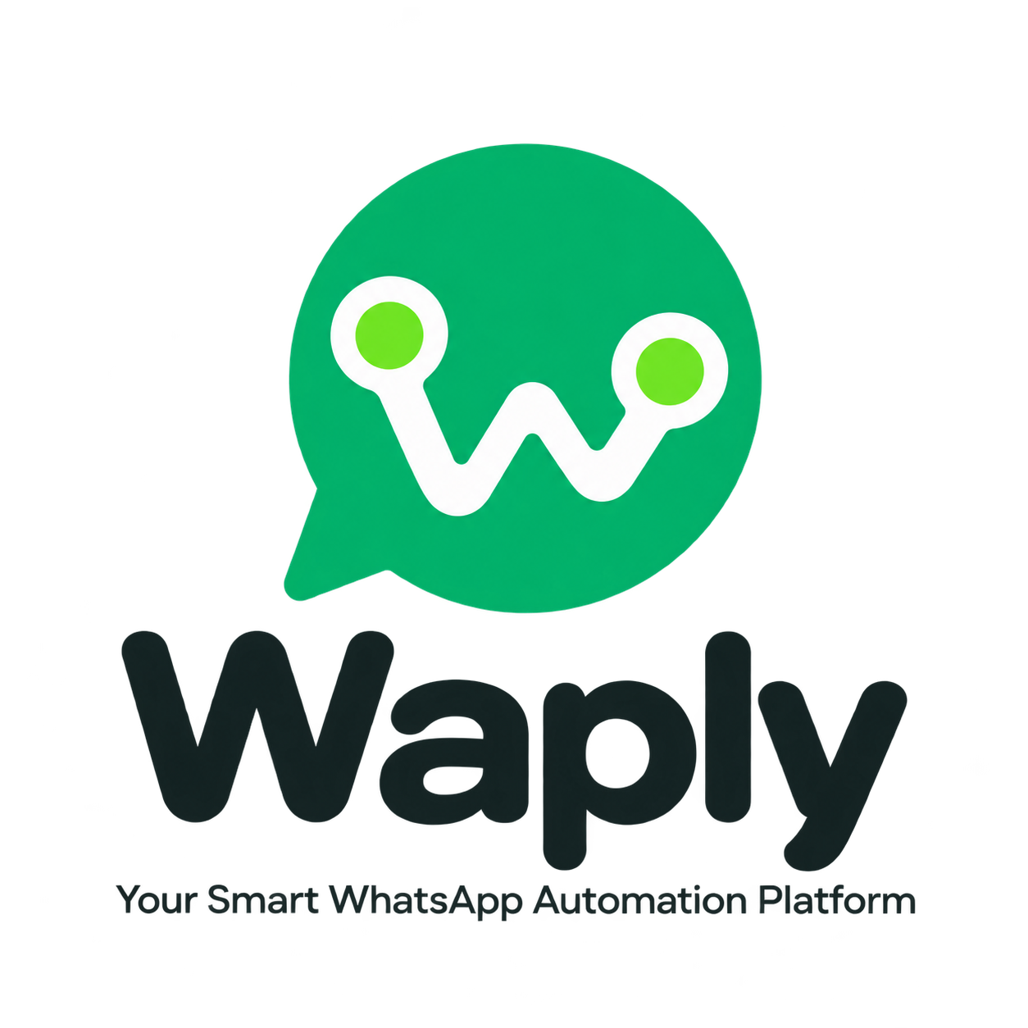

Waply Complete Business Proposal
Product Guide, Features, Use Cases and Pricing
Your Smart WhatsApp Automation Platform
Prepared for Business Owners Freelancers Agencies and Service Teams
September 2026

Contents
• What Waply Is and Why It Matters
• Business problems Waply solves
• Complete feature catalogue with reasons
• Business and freelancer possibilities
• Commercial pricing and add ons
• Onboarding support and purchase process
• Responsible use and important disclosure

What Waply Is and Why It Matters
Waply is a centralized WhatsApp automation and management platform. It helps businesses, freelancers and agencies manage multiple WhatsApp accounts, customer chats, campaigns, chatbots, leads, team access and integrations from one dashboard.
If your team replies to customer enquiries manually, misses follow-ups or struggles to track work across several numbers, Waply brings the communication workflow into one organized system. Results depend on the business process; the platform does not guarantee sales.

Direct Benefits for the Buyer
• Response time can improve because chats, templates and automation are available in one dashboard.
• Lead follow-up becomes organized, so enquiries are less likely to disappear in a manual chat list.
• Team permissions allow the owner to control access to accounts and actions.
• Freelancers and agencies can sell Waply as a recurring setup, support and automation service.

Who Waply Is For
Audience | How Waply Helps | Commercial Value
Small Business | Enquiries, offers, reminders and support | Less manual coordination
Sales Team | Lead capture, labels, templates and follow ups | Better pipeline discipline
Support Team | Shared chats, roles and quick responses | Faster issue handling
Freelancer | Client setup, campaign and chatbot service | Monthly recurring income opportunity
Agency | Multiple client sessions and team access | Serve more accounts from one dashboard

Business problems Waply solves
Current Problem | How Waply Helps
Messages scattered across phones | Dashboard brings supported sessions and chats into one working view.
Late replies | Live chats, templates and automation shorten the path to a response.
Leads forgotten after first enquiry | Lead capture, labels and routing create a visible follow up process.
Repeated typing | Reusable templates and chatbot replies handle common questions consistently.
No team control | Roles and session scoped access limit what each user can view or manage.
Website and WhatsApp disconnected | REST API and webhooks connect messages with websites, CRM and internal tools.
Campaign work is manual | Bulk messaging, scheduling and progress tracking organize opted in outreach.
No operational visibility | Status tracking, logs and health checks show what the system is doing.

Complete feature catalogue with reasons
Each feature is explained below in practical business language. Availability may depend on the active WhatsApp engine, configuration and selected commercial plan.
Feature | What It Does | Why It Matters
Web Dashboard | Manage sessions, chats, campaigns and settings from one visual dashboard. | Keeps daily work organized and reduces the need to switch between tools.
Multi Session Management | Connect and manage multiple WhatsApp accounts in one system. | Supports separate numbers for branches, brands or client accounts.
QR and Pairing Code Login | Connect a WhatsApp account by QR scan or pairing code. | Simplifies technical setup and speeds up account onboarding.
Live Chats | View and reply to incoming and outgoing conversations in real time. | Helps teams avoid missed enquiries and improve response time.
Text Messaging | Send and receive standard text messages. | Centralizes sales follow-ups, support and routine communication.
Media Messaging | Handle images, videos, documents and audio messages. | Makes it easy to share catalogues, quotations, invoices and demos.
Voice Notes | Send WhatsApp-style voice notes. | Adds speed and a personal touch for field sales and service teams.
Message Replies and Quotes | Quote a specific message when replying. | Keeps context clear in long conversations and reduces misunderstandings.
Message Reactions | React to supported messages with emojis. | Provides quick acknowledgement while keeping conversations natural.
Message Editing | Edit supported sent messages. | Allows quick correction of typing errors or inaccurate information.
Delivery and Read Status | Track sent, delivered and read states. | Helps teams choose the right time for a follow-up.
Bulk Campaigns | Send planned messages to an opted-in contact list. | Delivers offers, reminders and updates with less manual effort.
Campaign Scheduling | Schedule campaigns for a future date and time. | Sends messages at the intended time without requiring staff to be online.
Campaign Progress | View campaign delivery progress and results. | Helps identify failed sends and monitor campaign performance.
Reusable Templates | Save frequently used messages as reusable templates. | Improves consistency, reduces typing and protects brand language.
AI Chatbot | Configure automated AI-assisted replies for common questions. | Provides an immediate first response and reduces repetitive staff work.
Human Handover | Transfer an automated conversation to a human agent. | Ensures complex or sensitive enquiries receive personal attention.
Lead Capture | Capture and organize lead details from incoming conversations. | Prevents enquiries from being lost and creates actionable sales data.
Lead Routing | Route captured leads to the right team member or workflow. | Speeds up follow-up and improves the chance of conversion.
Contact Management | Search, view and manage customer contacts. | Makes customer information and targeted communication easier to access.
Group Management | Create, join and manage supported WhatsApp groups. | Simplifies administration for communities, projects and customer groups.
WhatsApp Channels | Use supported channel and newsletter actions. | Adds another option for broadcast-style updates and audience engagement.
Labels | Organize chats with custom labels. | Makes stages such as Hot Lead, Payment Pending and Support easy to filter.
Team Users | Give multiple team members access to the dashboard. | Allows sales, support and administration to work in one shared system.
Role Based Access | Assign different permissions to administrators, operators and viewers. | Limits each user to required actions and reduces accidental changes.
Session Scoped Access | Limit a user or API key to selected WhatsApp sessions. | Helps agencies separate client accounts and access securely.
API Key Security | Protect dashboard and API access with managed API keys. | Reduces unauthorized access and centralizes credential control.
REST API | Connect Waply with websites, CRM, ERP or custom software. | Enables automated order alerts, reminders and custom workflows.
Webhooks | Send message, status and event data to external systems in real time. | Triggers CRM updates or business actions as soon as an event occurs.
Webhook Security | Use HMAC signatures and filters for webhook delivery. | Helps identify fake requests and reduces unnecessary external events.
Interactive API Docs | Access Swagger-based API documentation. | Helps developers understand, test and complete integrations faster.
Message Tester | Test API messaging directly from the dashboard. | Verifies phone numbers, payloads and delivery flow before launch.
Audit Logs | Record important administrative and system actions. | Supports troubleshooting, accountability and operational review.
Rate Limiting | Configure message and request speed. | Controls overuse and supports responsible sending practices.
Proxy Support | Configure a proxy for supported sessions. | Supports different deployment needs, although it does not remove policy risk.
IP Whitelisting | Restrict access to approved IP addresses. | Adds an extra security layer for publicly hosted servers.
SQLite Database | Use a zero-configuration database for smaller deployments. | Allows pilots and small businesses to start quickly.
PostgreSQL Database | Use a scalable database for larger production deployments. | Provides a stronger foundation for growing data and multi-user usage.
Redis Cache | Add optional Redis caching and queue support. | Can improve responsiveness and background job processing under load.
S3 and MinIO | Use compatible storage for backup and migration. | Improves data portability and infrastructure planning.
Docker Deployment | Install and deploy the platform with containers. | Makes server setup repeatable and maintenance easier.
Health Checks | Expose application health endpoints for monitoring. | Helps monitoring systems detect downtime or service problems quickly.
Backup and Migration | Export and import configuration and supported data. | Supports continuity during server changes or disaster recovery.
Plugin System | Extend capabilities with Chatwoot, Typebot and supported integrations. | Allows the platform to adapt to different business workflows.
Search | Search chats and records for information. | Saves time when retrieving previous customer context.
Light and Dark Theme | Use light, dark or system interface themes. | Supports individual viewing preferences during long working sessions.
Multiple Languages | Use the dashboard in multiple supported languages. | Makes adoption easier for diverse teams.

Business and freelancer possibilities
Waply is more effective when positioned as an outcome-based service instead of only as software. Clients value faster responses, organized leads and reliable follow-up more than the dashboard itself.
Industry or Role | Possible Workflow | Potential Benefit
Retail and E commerce | Product enquiry, catalogue, order update, payment reminder, offer campaign | Faster replies and repeat sales opportunities
Clinic and Healthcare Admin | Appointment reminder, queue update, basic FAQs | Fewer missed appointments; sensitive workflows should use approved official channels
Education and Coaching | Admission enquiry, batch update, fee reminder, study material | Less repetitive coordination and faster lead follow up
Real Estate | Property enquiry, brochure sharing, visit scheduling, lead labels | Every enquiry gets organized follow up
Travel and Hospitality | Booking enquiry, itinerary, check in instruction, support | One consistent communication channel for guests
Service Business | Quotation, booking confirmation, job status, feedback request | Professional customer updates with less calling
Agency | Separate client sessions, campaigns, team roles and reporting | Manage more clients from one operating system
Freelancer | Offer chatbot setup, campaign management and API integration | Create recurring monthly service revenue

Income Opportunities for Freelancers
• Offer client onboarding and dashboard setup services.
• Sell a monthly campaign management package.
• Customize FAQ chatbots and lead workflows.
• Integrate Waply with websites, CRM or booking software.
• Charge a recurring fee for team training, support and maintenance.
• Offer dedicated hosting and monitoring as a managed service.

Suggested sales positioning
Waply helps your team manage WhatsApp enquiries, follow-ups, campaigns and automation from one dashboard. We provide setup, training and ongoing support so your team can start quickly.

Commercial pricing
The pricing below is an affordable launch structure. Taxes, Meta charges, hosting scope and custom work may be quoted separately.
Plan | Monthly Price | Setup Charge | Included | Best For
Starter | ₹999 per month | ₹999 one time | 1 number, dashboard, live chats, templates and basic campaigns | Small business and individual freelancer
Business | ₹1,999 per month | ₹1,999 one time | Up to 2 numbers, chatbot, lead capture, campaigns and 3 users | Growing business and small team
Pro | ₹3,499 per month | Free setup | Up to 5 numbers, advanced automation, up to 10 users and priority support | Agency and multi branch business

Launch offers
Offer | Price | Terms
Zero Setup Plan | ₹1,499 per month | Minimum 3 month commitment
Business Six Month Pack | ₹9,999 total | Free setup with 6 month advance payment
Annual Value Plan | ₹17,999 per year | Free setup and standard support included

Optional add ons
Add On | Price
Additional WhatsApp number | ₹499 per month
Additional team user | ₹199 per month
Custom chatbot setup | Starting from ₹999
Custom CRM or API integration | Starting from ₹2,499
Dedicated hosting | ₹999 per month
Personal training session | ₹499 per session

Pricing notes
• All prices are suggested commercial rates and can be revised before signing a client.
• Custom development starts only after written scope and quotation approval.
• Official Meta WhatsApp Cloud API usage or conversation charges are not included unless a proposal states otherwise.
• Unofficial connectivity should use a dedicated secondary number and requires written risk acceptance.

Onboarding and support
A clear onboarding process builds client trust and reduces the support workload after purchase.
1. Confirm the business use case, users, numbers, campaigns and integrations during the requirement call.
2. Provide the selected plan, setup fee, support scope and payment terms in a written quotation.
3. Connect a dedicated WhatsApp number and create the required team users.
4. Configure templates, labels, chatbot, lead flow and campaign settings.
5. Test messages and verify the workflow with a small approved contact set.
6. Train the team and explain responsible messaging rules.
7. Define the support channel and response time after launch.

Plan wise support
Support Area | Starter | Business | Pro
Initial setup | Basic | Guided | Included
Training | Video guide | One session | Two sessions
Response priority | Standard | Business priority | Priority
Custom workflow review | Paid add on | One basic review | Included basic review

What the client needs to provide
• Dedicated WhatsApp number and compatible phone access
• Opt in customer list and approved message content
• Business details, support contact and authorized team users
• Server or hosting decision where dedicated deployment is selected
• Timely approval for templates, chatbot answers and integrations

Responsible use and important disclosure
Waply’s current OpenWA-based connectivity layer may use reverse-engineered WhatsApp clients and is not Meta’s official WhatsApp Cloud API. Commercial use carries a non-zero risk of account restriction or suspension. It must not be marketed as the Official WhatsApp API.
Do not use a client’s primary personal or business number with unofficial connectivity. A dedicated secondary number, conservative sending limits, recipient opt-in and a clear unsubscribe process are strongly recommended.

Responsible messaging rules
• Message only recipients who have clearly agreed to receive WhatsApp messages.
• Avoid cold outreach blasts, purchased contact lists and high-volume spam campaigns.
• Honor STOP and unsubscribe requests immediately.
• Provide a clear human support or escalation option within automation.
• Prefer the official Meta Cloud API for healthcare, finance, authentication-critical and regulated workflows.
• Do not guarantee results, delivery or account safety.

Commercial terms to include
Term | Recommended Wording
Payment | Subscription is payable in advance and activates after payment confirmation.
Setup | Includes only items listed in the approved quotation.
Support | Platform assistance is covered; custom development is billed separately.
Messaging | The client is responsible for consent, content and recipient lists.
Availability | Features depend on the engine, WhatsApp changes and server configuration.
Risk | Unofficial connectivity may be restricted and has no zero risk guarantee.

Start with Waply
If your business handles enquiries, support, reminders or campaigns on WhatsApp, you can start with a controlled Waply pilot. One dedicated number, a limited opted-in audience and one practical workflow make it easier to evaluate value.

Recommended first purchase
The Business Plan at ₹1,999 per month plus a ₹1,999 one-time setup fee is the recommended starting option for most small teams. The six-month advance package is ₹9,999 with free setup. The Pro Plan at ₹3,499 per month is suitable for agencies and multi-branch businesses.

Next action
1. Share your business type and the number of WhatsApp accounts required.
2. Tell us whether you need campaigns, chatbot, lead capture or API integration.
3. Receive a suitable plan and an exact implementation quotation.
4. Activate the full subscription after the demo and pilot setup.
DM “Waply” on WhatsApp for Full Information and a Demo
Waply Your Smart WhatsApp Automation Platform

