Level-6

Prinja Car Yard

By

YOGESH KUMAR

# Project Proposal

## Goals and Purposes

The goal of this project is to create a car-selling internet shopping app. In this programme, there are two sorts of users: admin and regular. Admin may add, modify, and delete any car information, however an ordinary user cannot do so through the app.

## Scope of Project

Prinja Car Yard, an online buying application, was launched as part of a 20-day initiative. This project's goal is to sell cars. Also, to show off the various automobiles that are available. New users are welcome to join the programme and purchase vehicles.

## 

## Specifications of Projects

Login and account signup are both stable.

The Administrator has the ability to edit and delete accounts.

Any car's details can be added, modified, or updated by an administrator.

A new automobile will be purchased by the users.

## Target Audience

Normal users and everyone interested in purchasing an automobile between the ages of 18 and 100 will attend.

## Requirements for Resource

Following technology and methods of growth:

* Asp.net MVC Framework.
* Identity framework- ASP.
* Windows Operating System.
* 64-bit Processor and 4 GB RAM.

## Project Assumptions

Prinja Car Yard is a car-buying app that has all the information you need. This application admin may edit, modify, and remove any automotive information, while regular users can access the data via the app. Only registered users have full access to the web application.

**Home page.**

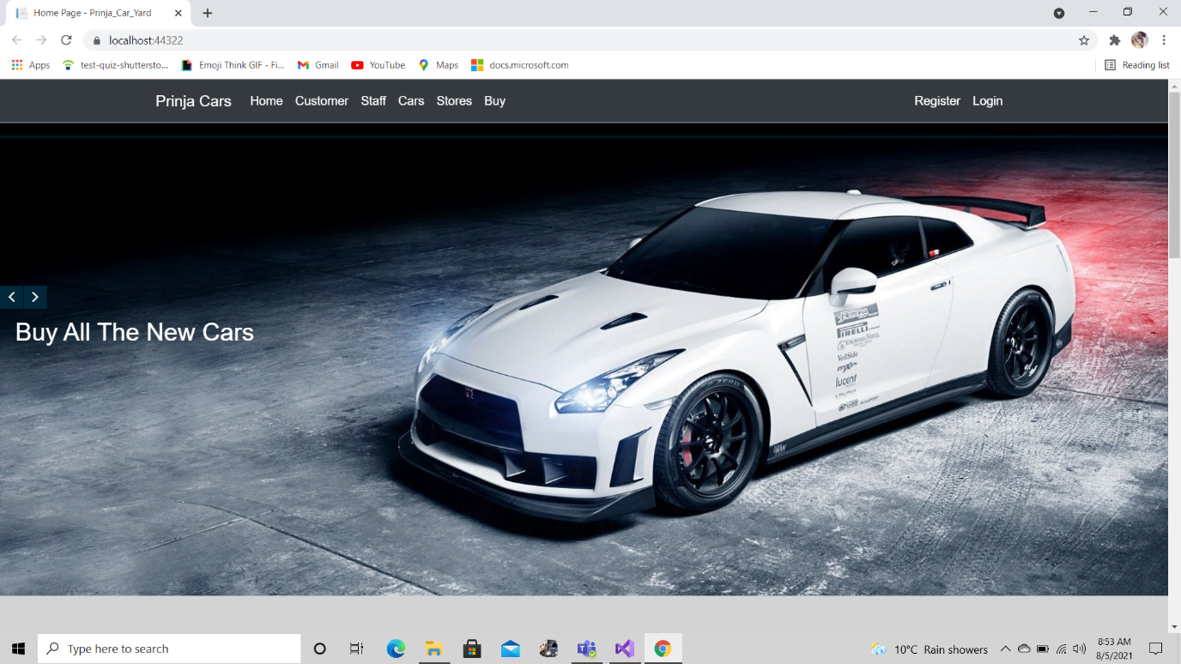

**Customer Page.**

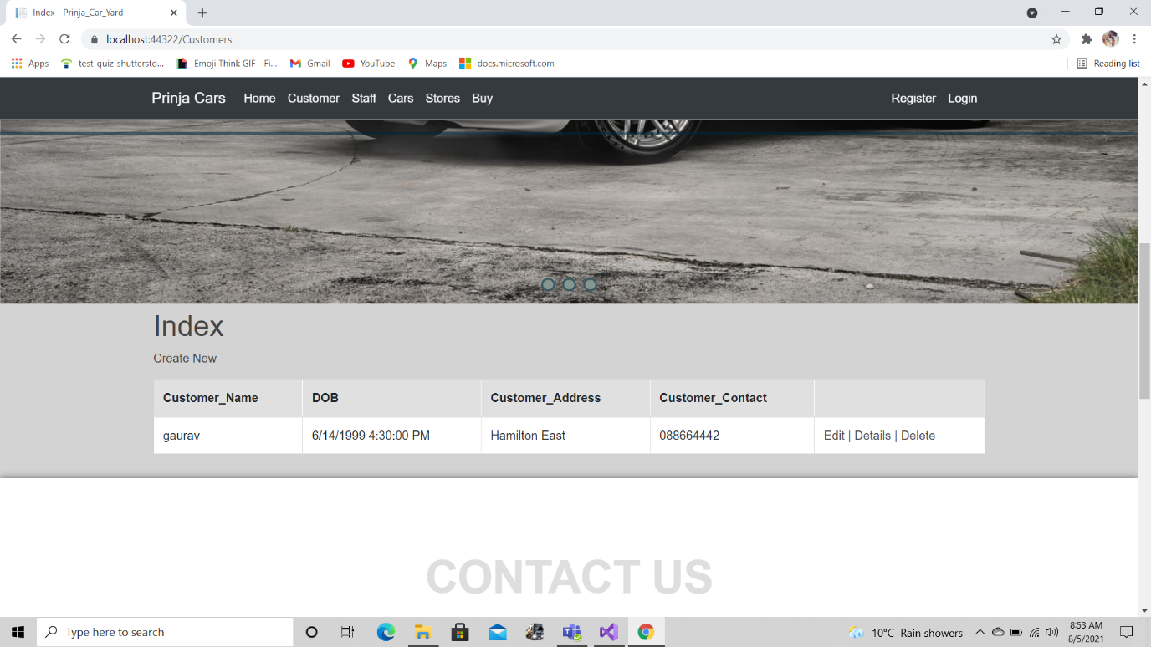

**Staff Page.**

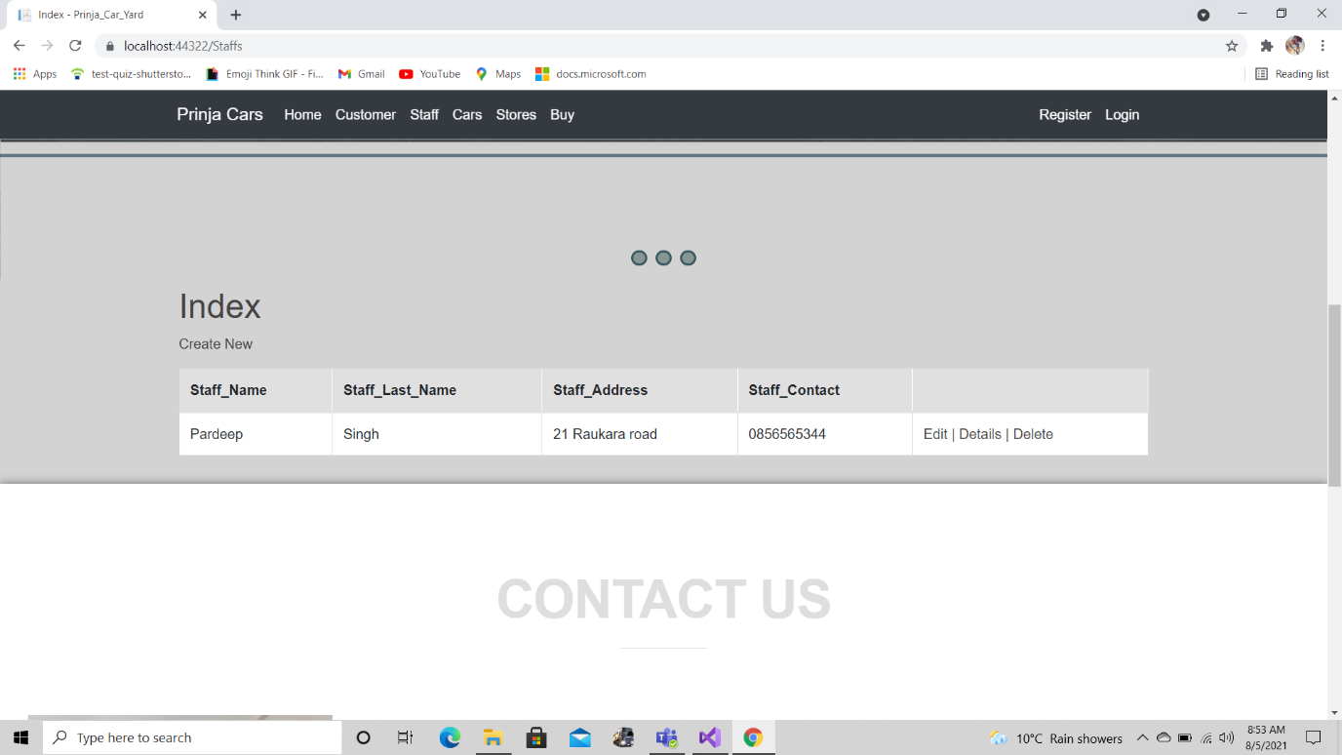

**Cars Page.**

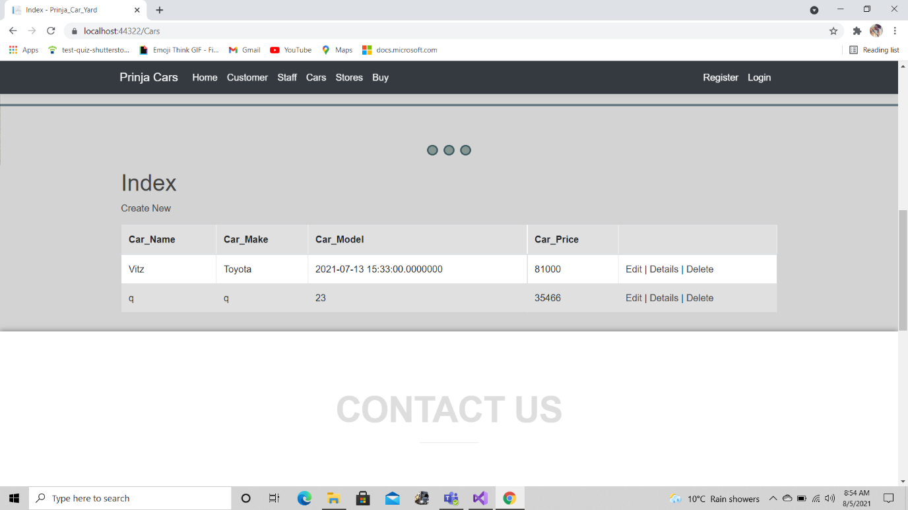

**Stores Page.**

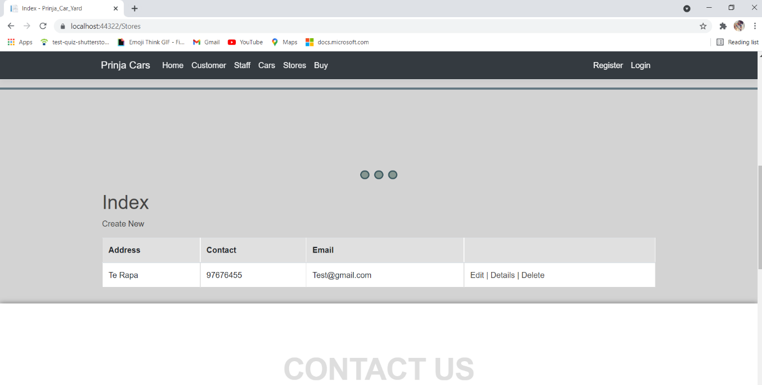

**Buy Page.**

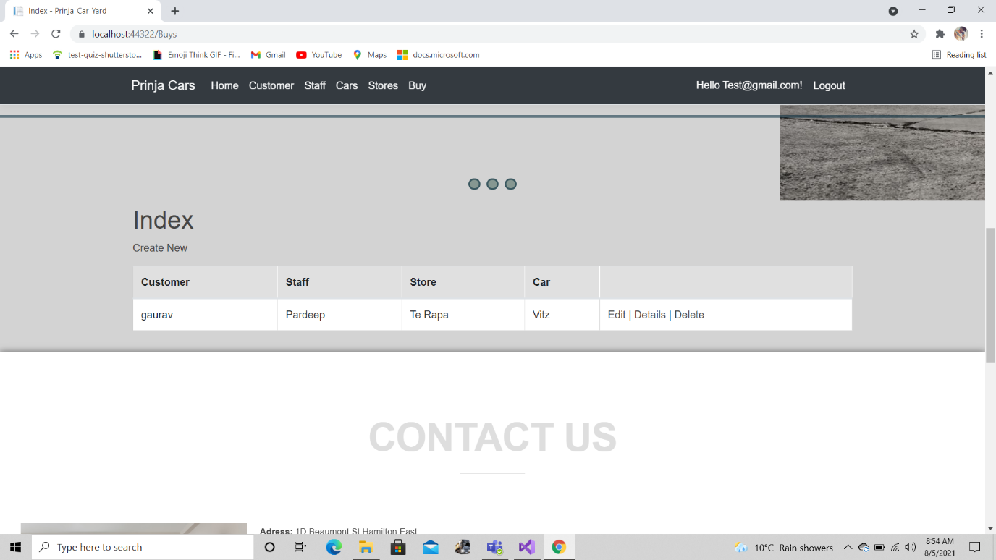

**Register Page.**

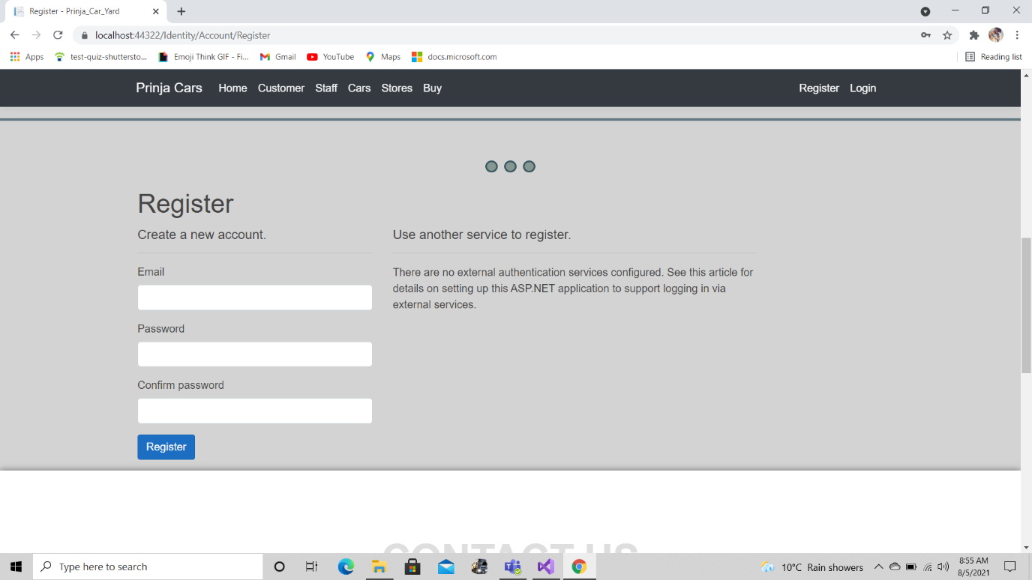

**Login Page.**

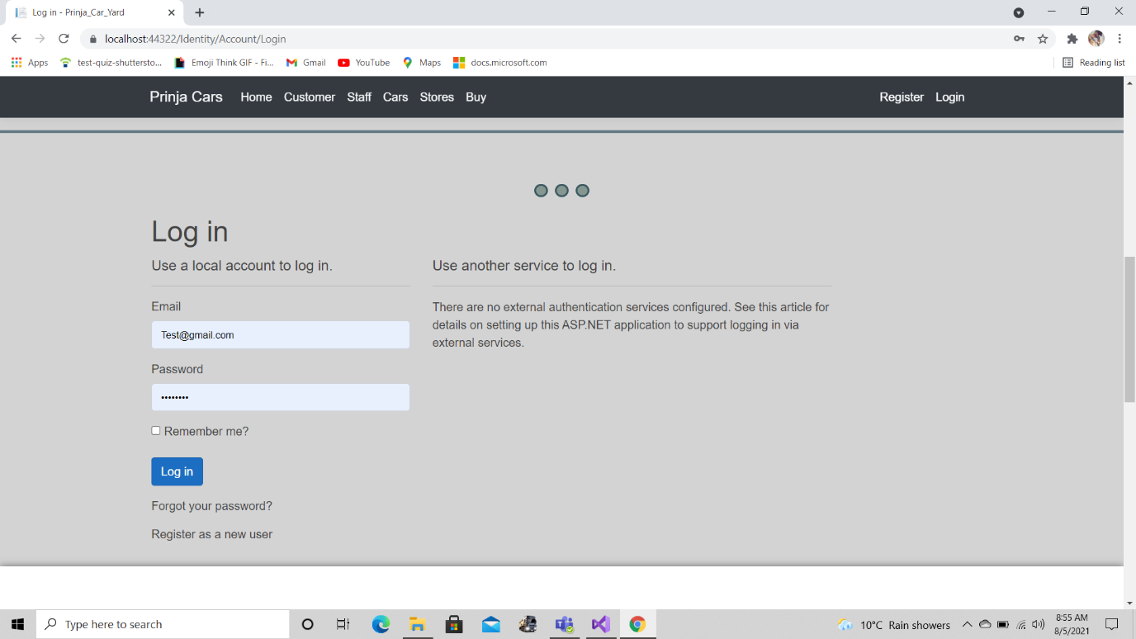

# Testing Project

## Checking for Device Usability

|  |  |  |  |  |  |  |
| --- | --- | --- | --- | --- | --- | --- |
| **Tester** | | **Answer Scale** | | | | |
| **No.** | **Question** | **Strongly Disagree (1)** | **Disagree (2)** | **Normal (3)** | **Agree (4)** | **Strongly Agree (5)** |
| 1 | I think that I would like to use this system frequently |  |  |  |  |  |
| 2 | I found the system unnecessarily complex |  |  |  |  |  |
| 3 | I thought the system was easy to use |  |  |  |  |  |
| 4 | I think that I would need the support of a technical person to be able to use this system |  |  |  |  |  |
| 5 | I found the various functions in this system were well integrated |  |  |  |  |  |
| 6 | I thought there was too much inconsistency in this system |  |  |  |  |  |