

Software Safety Requirements and Architecture

Lane Assistance

**Document Version: [Version]**

**Template Version 1.0, Released on 2018-05-24**



# Document history

|  |  |  |  |
| --- | --- | --- | --- |
| Date | Version | Editor | Description |
| 2018-05-24 | 1.0 | Yogesh Mahawar | Initial Draft for software requirement and Architecture |
|  |  |  |  |
|  |  |  |  |
|  |  |  |  |
|  |  |  |  |

# 

# Table of Contents

Document history

Table of Contents

Purpose

Inputs to the Software Requirements and Architecture Document

Technical safety requirements

Refined Architecture Diagram from the Technical Safety Concept

Software Requirements

Refined Architecture Diagram

# Purpose

This document identifies the new requirements for the software components at a component level to identify potential problems on software design and architecture that could lead to a violation of safety goals. These requirements are more detail oriented than the technical safety concept requirements.

# Inputs to the Software Requirements and Architecture Document

## Technical safety requirements

Technical Safety Requirements related to Functional Safety Requirement 01-01 are:

|  |  |  |  |  |  |
| --- | --- | --- | --- | --- | --- |
| **ID** | **Technical Safety Requirement** | **ASIL** | **Fault Tolerant Time Interval** | **Architecture Allocation** | **Safe State** |
| Technical  Safety  Requirement  01 | LDW safety component shall ensure that the amplitude of the ‘LDW_Torque_Request’ sent to the ‘Final electronic power steering Torque’ component is below ‘Max_Torque_Amplitude.’ | C | 50ms | LDW Safety | Lane Departure Warning torque to set zero. |
| Technical  Safety  Requirement  02 | When the LDW is deactivated, the ‘LDW Safety’ software module shall send a signal to the Car Display ECU to turn on a warning signal. | C | 50ms | LDW Safety | Set Lane Departure Warning torque to zero. |
| Technical  Safety  Requirement  03 | When a failure is detected by the LDW functionality, it shall deactivate the LDW feature and set ‘LDW_Torque_Request’ to zero. | C | 50ms | LDW Safety | Set Lane Departure Warning torque to zero. |
| Technical  Safety  Requirement  04 | The validity and integrity of the data transmission for ‘LDW_Torque_Request’ signal shall be ensured. | C | 50ms | Data Transmission Integrity Check | Set Lane Departure Warning torque to zero. |
| Technical  Safety  Requirement  05 | Memory test shall be conducted at startup of the EPS ECU to check for any memory problems | A | Ignition cycle | Data Transmission Integrity Check | Set Lane Departure Warning torque to zero. |

## Refined Architecture Diagram from the Technical Safety Concept

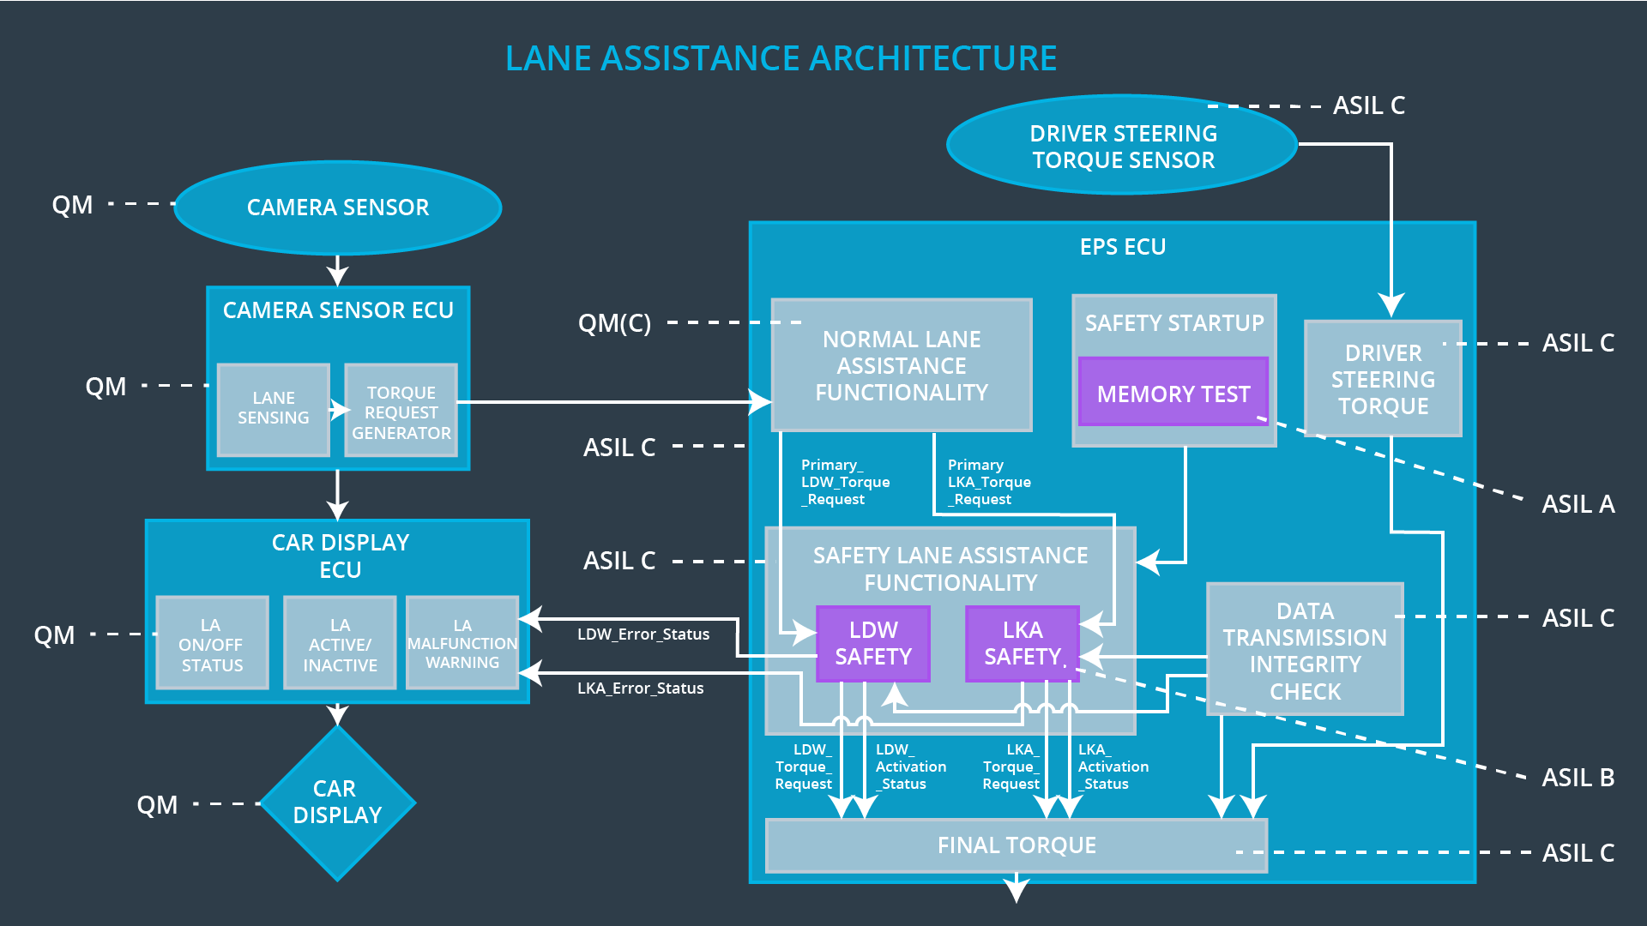

# 

# Software Requirements

**Lane Departure Warning (LDW) Amplitude Malfunction Software Requirements:**

|  |  |  |  |  |  |
| --- | --- | --- | --- | --- | --- |
| **ID** | **Technical Safety Requirement** | **ASIL** | **Fault Tolerant Time Interval** | **Allocation to Architecture** | **Safe State** |
| Technical  Safety  Requirement  01 | The Lane Departure Warning safety component shall ensure that the amplitude of the ‘LDW_Torque_Request’ sent to the ‘Final electronic power steering Torque’ component is below ‘Max_Torque_Amplitude.’ | C | 50ms | LDW Safety | Lane Departure Warning torque to zero. |

|  |  |  |  |  |
| --- | --- | --- | --- | --- |
| ID | Software Safety Requirement | ASIL | Allocation Software Elements | Safe State |
| Software  Safety  Requirement  01-01 | The input signal ‘Primary_LDW_Torq_Req’ shall be read and pre-processed to determine the torque request coming from the ‘Basic/Main LAFunctionality’ SW Component. Signal ‘processed_LDW_Torq_Req’ shall be generated at the end of the processing. | C | LDW_SAGETY_INPUT_PROCESSING | N/A |
| Software Safety Requirement 01-02 | In case the ‘processed_LDW_Torq_Req’ signal has a value greater than ‘Max_Torque_Amplitude_LDW’ (maximum allowed safe torque), the torque signal ‘limited_LDW_Torq_Req’ shall be set to zero, else ‘limited_LDW_Torq_Req’ shall take the value of ‘processed_LDW_Torq_Req’ | C | TORQUE_LIMITER | ‘limited_LDW_Torq_Req’ = 0 (Nm=Newton-meter) |
| Software Safety Requirement 01-03 | The ‘limited_LDW_Torq_Req’ shall be transformed into a signal ‘LDW_Torq_Req’ which is suitable to be transmitted outside the LDW Safety component (‘LDW Safety’) to the ‘Final EPS Torque’ component. | C | LDW_SAFETY_OUTPUT_GENERATOR | LDW_Torq_Req = 0 (Nm) |

|  |  |  |  |  |  |
| --- | --- | --- | --- | --- | --- |
| **ID** | **Technical Safety Requirement** | **ASIL** | **Fault Tolerant Time Interval** | **Allocation to Architecture** | **Safe State** |
| Technical  Safety  Requirement  02 | The validity and integrity of the data transmission for LDW_Torque_Request signal shall be ensured | C | 50ms | Data transmission integrity check | N/A |

|  |  |  |  |  |
| --- | --- | --- | --- | --- |
| **ID** | **Software Safety Requirement** | **ASIL** | **Allocation Software Elements** | **Safe State** |
| Software Safety Requirement 02-01 | Any Data to be transmitted from LDW Safety component including “LDW_Torque_Req” and “activation_status” shall be protected by End2End(E2E) Protection Mechanism | C | E2E Calculation | LDW_Torque_Req = 0 (Nm) |
| Software Safety Requirement 02-02 | The E2E protection protocol shall contain and attach the control data: alive counter SQC and CRC to the Data to be transmitted. | C | E2E Calculation | LDW_Torque_Req = 0 (Nm) |

|  |  |  |  |  |  |
| --- | --- | --- | --- | --- | --- |
| **ID** | **Technical Safety Requirement** | **ASIL** | **Fault Tolerant Time Interval** | **Allocation to Architecture** | **Safe State** |
| Technical  Safety  Requirement  03 | As soon as a failure is detected by the LDW function, it shall deactivate the LDW feature and the LDW_Torque_Request shall be set to zero | C | 50ms | LDW Safety | LDW_Activation_Status is zero |

|  |  |  |  |  |
| --- | --- | --- | --- | --- |
| **ID** | **Software Safety Requirement** | **ASIL** | **Allocation Software Elements** | **Safe State** |
| Software Safety Requirement03-01 | Each Software element shall output a signal to indicate any error which is detected by the element. Error signal = error_status_input (LDW_SAFETY_INPUT_PROCESSING), error_status_torque_limiter(TORQUE_LIMITER), error_status_output_gen(LDW_SAFETY_OUTPUT_GENERATOR) | C | All | N/A |
| Software Safety Requirement03-02 | A software element shall evaluate the error status of all other software elements and in case any one of them indicates an error, it shall deactivate the Lane Departure Warning feature (‘activation_status’=0) | C | LDW_SAFETY_ACTIVATION | Lane Departure Warning function deactivated (‘activation_status’ =0). |
| Software Safety Requirement03-03 | In case of a no error from the software elements, the status of the Lane Departure Warning feature shall be set to activated (‘activation_status’=1). | C | LDW_SAFETY_ACTIVATION | N/A |
| Software Safety Requirement03-04 | In case an error is detected by any of the software elements, it shall set the value to its corresponding torque to zero so that ‘LDW_Torq_Req’ is set to zero | C | All | LDW_Torq_Req = 0 |
| Software Safety Requirement03-05 | Once the Lane Departure Warning functionality has been deactivated, it shall stay deactivating until the time the ignition is switched from off to on again. | C | LDW_SAFETY_ACTIVATION | Lane Departure Warning function deactivated (‘activation_status’ =0). |

|  |  |  |  |  |  |
| --- | --- | --- | --- | --- | --- |
| **ID** | **Technical Safety Requirement** | **ASIL** | **Fault Tolerant Time Interval** | **Allocation to Architecture** | **Safe State** |
| Technical  Safety  Requirement  04 | As soon as the LDW function deactivates the LDW feature, the LDW Safety software block shall send a signal to the car display ECU to turn on a warning light | C | 50ms | LDW Safety | LDW_Error_Status is zero |

|  |  |  |  |  |
| --- | --- | --- | --- | --- |
| **ID** | **Software Safety Requirement** | **ASIL** | **Allocation Software Elements** | **Safe State** |
| Software Safety Requirement 04-01 | When The LDW Function is Deactivated (acticvation_status set to 0), the Activation status shall be sent to car display ECU | C | LDW_SAFETY_ACTIVATION, Car Display ECU | N/A |

|  |  |  |  |  |  |
| --- | --- | --- | --- | --- | --- |
| **ID** | **Technical Safety Requirement** | **ASIL** | **Fault Tolerant Time Interval** | **Allocation to Architecture** | **Safe State** |
| Technical  Safety  Requirement  05 | Memory test shall be conducted at start up of the EPS ECU to check for any faults in memory | A | Ignition cycle | Memory Test | LDW_Activation_Status is zero |

|  |  |  |  |  |
| --- | --- | --- | --- | --- |
| **ID** | **Software Safety Requirement** | **ASIL** | **Allocation Software Elements** | **Safe State** |
| Software Safety Requirement 05-01 | A CRC verification check over the software code in the Flash memory shall be done every time the ignition is switched from off to on to check for any content corruption. | A | MEMORYTEST | Activation_status = 0 |
| Software Safety Requirement 05-02 | Standard RAM test to check the data bus, address bus and device integrity shall be done every time the ignition is switched from off to on (e. G. walking 1s test, RAM pattern test, Refer to RAM and processor vendor recommendations) | A | MEMORYTEST | Activation_status = 0 |
| Software Safety Requirement 05-03 | The test result of the RAM or Flash memory shall be indicated to the LDW_Safety component via the ‘test_status’ signal. | A | MEMORYTEST | Activation_status = 0 |
| Software Safety Requirement 05-04 | In case any fault is indicated via the ‘test_status’ signal the | A | LDW_SAFETY_INPUT_PROCESSING | Activation_status = 0 |

# 

# Refined Architecture Diagram

