**Spring Core Annotations Summary**

1. **@Component:**

-> Marks a Java class as a Spring-managed bean.

-> @Component annotation has the following sub-types:

1. **@RestController:** Used for RESTful web services (combines @Controller and @ResponseBody).
2. **@Service:** Indicates a service layer component containing business logic.
3. **@Repository:** Marks a data access object (DAO) and provides exception translation.

**Note:**

If you’re creating a Java class in a Spring Boot project and none of the specialized annotations (@RestController, @Service, @Repository) are suitable for the purpose of that class, you can use **@Component** to mark it as a Spring-managed bean.

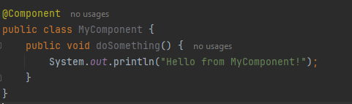

1. **@Configuration:**